w w f r
Edited by Professor LB. Ventskivska
Recommended by the Ministry of Public Health of Ukraine as a textbook for students of institutions of higher medical education of the IV level of accreditation, who master the discipline in English
Kyiv
"MEDICINE" 2008
CONTENTS
PHYSIOLOGICAL OBSTETRICS 7
Chapter 1. FERTILIZATION AND FETAL
EGG DEVELOPMENT 7
1.2. Spermatogenesis 7
- Oogenesis 8
- Fertilization 9
- Implantation 12
- Embryogenesis 14
- Fetal Period 16
- Placenta Development 20
Chapter 2. PHYSIOLOGICAL CHANGES
IN THE MATERNAL ORGANISM DURING PREGNANCY 25
Chapter 3 . MATERNAL PASSAGES 35
- Female Genitals Anatomy in Point of Obstetrics 35
- Female Pelvis in Point of Obstetrics 37
Chapter 4 . FETUS AS DELIVERY OBJECT 44
- Morphologic Features of the Fetal Head and Body 44
- Mature and Full-Term Fetus Signs 45
Chapter 5 . PREGNANT WOMEN EXAMINATION 47
5.1. Early Pregnancy Diagnostics 47
3
CONTENTS
5.2. Late Pregnancy Investigation 50
Chapter 6. FETAL CONDITION IMAGING
AND ASSESSMENT 59
Chapter 7 . PHYSIOLOGICAL DELIVERY 77
7.L Delivery Biomechanism at Vertex Presentation ...77- -
- Delivery Stages 81
- Methods of Examining Parturient Women during Delivery 87
- Clinical Course and Management
of the First Delivery Stage 92
7.5. Clinical Course and Management of the Second
Delivery Stage 93
7.6. Clinical Course and Management
of the Third Delivery Stage 98
Chapter 8 . DELIVERY PAIN RELIEF 104
- Methods of Delivery Pain Relief 104
- Nonmedicamentous Obstetric Anesthetic Techniques 105
- Medicamentous Obstetric Anesthetic Techniques 106
Chapter 9. PHYSIOLOGICAL PUERPERAL PERIOD Ill
- Changes in the Woman's Organism in the Puerperal Period Ill
- Puerperal Period Management 114
Chapter 10. PHYSIOLOGICAL NEWBORN PERIOD 117
- Newborn Condition Assessment 117
- Anatomico-Physiological Peculiarities of Newborns 120
- Borderline States of Newborns 123
- Newborns Care 125
PATHOLOGICAL OBSTETRICS 127
Chapter 11. PELVIC PRESENTATION 127
Chapter 12. MULTIPLE PREGNANCY 142
Chapter 13. GESTOSES 152
- Early Gestoses 153
- Late Gestoses 155
4
CONTENTS
Chapter 14. PREGNANCY ISOSENSITIZATION 170
Chapter 15. NONCARRYING OF PREGNANCY 181
- Spontaneous Abortion 181
- Induced Abortion 188
- Preterm Delivery 193
Chapter 16. PLACENTAL INSUFFICIENCY.
FETAL DEVELOPMENT DELAY 199
- Placental Insuffiency 199
- Fetal Development Delay 202
Chapter 17. UTERINE BIRTH ACTIVITY ANOMALIES 205
- Pathological Preliminary Period 205
- Powerless Labor 206
- Discoordinated Birth Activity 207
Chapter 18. BONY PELVIS ANOMALIES 211
Chapter 19. MALPOSITIONS 228
Chapter 20. OBSTETRIC HEMORRHAGES 233
- Hemorrhages during Pregnancy 233
- Hemorrhages in the Course of Delivery
and in the Puerperal Period 237
Chapter 21. PARTURIENT MATERNAL
TRAUMATISM 250
- Vulva, Vagina, Perineum Ruptures 250
- Cervical Rupture 256
- Hysterorrhexis 257
- Inversion of Uterus 268
- Separation of Symphysis Pubis and Symphysiolysis 269
Chapter 22. FETAL DISTRESS. POSTNATAL
ASPHYXIA 271
- Fetal Distress 271
- Postnatal Asphyxia 275
Chapter 23. OBSTETRIC OPERATIONS 279
23.1. Obstetric Forceps 279
5
CONTENTS
- Vacuum Fetus Extraction 285
- Fetus Extraction by the Pelvic Pole :288
- Cesarean Section 293
- Embryotomies 298
Chapter 24. POSTNATAL INFECTIOUS COMPLICATIONS 306
- Wound Infection 309
- Postnatal Endometritis 313
- Thrombotic Complications in the Puerperal Period.... _{y}315
- Lactational Mastitis 316
- Systemic Inflammatory Response Syndrome 318
Chapter 25. EXTRAUTERINE PREGNANCY 323
6
PHYSIOLOGICAL OBSTETRICS
Chapter 1
FERTILIZATION
AND FETAL EGG DEVELOPMENT
1.2. SPERMATOGENESIS
Spermatogenesis takes place in the testicular tubules of male gonads. It is completed in the period of sexual maturity with the formation of mature conceptive spermatozoa. Complete maturation is preceded by the process of meiotic division, which results in the haploid number of chromosomes in the sperm nucleus.
There are two types of spermatozoa: Y and X chromosome carriers. Fusion of a spermatozoon, which is an X chromosome carrier, with an ovum results in the formation of a female embryo; if an ovum fuses with a spermatozoon carrying Y chromosome, a male embryo forms.
A mature spermatozoon is 50—60 urn long and consists of a head (karyomere), a neck, and a tail. The head is of oval form, contains a nucleus surrounded by a thin layer of protoplasm. The neck has protoplasm containing a modified centrosome, which promotes fertilized ovum division. The tail consists of protoplasm and performs the movement function. Oscillating movements of the tail part enable spermatozoa to move independently in the female genital tracts at 2—3 mm/min. Spermatozoa get the ability to move after contacting the secretion of the seminal vesicles and prostate gland. During coitus about 3—5 ml semen, containing something like 300—500 million spermatozoa, get into the vagina.
7
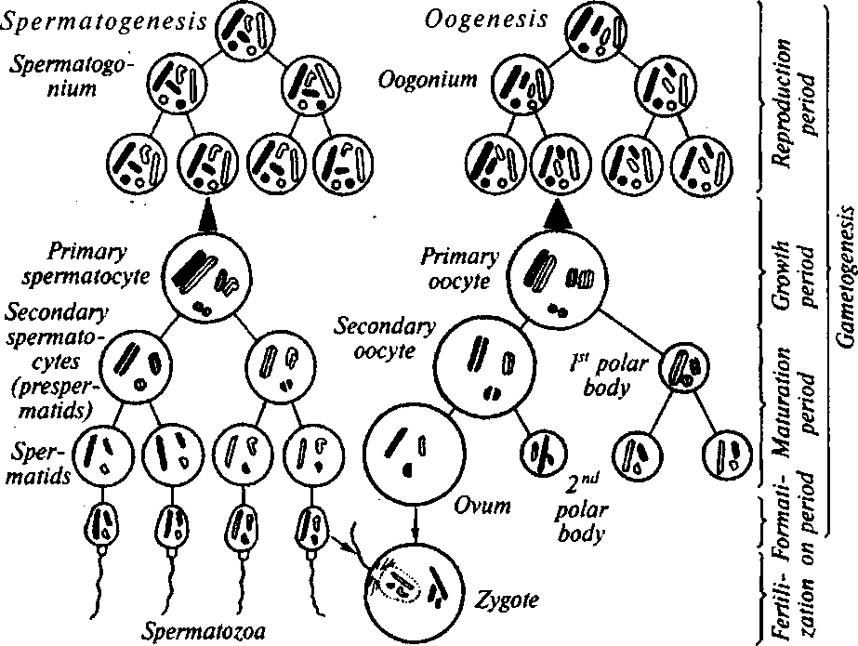
PHYSIOLOGICAL OBSTETRICS
Fig. 1. The general scheme of spermatogenesis, oogenesis, and fertilization
The seminal fluid has complex structure: it contains fructose, pro-teic substances, proteases, acid phosphatase, citric acid, prostaglandins. The seminal fluid has evident antigen strength: in the process of fertilization the antigens of spermatozoa are neutralized (Fig. 1).
1.2. OOGENESIS
Ova development is connected with the growth and development of primary follicles located in the cortical layer of the ovaries. For convenience, ovum maturation can be divided into nucleus maturation and cytoplasm maturation.
From puberty till menopause there usually matures one ovum in every menstrual cycle. A primary oocyte turns into a secondary oocyte when the first polar body detaches. At the moment of ovulation the secondary oocyte is blocked at the metaphase stage of the second meiotic division.
8
Chapter 1. Fertilization and Fetal Egg Development
A mature ovum consists of a nucleus and cytoplasm surrounded by the pellucid zone and cells of the radiating crown, which is the remains of granulose follicle cells. A female sex cell, especially the pellucid zone, is characterized by antigenicity
1.3. FERTILIZATION
Fertilization is the process of fusion of mature male (spermatozoa) and female (ova) sex cells resulting in the formation of a zygote, which carries both the father's and mother's information.
Gametes transport. First of all this concerns spermatozoa transfer in the female genital tracts. At normal ejaculation about 100 million spermatozoa get into the vagina; some spermatozoa have different morphological or functional deviations. A part of spermatozoa, including inadequate ones, remain in the vagina and undergo phagocytosis. Other semen components get into the vagina together with spermatozoa, of these prostaglandins are of special emphasis: under their influence the contractive activity of the uterus and uterine tubes is promoted, which is very important for gametes transport. The latter quickly get from the vagina (in healthy women it has acidic medium, which destructively influences the vital activity of spermatozoa) into the cervical mucus that is secreted from the cervical canal during coitus under the influence of cervical muscles contractions. The presence of alkalescent medium in the cervical canal promotes spermatozoa mobility increase.
The most favourable composition of cervical mucus is formed by the moment of ovulation under the influence of the estrogenic hormones of the ovaries. Turbulent motions of spermatozoa are the most evident in the parietal areas of the neck of womb, at that most spermatozoa are deposited in the crypts of the neck of womb, thereby creating a peculiar semen reserve, from which their auxiliary motion up the canals of the reproductive system might take place during 72 h.
Having gone through the neck of womb, spermatozoa start moving rather quickly in the direction of the uterine tube ampulla, where mature ovum fertilization usually takes place. Fertilization must be preceded by spermatozoa capacitation — the estrogen- and calcium-dependent process of its activation. As a result of the process, the internal acrosomal membrane changes in such a way that it is ready to fuse with the internal ovum membrane.
Acrosomal reaction results in the denudation of the internal acrosomal membrane — the part of the spermatozoon, with which it fuses
9
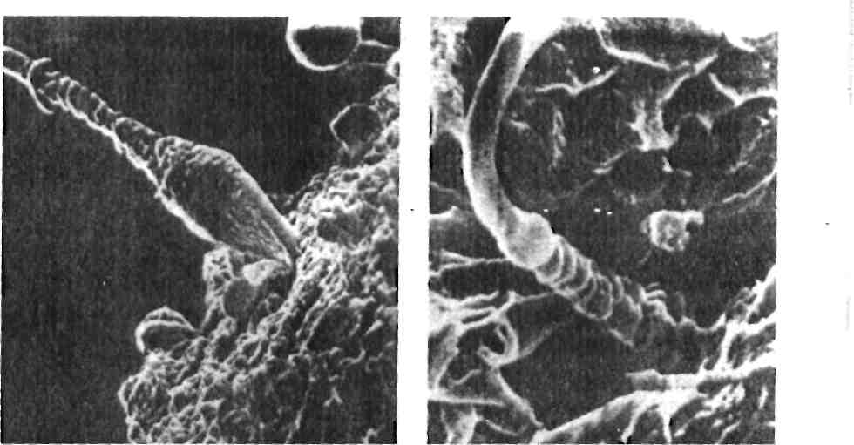
PHYSIOLOGICAL OBSTETRICS
Fig. 2. The stages of spermatozoa approaching the ovular membrane
with the ovum. An acrosome is a specialized lysosome located in the spermatozoon head and taking 2/3 of its volume (Fig. 2).
Spermatozoa are transported into the womb and then into the uterine tubes mostly by means of contractions of these organs' non-striated muscle fibers.
Modern scientific findings testify to the diphase process of spermatozoa transfer along the uterine tube's. In the first phase spermatozoa begin quickly getting into the ampulla of the uterine tube. This phase lasts a couple of minutes and is regulated by the contractive activity of the uterus and uterine tubes. During the longer second phase spermatozoa with much less rate are transported to the place oi fertilization. In the ampullar part of the uterine tube in the long-term phase of transportation a normal quantity of spermatozoa is kept at a certain level due to continuous substitution of the spermatozoa, which have got to the abdominal cavity, by the spermatozoa deposited in the uterine neck crypts.
Ovum capture by the ampullar part of the uterine tube is of great importance for gametes transport and fertilization.
The First Phase of the Tube Period
Post-ovulatory -period and fertilization (lasting from a couple of hours to 1.5—2 days). The ampullar part of the uterine tube is kind of covering the ovary with its fimbriae in the place of ovulation; this
Chapter 1. Fertilization and Fetal Egg Development
considerably facilitates the transfer of the mature ovum into the uterine tube ampulla.
In the lumen of the Fallopian tube the ovum is surrounded by numerous follicular cells and gelatinous mass — the so-called "radiating crown" performing the function of a protector for closer contact with dense ciliated coating of the distal part of the tube ampulla. The en-dosalpinx cilia not only hold the ovum in the lumen of the ampulla,-but also push it to the upper ampulla, to the place of fertilization. In the meantime ovum denudation occurs, i.e. gradual release of the female gamete from the "radiating crown", which is necessary for the unhampered penetration of the spermatozoon into the ovum. After denudation the ovum is covered only with the pellucid zone, which contains spermatozoon-binding receptors. The contact of the spermatozoon with the ovum membrane is a signal for cortical reaction start and meiosis completion with the separation of the second polar body and, thereby, its definitive maturing. Meiosis completion is a more lasting process. The most important result of meiosis is that the hap-loid number of chromosomes remains in the oocyte. The male pronucleus is being formed simultaneously with the female one. As the formed male and female pronuclei approach, DNA replication is taking place in them forestalling syngamy — integration of the genetic-material of the two gametes. Further the pronuclei lose their envelopes, after which the maternal and paternal chromosomes mingle, the first mitotic division of the formed nucleus takes place. The cortical reaction hampers polyspermy, therefore it is a necessary condition of successful fertilization (sec Fig. 2).
After the first division of the zygote embryo development begins.
The Second Phase of the Tube Period
The second phase lasts from fertilization till the embryonic material gets into the uterus. Functionally and morphologically it consists of inseparably linked and simultaneous processes.
Transport of a fertilized ovum into the uterine cavity lasts from 6—8 to 9—11 days. Right after fertilization rapid growth of progesterone concentration is noted. Under its influence longitudinal muscles relax gradually, which defines the congruence of the uterine tube lumen to the dimensions of the growing fertilized ovum.
The tube cycle of embryo development (6—10 days). A mature, ready for implantation blastocyst gets into the uterine cavity. In a day after zygote formation as a result of division there appear two
11
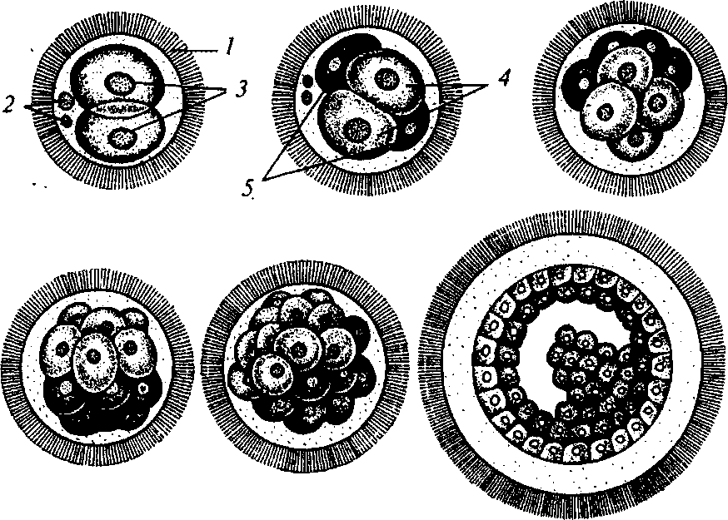
PHYSIOLOGICAL OBSTETRICS
Fig. 3. The scheme of fertilized ovum cleavage:
1 — pellucid zone; 2 — polar bodies; 3 — cleavage layers; 4 — light layers, which form the external blastophylliini; 5 — dark layers, which form the internal blasto-phyllum
blastomeres. Continuous cleavages of a group of elastomers on the 3rd—4th day result in a dense ball of cells — a morula (Fig. 3). During 4—6 days the morula turns into a blastocyst — an embryo in the form of a vesicle. The cells might be external and internal. The internal cells form an embryoblast, from which an embryo forms in future, amnion, and a yolk sac; the external cells turn into a trophoblast necessary for implantation in the myometrium. At that, trophoblast actively produces fluid and absorbs the secretion of the tube glands. Thus the blastocyst is formed, which consists of trophoblast, surrounding the germinal vesicle cavity, inside which there is embryoblast in the form of a microscopic embryonic islet.
1.4. IMPLANTATION
After getting into the uterine cavity the blastocyst (about 0.1 — 0.3 mm in diameter) deepens into the mucous tunic during 2—4 days. Before nidation, already in the uterine cavity, the embryo comes out
12
Chapter 1. Fertilization and Fetal Egg Development
of the thin pellucid zone, which has persisted from the moment of fertilization. This is caused both by blastocyst pulsation and embryonic membrane lysis damaged by secretory endometrium enzymes. Denuded trophoblast damages the protective epithelium of the endometrium, the trophoblastic cavity gradually deepens into the functional layer of the endometrium (Fig. 4).
After implantation completion (10—12 days after fertilization) around the embryo (0.4—0.5 mm in diameter) from the modified endometrium there forms the decidual membrane, which will later become a part of placenta.
Right after implantation trophoblast enlarges considerably and chorion forms from it consisting of villous (placenta predecessor turned to the uterine wall) and smooth (turned to the uterine cavity) parts (Fig. 5). After primary chorionic villi formation the blastocyst is called a fetal sac — 14—15 days after fertilization (2—3 weeks of pregnancy).
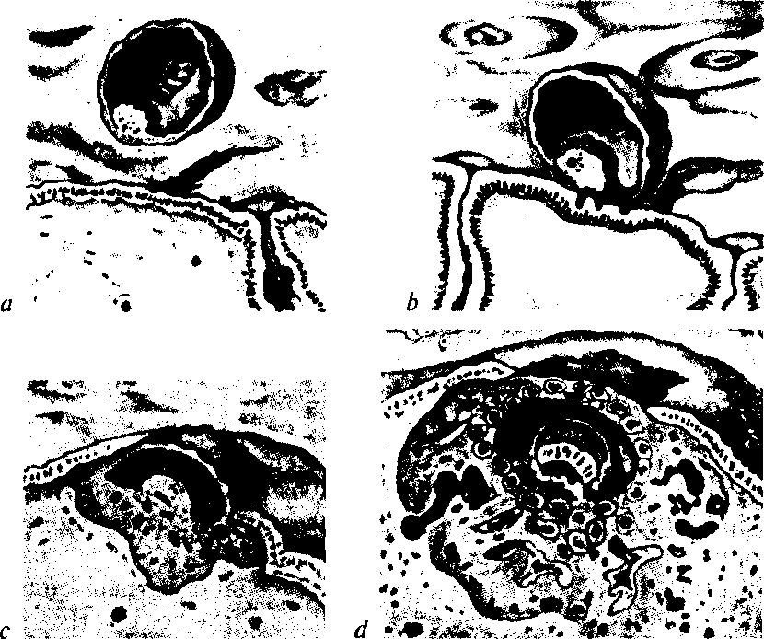
Fig. 4. Implantation:
a — the blastocyst before implantation; b — initial contact of the blastocyst with the caduca; c — immersion of the blastocyst into the caduca; d — implantation completion
13
PHYSIOLOGICAL OBSTETRICS

Fig. 5. Chorion development:
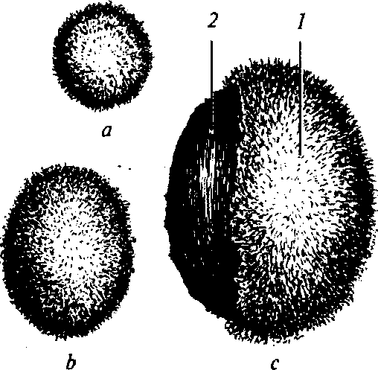
a — the fetal egg of the 1st month of pregnancy (chorionic villi developed uniformly on the whole fetal egg surface); b - the fetal egg of the 2 ^{nd} month of pregnancy; c — the fetal egg of the 3rd month of pregnancy: 1 — chorion frondo-sum, 2 — chorion leaf

1.5. EMBRYOGENESIS
Embryoblast is developing simultaneously. By the mentioned above term it turns into amnion (an amniotic sac) and a yolk sac, connected to the villous chorion with the amniotic stalk. This period is called the early stage of uterine embryogenesis, the period of gastrulation.
The second phase of gastrulation begins after the completion of the described above process of extraembryonic organs formation. It lasts for 3 days and ends with the anlage of three basic germ layers (ectoderm, entoderm, and mesoderm) and allantois, which grows into the amniotic stalk. By the 17th— 18th day after fertilization three-week pregnancy is an oval fetal bladder, the greater part of which is taken by the fluid separated from the endometrium by smooth chorion and decidual membrane. Inside it there is an embryo in the form of two sacs, amniotic and yolk, connected to the villous chorion with the amniotic stalk. The embryo itself has the appearance of a microscopic oval fold located on the yolk sac and somewhat protruding into the amniotic cavity (Fig. 6).
From the 17th—18th day the period of axial organs anlage begins, and from the 20th—21st day after fertilization the body of the embryo isolates from the extraembryonic organs. The fetal egg grows both due to the volume gain of the decidual-chorionic cavity and rapid enlargement of the amniotic sac. By the 4th week of pregnancy the amnion conjugates from within with the smooth chorion by 50 % of its circumference. In the same period- in the part of chorion located be-
14

Chapter 1 . Fertilization and Fetal Egg Development
tvvecn the uterine wall and the embryo the primary villi become bigger, more branchiate; in other parts they disappear. Chorion frondo-sum is formed, which together with the basal part forms the placenta. During 4—5 weeks the amnion quickly gains volume and constitutes 80—95 % of the embryonal fluid. Remains of the "old" decidual-chorionic cavity are preserved in the form of individual slot-like spaces on the periphery of the embryo sac. The mass of the embryo grows
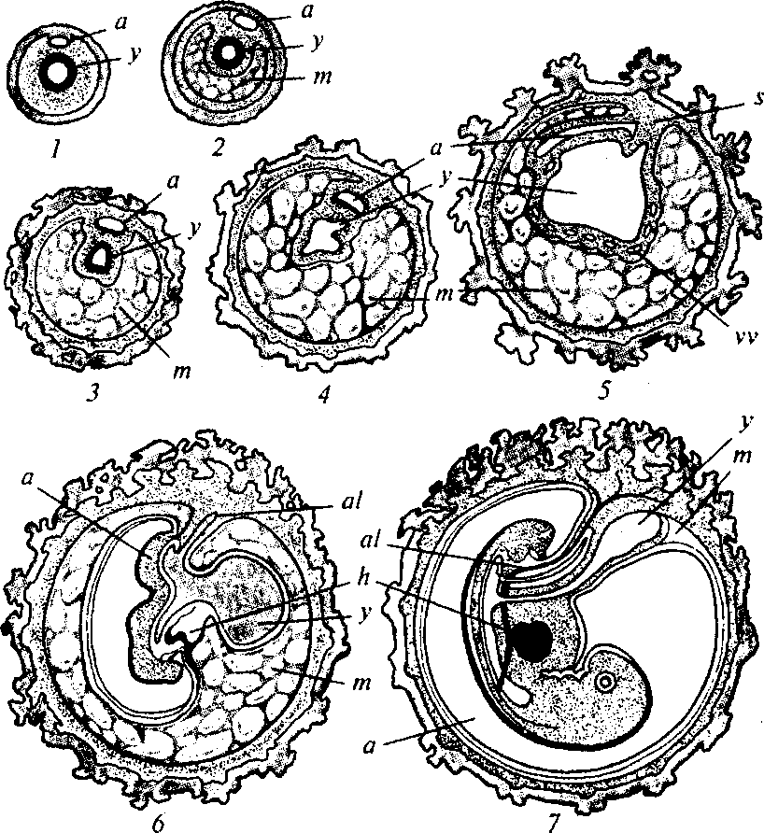
Fig. 6. The scheme of fetal membranes development:
1 — the earliest period of human ovum development; 2 — a separated embryo; 3,4 — further fetal development, formation of an attaching stalk; 5 — further fetal development; 6 — amniotic cavity increase and yolk cavity decrease; 7 — disappearance of the magma cavity; a — amniotic (ectoblast) cavity, al — allantois, y — yolk (entoblast) cavity, vv — vitelline vessel, m — magma, s — stalk, h — heart, e — embryo
15
PHYSIOLOGICAL OBSTETRICS
considerably; the embryo turns into a macroscopic inclusion, visible by means of ultrasonic scanning.
At 5 weeks of pregnancy the amnion, as a rule, completely conjugates with the smooth chorion, the embryo sac completely transforms into the amniotic cavity. The amnion is directed to the fetus. It lines the placenta and proceeds to the umbilical chord, conjugating with the fetal skin in the -region of the umbilical ring. Macroscopically the amnion is a transparent membrane. In the process of embryogenesis the amnion develops from the ectoblastic sac. The amniotic epithelium forms from the ectoderm, connective tissue base — from the mesoderm. Amniotic epithelial cells contain lipids, polysaccharides, proteins, phosphatic compounds, and also a number of enzymes taking part in amniotic fluids metabolism and also in paraplacental metabolism.
The wall of the decidual-chorionic-amniotic cavity consists of three layers: internal — the amniotic sac, middle — the smooth chorion, and external — the decidual membrane. In this period dimensions of the embryo reach 3—4 mm.
In the decidual membrane three parts are differentiated:
- the part lining the uterine cavity (decidua parietalis);
- the part covering the fetal egg from the side of the uterine cavity (decidua capsularis);
- the part located between the fetal egg and the uterine wall (decidua basalis).
In the process of fetal egg growth decidua parietalis and decidua capsularis stretch, become thin, and approach one another (Fig. 7).
From the 5th till the 6th week further increase of embryo and amniotic cavity dimensions takes place. During the 6th week of pregnancy the embryo becomes fabiform and contains anlages of all major organs with the exception of sexual glands, whose anlage takes place during the 2nd week of embryonal life (Fig. 8).
During the 4th—5th week of pregnancy the fetal egg takes the whole uterine cavity; decidua parietalis conjugates with decidua capsularis. On the contrary, decidua basalis hypertrophies considerably and transforms into the maternal part of the placenta.
1.6. FETAL PERIOD
This period lasts from the 12th till the 40th week of pregnancy.
The fetal nervous system. Formation of the nerve tube and cerebral vesicles takes place during the first weeks of embryogenetic develop-
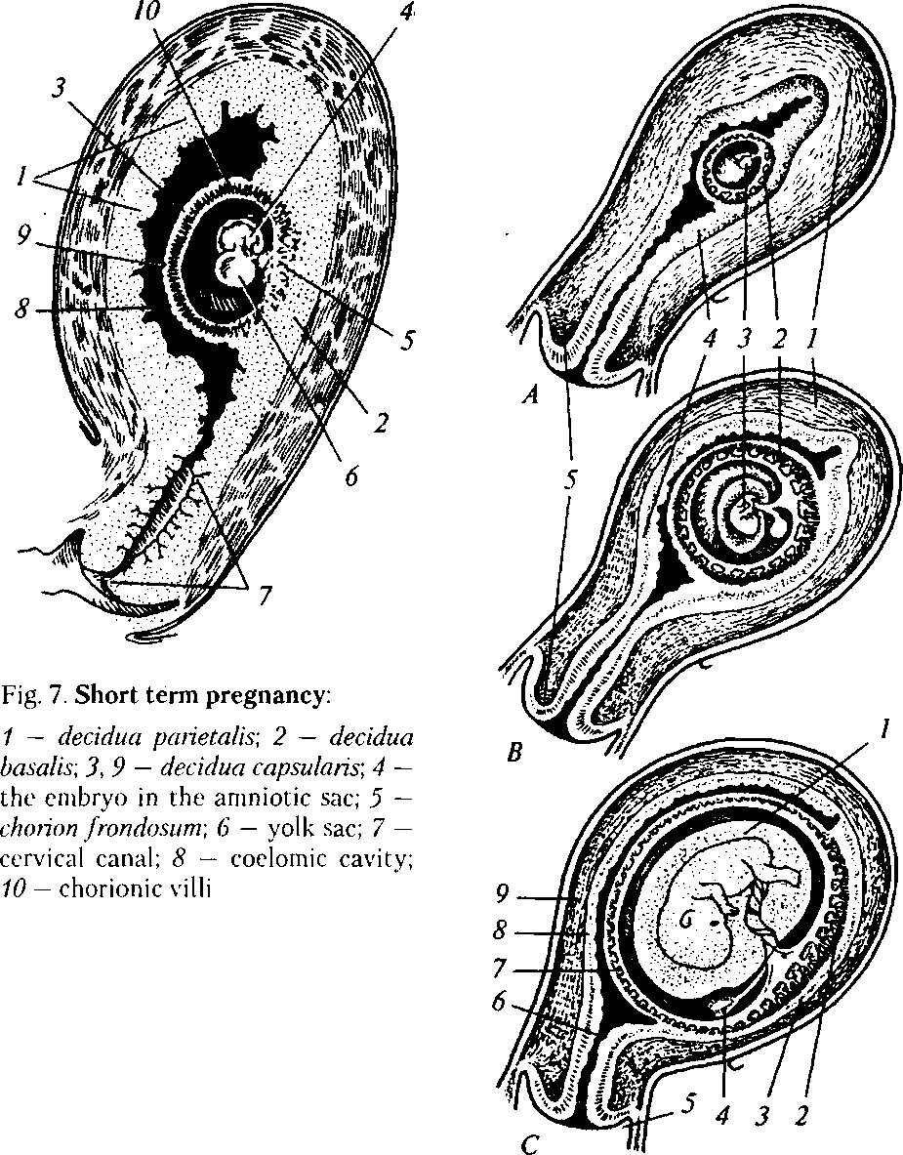
Chapter- 1 . Fertilization and Fetal Egg Development
Fig. 8. Appearance of the uterus during the first pregnancy weeks:
^4 — 3 weeks, B — 5 weeks, C — 8 weeks after fertilization. A and B: 1 — fundus of uterus; 2 — chorionic vesicle; 3 — embryo; 4 — endometrium; 5 — neck of uterus; C: 1 — amnion; 2 — villous part of chorion; 3 — basal lamina {decidua basalts); 4 — yolk sac; 5 — anterior part of the vault of vagina; 6 — cervical canal of uterus; 7 — deciduous capsular membrane (decidua capsularis); 8 — deciduous parietal membrane (decidua parietalis); 9 — myometrium
17
PHYSIOLOGICAL OBSTETRICS
ment. During the 2nd week reflex arch elements form — from here on the first motor reflexes appear. During the 21st week the fetus has the first spontaneous sucking movements, the first electrical potentials of the brain appear. By the end of the intrauterine period formation of the most important parts of the central and peripheral nervous system is completed.
The fetal endocrine system. Formation and development of the fetal endocrine system is associated with the maternal endocrine system. Somatotropin production begins from the 7th—8th week of intrauterine development. The increase of this hormone concentration is observed till 20—24 weeks of pregnancy, which correlates with the indices of fetal growth. Still, at later stages of pregnancy this tendency is not preserved, which means that fetus growth is not completely controlled by this hormone production.
The hypophysis produces gonadotropic hormones in the following order: the hypophysis synthesizes follicle-stimulating hormone beginning from 13 weeks of ontogenesis, luteinizing horomone — from 18 weeks, prolactin — from 19 weeks. Sex hormones of female (estrogens) and male (testosterone) gonads form in the antenatal period in small quantity. These hormones play a considerable part in the processes of internal and external genitals.
During the 9th week of embryo development there appear signs of adrenocorticotropic hormone (ACTH) production. ACTH stimulates the function of the cork layer of adrenal glands with formation of Cortisol and dehydroepiandrosterone. Fetal Cortisol plays an important role in the synthesis of surfactant system, which stimulates pulmonary tissue ripening. Dehydroepiandrosterone of the fetus is material for estriol synthesis by the placenta.
The fetal cardiovascular system. Blood circulation of the fetus has such features:
- blood is oxygenated in the placenta;
- the right and left ventricles are rather contracting simultaneously than in turn;
- the heart, brain, and upperparts get blood from the left ventricle, the placenta and lower part of the body — from both ventricles.
Due to these peculiarities oxygenated blood gets to the fetal brain from the placenta. The peculiarities include the presence of venous and arterial ducts, and also of the oval window. Oxygenated blood returns to the fetus through the umbilical vein, the latter divides into two branches: one of them falls into the portal vein of the liver, and the other one, which is called the venous duct, flows into the postcava
1
Fig. 9. The scheme of placental and fetal circulation
Chapter 1. Fertilization and Fetal Egg Development
in the place of its entering the right atrium. Half the blood flows to the hepatic-portal system, another half — to the venous duct. Great speed of blood in the venous duct in combination with the membra-naceus valve in the right atrium prevents mixing of oxygenated blood from the venous duct with poorly oxygenated blood of the postcava. The blood from the venous duct goes from the right atrium through the physiological defect in the interatrial septum (oval window) into the left atrium; from this place blood flows through the mitral valve into the left ventricle and is thrown into the aorta (Fig. 9).
The blood from the inferior vena cava and superior vena cava passes through the tricuspid valve to the right ventricle. The main part of blood gets through the arterial duct into the descending aorta lower than the origin of the subclavian and carotid arteries from the arch of aorta.
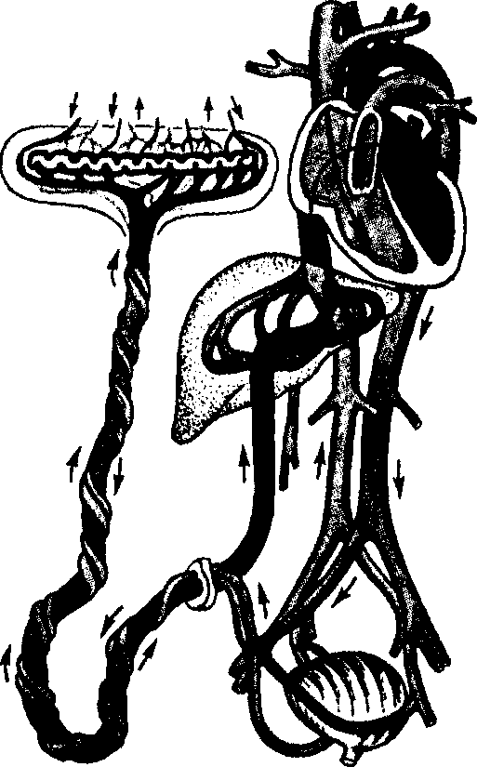
19
PHYSIOLOGICAL OBSTETRICS
At birth blood flow stops in the umbilical vein and arterial duct, pressure falls in the right atrium, the oval window closes. Ventilation of lungs opens the pulmonary blood flow, and as a result of oxygen (P0₂) increase the arterial duct closes.
The fetal blood. The first blood cells form on the surface of the yolk sac. During the 6th week of embryogenesis extramedullar hemopoiesis takes place mainly in the liver and in a less degree — in the spleen of the fetus. The bone marrow begins producing erythrocytes during the 16th week of pregnancy, and after 26 weeks becomes the primary source of erythrocytes.
The major portion of fetal hemoglobin is fetal HbF, which includes two gamma-chains. Instead of adult hemoglobin in the period from the 10th till the 28th week of pregnancy 90 % hemoglobin is comprised by HbF; from the 28th till the 34th week transition to HbA takes place; on delivery date the ratio HbF/HbA makes 80/20. The higher concentration of hemoglobin in the fetus and higher sensitivity of HbF to oxygen increase oxygen delivery through the placenta.
The fetal lungs. The differentiation of capillary and tubular structures completes by the 20th week of intrauterine development. The alveoles develop after the 24th week. Lecithin is the main phospholipid of the lungs. Cortisol stimulates lecithin production.
The fetal immune system. During the 9th—10th week of pregnancy there appear first signs of immunoglobulin M synthesis, whose production increases with pregnancy term. The first lymphocytes appear around the 8th week of pregnancy. In the middle of midpregnancy all phagocytes, complement, T- and B-lymphocytes are produced in the quantity sufficient for immune response. Immunoglobulins of G class are generally obtained from the mother's blood. In the fetal organism usually forms a small quantity of immunoglobulins M and A, which do not go through the placenta. General immunological protective factors include the amniotic fluid (lysozyme, immunoglobulin G), placenta (lymphoid cells, phagocytes, barrier function), neutrophils from the liver and bone marrow, and interferon of lymphocytes.
1.7. PLACENTA DEVELOPMENT
Human placenta has a hemochorial pattern. This type of placentation is characterised by the presence of direct contact between the mother's blood and chorion as a result of decidua integrity violation with its vessels rupture. Placenta performs important functions: respirato-
Chapter 1 . Fertilization and Fetal Egg Development
ry, excretory, trophic, protective, incretory, and also of antigens formation and.immune protection. Fetal integuments and amniotic fluid play a big role in their realization.
The major part of placenta is comprised by chorionic villi — tro-phoblast derivatives (Fig. 10). The epithelium of the primary villi consists of two layers: cytotrophoblast layer (Langhans' layer) and syncytiotrophoblast layer (symplast layer). The primary villi have no vessels, therefore nutrients are transported by means of osmosis and diffusion. By the end of the 2nd week of pregnancy connective tissue grows into the primary villi and secondary villi form. Their base is formed by connective tissue, and the investment — by epithelium (trophoblast). Both primary and secondary villi are evenly distributed on the surface of the fetal egg.
From the 3rd week of embryogenesis the process of placenta development begins, which consists in villi vascularization, their transformation into tertiary ones containing vessels. Placental villi are formed both from angioblasts and umbilical vessels, which origin from allantois. Allantois vessels grow into the tertiary villi, which results
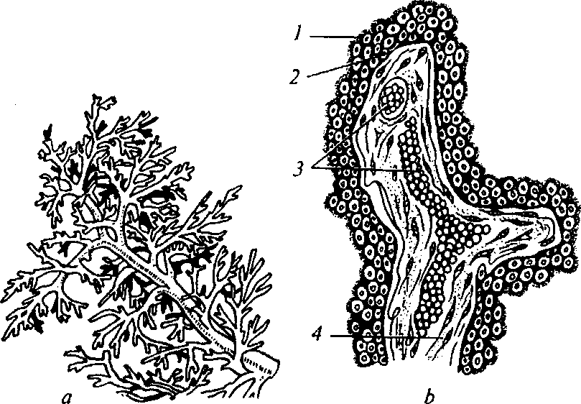
Fig. 10. Chorionic villus structure:
a — chorionic villi of mature placenta; b — minute structure of a villus: 1 — syncytium; 2 — cytotrophoblast (Langhans cells); 3 — blood capillaries; 4 — embryonic connective tissue.
21
PHYSIOLOGICAL OBSTETRICS
in secondary villi vascularization. Thus the chorion is vascularized. Allantoic circulation formation provides intensive metabolism between the organisms of the mother and the fetus.
At early stages of intrauterine development the chorionic villi are evenly distributed on the whole surface of the fetal egg. Though, beginning from the 2nd month of ontogenesis, the villi are atrophied on the bigger part of the fetal egg surface, meanwhile.the villi directed at the basal part of the decidual membrane are well-developed. Thus smooth and frondosum types of chorion are formed.
Blood flow in the uterus is provided with the help of 150—200 maternal spiral arteries, which open into the intervillous space. The spiral arteries are of peculiar structure, their walls have no muscular layer, and the mouth can not contract and relax.
The spiral arteries have low vascular resistance to the blood flow. Contrary to the uterine arteries, in which evident reduction of vascular resistance is observed from the 12th—13th week of pregnancy, in the spiral arteries this process is observed from the 6th week of pregnancy. The most evident decrease of vascular resistance in the spiral arteries is observed during the 13th—14th weeks of pregnancy, which morphologically reflects the termination of the process of trophoblast villi invasion into the decidual membrane.
Such peculiarities of hemodynamics provide continuous transport of arterial blood from the mother's organism to the fetus. The discharged arterial blood washes the chorionic villi, giving into the blood of the fetus oxygen, nutrients, some hormones, vitamins, electrolytes and other chemical substances, and also microelements necessary for the regular fetal growth and development. The blood containing C0₂ and other metabolites pours into the venous foramens of the mother's veins, whose total amount exceeds 180.
Bloodstream in the intervillous lacuna is rather intensive at the end of pregnancy and makes 500—700 ml of blood per minute.
With the beginning of the second trimester of pregnancy cytotro-phoblast intensively transforms into syncytium, which leads to Lang-hans' layer disappearance on many areas.
At the end of pregnancy involutional-dystrophic processes, sometimes called placenta ageing, begin in the placenta. Fibrin (fibrinoid) begins precipitating from the blood circulating in the intervillous lacuna; it deposits on the villi surface for the most part. This substance precipitation promotes the processes of blood clot organization, death of some areas of the epithelial cover of the villi. The villi covered with
C h a p t e r 1 . Fertilization and Fetal Egg Development
fibrinoid are usually excluded from the active feto-maternal metabolism.
Involutory processes in the placenta are accompanied by opposite phenomena during pregnancy: there increases the quantity of young villi, which considerably compensate the function of the lost ones. Still, young villi development only partially improves the function of the placenta in whole. As a result; at the end of pregnancy the placental function diminishes.
Mature Placenta Structure
Macroscopically the mature placenta reminds of a thick soft flat cake. The placenta weighs 500—600 g, is 15—18 cm in diameter and 2—3 cm thick. The placenta has two surfaces: maternal, directed to the uterine wall, and fetal — to the fetus (Fig. 11).
The maternal surface of the placenta is of grayish-red color and is remains of the basal part of the decidual membrane.
The fetal surface is covered with a lustrous amniotic sac, under which the chorion is approached by arteries going from the place of umbilical cord attachment to the placental periphery. The bulk of the fetal placenta is presented by numerous chorionic villi, united in incomplete formations — cotyledons. There are 15—20 of them. Particles of the placenta form as a result of chorionic villi separation by the
Fig. 11. Placenta:
a — maternal surface; b — fetal surface
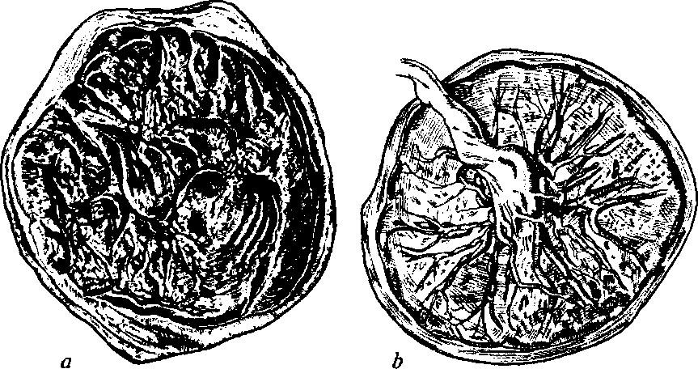
23
PHYSIOLOGICAL OBSTETRICS
septa, which originate from the basal lamina. Each such particle contains a rather big vessel.
Microscopic structure of a mature villus. There are usually differentiated two types of villi: free and anchoring. The free villi, and there are most of them, are located in the intervillous lacuna of the decidual membrane and provide fixation of the placenta to the uterine wall. At the third labor stage this connection is broken under"the influence of uterine actions, and the placenta separates from the uterine wall.
24
PHYSIOLOGICAL CHANGES IN THE MATERNAL ORGANISM DURING PREGNANCY
Pregnancy is an additional load on the woman's organism. Substantial changes take place in virtually every system of the mother's organism to provide the vital activity, growth, and development of the embryo and fetus. Compensatory changes in the organs and systems of the pregnant woman lead to unstable tense equilibrium of homeostasis. Violations of this equilibrium might cause homeostasis changes and realization of an obstetrical or extragenital pathology, of which doctors of all specialties must be aware.
Substantial changes take place in virtually every system of the woman's organism during pregnancy.
Psychological Condition
Psychological condition changes appear in the form of emotional feelings: irritation, depression, etc. The following factors influence psychological disorders development during pregnancy:
- hormonal and physiological changes;
- personal qualities;
- socio-economic status;
- unsolved conflicts;
- genetic propensity (e.g. for depression);
- physical and mental diseases;
- alcohol and drug abuse.
Doctors should take into account emotional and physical feelings of prospective mothers during observation of pregnancy, delivery, and puerperal period.
Discomfort Conditions
In the course of pregnancy there often arise typical discomfort conditions, which have no serious consequences, but lead to significant discomfort and unpleasant sensations in the pregnant woman. Such conditions should include: fatigue, morning sickness, heartburn, consti-
25
PHYSIOLOGICAL OBSTETRICS
pation, hemorrhoid, feet edema. Timely interpretation of the essence of such phenomena and professional advise of the doctor considerably improve the life quality of the pregnant woman.
The Immune System
- The factors of local and general immunity are depressed in the maternal organism. Reactions are conditioned by the action of CGH, placental lactogen, glucocorticoids, estrogens, progesterone, alpha-fetoprotein, alpha-2-glycoprotein, trophoblast of specific globulin;
- there forms immunological tolerance between the maternal organism and the fetus.
The Endocrine System
- The hypothalamus: the supraoptical and paraventricular nuclei intensify oxytocin and vasopressin formation, and also take part in the regulation of folitropin, lutropin, corticotrophin, and thyrotropin secretion by the adenohypophysis;
- the hypophysis: adenohypophysis increase due to hyperplasia and hypertrophy of its cells; increased secretion of gonadotropic hormones; increased production of prolactin; depressed production ofSTH;
- the thyroid gland increases in size (in 35—40 % pregnant women), its function rises but remains euthyroid, production of thy-roxin-binding globulin is increased (the action of estrogens), the levels of total T₃ and T₄ rise, the level of free T₄ remains within the mark;
- the parathyroid glands function with hyperactivity; if their function is diminished, hypocalcemia develops, which declares itself by convulsions, spasms of the pyloric part of the stomach, asthmatic phenomena;
- the adrenal glands increase production of glucocorticoids, which regulate carbohydrate and protein metabolism, and of mineral-ocorticoids, which regulate mineral metabolism;
- insulin resistance is increased (sensitivity to insulin decreases by 50—80 %), glucose consumption by tissues decreases, the level of glucose in blood decreases;
- the ovaries: a new endocrine gland forms — the yellow body, which produces progesterone (reduces excitability and contractive activity of the uterus, creates conditions for fetal egg implantation
Chapter 2. Physiological Changes in Maternal Organism during Pregnancy
and regular development of pregnancy), functions during the first 3.5—4 months of pregnancy;
— the placenta: from the 7th day of pregnancy there is noted the
increase of human chorionic gonadotropin (beta-HCG) and progester
one concentration, estrogens are mainly synthesized by the placenta-
fetus complex from the metabolites of maternal cholesterol and nor
mally their production undeviatingly increases,.which provides forma
tion and growth of the uterus, regulation of biochemical processes in
the myometrium, increase of enzyme systems activity, intensification
of energy metabolism, glycogen and ATP accumulation. Placental lac
togen (PL) is formed by the placental syncytiotrophoblast from the
5th—6th week pregnancy (90 % of PL is in the plasma of the pregnant
woman, 10 % — in the amniotic fluid), and its maximum concentration
is detected during the 36th—37th weeks of pregnancy, then its level sta
bilizes and starts to reduce from the 40th—41st week of pregnancy.
The Central Nervous System
- Excitability of the cerebral brain cortex reduces by the 3rd—4th month, and then gradually increases (this is connected with the formation of a focus of hyperexcitability in the cerebral cortex — gestational dominant, which declares itself by certain lethargy of the pregnant woman and orientation of her interests at carrying of the pregnancy);
- depressed excitability of the CNS components located lower and also of the reflex apparatus of the uterus. Right before delivery the excitability of the spinal marrow and nervous elements of the uterus increases;
- the tonus of the vegetative nervous system changes, which conditions such symptoms at early stages of pregnancy: sleepiness, increased irritability, whining, vertigo.
The Cardiovascular System
- There is noted: reduced adaptation to physical loads; increased blood volume of the jugular veins, peripheral tissues swelling;
- the heart: systolic murmur (95 %) and systolic gallop rhythm (90 %);
- central hemodynamics: circulating blood volume (CBV) increase begins from the 6th week of pregnancy, rapidly increases by the 20th—24th weeks of pregnancy and at 36 weeks the increase makes
27
PHYSIOLOGICAL OBSTETRICS
35—45 %. CBV increase takes place due to the increase of the volume of plasma circulation (VPC);
— cardiac output (CO) increases by 30—40 % beginning from
the early terms of pregnancy and reaching maximum at 20—24 weeks
of pregnancy. In the first half of pregnancy cardiac output increases
due to the increment of stroke volume (by 30—40 %); in the second
half of pregnancy — mainly due to the increase of heart rate (HR)'fre-
• quency by 15 %. CO increase is explained by the action of placental hormones (estrogens and progesterone) on the myocardium and partially as a consequence of the formation of uteroplacental circulation;
- reduction of systolic and diastolic arterial pressure from the beginning of pregnancy till the 24th week of pregnancy (by 5— 15 mm Hg from the initial); decrease of systemic vascular resistance by 21 %; reduction of pulmonary vessels resistance by 35 % (this is explained by the vasodilating action of progesterone);
- peripheral vascular resistance reduces (relaxing action on the vascular wall of HCG, estrogens, progesterone and uteroplacental circulation formation, which has low vascular resistance);
- central venous pressure (CVP) in the third trimester of pregnancy makes 8 (4—12) cm of water on average, in nonpregnant — 3.6 (2—5) cm of water;
- venous pressure increase (7—10 mm Hg) in the lower extremities (conditioned by the mechanical pressure of the uterus on the inferior vena cava and pelvic veins by more than 10 times by increasing uterine blood flow during pregnancy), relaxing action of progesterone on the vascular wall, reduction of osmotic blood pressure, increased capillaries permeability (the action of progesterone and aldosterone), intratissular pressure rise (natrium retention), which explains inclination to edemas, varix dilatation, and hemorrhoid;
- heart position displacement closer to the horizontal axis and decrease of the angle of the arch of aorta, which is explained by diaphragm elevation and leads to the increase of load on the left heart ventricle;
- ECG — displacement of the electrical heart axis to the left.
The Blood System
- Plasma volume increases from 2,600 ml by 45 % (1,250 ml at primipregnancy and 1,500 ml during following pregnancies) and makes 3,900-4,000 ml;
- total erythrocytes volume increases from 1,400 ml by 33 %
Chapter 2. Physiological Changes in Maternal Organism during Pregnancy
due to the influence of erythropoietin, chorionic gonadotropin, and placental lactogen;
- physiological hyperplasia is characterised by reduction of the packed cell volume to 30 %, hemoglobin from 135—140 to 110— 120 g/L; it is necessary for the mother and fetus, protects from inferior vena cava syndrome, compensates blood loss during delivery, reduces blood viscosity thus decreasing peripheral resistance;
- the level of hematocrit and albumin reduces by 25 % (as a result of hemodilution);
- hemoglobin level changes and on average makes 122 g/L by the 12th weeks of pregnancy, 118 g/L — by the 28th week of pregnancy, 129 g/L — by the 40th week of pregnancy;
- white blood count increases in the peripheral blood and in the first trimester of pregnancy makes 3,000—15,000/mm³, in the second and third trimesters — 6,000—16,000/mm³, during delivery the count might reach 20,000-30,000/mm³;
- thrombocytes count is within normal (for pregnant women) values, but as pregnancy progresses, the level of thrombocytes gradually decreases;
— the hemostasis system: gestation is characterised by the state
of hypercoagulation (during the whole period of pregnancy there
constantly progresses the increase of fibrinogen level (I factor) by 2
times (to 600 mg) and the level of factors VII—X); fibrinolytic activi
ty of blood decreases;
- ESR increases to 40—50 mm/h;
- pCO² of blood reduces (by 15—20 %), which promotes carbonic acid transition through the placenta;
- pO² rises;
- oxygen delivery to the tissues and placenta increases;
- bicarbonates excretion enhances.
The Respiratory System
- There is noted: dyspnea (65 % women), rhinedema, nasal hemorrhages, chest circumference increase, the cupula of diaphragm rises by 4 cm, the inferior aperture of thorax dilates;
- there increases: oxygen requirement, oxygen pressure, respiratory volume (30—40 %), inspiratory capacity (5 %), lung capacity, minute volume (by 40 %);
- there reduces: functional residual air and expiratory volume by 20 % approximately, total lung capacity (by 5 %), carbon dioxide content (moderate respiratory alkalosis).
29
PHYSIOLOGICAL OBSTETRICS
The Gastrointestinal Tract
- Appetite increases, sometimes with unusual gustatory preferences;
- there is noted: morning sickness (in almost 70 % pregnant women), whose frequency is maximal during the 8th—10th weeks of pregnancy; it stops between the 14th and 16th weeks due to the increase of progesterone, HCG, relaxation of the smooth stomach muscles;
- gingivitis frequency increases, vascularized tumors may appear abundantly and regress after delivery;
- gastric ulcer probability reduces (this is connected with the increased secretion of mucin by the mucous coat of stomach and reduced secretion of hydrochloric acid);
- the risk of gastroesophageal reflux increases, which is conditioned by esophagus hypotony, gastroesophageal sphincter relaxation, anatomic displacement of the stomach;
- constipation frequency increases (to 30 %) caused by intestinal peristalsis reduction and hemorrhoidal veins dilatation due to the increase of central venous pressure and progesterone action;
- increase of the risk of gallstones formation due to the dilatation and worsening of gall evacuation from the gallbladder and increase of cholesterol level in blood;
- the liver: blood circulation increases, liver dimensions do not increase, the content of alkaline phosphatase increases (due to additional formation in the placenta), aspartate aminotransferase (AST) activity increases, albumins production reduces, globulins concentration increases, the synthetic function of the liver increases (lipidemia with a high level of cholesterol and its esters), the antitoxic function of the liver reduces;
— hemorrhoid frequency increases as a result of constipations,
increased venous pressure, and relaxing action of progesterone on the
vascular wall.
Metabolism
- Basal metabolism increases by 20 %;
- the need in kilocalories on average increases to 2,000— 3,200 kcal a day (150 kcal/day in the first trimester and 350 kcal/day in the second and third trimesters of pregnancy);
- plastic processes enhance (anabolism processes prevail over catabolism processes);
30
C h a p t e r 2 . Physiological Changes in Maternal Organism during Pregnancy
- RNA synthesis increases, which leads to increased synthesis of proteins in ribosomes;
- lipid exchange — lipids assimilation rises, their oxidation decreases, which causes ketone bodies, y-aminobutyric and acetoacetic acids accumulation in blood, increased lipopexia in different organs and tissues of the organism (adrenal glands, placenta, skin, mammary glands, etc.);
- carbohydrate metabolism — labile glycemia (somewhat exceeding the norm) and periodical presence of sugar in blood;
— vitamins and microelements metabolism increases due to
considerable activation of cellular metabolism processes in the mater
nal and fetal organisms.
The Kidneys
- Anatomical changes: increase in size (by 1 — 1.5 cm on average), pyelocaliceal system dilation (by 15 mm in the right and by 5 mm in the left kidney), urethras diameter increase by 2 cm (more often of the right urethra due to the rotation and displacement of the uterus to the right and pressing of the urethra to the terminal pelvic line) condition the increased risk of pyelonephritis development. Urinary tracts dilatation begins in the first and reaches its maximum in the second and third trimesters of pregnancy (is explained by the action of placental progesterone and, to a lesser extent, by urinary tracts compression by the uterus);
- functional changes: kidneys filterability changes — to the 16th week of pregnancy renal blood flow increases by 75 %, glomerular filtration increases already from the 10th day of pregnancy to 50 % (is conditioned by arterial dilatation and secondary retention of Na and water in the organism). In the second and third trimesters glomerular filtration decreases, and tubular reabsorption remains unchanged, which causes the increase of the total quantity of fluid in the maternal organism (to 7 L). Creatinine clearance increases by 40 %, glucose excretion increases, proteins filtration does not change. Sometimes physiological (orthostatic) albuminuria (albumin presence in urine) and glycosuria may take place, which is connected with enhanced capillaries permeability.
The Genital Organs
— Uterus dimensions increase, its volume grows by 1,000 times,
the weight increases from 50—60 g in nonpregnant state to 1,000 g in
the end of pregnancy (mainly due to myometrium cells hypertrophy);
31
PHYSIOLOGICAL OBSTETRICS
- the form of the uterus is elongated, spherical during the 8th week, and again elongated during the 16th week of pregnancy;
- uterus position: the uterus exits the pelvic cavity, rotates and inclines to the right;
- uterus consistency softens progressively due to enhanced vascularization and amniotic fluid presence;
- the neck of uterus softens and becomes cyanotic;
- the border between the endo- and exocervix: the border of the transitional epithelium displaces outside and ectopia of the cylindrical epithelium takes place, which can not be viewed as erosion;
— uterine contractions from the first trimester are irregular and
painless (Braxton—Higgs' contractions), but later they cause discom
fort and may be the cause of false labor pains;
- uterus capacity grows from 4—8 ml in nonpregnant state to 5,000 ml in the end of pregnancy;
- the myometrium hypertrophies (estrogens effect), becomes hyperplastic (progesterone effect), some muscle fibers stretch by 15 times;
- the uterine blood vessels dilate, elongate, especially the venous ones, and form, due to what uterine blood flow increases by more than 10 times (before pregnancy it makes 2—3 % of CO, and in late terms of pregnancy - 20-30 % of CO - 500-700 ml/min). The uterine circulation forms — "the second heart" associated with the placental and fetal blood flow;
- nervous elements of the uterus — there increases the quantity of sense, baro-, osmo-, chemo- and other receptors;
- biochemical changes: significant increase of the quantity of actomyosin, phosphocreatine and glycogen, enzyme systems activity grows (actomyosin ATPase etc.), high-energy compounds (glycogen, high-energy phosphates), muscle proteins, and electrolytes (calcium, natrium, potassium, magnesium, and chlorine ions) are accumulated;
- the uterine tubes thicken, blood circulation in them considerably increases;
- the ovaries somewhat enlarge, but cyclic processes in them stop. The yellow body undergoes involution after the 16th week of pregnancy;
- the ligaments of uterus considerably thicken and elongate, especially the round and sacrouterine ones;
- vulva cyanosis is a result of increased blood supply, complicated blood outflow through the veins, which are compressed by the increased uterus, and vasodepression;
Chapter 2. Physiological Changes in Maternal Organism during Pregnancy
- hyperpigmentation of the skin of vulva and perineum is explained by hyperestrogenism and increased concentration of melanin-stimulating hormone;
- increased quantity of vaginal leucorrhoea with decreased
pH (4.5—5.0) is a result of vaginal epithelium hyperplasia, blood circulation increase, and transudation.
Body Weight
- Average increase in weight is 10—12 kg and depends on constitution;
- weight usually increases in the second and third trimesters (350-400 g a week);
- slightly more than half of the gained weight goes into the tissues of the mother (blood, fat, breasts), and the rest — into the fetus (3,000— 3,500 g), placenta (650 g), amniotic fluid (800 g), and uterus (900 g).
The Skin
- Vascular spiders on the face, arms, upperparts;
- palmar erythema caused by 20 % increase of general metabolism and 16 % increase of the quantity of the capillaries, which did not function before;
- the striae atroph icae (striae gravidarum) on the lower parts of the stomach, mammary glands and thighs, which are pink or crimson (connected with the stretch of the connective tissue and elastic skin fibers);
- hyperpigmentation in the region of the navel, mammary glands areolae, white line, vulva and perineum skin, there might appear the "mask of pregnancy", or chloasma;
- the navel smoothes in the second half and bulges out in the end of pregnancy;
- the nevuses enlarge and become more pigmented (abrupt increase requires a specialist's consultation);
- the perspiratory and sebiferous glands — hyperproduction sometimes leads to acne;
- hair growth is sometimes noted on the skin of the face, stomach, and thighs, which is conditioned by increased production of androgens by the adrenal glands and partially by the placenta. Considerable loss of hair takes place during the first 2—4 months of pregnancy, and recovery of normal hair growth — in 6—12 months after delivery.
33
PHYSIOLOGICAL OBSTETRICS
The Mammary Glands
- Sensation of pricking and spreading is connected with the significant increase of blood supply of the mammary glands;
- development of excretory ducts (estrogens influence) and alveoles (progesterone influence);
- activation of the smooth muscles of nipples, enlargement of the Montgomery's follicles and small humps near the areolae;
- weight increase from 150—250 g (before pregnancy) to 400— 500 g (in the end of pregnancy);
- foremilk is produced, more often in women, who have already had children (combined action of estrogens, progesterone, prolactin, placental lactogen, Cortisol, and insulin).
The Musculoskeletal System
- Increase of compensatory lumbar lordosis, which declares itself by pains in the lower loin parts;
- development of relative ligamentous laxity under the influence of relaxin and progesterone. The symphysis pubis becomes movable and widens by 0.5—0.6 cm on average in 28—30 weeks, which leads to unsteady gait, disequilibrium, and falling (symphysiopathy);
- development of the inferior aperture of thorax;
- calcium metabolism: concentration of the ionized form of calcium in blood does not change due to the increase of parathormone production, the total quantity of calcium decreases because of its mobilization for the needs of the fetus. At normal pregnancy salt metabolism in bones increases (calcitonin influence), but bone density is not lost;
- herniary defects increase, especially in the region of the navel and along the midline — diastasis recti abdominis (a result of uterus increase and its pressure on the anterior abdominal wall from within).
Chapter 3 MATERNAL PASSAGES
The maternal passages are divided into the bone and soft parts. The' bone part includes the small pelvis, the soft part — the uterine neck, vagina, and musculofascial system of the pelvic floor.
3.1. FEMALE GENITALS ANATOMY IN POINT OF OBSTETRICS
The female genital system consists of the external genital organs: the pubis, large and small lips of pudendum, clitoris, vestibule of vagina, urethra, perineum (Fig. 12); and internal genital organs: the uterus, ovaries, uterine tubes, and vagina (Fig. 13).
The perineum forms the pelvic floor, closing its outlet. In obstetrics the notion of perineum is narrower than in anatomy, where

Fig. 12. External female genital organs:
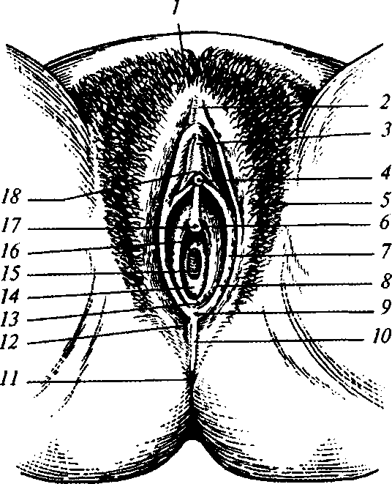
1 — pubis; 2 — anterior commissure; 3 — prepuce of clitoris; 4 — glans of clitoris; 5 — large lip of pudendum; 6, 7, 8 — small lip of pudendum; 9 — frenulum of pudendal lips; 10 — perineum; 11 — anus; 12 — posterior commissure; 13 — vestibule of vagina; 14 — hymen; 15 — opening of vagina; 16 — opening of vestibule of vagina; 17 — external opening of urethra; 18 — frenulum of clitoris

35

PHYSIOLOGICAL OBSTETRICS

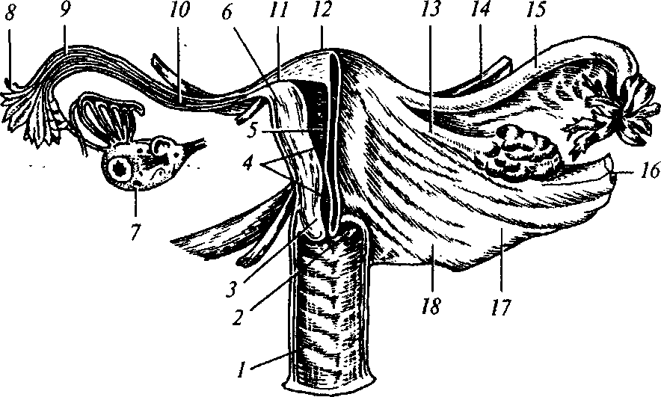
Fig. 13. Internal genital organs (front section):

I — vagina; 2 — vaginal part of the neck of uterus; 3 — cervical canal of uterus;
4 — isthmus; 5 — uterine cavity; 6 — myometrium; 7 — ovary in section; 8 — uter
ine tube pili; 9 — ampullar part of uterine tube; 10 — isthmic part of uterine tube;
II interstitial part of uterine tube; 12 — fundus of uterus; 13 — utero-ovarian
ligament; 14 — round ligament of uterus; 15 — uterine tube; 16 — suspensory liga
ment of ovary; 17 — mesodesma; 18 — sacrouterine ligament

Fig. 14. Muscles of female perineum:
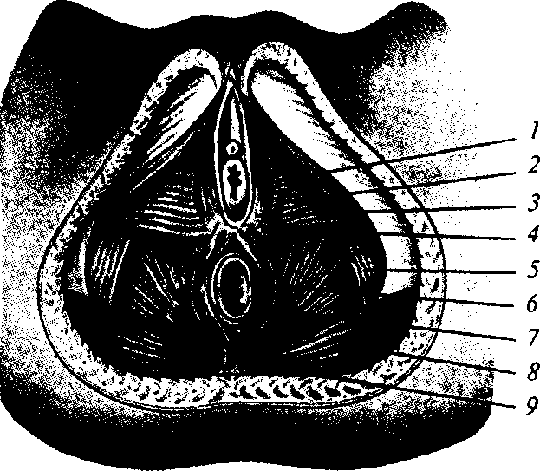
1 — ischiocavernous muscle; 2 — urogenital diaphragm; 3 — bulbocavernous muscle; 4 — superficial transverse muscle of perineum; 5 — obturator internus muscle; 6 — rectum; 7 — external sphincter muscle of anus; 8 — gluteus maximus muscle; 9 — anococcygeal ligament
36

Chapter 3. Maternal Passages
perineum is the space between the posterior commissure of pudendal lips and the anterior margin of anus. ■
The floor of small pelvis is formed by two diaphragms — pelvic and urogenital.
The pelvic floor muscles consist of three layers (Fig. 14).
The superficial (external) layer is formed by such muscles: ischiocavernous (m. ischicavernosus) — begins from the ishial tuberosity and interweaves with the clitoris tissues; bulbocavernous (m. bul-bospongiosus) — begins from the tendinous center of the perineum and attaches to the vaginal walls; the external sphincter muscle of anus (m. sphincter ani externus) — begins in the region of the pelvic bone apex, envelops the anus, and interweaves into the tendinous centre of the perineum; the superficial transverse muscle of perineum (m. transversum perinei superficialis) — begins from the ishial tuberosity and ends in the tendinous centre of the perineum.
The middle layer of the pelvic floor muscles consists of the urogenital diaphragm, which is located between the symphysis pubis, pubic and ischial bones in the form of a triangle. It is formed by the sphincter muscle of urethra (m. sphincter urethrae internum) and the deep transverse muscle of perineum (m. transversus perinei profundus).
The internal layer of the pelvic floor muscles is named the pelvic diaphragm. This is the strong binate elevator muscle of anus (m. levator ani), which consists of muscle bundles: pubococcygeal (m. pubo-coccygeus) and iliococcygeal (m. iliococcygeus). The coccygeal muscle (m. coccygeus) is rudimentary and attaches to the lower vertebrae of sacral and pelvic bones.
3.2. FEMALE PELVIS IN POINT OF OBSTETRICS
From considerations of obstetrics the female pelvis is divided into two parts: the large and small pelvis. The border between them goes along the innominate line (linea innominata). The large pelvis is bounded by the wings of ilia on either side, by the spine — from behind, and there is no wall from the front. The small pelvis is formed by the pubic bones branches from the front, by parts of the bones forming the femoral fossa — on the sides, and by the sacral and pelvic bones — from behind (Fig. 15).
During delivery the small pelvis, as a dense bone tunnel, limits and defines the dimensions, form, and direction of the parturient
37
PHYSIOLOGICAL OBSTETRICS
canal, to which the fetus moves and must conform, changing its own configuration.
Pelvis measuring is the most important method of pelvis examination.
Most internal dimensions of the pelvis are inaccessible for measurement, therefore usually its external dimensions are measured, by which the internal ones are evaluated.
The pelvis is measured with the help of the pelvimeter.
Usually there are measured four main dimensions of the pelvis. three transversal and one straight. Distantia spinarum is the distance between the anterosuperior axes of the ilia. This dimension makes 25 cm. Distantia cristarum is the distance between the most distant points of the iliac crests; it makes 28 cm on average. Distantia tro-chanterica is the distance between the greater trochanters. This dimension makes 21 cm.
Conjugata externa (external conjugate) is the straight dimension of pelvis. The woman is put on her side; the leg lying below^{r} is bent in the hip and knee joints, the other leg is straightened. The end of the pelvimeter is set in the middle of the superior-external border of the symphysis, the other end is pressed to the supersacral fossa, which is situated between the process of the fifth lumbar vertebra and the beginning of the first sacral vertebra. The external conjugate makes 20 cm (Fig. 16).
Dimensions of small pelvis are of great importance in obstetric-practice since the course and completion of delivery depend on them. But most dimensions of small pelvis can not be measured directly.

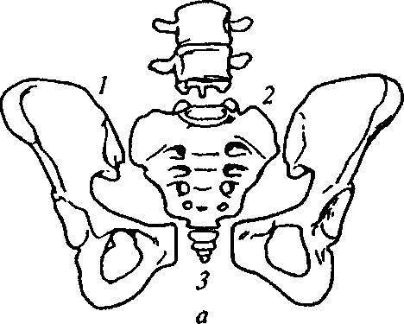
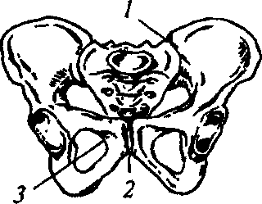
Fig. 15. Pelvic bones:

a: 1 — innominate bone; 2 — thigh bones; 3 — coccygeal bone and coccygeal plexus; b: 1 — sacroiliac articulation; 2 — pubic symphysis; 3 — sacrococcygeal articulation
38

Chapter 3 . Maternal Passages
The large pelvis is not of big importance for the birth of a child, but it is possible to judge about the form and size of small pelvis by its dimensions.
The small pelvis cavity is the space between its walls, limited from above and from below by the area of brim and the area of pelvic outlet. It looks like a cylinder truncated from the front backwards in such a way that the anterior part (directed to the womb) is three times as low as the posterior one (directed to the sacral bone). There are dif-

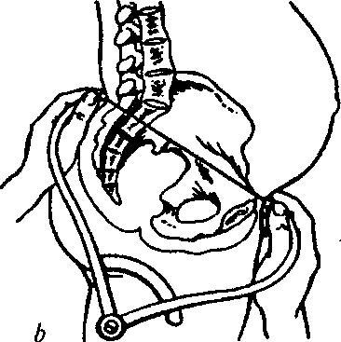
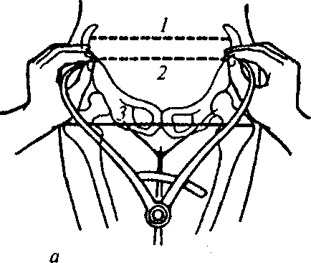

Fig. 16. External dimensions of pelvis:

a — transversal dimensions of pelvis: 1 — distantia cristanim, 2 rum, 3 — distantia trochanterica; b — external conjugate
distantia spina-

Fig. 17. Female pelvis
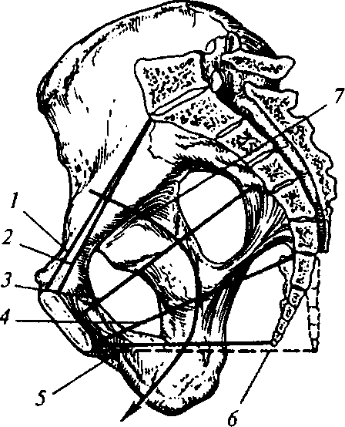
(sagittal section):
1 — anatomic conjugate; 2 — true conjugate; 3 — straight dimension of the pelvic plane of greatest dimensions; 4 — straight dimension of the third parallel pelvic plane; 5 — straight dimension of the area of pelvic outlet at normal position of the coccygeal bone; 6 — straight dimension of the area of pelvic outlet at the retroposed coccygeal bone; 7 — axis of pelvis

39

PHYSIOLOGICAL OBSTETRICS
ferentiated four planes in the small pelvis cavity: the area of brim, the pelvic plane of greatest dimensions, the third parallel pelvic plane, and the area of pelvic outlet (Fig. 17).
The planes of small pelvis and their dimensions:
a) the area of brim is limited from behind with the promontory
of sacral bone, on the sides — with the terminal lines of hip bones,
from the front — with the upper margin of pubic bone and symphysis.
There are differentiated four dimensions.
The straight dimension — the distance from the promontory of sacral bone to the most protrudent point of the superointernal margin of symphysis, it is also called the true or obstetric conjugate (conjugata vera), makes 11 cm. There is also distinguished the anatomic conjugate (conjugata anatomicd) — the distance from the promontory of sacral bone to the upper margin of symphysis, it is by 0.3 cm larger than the obstetric one.
The transversal dimension — the distance between the utmost points of the arcuate lines of ilia (linea innominata); it makes 13 cm.
The oblique dimension (left and right) — the distance from the left sacroiliac joint (articulatio sacroiliaca) to the right iliopubic eminence (eminentia iliopubica) and vice versa; it makes 12 cm (Fig. 18);
b) the pelvic plane of greatest dimensions is limited from behind
by the junction of the second and third sacral vertebrae, from the
sides — by the middle of femoral fossae, from the front — by the mid
dle of the internal surface of symphysis. In this plane two dimensions
are differentiated — straight and transversal.
The straight dimension — from the projection of the junction of
Fig. 18. Dimensions of small pelvis planes:
1 — straight; 2 — transversal; 3,4 — right and left oblique
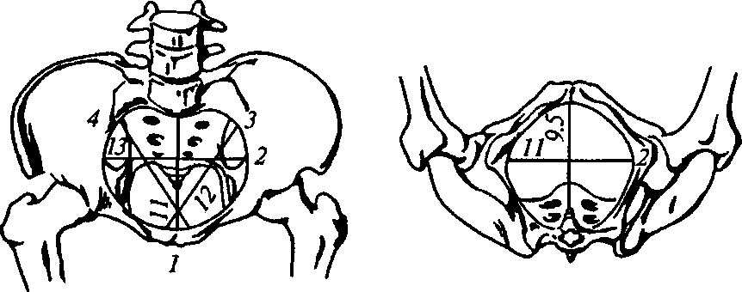
Chapter 3. Maternal Passages
the second and third sacral vertebrae to the middle of the internal surface of symphysis; it makes 12.5 cm.
The transversal dimension — between the middles of femoral fossae; it makes 12.5 cm (Fig. 19);
c) the third parallel pelvic plane is limited from the front by the
inferior margin of symphysis, from behind — by the sacrococcygeal
joint, from the sides — by the axes of ischial bones. There are differen
tiated two dimensions of the third parallel pelvic plane — straight and
transversal.
The straight dimension — from the sacrococcygeal joint to the middle of the inferior margin of pubic symphysis; it makes 11 cm.
The transversal dimension — between the internal surfaces of ischial bones axes; it makes 10.5 cm;
d) the area of pelvic outlet is limited from the front by the infe
rior margin of symphysis, from behind — by the pelvic bone apex,
from the sides — by the internal surfaces of ishial tuberosities. The
dimensions of the area of pelvic outlet are straight and transversal.
The straight dimension — the distance from the middle of the inferior margin of symphysis to the pelvic bone apex; it makes 9.5 cm (during delivery, when the fetal head is being born, the pelvic bone reclines by 1.5 cm and the straight dimension increases to 11 cm).
The transversal dimension — the distance between the internal surfaces of ishial tuberosities; it makes 11 cm.
The dimensions of the pelvic outlet can be measured directly. For this purpose the pregnant is put on her back, the legs are bent in the hip and knee joints, moved sideways and pulled to the stomach. The measurement is conducted with a measuring tape or a special pelvimeter.

Fig. 19. Dimensions of the pelvic plane of greatest dimensions:
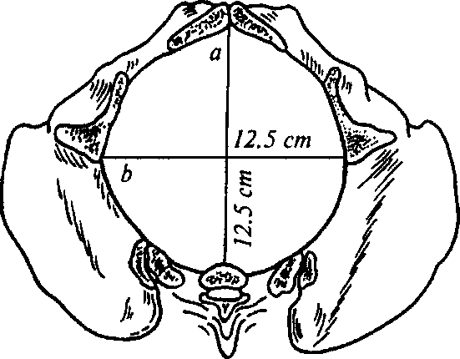
a: straight — fsrom the middle of pubis to the level between the second and third sacral vertebrae; b: transversal — between the middles of femoral fossae

41

PHYSIOLOGICAL OBSTETRICS
The straight dimension is measured between the mentioned above landmarks. To measure the transversal dimension-one should add 1.5 cm to the obtained distance between the internal surfaces of ishial tuberosities (9.5 cm), taking into account the soft tissues thickness.
The line, which goes in the middle of all the straight dimensions of the planes, is called the axis of pelvis (the plane of pelvic canal). The pubic angle makes 90—100°, the angle of pelvic inclination — 55—60ª. The height of symphysis is measured during vaginal examination and makes 3.5—4 cm.
The most important dimension for pelvis evaluation is the true conjugate, which can not be measured directly. Therefore it is calculated from the dimensions, which are accessible to measurements — the external and diagonal conjugates.
To find the true conjugate 8 cm are subtracted from the value of the external conjugate if the circumference of the radiocarpal articulation < 14 cm; 9 cm — if the circumference of the radiocarpal articulation makes 14—16 cm; 10 cm — if the circumference of the radiocarpal articulation > 16 cm. For example: 20 cm - 9 cm = 11 cm.
The diagonal conjugate is the distance from the inferior margin of symphysis to the most protrudent point of the sacral bone promontory. The diagonal conjugate is measured by means of vaginal examination.
When introduced into the vagina, the index and long fingers move along the hollow of sacrum to the promontory of sacra, the tip of the long finger is fixed on the promontory apex, and the edge of palm rests against the inferior margin of symphysis. The place, where the doctor's hand touches the inferior margin of symphysis, is marked with a finger of the other hand. After the fingers are taken out of the vagina, the distance from the tip of the long finger to the marked point of the palm edge encounter with the inferior margin of symphysis is measured with a measuring tape or a pelvimeter.
The diagonal conjugate makes 13 cm on average. If it is impossible to reach the sacral bone promontory with a fingertip, the diagonal conjugate dimension is considered close to normal.
In order to find the true conjugate one has to subtract 1.5—2 cm from the diagonal conjugate depending on the circumference of the radiocarpal articulation: if the circumference makes 15 cm — 1.5 cm, if it makes 16 cm and more — 2 cm.
The main external pelvis dimensions and diagonal conjugate are measured in all pregnant and parturient women without exception.
If examination shows that the main dimensions are irregular and narrow pelvis is suspected, additional measurements are conducted.
Chapter 3 . Maternal Passages

Additional Pelvis Dimensions
The lumbosacral rhomb (the Michaelis' rhomb) is a plane on the posterior surface of sacra, the upper angle of which is a recess under the spinous process of the fifth lumbar vertebra, lateral angles correspond to the posterosuperior axes of hipbones; the lower angle — to the apex of sacra; from above and from the outside the rhomb is limited by the prominences of the broadest muscles of back, from below and from the outside — by the prominences of glutei. The rhomb has two dimensions: longitudinal — between its upper and lower angles (11 cm) and transversal — between the lateral angles (9 cm). The total of the longitudinal and transversal dimensions of the rhomb correspond to the size of the external conjugate (Fig. 20).
The lateral conjugate is measured with a pelvimeter from the an-terosuperior to the posterosuperior axis of hipbone of the similar side; it makes 14.5 cm.
Oblique pelvic dimensions are measured to find its asymmetry. For this purpose distances between such points are compared:
- from the middle of the superior margin of symphysis to the posterosuperior axis of iliac crests on the right and on the left; these dimensions equal 17 cm on both sides;
- from the anterosuperior axis of one side to the posterosuperior axis of the opposite side and vice versa. This dimension makes 21 cm;
- from the spinous process of the fifth lumbar vertebra to the anterosuperior axis of the right and left iliac bones; it makes 18 cm.
In a symmetrical pelvis all oblique dimensions are equal. The difference between oblique dimensions of one side and oblique dimensions of the other side bigger than 1.5 cm testifies to pelvic asymmetry.
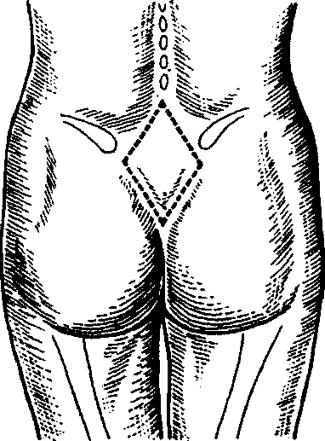
Fig. 20. Lumbosacral Michaelis' rhomb

43

Chap ter 4
FETUS AS DELIVERY OBJECT
4.1. MORPHOLOGIC FEATURES OF THE FETAL HEAD AND BODY
Mature fetal head structure. On the fetal head there are sutures (frontal, sagittal, coronal, lambda) and fontanels (large, small, and two lateral on each side).
The frontal suture is situated between the frontal bones, the sagittal suture — between the parietal bones, the coronal suture — between both frontal and both parietal bones, the lambda suture — between two parietal and the occipital bone.
The large fontanel (anterior) is located between the posterior parts of both frontal and anterior parts of both parietal bones; it is a rhomboid connective tissue plate. The small fontanel (posterior) is triangular and is located between the posterior parts of both parietal bones and the occipital one.
The large and small fontanels are joined with the sagittal suture.
The lateral fontanels are situated: anterior — between the frontal, temporal and cuneiform bones, posterior — between the temporal, parietal and occipital bones. They are closed in a mature fetus.
The fetal head has the following dimensions and corresponding circumferences (Fig. 21, 22):
- the straight dimension {d. frontooccipitalis) is measured from the bridge of nose to the most protrudent point of occiput, makes 12 cm; the circumferencia frontooccipitalis makes 35 cm;
- the large oblique dimension (d. mentooccipitalis) is measured from the chin to the most distant point of occiput, makes 13.5 cm. The corresponding circumference makes 41 cm;
- the small oblique dimension (d. suboccipito-bregmaticus) is measured from the suboccipital fossa to the middle of large fontanel, makes 9.5 cm. The corresponding circumference makes 32 cm;
- the middle oblique dimension (d. suboccipito-frontalis) is measured from the occipital fossa to the margin of the pilar part of forehead, makes 10 cm. The corresponding circumference makes 33 cm;
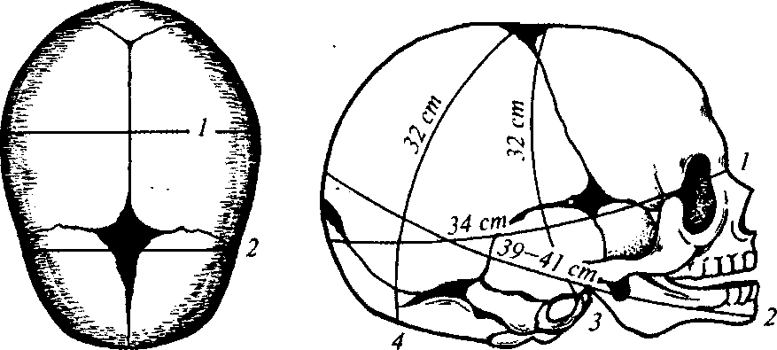
Chapter 4. Fetus as Delivery Object
Fig. 21. Newborn's skull Fig. 22. Circumference of the newborn's
(top view): head according to its dimensions:
- — large transversal dimension; 1 — straight, 2 — large oblique, 3 — vertical, 4
- — small transversal dimension — small oblique dimensions

- the vertical dimension (d. sublinguabregmaticus) is measured from the middle of large fontanel to the hyoid bone, makes 9.5 cm; The corresponding circumference makes 33 cm;
- the large transversal dimension (d. parietalis) is measured between the most distant points of parietal protuberances, makes 9.5 cm;
- the small transversal dimension (d. parietalis) is measured between the most distant points of coronal suture, makes 8 cm;
- the diameter of the pelvic area (d. interotrochanterica) makes 9.5 cm. The corresponding circumference makes 28 cm;
- the diameter of the shoulder girdle (d. biacromalis) makes 12 cm. The corresponding circumference makes 35 cm.
4.2. MATURE AND FULL-TERM FETUS SIGNS
Fetal maturity signs:
- mature fetus' height is more than 47 cm;
- mature fetus' weight is more than 2,500 g;
- the umbilical ring is located in the middle between the uterus and the xiphoid process;
- the skin is pink, healthy, developed. Vernix caseosa is found only in the inguinal and axillary folds;
45
PHYSIOLOGICAL OBSTETRICS
- the fingernails cover the ends of finger bones;
- the hair on the head is 2 cm long;
- the cartilages of nose and ears are tight;
- in boys the testicles are in the scrotum; in girls the large lips of pudendum cover the clitoris and small lips of pudendum.
The fetus is considered full-term if it is born in the period from the 37th to the 41st week of pregnancy inclusive. Most often there is perfect coincidence between fetal maturity and its being full-term. Still, sometimes a child is born before the term being absolutely mature by its development. At unfavorable conditions of intrauterine development a full-term child may have signs of immaturity.
Chapter 5
PREGNANT WOMEN EXAMINATION
5.1. EARLY PREGNANCY DIAGNOSTICS
Early pregnancy is diagnosed by a combination of signs, data of gynecologic examination, instrument and laboratory methods of investigation.
Pregnancy signs are divided into three groups.
1. Doubtful signs are various subjective sensations and objec
tively detected changes in the organism except for the changes in the
internal genital organs:
- subjective phenomena — nausea, vomiting, loss or increase oi appetite, gustatory caprices (addiction to salty or sour food, chalk, etc.), changes of olfactory sensations (aversion to the smell of meat products, tobacco smoke, etc.), slight fatigability, sleepiness;
- objective phenomena — pigmentation of the face skin, white line, external genital organs, increased pigmentation of the nipples and the skin around them.
2. Probable signs are objective signs detected in the genital or
gans, mammary glands, and also with the help of immune response to
pregnancy. These are characteristic of pregnancy, though sometimes
may arise because of other reasons. The signs include cessation of
menstruation at the childbearing age, mammary glands enlargement,
and nipple discharge of milk or colostrum.
Probable signs also include gynecological examination data: inspection of the external genital organs, examination of the neck of uterus with the help of specula, bimanual gynecological examination. Softening and cyanosis of the vestibule of vagina, vagina itself, and the neck of uterus may be observed; enlargement and softening of the uterus, change in its form; increase of the contractile capacity of uterus (short-term hardening of the softened uterus).
During the examination of the gravid uterus the most important signs are the following:
a) the Genter's sign: vaginal examination during early pregnancy shows a cristate protuberance on the anterior surface of uterus, di-
47
PHYSIOLOGICAL OBSTETRICS

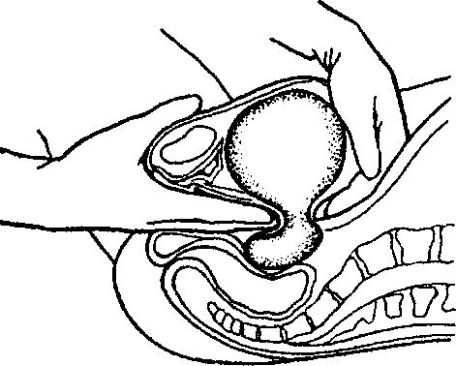
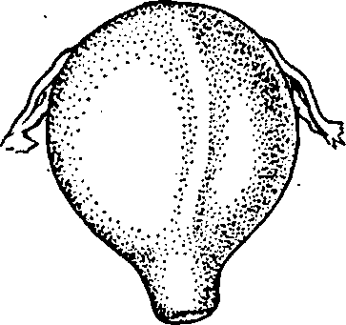

Fig. 23. Genter's sign

Fig. 24. Hegar's sign

rectly on its midline; the protuberance does not spread either to the fundus, or its posterior surface, or the neck (Fig. 23);
- the Hegar's sign: vaginal examination shows softening in the region of isthmus, as a result the fingers of the external and internal hands easily meet in this place. The neck is felt as a more dense body (Fig. 24);
- the Piskachek's sign: vaginal examination shows that the contours of the fundus of uterus and the regions of its angles appear to be irregular. The angle corresponding to the place of egg implantation protrudes much more than the opposite one. The whole uterus appears to be asymmetric (Fig. 25);
- the Snegirev's sign: during vaginal examination the gravid uterus begins contracting under the fingers and becomes denser as a result of mechanical irritation.

Fig. 25. Piskachek's sign:
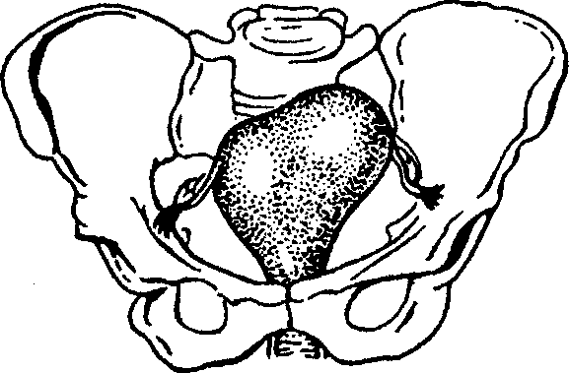
external protrusion of the right uterine angle if the pregnancy term approaches 12 weeks
48

Chapter 5 . Pregnant Women Examination
Probable signs include immune responses to pregnancy, which are based on HCG detection in the urine or blood plasma. HCG is produced by the trophoblast, then by the chorion, placenta. This hormone consists of alpha- and beta-subunits. Production begins from the 7th—8th day after fertilization, therefore laboratory diagnostics is possible after this term. Since the method has a threshold of sensitivity, one should take morning urine for the investigation — it has the highest concentration of the hormone. Detection of beta-HCG in the plasma is more reliable. It should be emphasized that though HCG is produced by trophoblast, the reaction is referred to probable signs, because at such pathological state as chorioepithelioma positive reactions to HCG are also observed. Besides, after abortion reactions remain positive during 7—10 days, and at pathological states (trophoblast diseases) — during 2—4 months. The lower threshold of sensitivity of the method is 5 IU/L.
3. True signs of pregnancy are conclusive proofs of pregnancy in the examined woman. All the signs of this group are objective and originate from the fetus. They include the signs shown by intravagi-nal ultrasound investigation. Other true signs reveal beginning from the 20th week of pregnancy and do not belong to the signs of early pregnancy; they are: fetal movement detected manually or during auscultation (not the movement felt by the pregnant woman); auscultation of fetal heart tones; palpation of fetal parts (the head, legs, buttocks, arms); detecting fetal heartbeats by means of cardiotoco-graphy. It should be noted that application of the color impulsive Doppler is forbidden till the end of the crucial period of organogenesis. This is connected with the fact that the usage of modern Doppler technologies at transvaginal echographies if pregnancy term is less than 10 weeks has a potential threat of teratogenic thermal effect as a result of embryo heating.
Currently the standard of early pregnancy diagnostics is the combination of two methods:
a. detecting beta-HCG in the urine or blood plasma;
b. transvaginal ultrasound investigation.
The uterus dimensions during the first 3 months of pregnancy, when it is still in the small pelvis cavity, are detected by means of bimanual gynecological examination, further at abdominal palpation — by the height of uterine fundus standing.
The accuracy of pregnancy term determination depends on the early visit of the woman to the antenatal clinic. It is recommended to
49
PHYSIOLOGICAL OBSTETRICS
conduct the primary examination of the woman by two specialists-obstetricians. Taking into account the difficulty of detecting the term of fertilization, pregnancy is diagnosed with a week interval (for example: pregnancy of 8—9 weeks). Pregnancy term is detected more reliably on the basis of measuring the parameters of the embryo and fetus by the method of ultrasound investigation.
5.2. LATE PREGNANCY INVESTIGATION
The methods of late pregnancy investigation include: general examination of the pregnant or parturient woman, external measuring of the uterus and pelvis of the woman, external and internal obstetric examination; auscultation of fetal heartbeats, auxiliary instrument and apparatus methods of investigating the fetal condition (see the chapter Fetal Condition Imaging and Assessment).
Anamnestic data — pregnancy term calculation in weeks with the help of the pregnancy table from the date of the last menstruation and from the date of the first fetal movement (in para I the first fetal movement is usually felt beginning from 20 weeks of pregnancy, in para II — from 18 weeks). To calculate the term of delivery by the date of the last menstruation one has to count 3 months off it and add 7 days to the obtained date.
Results of objective examination — the height of uterine fundus standing over the womb at measuring with a measuring tape in relation to a standard gravidogram, external obstetric examination (the Leopold's maneuver), auscultation of fetal heartbeats (beginning from 20 weeks), the data of ultrasound fetometry.
Fetus Attitude in the Uterine Cavity
Attitude of fetus is the relation of small fetal parts and head to the body. At normal attitude the spine is bent to the abdominal surface, the head is pulled to the chest, the arms are bent in the elbow joints and folded on the chest, the legs are bent in the knee and hip joints, pulled to the stomach.
Fetal lie is the relation of the longitudinal axis of fetus to the longitudinal axis of uterus. There are differentiated the following fetal lies:
— longitudinal — the longitudinal axis of fetus and the longitudinal axis of uterus coincide;
50
Chapter 5. Pregnant Women Examination
- transversal — the longitudinal axis of fetus crosses the longitudinal axis of uterus;
- oblique — the longitudinal axis of fetus crosses the longitudinal axis of uterus at a sharp angle.
Fetus position is the relation of the fetal back to the right and left sides of uterus. Two positions are differentiated:
- the first — the fetal back is turned to the left;
- the second — the fetal back is turned to the right.
At transversal and oblique lie the position is detected by head location: the head is on the left of the maternal stomach midline — the first position, on the right — the second.
The type of position — relation of the fetal back to the anterior or posterior uterine wall. There are two types:
— anterior — the fetal back is turned to the front;
— posterior — the fetal back is turned backwards.
Presentation is the relation of a big fetal part (the head or pelvis)
to the inlet of small pelvis. There are differentiated cephalic and pelvic presentations.
A presenting part is the part of fetus, which is located closer to the inlet and is the first to go through the maternal passages. At the bent fetal head the most low located part is the occiput. Such presentation is called vertex and is observed most often.
Considerably less frequently the head is unbent. Depending on the level of unbending the presenting part may be the crown (sincipital presentation), forehead (brow presentation), or face (face presentation).
At pelvic presentation the most low located part might be the buttocks (breech presentation) or feet (foot presentation).
The major segment of fetal head is understood as the largest circumference of the head, with which it goes through the planes of small pelvis depending on its fitting. At vertex presentation, when the head is fitted into the pelvis in bent position, the largest circumference is the one corresponding to the circumference of the small oblique size. At extended fitting of the head the major segment will be different (depending on the degree of deflexion).
The minor segment of fetal head is considered by convention the part of the head smaller than the major segment, with which the head goes through the smaller pelvis planes.
51
PHYSIOLOGICAL OBSTETRICS

External Obstetric Examination
EXTERNAL OBSTETRIC EXAMINATION MANEUVERS (THE LEOPOLD'S MANEUVERS)
The first maneuver. The purpose is to detect the standing of the fundus of uterus and the part of fetus located close to the fundus of uterus. To do this, the doctor stands on the right of the pregnant woman, facing her, puts both palms on the fundus of uterus, detects the height of its standing over the womb and the part of fetus located close to the fundus of uterus (Fig. 26).
The second maneuver. The purpose is to detect the position and position type of the fetus. Both palms are removed from the fundus of uterus and in turn palpate the parts of fetus directed to the lateral uterine walls. The back and small parts of fetus are found. At irregular position the head is adjacent to one of the lateral uterine walls.
The third maneuver. The purpose is to detect the character of the presenting part of fetus (presentation). With one hand, usually the right one, which is lying slightly above the pubis, the presenting part of fetus is covered, after what cautious movements are made with this hand to the right and to the left. At cephalic presentation a dense, spheric part is detected, which has well-defined contours. If the fetal head is not yet fitted into the area of brim, it easily moves between the thumb and the rest of fingers. At pelvic presentation a voluminous soft part is detected, it is not spheric and can not move.
The fourth maneuver. The purpose is to detect the level of presenting part standing (of the head in particular) relative to the area of brim and to the degree of its fitting. The doctor stands on the left, with the face to the lower extremities of the pregnant woman, puts both hands with palms down on the lateral parts of the lower uterine segment and palpates accessible parts of the presenting part of fetus, trying to get with the fingertips between the presenting part and lateral parts of the area of brim (Fig. 27).
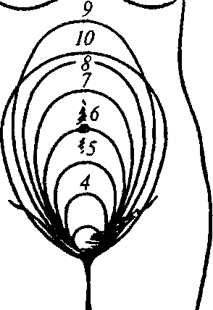
Fig. 26. The height of uterine fundus standing at different pregnancy terms
(obstetric months)
52

Chapter 5. Pregnant Women Examination
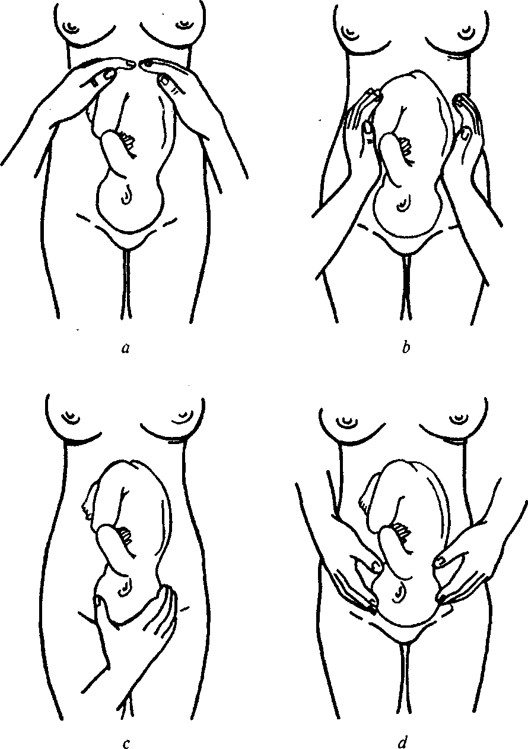
Fig. 27. Maneuvers of external obstetric examination of the pregnant woman:
a — the first, b — the second, c — the third, d — the fourth Leopold's maneuvers
53
PHYSIOLOGICAL OBSTETRICS
Conducting external examination by means of the fourth Leopold's maneuver allows obtaining the following data:
- the head is movable over the area of brim — if fingers may be brought under the head;
- the head is pressed to the area of brim — fingertips do not meet over the head, but the occiput and the whole face part are palpated over the area of brim; . . ■ -

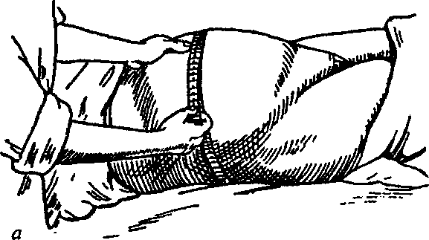
Fig. 28. Measuring of the abdomen circumference (a) and of the height of uterine fundus standing (b)

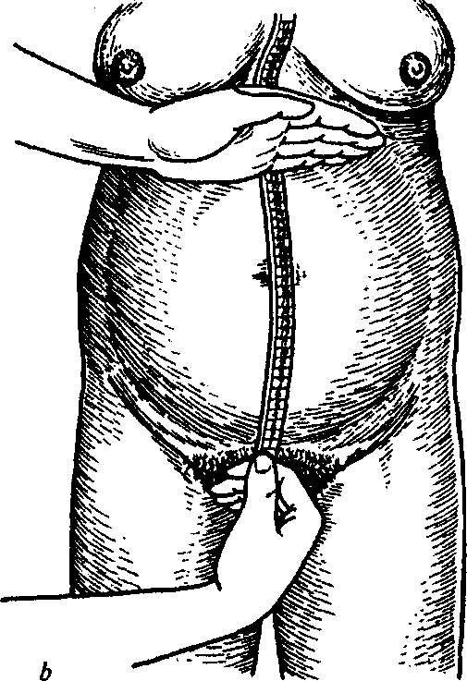
54

Chapter 5 . Pregnant Women Examination
- the head is in the area of brim with its minor segment — the occipital part of head protrudes above the area of brim by two fingers, and the face part — completely;
- the head is in the area of brim with its major segment — the occipital part of head is not palpated above the area of brim, and the face part protrudes by two fingers;
- the head is in the pelvic cavity — only the-chin is palpated or parts of fetal head are not defined at all.
External methods of investigation include measuring of the external dimensions of pelvis. It is conducted during the first examination of the pregnant woman in the antenatal clinic and maternity hospital. If it is necessary, the pelvis is measured repeatedly during delivery (see the chapter Maternal Passages).
MEASURING THE ABDOMEN CIRCUMFERENCE AND THE HEIGHT OF UTERINE FUNDUS STANDING
Abdomen circumference (AC) is measured with ameasuring tape, which goes through the navel in front and through the middle of lumbar area from behind (Fig. 28).
The height of uterine fundus standing (HUFS) is measured with a measuring tape from the upper margin of symphysis to the most protruding point of the fundus of uterus. The results of HUFS measuring are compared with a standard gravidogram (normally by the 30^{lh} week of pregnancy HUFS increase makes 0.7—1.9 cm a week; at 30—36 weeks — 0.6—1.2 cm a week; at 36 and more — 0.1—0.4 cm. If case monitoring shows lagging of dimensions by 2 cm or absence of increase during 2—3 weeks, it gives ground to suspect fetal growth inhibition).
CALCULATING THE FORESEEABLE FETAL BODY WEIGHT
The foreseeable fetal body weight (FBW) is approximately calculated by the following formula:
FBW = AC x HUFS.
More reliably fetal body weight is estimated by ultrasonic fetometry.
DETERMINING THE TERM OF ANTENATAL LEAVE (30-WEEK PREGNANCY SIGNS)
— The fundus of uterus is in the middle between the navel and xiphoid process;
55
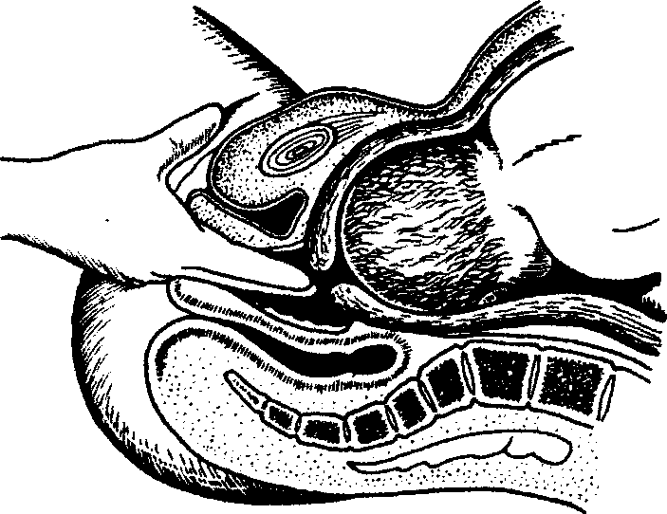
PHYSIOLOGICAL OBSTETRICS
Fig. 29. Vaginal touch
- the height of uterine fundus standing above the womb, if measured with a measuring tape, makes 25—28 cm (26 cm on average); abdomen circumference — 83—85 cm;
- the fetal head is movable above the area of brim in primigra-vida;
- the vaginal part of the uterine neck is not contracted;
- ultrasound fetometry results: biparietal dimension of the fetal head makes 75—76 mm on average; the average chest diameter — 77—78 mm; the average abdomen diameter — 79—80 mm; thigh length — 57—58 mm.
Internal Obstetric Examination
At physiological pregnancy the internal (vaginal) obstetric inspection is conducted during the first examination of the patient in the antenatal clinic during early pregnancy and last weeks of pregnancy to find the degree of uterine neck maturity (Fig. 29).
Internal investigation may be indicated at any term of pregnancy.
Before vaginal examination (vaginal touch) attention is paid to:
— processing of the doctor's hands, the pregnant woman's vulva
and vestibule of vagina;
56
Chapter 5 . Pregnant Women Examination
- position of the woman during vaginal examination;
- indications to vaginal examination.
Internal obstetric inspection gives information about the peculiarities of the soft tissues of parturient canal (elasticity, extensibility; as for the uterine neck — about its form, length, dilatation degree), fetal sac, presenting part, location of its main landmarks relative to the pelvis, about the bony pelvis (exostoses, deformations, promontory accessibility).
The internal obstetric inspection procedure:
- examination of the external genital organs, their development;
- detection of the vaginal orifice width, lumen, vaginal walls stretch, presence of scars, inflammatory alterations, tumors, condition of the perineum, filling of the rectal ampulla and urinary bladder;
- detection of the from and depth of vaults;
- position of the vaginal part of the uterine neck, its from, size, consistency, presence of scars and ruptures;
- the state of the internal and external mouths, their permeability (dilatation in centimetres), shortening or flatness of neck; detection of the ratio of the vaginal part of the uterine neck to the cervical canal of uterus;
- detection of fetal sac presence, form and density; its condition during and between birth pains: fills only during parodynia, remains filled after parodynia, too tense, weakens or does not fill at all during parodynia (flat sac), etc.;
- detection of the character of the presenting part (head, buttocks), location of its landmarks, establishment of the relation of the presenting part to a small pelvis plane (above the area of brim, in the area of brim with the major or minor segment, in the wide part of small pelvis, in the narrow part or in the pelvic outlet); whether within the orifice there are detected loops of cord, placental tissue, small parts of fetus, etc.;
- detection of pelvic capacity, exostoses presence, and the size of diagonal conjugate;
- the character of vaginal discharge.
Vaginal touch determines the degree of uterine neck maturity. The following notions are differentiated: immature, insufficiently mature, and mature uterine neck.
To detect the readiness of the maternal organism to delivery by the data of uterine neck maturity there is evaluated the consistency of the uterine neck, the length of its vaginal part, permeability of the cervical canal of uterus, position of the neck relative to the axis of pelvis by the Bishop's Score (Table 1).
57
PHYSIOLOGICAL OBSTETRICS
Table 1 . Uterine Neck Maturity Grading by the Bishop's Score

Feature | Maturation degree
Feature | 0 points | 1 point | 2 points
. Neck position . . | Retroposition | Anteroposition | Median
Neck length (cm) | >2 | 1-2 | <1
Neck consistency | Dense | Macerated | Soft
External orifice condition | Closed | Opened by 1 cm | Opened by >2cm
Location of the presenting part of fetus | Movable above the inlet | Pressed to the inlet | Pressed or fixed in the inlet
- 0—2 points — the neck is immature;
- 3—5 points — the neck is insufficiently mature;
- > 6 points — the neck is mature.
Instrumental and apparatus methods of investigating the condition of fetus may be found in the chapter Fetal Condition Imaging and Assessment.
58
Chapter 6
FETAL CONDITION IMAGING AND ASSESSMENT
During pregnancy the fetus is visualized by means of ultrasound investigation.
Ultrasound investigation is a highly informative method and allows dynamic case monitoring of the fetal condition. This method does not require any special preparation of the pregnant woman. Only in case of early pregnancy term (up to 10—12 weeks) and if placental presentation or low placental attachment is suspected, urinary bladder filling is required at transabdominal investigation (an ultrasonic sensor is on the anterior abdominal wall). The pregnant woman lies on her back during investigation, the observed area of skin (the anterior abdominal wall) is processed with sound-conducting gel. Some obstetric situations might require transvaginal examination (an ultrasonic sensor is introduced into the vagina), for instance: extrauterine pregnancy diagnostics, detection of fetal heartbeat, uterine neck length, condition of the external and internal mouths of uterine neck, etc.
Ultrasound is high-frequency sonic waves with a frequency of 2— 15 MHz, the range of monochrome sound picture. These waves are not felt by the human ear and may be turned into waves used for body scanning. Ultrasonic waves are generated by piezoelectric elements of the sensor, which turns electric signals into ultrasonic waves. The same sensor perceives the signal and turns it back into an electric signal.
Ultrasound investigation might be two- and three-dimensional. At two-dimensional US with the help of electronics an ultrasonic bundle is transferred into a plane perpendicular to the sensor, at three-dimensional — into two planes. Thus, at three-dimensional US there is a possibility to reproduce a three-dimensional image of surface structures or organs of the fetus. Three-dimensional US is preferred to diagnose fetal malformations.
Ultrasound fetometry is informative beginning from the 20th week of pregnancy. Ultrasound fetometry is presently the most objective method of diagnosing intrauterine growth retardation (IGR). It is
59
PHYSIOLOGICAL OBSTETRICS
expedient to conduct this investigation thrice during pregnancy (10-12, 16-22, 32-34 weeks).
During the 1st trimester of pregnancy US may be indicated by:
- Detected and confirmed pregnancy developing in the uterus, especially if extrauterine pregnancy is suspected.
- Bloody discharge in the pregnant woman — to diagnose chorion detachment; abortion, which has begun; incomplete and complete abortion; pregnancy, which does not develop; chorion diseases.
- Evident pain syndrome.
- Intrauterine contraceptive (IUC) diagnostics, taking into account the pregnant woman's anamnesis.
- Diagnostics of clinically foreseeable multiple pregnancy.
- Diagnostics of fetal maldevelopments at the pregnancy term of 10—12 weeks in such cases: fetal maldevelopment at previous pregnancy, stillborn previous pregnancy, pathological prenatal screening I (see below), complicated course of pregnancy up to 10—12 weeks.
- Diagnostics and observation of pregnancy if any extragenital or genital pathology is found and treated.
US during the 1st trimester of pregnancy finds:
- size of the fetal egg;
- coccygeal-parietal dimension of the embryo;
- heartbeat and mobility of the embryo;
- localization and condition of the chorion;
- dimension of the yolk sac;
- dimensions of the uterus, its form;
- IUC presence;
- condition of the uterine appendages;
- condition of the uterine neck;
- dimension of the nuchal region (after 10—13 weeks of pregnancy).
In the 1st trimester of pregnancy US is also conducted at chromosomal anomalies screening.
Chromosomal anomalies screening in the 1st trimester of pregnancy includes:
- Ultrasonic measurement of the nuchal region at 10—13 weeks of pregnancy. The nuchal region is an area between the internal contour of skin and external edge of soft tissues located on the surface of cervical spine. At the width more than 3 mm a chromosomal fetal pathology may be suspected.
- Detection of PAPP-A (pregnancy-associated plasma protein A) test in blood at 10—13 weeks of pregnancy. Venous blood is drawn
60
Chapter 6 . Fetal Condition Imaging and Assessment
on an empty stomach. During pregnancy PAPP-A forms in the syn-cytiotrophoblast cells. Reduction of the level of this index below 0.6 MoM, especially with simultaneous increase of the level of the free p-subunit of chorionic gonadotropic hormone (CGH) in blood, most likely testifies to a chromosomal pathology in the fetus. Increase of PAPP-A test does not have any clinical significance.
3. Detection of the free p-subunit of CGH, synthesized, by tro-phoblast cells, in the pregnant woman's blood. Reduction of this index may take place during pregnancy, which does not develop. If CGH level increases, one should assess the indices of PAPP-A test and US. If PAPP-A and US data are normal and CGH level is increased, there may be threat of fetus wastage, multiple pregnancy, or chorion disease.
In the course of US at 16—22 weeks of pregnancy fetal anatomy is thoroughly investigated to detect maldevelopments and also to find the gestational term of pregnancy, localization and structure of the placenta, quantity of the amniotic fluid.
One should necessarily measure the biparietal diameter (BPD) of the fetal head, medium size of the chest and stomach, and also the length of the femoral bone. If inadequacy of one or a couple of photometric indices of the pregnancy term is detected, extended photometry is conducted and the ratio of the frontooccipital dimension to BPD, head circumference to abdominal circumference, BPD to femur length, femur length to abdominal circumference is calculated.
At 16—18 weeks of pregnancy US is also conducted at chromosomal anomalies screening during the 2nd trimester of pregnancy.
Chromosomal anomalies screening during the 2nd trimester of pregnancy (15—20 weeks) includes:
- Detection of alpha-fetoprotein (AFP) in the venous blood on an empty stomach. This is fetal globulin, which is synthesized by 13 weeks of pregnancy in the fetal gallbladder, and beginning from 13 weeks — in the fetal liver. Increase or decrease of AFP level is a sign of fetal condition disorder (fetal maldevelopments, isoserological ma-terno-fetal incompatibility, fetal development delay, fetal death).
- Detection of estriol in the venous blood of the pregnant woman on an empty stomach. Estriol level decrease indicates derangement of fetal condition (fetal maldevelopments, intrauterine infections, fetal development delay, fetal death) or fetoplacental system. Level increase may take place at multiple pregnancy, a large fetus.
- Detection of the level of the free CGH p-subunit in the pregnant woman's blood on an empty stomach. Its level increase may take
61
PHYSIOLOGICAL OBSTETRICS.
place at stillborn pregnancy. If CGH level is increased, there may be miscarriage threat, multiple pregnancy, chorion disease, chromosomal aberrations of the fetus.
In the 3rd trimester of pregnancy US detects the same indices as in the 2nd trimester. The most valuable index is foreseeable fetal weight. There is also found the presenting fetal part, localization of placenta (especially in cases of placental presentation, low location of placenta), umbilical cord.
A reason for supersonic fetometry at late pregnancy terms may be fetal growth delay suspected by the data of external measurement of the height of uterine fundus standing and circumference of the pregnant woman's abdomen at a known pregnancy term, and also, in certain cases, to detect the pregnancy term by special tables if its term is hard to find by anamnestic data.
In cases when screenings of chromosomal anomalies in the 1st or 2nd trimester of pregnancy find data confirming a chromosomal fetal pathology, invasive methods of investigating the prenatal diagnostics of chromosomal fetal disorders are resorted to. They include: amniocentesis, chorion biopsy, chordocentesis.
Amniocentesis is an operation of sampling the amniotic fluid for its further biochemical, hormonal, immunological, genetical, and cy-tological investigation.
Indications: suspected fetal maldevelopments, isoserological ma-terno-fetal incompatibility, microbiological investigation, chronic fetal distress, antenatal diagnostics of fetal gender.
Amniocentesis may be transabdominal and transvaginal. It is always performed using the guidance of US (Fig. 30).
Transabdominal amniocentesis technique:
- processing of the anterior abdominal wall with antiseptic;
- local anesthesia of the skin, hypodermic tissue, subgaleal space with 0.5 % novocaine solution;
- puncture of the anterior abdominal wall, uterine wall to the amniotic fluid using US guidance with the same needle as for spinal anesthesia;
- sampling of 10—15 ml of amniotic fluid, its transportation into a dark container (the fluid should not be colored with blood or meconium);

- aseptic dressing on the skin. Transvaginal amniocentesis technique:
- processing of the vagina, uterine neck with antiseptic;
- imaging of the uterine neck in specula;
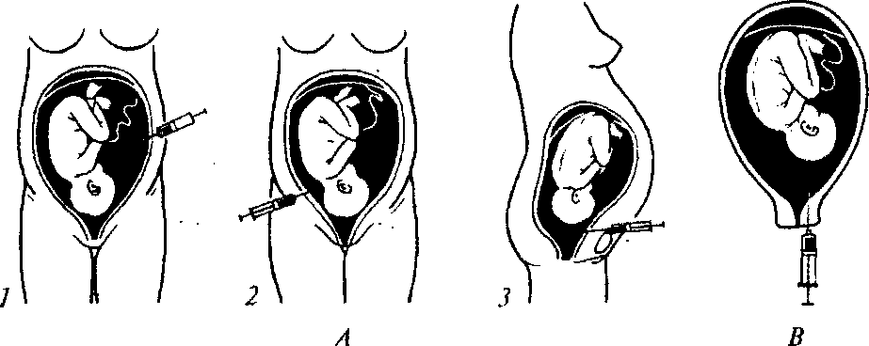
Chapter 6. Fetal Condition Imaging and Assessment
Fig. 30. A — Transabdominal amniocentesis.
1 — puncture below the navel, from the side of small fetal parts; 2 — puncture below the navel, from the side of the occipital bend of fetal neck; 3 — suprapubic puncture;
B — Transcervical amniocentesis
- fixation with bullet forceps of the posterior or anterior lip of ostium of uterus depending on the puncture type;
- puncture with a needle (see the paragraph above) of the uterine neck using US guidance through the posterior or anterior vaginal fornix or cervical canal of uterine neck depending on placenta localization;
- sampling of 10—15 ml of amniotic fluid and transporting it into a dark container (the fluid should not be colored with blood or meconium); removal of instruments.
Complications: premature breaking and discharge of waters, preterm delivery, placenta detachment, fetal injure, umbilical cord, cho-rioamnionitis, injury of the maternal urinary bladder and bowels.
Contraindications: miscarriage threat, refusal of the pregnant woman.
It should be noted that if highly qualified US is possible, amniocentesis is inexpedient.
Chorion biopsy is an operation of getting chorion cells for the purpose of detecting chromosomal or genie anomalies of fetal development or fetal gender (Fig. 31).
Chorion biopsy is conducted transabdominally or transcervicalty using US guidance at 8—12 weeks of pregnancy. The technique is similar to the amniocentesis technique with some exceptions. Instead of a needle a sterile polyethylene cannula 26 cm long and with exter-
63
PHYSIOLOGICAL OBSTETRICS
cated on the anterior abdominal wall of the mother in the place of the best auscultation of fetal heart tones, and the external tensometric sensor — in the region of the right angle of uterus.
Direct CTG may be only conducted during delivery. In order to register fetal heartbeats an electrode is applied to the fetal scalp; to assess the contractile function of uterus the sensor is introduced through the vagina.
In the course of CTG analysis such parameters are assessed: basal heart rate (BHR), HR variability (amplitude and frequency of oscillations), presence and type of temporary BHR changes in the form of heart rate acceleration or deceleration.
In the presence of pathological HR parameters testifying to threatening fetal condition it is offered to keep continuous record of CTG during the whole period of delivery.
CTG structure and analysis:
- Basal fetal HR is a mean of instantaneous values of fetal HR nonregistering accelerations and decelerations. BHR is calculated in intervals in 10 min. Normal fetal BHR (normocardia) is the frequency from 110tol70bpm.
- HR variability is a complex parameter of fetal cardiac function. It can be assessed by the width of CTG record (HR amplitude) and by oscillations frequency.
Record width (amplitude) is measured between the absolute maximum and minimum of all oscillations nonregistering accelerations and decelerations, i.e. the amount of deflection from the basal rhythm (Fig. 32).
In the given example the amplitude will make 150-135 = = 15(bpm).
There are differentiated 4 variants of amplitude:
- monotonic — with deflections from the basal rhythm up to 5 bpm;
- flattened (extremely wave-like, with deflections from 5 to 9 bpm);
- wave-like — from 10 to 25 bpm;
— pulsating (saltatory rhythm) — more than 25 bpm.
Oscillations frequency is their quantity per minute (Fig. 33).
By frequency there are differentiated low (less than 3 per min), medium (3—6 per min), and high frequency (more than 6 per min) oscillations.
By the character of origination accelerations and decelerations may be sporadic, periodical, and regular, by duration — typical and prolonged.
Chapter 6. Fetal Condition Imaging and Assessment

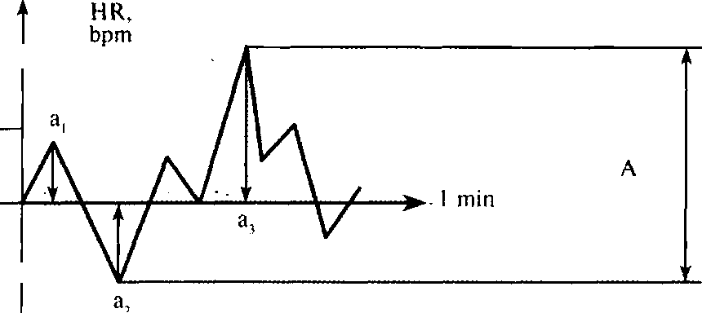
145
150 -
140
135 —

A - rhythm variability amplitude a,-— a₃ oscillations amplitude
Fig. 32. Estimation of the amplitude of basal rhythm variability and slow oscillation amplitude.
In the figure the record width, or the amplitude of basal rhythm variability, makes 15 bpm while slow oscillation amplitude does not exceed 10 bpm (a.,)
Sporadic — appear in response to fetal movements, are not regular.
Regular — are registered in approximately equal intervals of time and are connected with fetal movements.
Periodical — are connected with fetal vital activity, e.g. accelerations and decelerations arising after a labor pain or caused by umbilical cord compression.
Typical accelerations and decelerations last more than 15 sec, but not longer than 2 min.
Accelerations and decelerations are prolonged if basal rhythm change lasts more than 2 min.
- Accelerations are temporary BHR changes characterised by BHR increase during more than 15 sec (weak HR changes from 10 to 30 bpm, medium — 30—60 bpm, considerable — more than 60 bpm; Fig. 34).
- Decelerations — temporary BHR changes characterised by BHR decrease.
4.1. Spontaneous decelerations (dip 0). Short-term decelerations, last not more than 30 sec, the amplitude of 30—40 beats from the basal level. These changes have no practical meaning. Decelerations of this type may be sporadic, regular, and periodical.
67

PHYSIOLOGICAL OBSTETRICS
- Early decelerations (dip I) are periodical, i.e. are detected only if the uterus is active. Deceleration duration and amplitude correspond to the duration and intensity of parodynia (Fig. 35).
- Late decelerations (dip II) are periodical, i.e. also connected with parodynia, but arise later (up to 30 sec after beginning) and reach their high after the maximum uterine tension (Fig. 36). - --

1 min
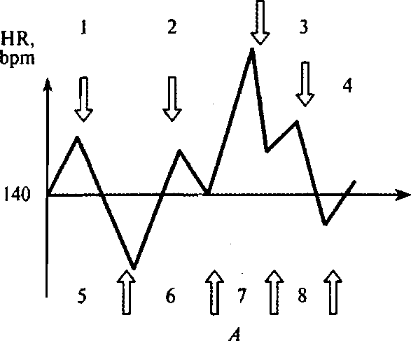

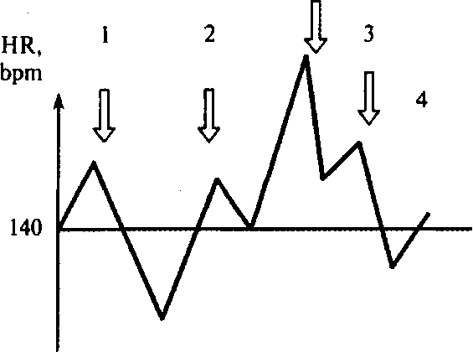
>» 1 min
B

Fig. 33. A — Estimation of frequency by the number of oscillation peaks. B — Estimation of frequency by the number of upward oscillation peaks:
4x2 = 8
68

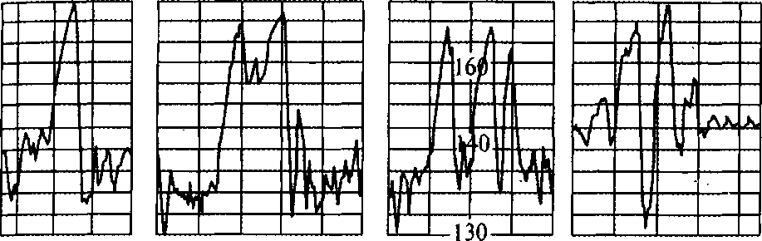
Chapter 6. Fetal Condition Imaging and Assessment
Fig. 34. Typical diversiform accelerations.
Unlike decelerations, they are not classified by appearance and dimensions
4.4. Variable decelerations (dip III) are also referred to periodical. This is a stable form of HR reduction, a combination of dip I and dip II. They are characterised by unsteady time of emergence relative to labor pains, different duration and form (Fig. 37). During delivery fetal condition is assessed by the W. Fisher's scale (1976; Table 2).
Table 2 . CTG Description by the W. Fisher's scale

CTG parameters | Points
CTG parameters | 0 | 1 | 2
Basal rhythm, bpm | < 100 > 180 | 100-119 161-180 | 120-160
Variability:  — amplitude, beats  — frequency per min | <3 <3 | 3-6; > 25 3-6 | >6-25 >6
Accelerations in 30 min | 0 | Periodical, 1—4 sporadic | 5 and more sporadic
Decelerations in 30 min | dip II, severe dip III | dip II,  moderate  dip II, mild | 0 dip I dipO
Note: 8—10 points — normal fetal condition; 5—7 points — mild hypoxia; less than 5 points — severe fetal hypoxia.
At normal fetal condition CTG is characterized by: BHR within 110—170 bpm (normocardia), variability (record width) — 10— 25 bpm with oscillation frequency of 3—6 cycles per min (undulating type), presence of HR accelerations and no decelerations.
69

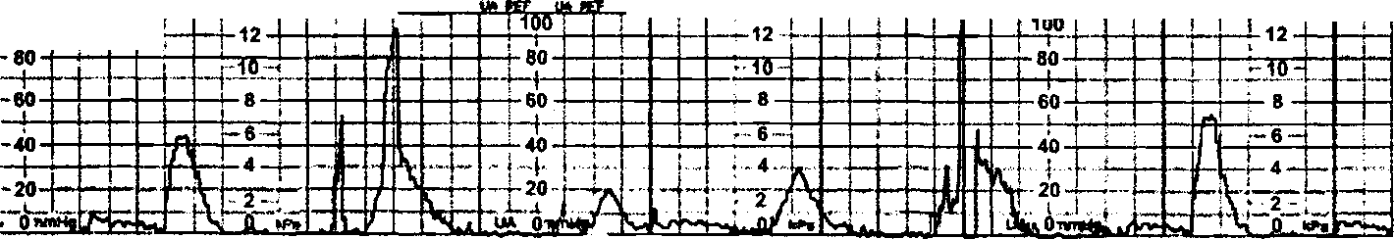
o
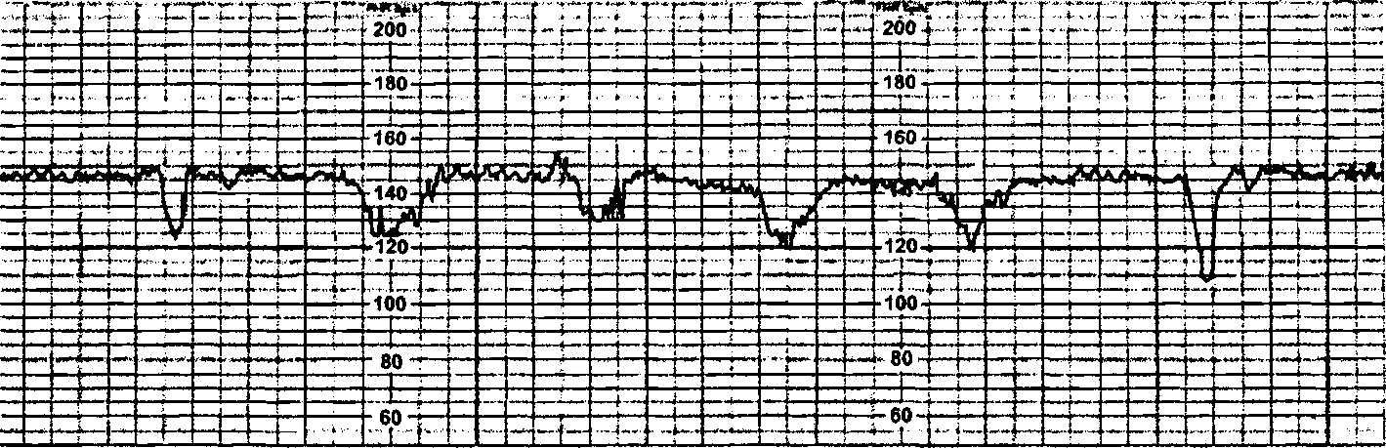
.1MIHF, IjVflf

wio uvmt turner
tfjo iiatEas tia _{w} root i tw»
ijetiua

Fig. 35. Early decelerations.
The peaks of parodynia and decelerations coincide, and decelerations themselves resemble parodyni

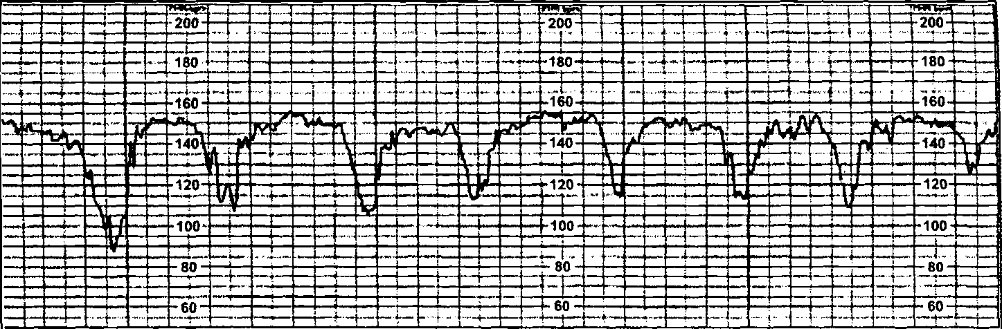

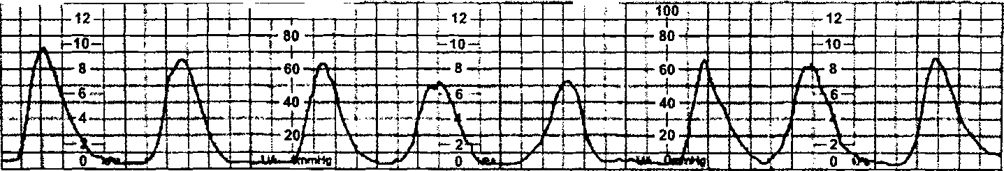
.*_{r}mM

^MooTT

ix rt;;r
(•• va tijco r
u> ty
AWJSRL-.

Fig. 36. Late decelerations.
The peaks of decelerations and parodynia are distant from one another by 35—40 sec. Deceleration d dynia amplitude to some extent. Decelerations are similar by form and, as well as early decelerations

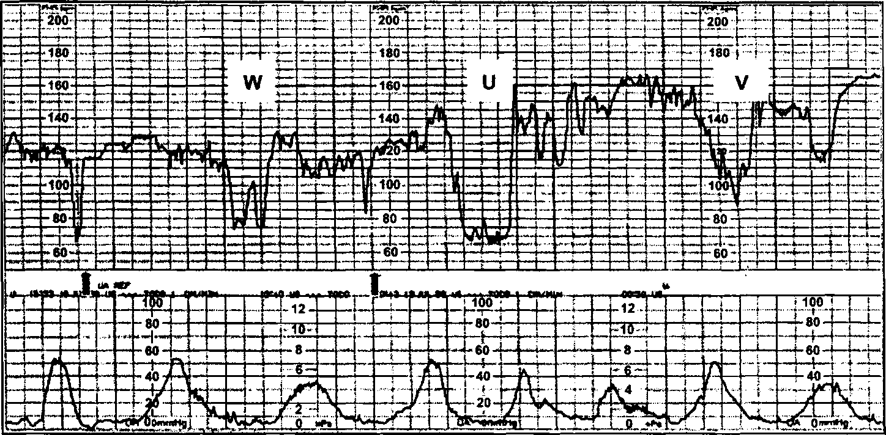
Fig. 37. Variable decelerations.
All rhythm decelerations differ from each other in form, geometrical dimensions, and time of on Deceleration peaks remind the letters W, U and V. Pointed decelerations are located between them
Chapter 6 . Fetal Condition Imaging and Assessment
Non-stress test (NST) is assessment of fetal cardiac function reactivity with the help of CTG during pregnancy in response to spontaneous movements. The pregnant woman is in comfortable position during CTG.
NST may be reactive (norm) when during 20 min there are 2 or more accelerations of fetal heartbeats by. more than 15 bpm and lasting not less than 15 sec connected with fetal movements. The test is areactive if there are less than 2 accelerations of fetal heartbeats by less than 15 bpm, lasting less than 15 sec, connected with fetal movements during 40 min of monitoring.
Stress test is assessment of fetal cardiac function reactivity by means of CTG during pregnancy in response to functional tests: oxytocin introduction, breath-holding, physical load of the mother, nipples stimulation, thermal irritation of the belly skin, or acoustic stimulation. This method has low predictive value concerning the fetus and a very high frequency of error-positive results.
Biophysical fetal profile (BFP) is a change of biophysical indices controlled by the central nervous system at fetal hypoxia.
Biophysical indices include: frequency of fetal respiratory movements, fetal motion activity, fetal tone, fetal cardiac function reactivity and NST, amniotic fluid volume, placenta maturity (Table 3).
Modified BFP combines NST with amniotic fluid index.
Amniotic fluid index is a total of maximal recesses with fluid in 4 quadrants of the uterine cavity: 0—5 cm — evident oligohydramnios, 5.1—8 cm — moderate oligohydramnios, 8.1 — 18 cm — normal index, more than 18 cm — hydramnion.
Each index is assessed in points from 0 (pathology) to 2 (norm), then the total of points of all biophysical parameters is analyzed. Thus, BFP is found.
BFP is detected beginning from 30 weeks of pregnancy.
Indications to BFP:
- Areactive NST of the fetus at CTG recording.
- Syndrome of fetal development delay.
- Chronic fetoplacental insufficiency.
- A high degree of risk in the pregnant woman at some extragenital pathology.
Dopplerometry of blood velocity in the umbilical artery. The Doppler effect is the frequency of sound produced by an object. When an object is moving to another object, sound frequency increases, and when an object is moving away — decreases. That is, the Doppler ef-
73
PHYSIOLOGICAL OBSTETRICS
feet is dependence of the length of reflected radiation wave on the frequency of an object moving relative to the wave radiation source.
Blood flow dopplerograms can be assessed in two ways: qualitatively and quantitatively. The qualitative analysis of blood velocity curves is widely spread in obstetric practice. The most important is the ratio between blood velocities in systole and diastole. Each vessel has its individual blood velocity curves.
Doppler US of blood flow in the umbilical artery has the biggest practical value during pregnancy.
Dopplerometry of blood velocity in the umbilical artery reflects the state of microcirculation in the fetal part of placenta, whose vascular resistance plays the main role in fetoplacental hemodynamics.
Diagnostic criteria:
- normal blood flow — high diastolic component in the dopplero-gram relative to the isoline; the ratio of systole amplitude to diastole does not exceed 3;
- pathological blood flow:

- decelerated blood flow — decrease of the diastolic component; the ratio of systole amplitude to diastole exceeds 3;
- terminal blood flow — testifies to a strong possibility of antenatal fetal death;

- zero blood flow — blood flow in the phase of diastole stops (no diastolic component in the dopplerogram);
- negative (reverse) blood flow — blood flow in the phase of diastole acquires reverse direction (in the dopplerogram the diastolic component is below the isoline).
Amnioscopy is transcervical inspection of the inferior pole of fetal bladder.
Indications: postmature pregnancy, fetal distress, isoserological materno-fetal incompatibility.
Technique:
- the pregnant woman is in the gynecological chair;
- the external genitals, vagina, and uterine neck are processed with antiseptic solutions;
- one conducts vaginal examination to detect cervical canal dilation;
- the uterine neck is visualized in specula;
- a cone with mandrel is introduced into the cervical canal behind the posterior orifice (the cone diameter may vary from 12 to 20 mm);
- the mandrel is removed, cone lighting is connected.
74
Table 3. Assessment of the Results of BFP Indices Detecting

Parameters | Points
Parameters | 2 | 1
NST (fetal cardiac function reactivity after fetal movements by CTG data) | 5 and more HR accelerations with an amplitude of not less than 15 bpm, lasting not less than 15 sec, connected with fetal movements taking place 20 min before monitoring | 2—4 HR accelerations with an amplitude of not less than 15 bpm, lasting not less than 15 sec, connected with fetal movements taking place 20 min before monitoring
Fetal respiratory movement (FRM) | Not less than 1 FRM episode lasting 60 sec and more 30 min before monitoring | Not less than 1 FRM episode lasting 30—60 sec and more 30 min before monitoring
Fetal motion activity | Not less than 3 generalized movements 30 min before monitoring | 1 or 2 generalized movements 30 min before monitoring
Fetal tone | One and more episodes of deflexion with returning into flexion position of the spine and extremities 30 min before monitoring | Not less than 1 episode of deflexion with returning into flexion position 30 min before monitoring
Amniotic fluid volume | Amniotic fluid is detected in the uterus, the vertical diameter of the free area of fluid makes 2 cm and more | The vertical diameter of the free area of fluid is more than 1 cm, but not less than 2 cm
Placenta maturity by Grannum | The 0, l^{sl}, 2^{I1(I} maturity degrees | The placenta along the posterior wall, it is difficult to explore, the 3^{rtl} maturity degree
BFP assessment | 9—12 points — satisfactory fetal condition;  7—8 points — dubious test (to be repeated in 2—3 days);  6 points and less — pathological BFP assessment (to decide the question of

PHYSIOLOGICAL OBSTETRICS
During amnioscopy the doctor pays attention to the color, consistency of amniotic fluid, admixture of meconium or blood, presence and motility of vernix caseosa flakes, presenting fetal part.
Contraindications: placental presentation, inflammatory process of the vagina and cervical canal.
The algorithm of diagnosing the functional condition of fetus during pregnancy:
- if HR is higher than 170 bpm and lower than 110 bpm, which testifies to fetal distress, one needs to assess the biophysically modified or extended BFP;
- at pathological BFP dopplerometry of blood flow in the umbilical artery is conducted. At normal blood flow in the umbilical artery repeated BFP is required in 24 hours;
- if BFP assessment is pathological (6 points and less), repeated (in a day) dubious BFP assessment (7—8 points), decelerated, or critical changes of diastolic blood flow in the umbilical arteries (zero and reverse) — hospitalization to the maternity hospital of the 3rd level of aid rendering.
PHYSIOLOGICAL DELIVERY
Normal (physiological, easy) labor is delivery with spontaneous beginning and labor activity progress in the pregnant woman of low risk level at the term of pregnancy of 37—42 weeks, vertex presentation, at satisfactory condition of the mother and newborn after delivery.
7.1. DELIVERY BIOMECHANISM AT VERTEX PRESENTATION
Delivery Biomechanism at Anterior Vertex Presentation
Biomechanism of delivery is a complex of progressive, rotational, flexion, and deflexion movements, performed by the fetus when it is going through the parturient canal.
Biomechanism of delivery at the anterior type of vertex presentation consists of four steps (Fig. 38).
The first step — flexion of the fetal head and its descending into the area of brim. That is rotation of the fetal head around its transverse axis. As a result of fetal head flexion the small fontanel is located on the lower pole of presenting part, approaching the axis of pelvis, and becomes the "leading point". Due to this flexion the fetal head goes through the pelvis with the smallest circumference, which goes through the small oblique dimension and makes 32 cm.
Fetal head flexion is the most easily explained by the law of double-arm lever. Progressive movements of fetal head are continuous, till the child is born. The fetal head is configured during this moment.
The second step — internal turning of the fetal head; it takes place when the fetal head moves from the wide to the narrow part of small pelvis. The fetal head slowly rotates around its axis in such a way that the occiput is directed to the symphysis, and the face — to the sacral bone. The sagittal suture gradually changes its position, changing from the transverse dimension to the oblique one, then from the oblique dimension — to the direct dimension of pelvic outlet.
77
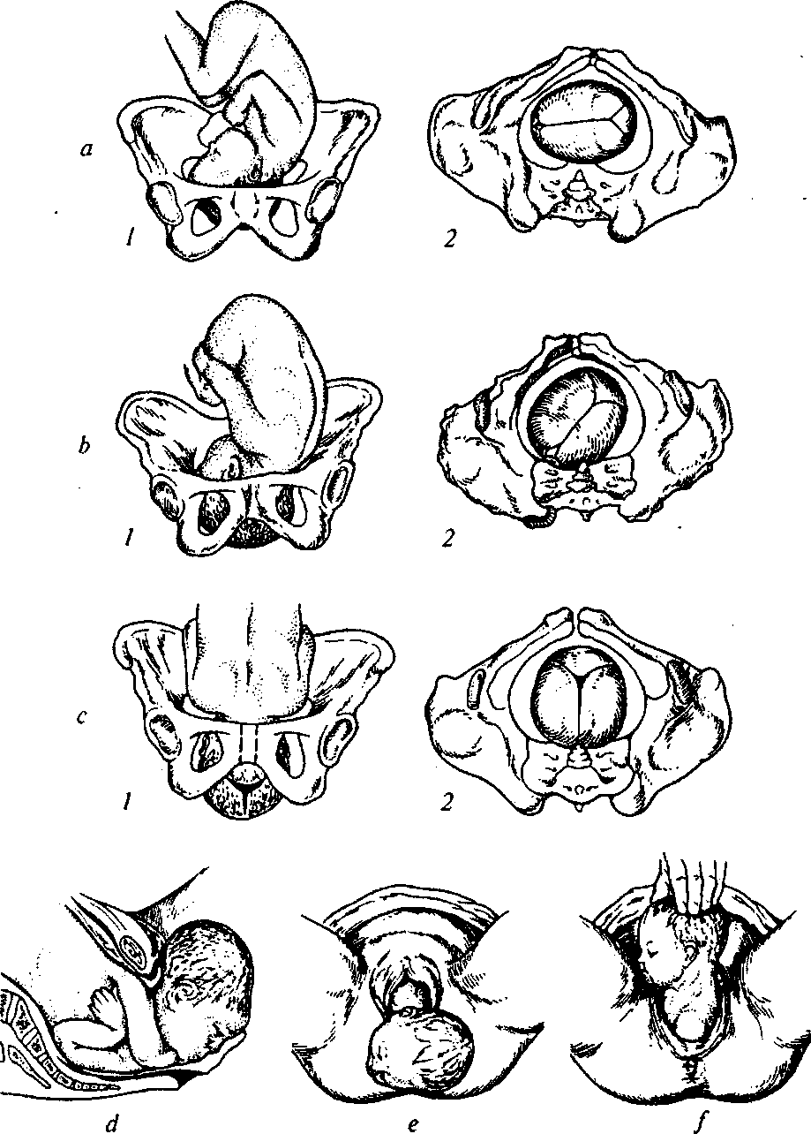
PHYSIOLOGICAL OBSTETRICS
Fig. 38. Delivery mechanism at anterior vertex presentation:
a - the 1st step: 1 - head flexion, 2 - pelvic outlet view (the sagittal suture in the transversal pelvic dimension); b - the 2nd step: 1 - internal head turning, 2 -pelvic outlet view (the sagittal suture in the right oblique pelvic dimension);
78
Chapter 7. Physiological Delivery
4* c 2"^{(l} step termination: 7 - the internal head turning is finished, 2 - pelvic view (the sagittal suture is in the straight pelvic dimension); d - the 3rd step: head deflexion- after formation of the fixation point (the head is under the pubic arch with the suboccipital fossa); e - the 4th step: external head turning, the shoulders are being born (the anterior shoulder is retained under the symphysis);/- the shoulders are being born, the posterior shoulder is disengaging above the perineum
At the first position the sagittal suture goes through the right oblique dimension, at the second — through the left oblique dimension of pelvis.
Internal fetal head turning is a consequence of adjustment of its smallest dimensions to the largest dimensions of pelvis, and also resistance of the pelvic muscular system to the progressive movement of head.
The third step — deflexion of the fetal head in the area of brim. The sagittal suture coincides with the direct dimension of pelvic outlet. A point of fixation is formed between the middle of the inferior margin of symphysis pubis and suboccipital fossa. Fetal head deflexion takes place around this point, and clinically it is accompanied by the birth of the fetal forehead, face, and chin.
The fourth step — internal turning of the fetal shoulders and external turning of the fetal head. As the fetal head cuts through, the fetal body moves to the small pelvis, the transverse dimension of shoulders enters one of the oblique dimensions of pelvic inlet. At the first position the shoulders take the left oblique dimension of the pelvic inlet, at the second — the right oblique dimension of pelvic inlet.
The shoulders perform internal turning on the pelvic floor, similarly to the turning of fetal head. Having performed the turning, the shoulders fix with their direct dimension in the direct dimension of pelvic outlet. This turning is transferred to the born head, which corresponds to the fourth step of delivery biomechanism. The head turns to the maternal hip with the face: at the first position — to the right, at the second — to the left.
The anterior shoulder gets under the pubic arch, fixes by the inferior margin of symphysis. The point of fixation is the place of the attachment of the deltoid muscle to the humeral bone. The body bends in the thoracic part around the point of fixation, the posterior shoulder is born first, then — the posterior arm. After the shoulder girdle is born, other parts of fetus appear, the birth of which has no special biomechanism since their dimensions are considerably smaller than of the head and shoulder.
79
PHYSIOLOGICAL OBSTETRICS
Delivery Biomechanism at Posterior Vertex Presentation (Fig. 39)

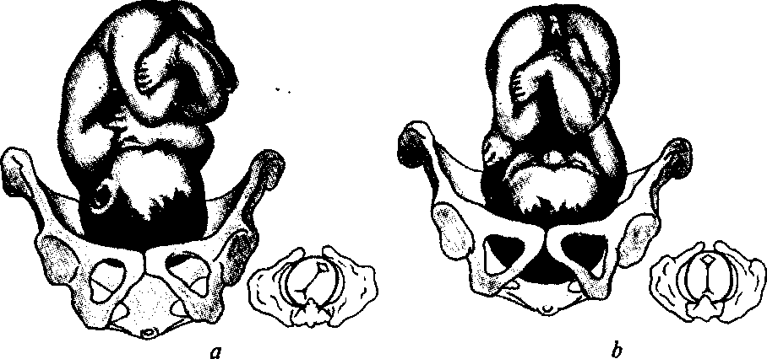
Fig. 39. Delivery mechanism at posterior vertex presentation:

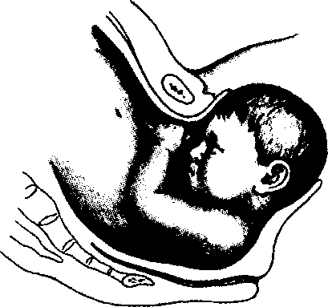
a - the 1st step: head flexion; b - the 2nd step: internal head turning; c - the 3^{rtl} step: additional head flexion
The first step — flexion and descending of the fetal head (does not differ from the anterior type of vertex presentation).
The second step — internal turning of the fetal head: the occiput turns not to the symphysis, as at the anterior type of vertex presentation, but to the sacral bone; the face is turned to the symphysis. After the occiput the fetal back turns back. Thus, the small fontanel is directed to the sacra, and the large one — to the symphysis. The sagittal suture through the oblique dimension similar to the position turns into the direct dimension of the pelvic outlet.
The third step — additional flexion of the fetal head. It is fixed in the middle of the inferior margin of the symphysis with a part of the anterior margin of the large fontanel; the first point of fixation is formed, around which the additional flexion is finished, which lasts till the second point of fixation forms.
80

Chapter 7. Physiological Delivery
The fourth step — head deflexion. Further cutting of the head is caused by the formation of the new, second point of fixation between the suboccipital fossa and the coccyx apex. Thus, the head is born with the face from under the symphysis, it disengages with a slightly less circumference than the circumference of the small oblique dimension — with the average oblique dimension.
The fifth step does not differ from the fourth step of delivery bio-mechanism at the anterior type-of vertex presentation.
Configuration of the head at the posterior type of vertex presentation is dolichocephalous.
Etiological moments of the formation of the posterior type of vertex presentation include changes of the form and dimensions of the pelvis, and also of the fetal head. This variant is often observed at small, premature or dead fetuses.
Peculiarities of the clinical picture of the course of delivery at the posterior type of vertex presentation: longer duration of the act of delivery than at the anterior type of vertex presentation; bigger waste of labor strength for excessive flexion of the head; most often there appear perineal ruptures, repeated powerless labor, fetal hypoxia, etc.
Labor prognosis is generally satisfactory. Labor management is expectant, but one should always be ready to render obstetric help or conduct a surgery.
7.2. DELIVERY STAGES
Delivery is divided into three stages:
- the first — the stage of cervical dilation;
- the second — fetal expulsion;
- the third — placental.
The first stage (dilation) is counted from the beginning of regular labor pains till sufficient cervical dilation (10 cm). Diagnostics and confirmation of delivery beginning:
- after the 37th week the pregnant woman has labor-like pains in the lower part of abdomen and loin with appearance of mucosanguin-eous and watery (in case of amniotic fluid discharge) discharge from the vagina;
- one labor pain in 10 min, which lasts for 15—20 sec;
- the uterine neck changes form (its progressing shortening and smoothing) and dilates;
- gradual descending of the fetal head to the small pelvis relative to the area of brim (by the data of external obstetric examination).
81
PHYSIOLOGICAL OBSTETRICS

Labor pains are involuntary contractions of uterine muscles. Intervals between labor pains are called a pause. Regular birth activity is such uterine activity (2—5 pains in 10 min), which leads to structural changes of the uterine neck — its smoothing and dilation.
Smoothing of the uterus is the reduction of its canal length due to the movement of the muscle fibers of internal orifice to the inferior uterine segment.
Cervical dilation is characterized by the increase of cervical canal diameter to 10 cm, which provides fetal advancement. Cervical dilation predominantly happens at the expense of contraction and retraction of muscle fibers of the body and fundus of uterus relative to one another, and also at the expense of distraction of cervical muscles and partially of the inferior uterine segment. In pauses between labor pains uterine contraction disappears completely, and retraction — partially.
During each pain intrauterine pressure rise is transmitted to the fetal membranes, amniotic fluid, and fetus. Amniotic fluid under the influence of intrauterine pressure moves down to the outlet from the uterus, as a result of what the fetal sac squeezes into the cervical canal of uterus. The presenting part (the head) is fixed in the brim and forms the internal girdle of fitting (Fig. 40). the amniotic fluid is thus divided into anterior and posterior. The external girdle of fitting is formed between the pelvic walls and the lower uterine segment.
Smoothing and dilation of the uterine neck happens differently in para I and para II. In para I smoothing takes place before dilation (Fig. 41); in para II these processes are simultaneous (Fig. 42). At physiological delivery in the end of the first period the fetal sac bursts and amniotic fluid pours out. Such amniotic fluid discharge is considered timely. Amniotic fluid discharge before the beginning of birth activity is called premature, and discharge before 5 cm cervical dilation — early.
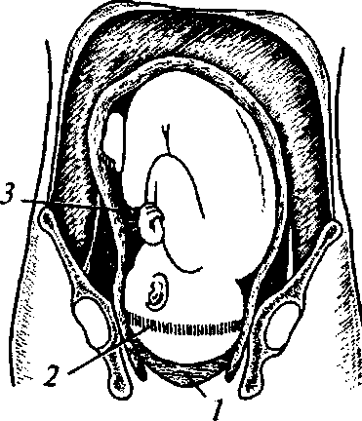
The first stage of labor is divided into two consecutive phases:
— the latent phase — the interval of time from the beginning of regular birth activity till complete
Fig. 40. Diagrammatic representation of the action of expulsion forces:
1 — anterior amniotic fluid; 2 — internal girdle of fitting; 3 — posterior amniotic fluid
82

Chapter 7. Physiological Delivery

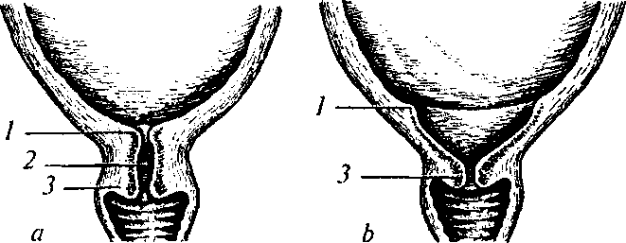

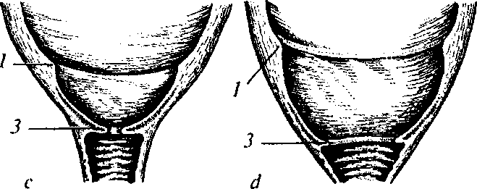
Fig. 41. Uterine neck in para I:

a — before delivery beginning; b — beginning of the dilation stage (uterine neck shortening); c — the first stage of delivery (uterine neck smoothing); d — the end of the first delivery stage (sufficient cervical dilation): 1 — isthmus of uterus; 2 — cervical canal of uterus; 3 — uterine neck

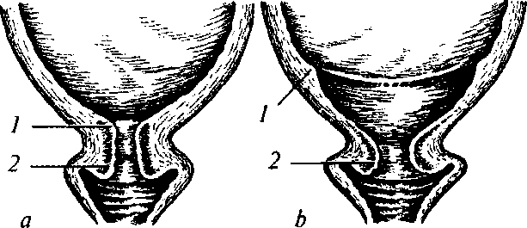
Fig. 42. Uterine neck in para II:


a — beginning of the period of cervical dilation; b — simultaneous dilation of isthmus (1) and neck of uterus (2); c — sufficient cervical dilation

83

PHYSIOLOGICAL OBSTETRICS
smoothing of the uterine neck with dilation to 3 cm if delivery is the first or to 4 cm at all further pregnancies. Usually this phase lasts 6—8 and 4—5 h accordingly;
— the active phase — cervical dilation from 3—4 to 10 cm. The minimal speed of cervical dilation in the active phase, which is considered normal, makes 1 cm/h both during the first and further deliveries. Usually dilation speed in para II is bigger than in para I.
The active phase in its turn is divided into three subphases: acceleration, maximal elevation, and deceleration. The subphase of acceleration in para I lasts 2 h, in para II — to 1 h. The subphase of maximal elevation lasts the same time accordingly. The subphase of deceleration in para I lasts 1—2 h, in para II — 0.5—1 h. Deceleration in the end of the first period is explained by the slipping down of the uterine neck from the advancing fetal head.
Uterine activity is detected by palpation of the uterus during 10 min. The presence of 2 or more uterine contractions during 10 min lasting for 20 or more sec is a sign of birth activity.
The conclusion about labor pains efficiency is based on their force, duration, and frequency, on dynamic cervical dilation and the signs of head advancement relative to the area of brim.
In the active phase of the first period of delivery effective contractile uterine activity must correspond to the following characteristics: 3—4 contractions in 10 min, lasting more than 40 sec.
Still, the most objective criterion of birth activity efficiency in the first period is cervical dilation, whose degree may be controlled by different methods.
The second stage (expulsion) lasts from the moment of sufficient cervical dilation till the child is born. It is important to differentiate
Fig. 43. Cutting-in of the fetal head Fig. 44. Disengagement of the fetal
head

Chapter 7. Physiological Delivery
the early phase of the second stage (from sufficient dilation till contractions beginning) from the active phase — the phase of contractions itself.
Important notions of the second stage are:
- contractions — rhythmical consciously controlled contractions of uterine muscles, prelum abdominale, diaphragm, and pelvic floor;
- cutting-in of the fetal head — the fetal head appears on the vulvar end only during contraction (Fig. 43);
- disengagement — the head keeps position in the vulvar end after contraction ceases (Fig. AA).
The maximum allowed duration of the second stage in para I and para II makes 2 and 1 h accordingly without epidural anesthesia application. The most part of this time falls on the early phase, when the fetal head gradually advances through the maternal passages to the pelvic floor, first without contractions addition, and then with gradual appearance and increase of powerful conmponent during contractions. Organization of contractions during the early phase, if the condition of the fetus and mother is normal, usually quickly leads to woman's fatigue, violation of the process of internal turning of the fetal head, injuring of the maternal passages and fetal head, cardiac abnormalities of the fetus, excessive medical intervention.
Full-value power activity appears only after the head is on the pelvic floor (the active phase).
Attention should be paid to the fact that long-term standing of the fetal head in a certain pelvic plane without any advancement dynamics may lead to the formation of recto- and urovaginal fistulas.
The third stage (placental) lasts from the fetal birth till the detachment of placenta and membranes. If there are no signs of hemorrhage, its duration should not exceed AO min.

Fig. 45. Central placenta detachment
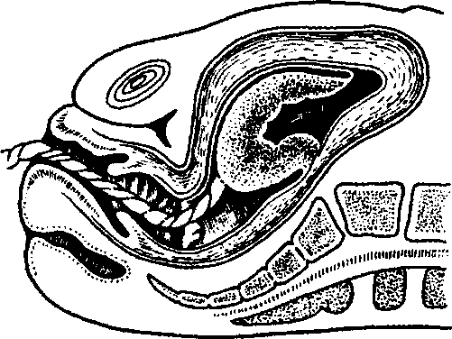
(the Schultze's mechanism): retroplacental hematoma

85

PHYSIOLOGICAL OBSTETRICS

Fig. 46. The placenta has detached from the uterine wall and is folded in the uterine neck
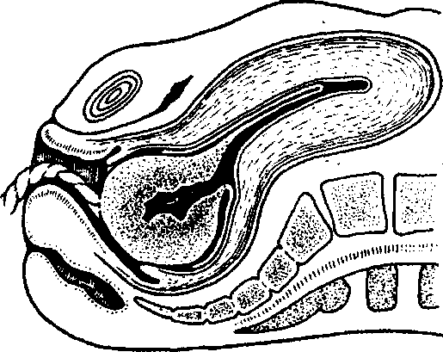
(the Schultze's mechanism)
Fig. 47. Beginning of placenta detachment
(the Duncan's mechanism)

Fig. 48. The inferior margin of detached placenta descends into the uterine neck
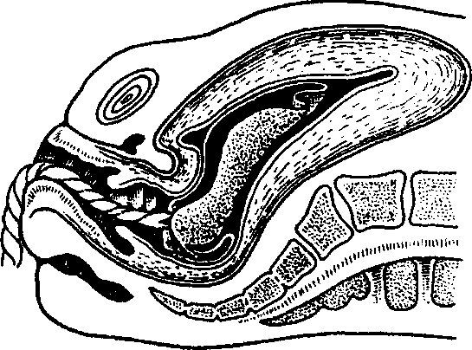
(the Duncan's mechanism)
86

Chapter 7. Physiological Delivery
The mechanisms of normally located placenta detachment may be different. Detachment of placenta from the centre with formation of a retroplacental hematoma and birth with fetal surface outside is called the Schultze's mechanism (Fig. 45, 46). If the placenta scales off not from the centre but from a side, such detachment mechanism is called the Duncan's mechanism (Fig. 47, 48).
Integrity of the born placenta is detected visually.
Loss of blood at the placental stage, which does not exceed 0.5 % of the parturient woman's weight, is considered physiological. The only objective method of blood loss calculation is its measurement.
7.3. METHODS OF EXAMINING PARTURIENT WOMEN DURING DELIVERY
External Methods of Evaluating the Degree of Cervical Dilation
It is possible to assess the degree of cervical dilation by means of external methods only approximately: the degree of cervical dilation during delivery is judged by the height of contraction ring standing (the boundary between the contracting empty muscle and the lower segment of the stretching uterus). During delivery the uterine neck is usually dilated as much as many finger breadths the contraction ring is located above the pubic arch.
Internal Methods of Evaluating the Degree of Cervical Dilation
In order to detect the dynamics of cervical dilation and location of the fetal head during delivery internal obstetric examination is conducted, which is performed when the woman is delivered to the maternity department, in every 4 hours during the first period of delivery and after amniotic fluid discharge (for the timely diagnostics of possible prolapse of the umbilical cord and small parts of the fetus with amniotic fluid flow).
The degree of the head fitting also may be detected by external and internal methods.
Detecting the Degree of Head Fitting by External Methods
The degree of head fitting may be detected by the 4th Leopold's maneuver (see the chapter Pregnant Women Examination).
87
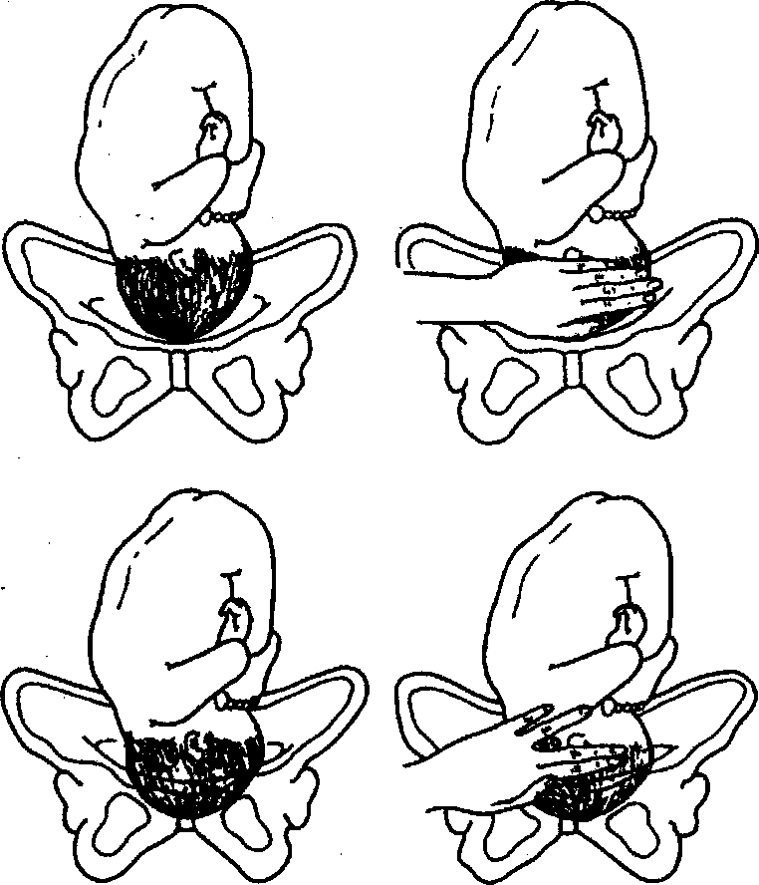
PHYSIOLOGICAL OBSTETRICS
Fig. 49. Detecting the degree of head advancement into the pelvic cavity by the method of abdominal palpation:
5/5 — the fetal head is located above the symphysis by the breadth of 5 fingers, the fetal head is above the pelvic inlet;
4/5 — the breadth of 4 fingers, the head is pressed to the pelvic inlet;
3/5 — the breadth of 3 fingers, the head is in the pelvic inlet with its small segment;
2/5 — the breadth of 2 fingers, the head is in the pelvic inlet with its large segment;
1/5—0/5 — the breadth of 1 finger, the head is in the pelvic cavity.
External palpation of the head is to be conducted right before internal obstetric examination. This allows avoiding mistakes in detecting the position of the head in case of the formation of a large edema of the presenting part of the fetal head.
88
Chapter 7. Physiological Delivery
The method of abdominal palpation is also recommended, which detects the height of fetal head sanding by the number of finger breadths above the symphysis (Fig..49):
Detecting the degree of fetal head fitting by the method of internal obstetric examination (Fig. 50).
- The head above the pelvic inlet. The pelvis is free, the head is located high, it does not prevent the palpation of the innominate pelvic line, promontory; the sagittal suture is in the transverse dimension at the same distance from the symphysis and promontory, the large and small fontanels are at one level.
- The head is in the pelvic inlet with a small segment. The hollow of the sacrum is free; the promontory may be approached with a bent finger (if it is reachable). The internal surface of the symphysis is accessible to examination, the small fontanel is lower than the large one. The sagittal suture is in slightly oblique dimension.
- The head is in the pelvic inlet with a large segment. The head takes the upper third of the symphysis and sacra. The promontory is inaccessible, the ischial spines are easily palpable. The head is flexed, the small fontanel is lower than the large one, the sagittal suture is in one of oblique dimensions.
- The head is in the broad part of the small pelvis. The head has gone through the pelvic plane of greatest dimensions with its largest circumference. Two thirds of the symphysis pubis and the superior half of the hollow of the sacrum are taken by the head. The 4th and 5th sacral vertebrae and ischial spines are easily palpable. The small fontanel is lower than the large one, the sagittal suture is in one of oblique dimensions.
- The head is in the narrow part of the small pelvis. Two upper thirds of the hollow of the sacrum and the whole internal surface of the symphysis pubis are taken by the head. The ischial spines are difficult to reach. The head is close to the pelvic floor, its internal turning is not finished yet, the sagittal suture is in one of oblique dimensions, close to the direct one. The small fontanel is lower than the large one by the womb.
- The head is in the pelvic outlet. The hollow of the sacrum is completely filled with the head, the ischial spines are not detected, the sagittal suture is located in the direct dimension of the pelvic outlet. The small fontanel is lower than the large one by the womb.
Internal examination may also detect the position of the head by relation to the level of the ischial spines — linia interspinalis ("0" position). The distance from the ischial spines to the area of brim equals
89
PHYSIOLOGICAL OBSTETRICS

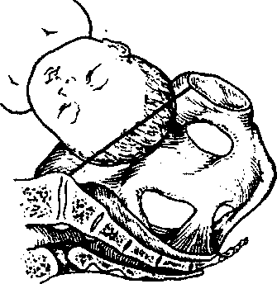
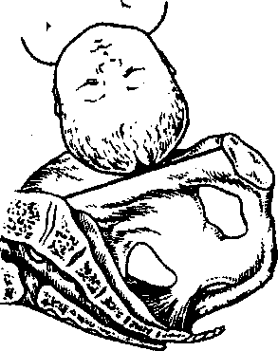
a

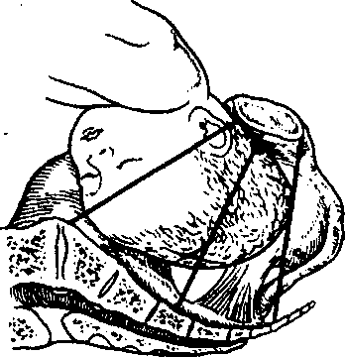
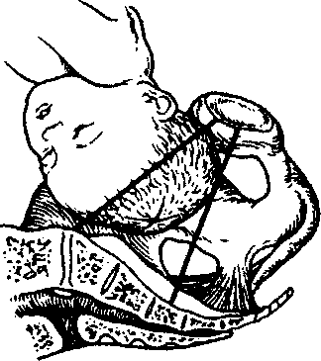

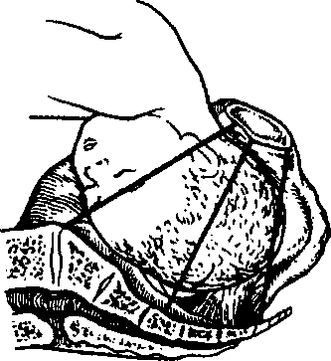
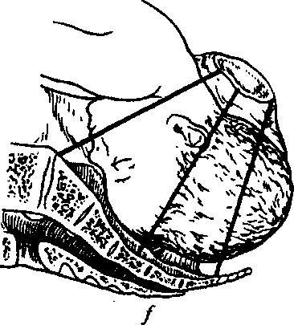
Fig. 50. Position of the fetal head as it moves along the maternal passages:

a — above the pelvic inlet; b — pressed to the pelvic inlet; c — with its small segment in the pelvic inlet; d — with its large segment in the pelvic inlet; e — in the cavity of the small pelvis;/— in the pelvic outlet
90

Chapter 7 . Physiological Delivery

Fig. 51. Detecting the position of fetal head relative to the interaxial line
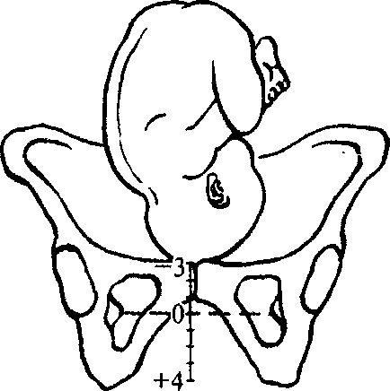
(stippled):
-3 — the head is above the pelvic inlet;
-2 — the head is pressed to the pelvic
inlet;
-1 — the head is in the pelvic inlet
with its small segment;
0 — the head is in the pelvic inlet with its large segment;
+ 1 — the head is in the broad part of the small pelvis;
+2 — the head is in the narrow part of the small pelvis; +3 — the head is in the pelvic outlet
the distance from the spines to the area of pelvic outlet. The sign "-" means that the head is above the ischial spines (closer to the pelvic inlet). The sign "+" means that the fetal head is lower than the ischial spines (closer to the pelvic outlet).
Position of the head is detected in the way shown in Fig. 51.
Fetal Condition Assessment during Delivery
Fetal condition is detected by the indices of heartbeats, amniotic fluid color, head configuration.
Fetal heartbeats are registered by means of periodic auscultation with the help of the fetoscope, manual Doppler analyzer or, by indications, fetal monitoring (cardiotocography) (see the chapter Pregnant Women Examination).
Periodic auscultation is conducted every 15—30 min according to the following rules:
- the pregnant woman is in the position on one side;
- auscultation is began right after the most intensive phase of contraction;
- auscultation lasts for 60 sec.
If there are any auscultative violations of fetal heartbeats, a car-diotocographic investigation is carried out.
Amniotic fluid is detected during its discharge and during each internal obstetric examination. Normally amniotic fluid is transparent. Appearance of fresh meconium in the amniotic fluid testifies to the

91

PHYSIOLOGICAL OBSTETRICS
impairment of fetal condition, especially in combination with fetal heart rate violation.
Fetal head configuration is the process of its adjustment to the maternal passages. Due to the presence of sutures and fontanels the cranial bones of the fetus can approach and cover one another, which leads to fetal head volume reduction. There are differentiated three ■ degrees of fetal head configuration:
- the first — the cranial bones are close, touch one another;
- the second — the bones gradually cover one another;
- the third — the bones considerably cover one another.
The third degree of head configuration in combination with the absence of head advancement along the parturient canal in the presence of active birth activity is a pathology.
The woman's condition is controlled by means of registering the following indices: pulse and arterial pressure (every 2 h), temperature (every 4 h), urine: volume, presence of protein or acetone — by indications (every 4 h).
7.4. CLINICAL COURSE AND MANAGEMENT OF THE FIRST DELIVERY STAGE
Observation over the course of the first period of delivery, condition of the mother and fetus is conducted with the help of a partogram (partograph).
Peculiarities of Partogram Conducting
The following indices are graphically represented on the partogram relative to the time axis:
1. Delivery course:
- the degree of cervical dilation detected by the method of internal obstetric examination (every 4 h);
- fetal head descending detected with the help of abdominal palpation (every 4 h);
- frequency (in 10 min) and duration (in seconds) of contractions (every 30 min).
2. Fetal condition:
- fetal heart rate evaluated by the method of auscultation or manual Doppler analyzer (every 15 min);
- the degree of fetal head configuration (every 4 h);
- condition of the fetal sac and amniotic fluid (every 4 h).
92
Chapter 7. Physiological Delivery
3. Condition of the parturient woman:
- pulse and arterial pressure (every 2 h);
- temperature (every 4 h);
- urine: volume, presence of protein and acetone — by indications (every 4 h).
A partogram scheme is shown in the Fig. 52. Partogram advantages:
- effective observation over delivery course;
- timely detection of delivery deviations from the normal course;
- rendering help in the process of making decision concerning necessary and sufficient interventions.
Special attention should be paid to the principles of managing the first period of delivery, which foresee measures aimed at psychological support of the parturient woman — partner delivery (presence of the husband or family members, in certain cases of close friends), prophylaxis of the woman's fatigue, fetal condition violation, avoiding traumatism of the mother and fetus in the course of delivery. An obligatory moment of labor management is that the woman chooses position herself (sitting, standing, forward inclination, lying on one side, etc.; Fig. 54); the position on the back is not advisable as it promotes the formation of aortocaval compression, circulatory disturbance in the uterus, negatively influences the general condition of the parturient woman, leads to sharp decrease of arterial pressure and fetal condition derangement. Besides, the position on the back reduces the intensity of uterine contractions and negatively influences the course and duration of delivery. The most justified in the first period of labor is active behaviour of the woman, which accelerates the process of cervical dilation, reduces labor pains and the frequency of fetal cardiac abnormalities.
7.5. CLINICAL COURSE AND MANAGEMENT OF THE SECOND DELIVERY STAGE
Management of the second stage of delivery demands:
- taking arterial pressure and pulse of the parturient woman every 10 min;
- control of the fetal heart function every 5 min during the early stage and after every second contraction during the active phase;
- control of fetal head advancement along the maternal passages, which is conducted with the help of internal obstetric examination every hour.
93
PHYSIOLOGICAL OBSTETRICS

 | PARTOGRAPH
Name | Gravida Para Hosoittl'no.
Date of admission | Time of admission Ruptured membranes | hours

180 170
r . ^{,6}°
fetal i5o
heart mq
rale 130
120
110
100
10
Cervix (cm) [Ptotxj
T
Descent 3 of head [PW10| Z
1
1 Hpw»0
Tmt

~r | T | :: ~ :_::r „ | r | , i , | : ii
| | r"r | T, X-. | I | t | t
| | ¹ I |  | I | i | i
1 | | | 1 j | { | T | t
j |  | j | l | | *
I | I | I ■ ■ | t | t
 | 1 | i | ---j. . | T | I
ZZ'Jl | x | i | ::± | I | f

 |  |  |  |  |  |  |  |  |  |  |  |  |  |  |  |  |  |  | j |  | 1 |  |  |  |  |  |  |  |  |  |  |  |  |  |  |  |  |  |  |  | i f |  | 1
 |  |  |  |  |  |  |  |  |  |  |  |  |  |  |  |  |  |  | 1 |  |  |  |  |  |  |  |  |  |  |  |  |  |  |  |  |  |  |  |  |  |  |  | I
 |  |  |  |  |  |  |  |  |  |  |  |  |  |  |  | Act |  | 1 wPn*»
 |  |  |  |  |  |  |  |  |  |  |  |  |  |  |  |  |  |  |  |  |  | f |  |  |  |  |  |  |  | ¥
 |  |  |  |  |  |  |  |  |  |  |  |  |  |  |  |  |  |  |  | V |  | f |  |  |  |  |  | *
 |  | L |  | j tent |  | Plan |  | 1
1 |  | ? |  | 3 |  | 4 |  | -J |  | « |  | 7 |  | ? |  | s |  | _ifi | it | _!i |  | 1? |  | 14 |  | »$ |  | *J& |  | 17 |  | H |  | 19 |  | _ZS |  | ?' |  | ?? |  | ?3 | ?<

s
Contractions per 10 trims
4 3
2 I
OnytocjnlHl dfoos/min

 |  |  |  |  |  |  |  |  |  |  |  |  |  |  |  |  |  |  |  |  |  |  |  |  |  |  |  |  |  |  |  |  |  |  |  | 1
 |  |  |  |  |  |  |  |  |  |  |  |  |  |  |  |  |  |  |  |  | J |  |  |  |  |  |  |  |  |  |  |  |  |  |  | 1
 |  |  |  |  |  |  |  |  |  |  |  |  |  |  |  |  |  |  |  |  | I |  |  |  |  |  |  |  |  |  |  |  |  |  |  | 1
 |  |  |  |  |  |  |  |  | 1 |  |  |  |  |  |  |  |  |  |  |  |  |  |  |  |  |  |  |  |  |  |  |  |  |  |  | j
 |  |  |  |  |  |  |  |  | 1 |  |  |  |  |  |  |  |  |  |  |  | 1 |  |  |  |  |  |  |  |  |  |  |  |  |  |  | 1
 |  |  |  | 1

Drugs given and IV fluids
ISO
170
-. 180
Putee • 150
140 130 120 110 100 90 80 70 60
and BP

'"■ "—
::"_:;:_:_::::_"__:i~: ::::::::::::::::::r-::::

Temp*C

, protein
Urine | Ketone
*■ volume
Fig. 52. A partogram scheme
94

Chapter 7 . Physiological Delivery
Because of the increase of the risk of ascending infection of the parturient canal additional obstetric examinations in the second period of delivery are permissible only by indications:
- conducting amniotomy if there is no timely amniotic fluid discharge;
- at multifetation after the first fetus is born;
- when the decision about operative vaginal delivery is taken (obstetric forceps, vacuum extraction, extraction of fetus by the pelvic pole).
The birth of the fetal head requires cautious manual aid aimed not
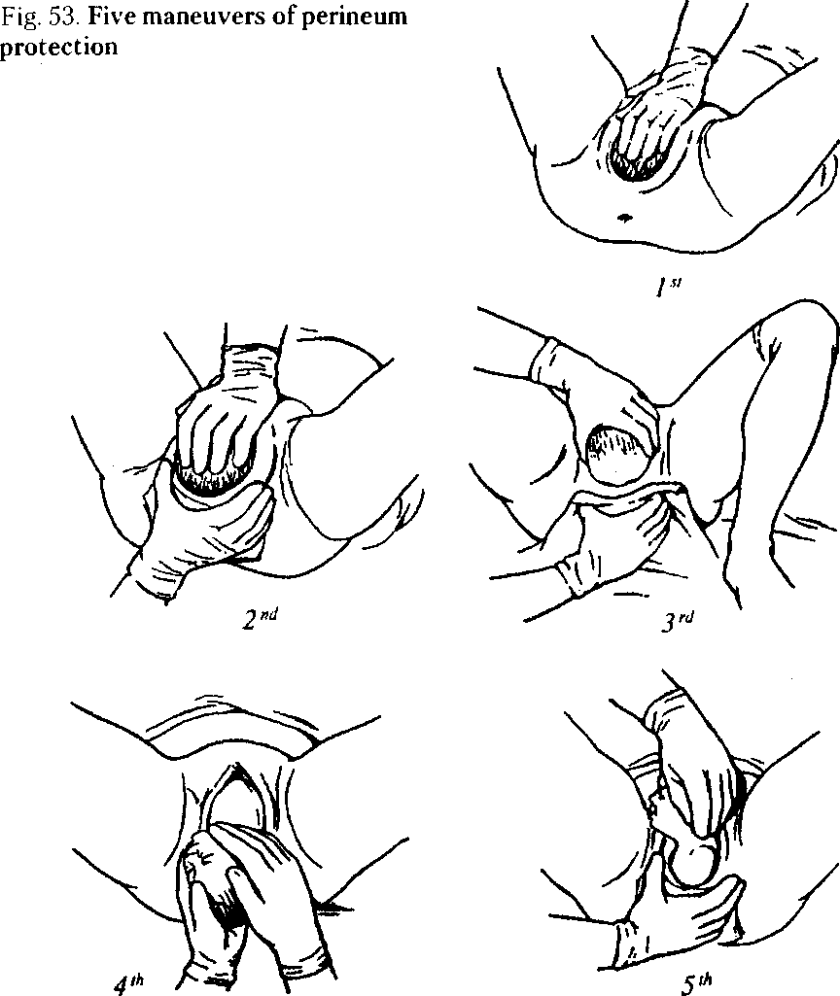
95
PHYSIOLOGICAL OBSTETRICS
only at the preservation of the integrity of the woman's perineum, but also prevention of intracranial, spinal, and other injuries of the fetus. Perineum protection consists of five maneuvers (Fig. 53):
- Prevention of premature deflexion of the fetal head — the palm of the left hand rests against the pubis, the fingers restrain rapid advancement of the head, carefully pressing it.
Fig. 54. Various positions of parturient women at the 1st stage of delivery
- Reduction of perineum tissue tension — the palmar surface of the right hand is located on the perineum, tissues of the large lips of pudendum are moved to the side of perineum with fingers.
- Taking the fetal head out of the pudendal fissure — after the point of fixation is formed, out of contraction, carefully removing lateral edges of the vulvar ring from the head, giving it a possibility to extend.
- Help during internal turning of the shoulders and external turning of the head — the born head is grasped with both hands in such a way that palms are on the area of ears; the head is carefully pulled down till the anterior shoulder gets under the pubic arch.
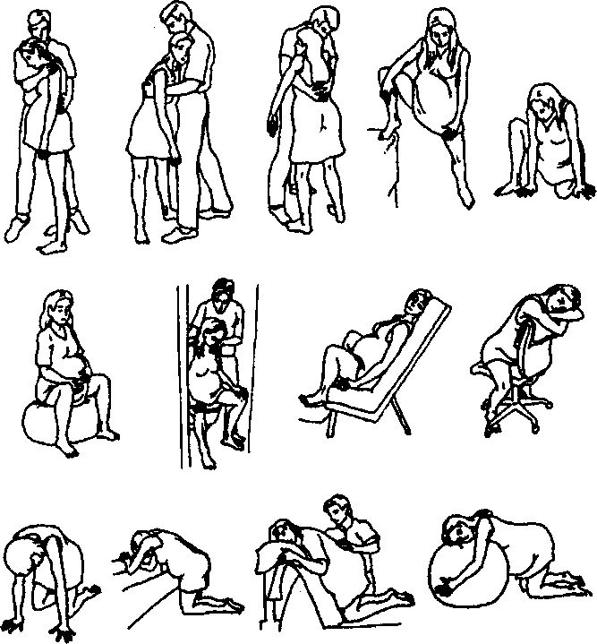
Chapter 7.. Physiological Delivery
5. Release of the shoulder girdle — the head is grasped with the left hand and drawn aside to the womb, perineum tissue is carefully taken off the posterior shoulder.
When the fetal shoulder girdle is born, the child's body is grasped with both hands, the fingertips must be in the fetal armpits. The fetal body is directed upwards, the fetus is taken out.
There exists tactics of managing the second stage of delivery without perineum protection. Giving free position to the woman during contractions promotes more dynamic passage of the fetus through the maternal passages; the most effective positions are the crouched position, sitting on a chair, standing, pulling up on a ladder, lying on one side (see Fig. 54).
It is important to emphasize that only in case of necessity during the stage of expulsion auxiliary perineum dissection is performed (perineo- and episiotomy).
Indications to perineum dissection (WHO):
- complicated vaginal delivery (vacuum extraction, obstetric forceps, breech presentation);
- presence of cicatricial changes of the perineum after dissection in previous delivery, especially after poor regenerative process;
- fetal distress.
According to modern scientific proofs episiotomy application by the indications of "perineal rupture threat" is not always grounded. The absence of clear objective criteria of "perineal rupture threat" is the basis for a wider usage of episiotomy, which is no other than 2nd degree iatrogenic perineal rupture. In most cases, when in the presence of so-called "perineal rupture threat" the perineum is not dissected, there takes place a spontaneous rupture only of the skin of perineum and vaginal mucosa, without any affection of the pelvic floor muscles (1st degree rupture).
It should also be recognized that in a number of cases the perineum is really a substantial obstacle for delivery and its dissection is a necessary measure of preventing severe ruptures. The decision to conduct the operation must be clinically grounded and agreed with the woman. The operation is to be conducted after preliminary local anesthesia.
Fetal Condition Assessment
Fetal condition is assessed by the Apgar score in 1, 5, and 10 min after birth. The score foresees assessment of five indices by a ten-point system (0—2 points for an index): heart rate, respiration, cutaneous co-
97
PHYSIOLOGICAL OBSTETRICS
verings, muscle tone, and reflexes. A good index is fetal condition at the assessment of not less than 8 points, satisfactory. — not less than 7, lower assessments testify to possible asphyxia of different degrees of severity.
If fetal condition is satisfactory, the child is put on the mother's abdomen, dried with a dry diaper, and covered with another dry diaper.
In 1 min after birth the umbilical cord is clamped and cut. If it is necessary, mucus is removed from the oral cavity with a bulb or an electrical suction unit. A hat and socks are put on.
If the child's condition is satisfactory, it is put on the mother's breasts and covered with a blanket together with the mother to provide conditions for the "thermal chain". The contact "skin to skin" leads to the activation of the child's sucking reflex and promotes early breast-feeding (during the first 2 h). After this the umbilical cord is processed, the child is loosely diapered and placed together with the mother.
Dynamic observation over the condition of the child and parturient woman, uterine contractions, character of discharge from the maternal passages is obligatory as well as taking body temperature of the newborn during the first 30 min with writing down into the newborn's development card. A necessary condition is following the temperature regime in the labor ward, where temperature must be not lower than 25 °C.
Ophthalmia prophylaxis in all newborns during the first hour of life is conducted with application of 0.5 % erythromycin or 1 % tetracycline ointment.
In 2 h after birth the child is dressed (not diapered!) and together with the mother transferred to the postnatal department for room-ing-in.
7.6. CLINICAL COURSE AND MANAGEMENT OF THE THIRD DELIVERY STAGE
There are two types of tactics of managing the third delivery stage: active and expectant.
Active Management of the Third Delivery Stage
Due to a number of advantages the active management of the third delivery stage is the most wide-spread tactics in the world and
Chapter 7. Physiological Delivery
is recommended by the WHO, International Federation of Gynecology and Obstetrics and International Confederation of Midwives.
Application of the technique of active management of the third delivery stage during every delivery allows reducing the frequency of postpartum hemorrhage caused by uterine insufficiency by 60 %, and also reducing the quantity of postpartum blood loss and transfusion necessity.
Standard components of the active management of the third delivery stage include:
- uterotonics introduction;
- placenta delivery by way of controlled tractions by the umbilical cord at drawing the uterus aside from the womb;
- massage of the uterus through the anterior abdominal wall after the placenta is born.
Rules of uterotonics introduction: during the first minute after the child's birth the uterus is to be palpated to exclude the presence of another fetus in it; if a fetus is present — 10 IU of oxytocin is introduced i.m. Oxytocin is a predominant uterotonic since its effect is evident already in 2—3 min, it may be used in all women.
If there is no oxytocin, ergometrine may be introduced — 0.2 mg i.m.
The woman must be informed about possible side effects of these drugs.
Ergometrine can not be used in women with preeclampsia, eclampsia, and hypertension.
Controlled tractions by the umbilical cord (Fig. 55):
- the umbilical cord is to be compressed with a clamp closer to the perineum; the umbilical cord and clamp are held in one hand;
- the other hand is put directly above the woman's pubis, the uterus is held drawing it aside from the womb;
- the umbilical cord is slightly tightened, then one waits for a strong uterine contraction (usually in 2—3 min after oxytocin introduction);
- simultaneously with a strong uterine contraction the woman is offered to bear down strongly, the umbilical cord is very carefully pulled down (traction) for the placenta to be born, simultaneous countertraction is continued with the other hand in the direction opposite to the traction (i.e. pushing the uterus away from the womb);
- if the placenta does not descend (is not born) during 30— 40 sec of controlled traction, the traction by the umbilical cord is to be stopped, but the cord must be held in the state of light tension, the other hand remains above the womb, holding the uterus;
99
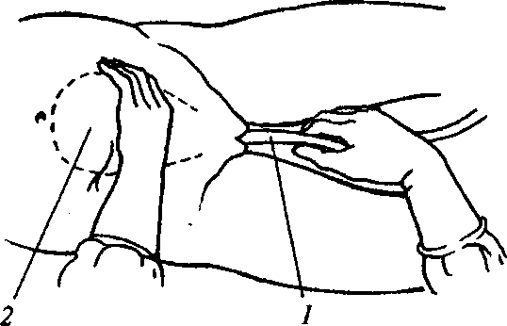
PHYSIOLOGICAL OBSTETRICS
Fig. 55. Placenta delivery by controlled tractions:
7 — umbilical cord; 2 — body of uterus
— one should wait till the uterus contracts again and repeat controlled traction by the umbilical cord with countertraction onto the uterus.
One must never conduct traction by the umbilical cord without applying countertraction of the well-contracted uterus above the womb. Conducting traction by the umbilical cord without uterine contraction may lead to uterus inversion.
After the placenta is born, it is held with both hands and carefully rotated, twisting the membranes, then it is carefully pulled down for labor termination.
In case of membranes rupture the vagina and uterine neck are carefully examined in sterile gloves. If membranes are detected, a fenestrated clamp is used to remove their remains.
The placenta is carefully examined to make sure it is intact. If the area of maternal surface is absent or there is an area of torn membranes with vessels, it is a reason to suspect retention of placenta parts and begin necessary measures.
Massage of the uterus: after the placenta is born the uterus is immediately massaged through the anterior abdominal wall till it becomes dense.
Further on the uterus is palpated every 15 min during the first 2 h to make sure that after massage the uterus is not relaxing and stays dense. In case of necessity repeated massage is conducted.
An ice pack is not put onto the lower part of the abdomen in the early puerperal period.
100
Chapter 7. Physiological Delivery
The active management of the third stage of delivery must be offered to every woman since it reduces the frequency of postnatal hemorrhages caused by uterine insufficiency.
The parturient woman must be informed about the active management of the third stage of delivery and give written consent to it.
Expectant Management of the Third Delivery Stage
After the umbilical cord pulsation is over, but not later than 1 min after the child is born, the umbilical cord is clamped and cut. The general condition of the parturient woman, signs of placenta detachment, quantity of bloody discharge are thoroughly observed.
If any signs of placenta detachment appear, the woman must be offered to bear down, which will lead to the birth of the placenta.
The signs of placenta detachment are:
The Schroder's sign: if the placenta has detached and descended into the lower segment or vagina, the uterine fundus elevates and locates above and to the right of the navel; the uterus acquires the from of an hourglass.
The Chukalov—Kiistner's sign: when the suprapubic area is pressed with the edge of hand the uterus elevates and the umbilical cord is not pulled into the vagina if the placenta is detached (Fig. 56).
The Alfeld's sign: the ligature, which is on the umbilical cord by the pudendal fissure of the parturient woman, in case of placenta detachment descends by 8—10 cm and lower than the vulvar ring.
The Dovzhenko's sign: the woman is offered to breathe deeply: if the umbilical cord is not pulled into the vagina at expiration, the placenta has detached.
The Klein's sign: the parturient woman is offered to bear down, if the umbilical cord is not pulled into the vagina, the placenta has detached.
To remove the placenta, which has detached, external methods are applied.
The Abuladze's method. After the urinary bladder is emptied the anterior abdominal wall is taken into a fold in such a way to grasp the rectus abdominal muscles. After this the parturient woman is offered to bear down: the placenta is easily born due to considerable reduction of abdominal cavity volume (Fig. 57).
The Crede—Lazarevich's method is conducted in the following sequence (Fig. 58):
101
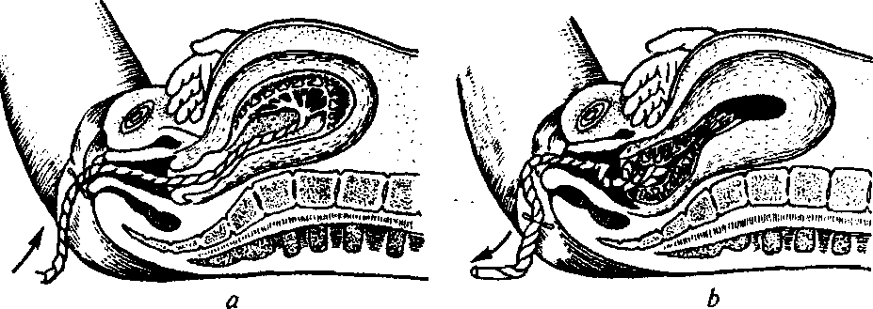
PHYSIOLOGICAL OBSTETRICS
Fig. 56. Chukalov—Kustner's sign:
a — placenta has not detached; b — placenta has detached
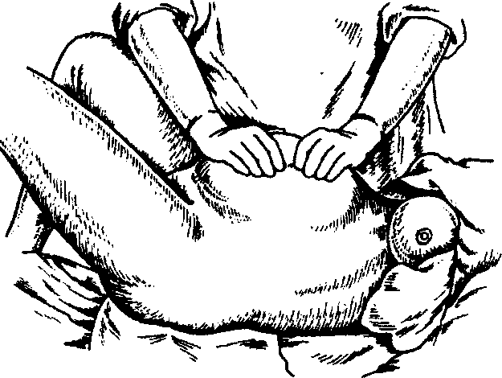
Fig. 57. Abuladze's method of placenta extraction
- the urinary bladder is emptied;
- the uterine fundus is brought into the median position;
- the uterus is lightly stroked for the purpose of its contraction;
- the uterine fundus is grasped with a hand in such a way that the palmar surfaces of its four fingers are located on the posterior uterine wall, the palm is on the uterine fundus, and the thumb — on the anterior uterine wall;
- the uterus is pressed with the whole palm in single stage in two directions (the fingers — front-back, the palm — top-down) to the pubis till the placenta is born from the vagina.
102
Chapter 7 . Physiological Delivery

Fig. 58. Crede—Lazarevich's method
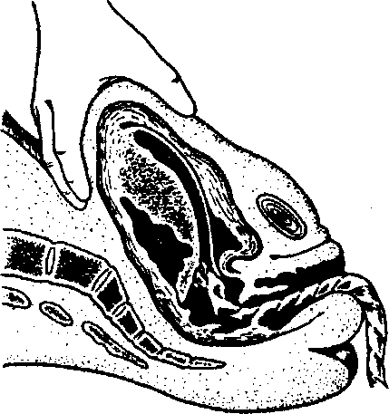
If there are no signs of placenta detachment and external hemorrhage during 30 min after the fetus is born, the placenta is detached and extracted manually.
If hemorrhage begins, manual detachment and extraction of the placenta must be conducted immediately under adequate anesthesia.
After the placenta is extracted it must be thoroughly examined (to make sure the placenta and membranes are intact).
On average the total duration of delivery makes 8—12 h in para I and 6—8 h in para II.
Examination of the maternal passages after delivery (with the help of vaginal specula) is performed only in the presence of hemorrhage, after operative vaginal delivery or if the doctor is not sure the maternal passages are intact (accelerated labor, labor outside a medical establishment).
103

DELIVERY PAIN RELIEF
Delivery pain relief is one of important questions of anesthetic management in obstetrics.
Delivery pain relief not only provides comfort for the mother and fetus, but also allows preventing the development of many complications during delivery and in the puerperal period, arising in response to pain syndrome and stress (heart rate disturbance, coronary blood flow decrease, respiratory impairment, uteroplacental blood flow decrease, disturbance of the contractive activity of the uterus, fetal distress).
8.1. METHODS
OF DELIVERY PAIN RELIEF
Despite the diversity of delivery pain relief methods (Table 4), there is no universal one.
Delivery pain relief methods are chosen individually in each case taking into consideration the following factors:
- presence of pregnancy complications or an extragenital pathology in the parturient woman;
- condition of the fetus;
- obstetric situation;
- experience of the obstetrician-gynecologist and anesthesiologist.
The necessary conditions to induce obstetric anesthesia are:
- safety for the mother and fetus;
- anesthesiologist's perfect knowledge of the chosen anesthetic technique;
- permanent monitoring of the mother's and fetus' condition;
- availability in the delivery room of the necessary medications and equipment providing the full amount of intensive care and resuscitation in case of complications;
- consent of the parturient woman to the anesthetic technique.
104
Chapter 8. Delivery Pain Relief
Table 4 . Obstetric Anesthetic Techniques

Nonmedicamentous obstetric anesthetic techniques
Techniques reducing painful stimuli | Techniques activating peripheral receptors | Techniques blocking painful impulses
— psychoprophylaxis;  — freedom of movements;  — support of medical staff  and relatives during  delivery;  — abdominal decompression | — external heat and cold;  — hydrotherapy;  — massage, acupuncture,  acupressure;  — transcutaneous  electrical stimulation | '— fixing and distracting attention;  — electroanalgesia;  — music and audio-  analgesia;  — homeopathy
Medicamentous obstetric anesthetic techniques
Noninhalation anesthesia | Inhalational anesthesia | Regional  and local anesthesia
8.2. NONMEDICAMENTOUS OBSTETRIC ANESTHETIC TECHNIQUES
Psychoprophylactic methods, which also include psychological antenatal preparation, are important for successful labor management.
Psychoprophylactic preparation aims at removing the psychogenic component of pain, promoting the creation of a new idea of delivery as a favorably running physiological process, which is not necessarily accompanied by pain, and eliminating the idea of its inevitability.
Psychoprophylactic preparation begins 6—8 weeks before delivery. It includes information about the normal anatomy and course of pregnancy, labor biomechanism, which allows reducing apprehension. Pregnant women are taught to react correctly to the beginning of birth activity, breathe correctly during parodynia, control the process of child-bearing. The patient forms positive emotions connected with the forthcoming labor and the birth of the child.
The presence of the husband or another familiar person is a positive psychological moment. It is advisable for the pregnant to get acquainted with the doctor and obstetrician, who are to manage the delivery, beforehand.
During delivery the parturient woman should concentrate her attention on some object, music, conversation with medical staff or a
105
PHYSIOLOGICAL OBSTETRICS
close person. All this distracts her attention and does not allow concentrating on pain.
Music has been proved to promote endorphine production and in such a way to reduce pain, distract attention, promote rhythmicity of breathing, relaxation. Currently, audioanalgesia is successfully used by some maternity obstetric services.
Attention should be paid to the methods'activating peripheral receptors, particularly heat baths, hydrotherapy, acupuncture, and acupressure. Under the influence of heat baths thermal and tactile receptors of skin are activated, which inhibits impulsing to the cortex. Hydrotherapy reduces pain, provides relaxation, reduces physiological tension and pressure on the abdominal muscles, improves oxygenation.
Disadvantages of labor in water include difficulties of providing aseptics, monitoring the contractive activity of the uterus, condition of the fetus, the moment of amniotic fluid discharge.
Massage during delivery is widely practiced in some countries. Different types of massage stimulate skin receptors. These stimuli are transferred quicker than the painful ones. The action of the "bombing" of the central nervous system reduces pain.
Many clinics use acupuncture and acupressure to anesthetize labor. These methods promote pain control during parodynia, normalize birth activity, and have no negative influence on the fetus. But the absence of qualified specialists limits their usage.
Still, completely painless labor is impossible without the application of an anesthetic technique. Medicamentous anesthesia is recommended in cases when nonmedicamentous techniques do not provide sufficient soothing effect, and especially if complications are present.
8.3. MEDICAMENTOUS OBSTETRIC ANESTHETIC TECHNIQUES
The choice of an obstetric anesthetic technique must be guided by the underlying principles of obstetric anesthesia:
- the used anesthetics must possess a strictly selective effect, without evident narcotic action;
- combination of the analgesic with spasmolytics for the purpose of shortening the duration of delivery, especially of the first stage, is permissible;
- increase of the duration of analgesic effect must be achieved by
Chapter 8. Delivery Pain Relief
means of the combined application of pharmacological agents, capable of potentiation and mutual prolongation of action on the basis of small doses combination;
- the used anesthetic technique should not inhibit uterine contractions and negatively influence the fetus and newborn;
- the method should be easy to control and accessible in any .conditions. " '
The main task of obstetric anesthesia is the achievement of continuous analgesia with consciousness preservation for the parturient woman to take active part in delivery, without negative influence on the organism of the mother and fetus.
It should be remembered that virtually all anesthetic preparations used in obstetrics go through the placenta in varying quantity.
Besides, the fact that newborns, especially premature, have the increased permeability of membranes, hematoencephalic barrier in particular, should be considered. The increased sensitivity of nerve cells to the action of medicinal agents is also noted. Therefore complications to pharmacological preparations, which were given to the mother, are observed in the newborn.
Analgetics classification may be presented in the following way:
1. Narcotic analgesics:
- morphine group preparations and structurally close synthetic compounds (morphine, omnopon, butorphanol, etc.);
- phinilpiperidin derivatives and other opioid synthetic analgesics (promedol, fentanyl, tramadol, etc.).
2. Nonnarcotic analgetics and nonsteroid antiinflammatory agents.
Recently combined preparations are used for anesthetic purposes;
they include nonnarcotic analgesics, spasmolytics, ganglionic blockers, particularly baralgin (spasmolgon, trigan, spasgan).
Among the preparations for noninhalation narcosis in obstetric practice such groups of preparations are presently used:
- Barbiturates. In obstetrics there are used barbiturates of ultrashort action (thiopental sodium, hexenal). Because of the inhibitory action on the respiratory and vasomotor centers they are mostly used for initial narcosis of operative delivery (cesarean section, forceps operation).
- Nonbarbiturate preparations (ketamine, midazolam, propanidid, diprivan).
Inhalation anesthetics include a number of easily vaporable (volatile) liquids (halothane, diethyl ether, methoxyflurane) and gaseous substances (nitrous oxide substantially).
107
PHYSIOLOGICAL OBSTETRICS
It should be noted that inhalation anesthetics are still used to relieve labor pain at the present time by means of applying subnarcotic doses in the form of monoanesthesia or in combination with block or intravenous anesthesia.
Most often labor pain is relieved by the method of intermittent autoanalgesia with the help of special anesthesia apparatus using a combination of nitrous oxide and oxygen. In the mixture nitrous oxide with oxygen in the ratio 1:1 cause analgesia without loss of consciousness and change of reflex excitability, children are born without evident depression. The parturient woman begins to breathe in the mixture when precursors of labor pains appear and stops to breathe it in on the height of the pains or by their end.
Nitrous oxide is a rather weak anesthetic with a high degree of safety (at correct dosage).
Obstetric anesthesia widely uses neuroleptics — butyrfenol derivatives (droperidol).
Benzodiazepine derivatives — sibazon (diazepam, relanium, seduxen, valium), lorazepam (ativan, tavor), mezapam (medazepam, nobri-um) — are applied in obstetric practice for preoperative preparation at cesarean operation, for medication sleep. Sibazon is used in obstetrics the most often.
In practical obstetrics to relieve labor pains there are presently used combinations of various preparations, which provide potentiation and mutual prolongation of action on the basis of small doses combination.
An attempt to achieve complete anesthesia with the help of considerable increase of doses of preparations or decrease of intervals between introductions may lead to powerless labor, hypotonic hemorrhage, depression of the fetus and newborn.
Block Methods of Anesthesia
The need in complete obstetric anesthesia with minimal influence on the organism of the mother and fetus led to the wide usage of block anesthetic techniques in obstetric practice.
By the way of introducing preparations block anesthetic techniques are divided into epidural, caudal, and spinal anesthesia (analgesia).
Epidural (peridural, extradural) anesthesia is a variety of block anesthesia, which is achieved by the introduction of concentrated so-
108
Chapter 8. Delivery Pain Relief
lutions of local anesthetics into the epidural cavity leading to the blockade of the spina) nerves and their roots. Thus, segmental muscle relaxation and sympathectomy are the components of the obtained blockade. Introduction of weak solutions of local anesthetics, narcotic analgesics and other preparations possessing analgesic activity or a combination of these preparations achieves analgesia only. Introduction of weak solutions of local anesthetics is also accompanied by the blockade of thin sympathetic fibers.
Caudal (sacral) anesthesia is a variety of epidural anesthesia, at which solution of local anesthetic is introduced into the sacral canal.
Spinal (subarachnoid, intrathecal) anesthesia is a variety of block anesthesia achieved by the introduction of weak solutions of local anesthetics into the subarachnoid cavity, which leads to the blockade of all types of somatic and vegetative sensitivity and is accompanied by regional muscle relaxation and sympathectomy.
Epidural anesthesia (EPA) has the biggest advantages among the described methods.
If cesarean operation is necessary, already conducted EPA allows conducting the operation immediately.
EPA is successfully conducted at a delivery complicated by premature discharge of amniotic fluid, discoordinated labor activity, primary uterine inertia. EPA at pelvic delivery provides sufficient anesthesia and relaxation of the muscles of pelvic floor, reducing obstetric traumatism.
The principle of EPA action: medicinal preparation is introduced into the epidural cavity, the subdural nerves are blocked in the segments T₁₀ and L_{r}
To conduct EPA one uses both local anesthetics and narcotic analgesics (fentanyl, butorphanol).
Presently the most often EPA is conducted with local anesthetics, which cause a reversible block of impulse conduction via the peripheral nerves.
Amide anesthetics (lidocaine, bupivacaine, mepivacaine, ropiva-caine) are the most widely used, among them lidocaine is used the most often.
During delivery the following solutions of anesthetics are used for EPA: 1-1.5 % lidocaine, 2-3 % chloroprocaine, 0.25-0.5 % bupivacaine.
A dose of local anesthetic is selected individually taking into account concentration of the preparation, the necessary level of blockade and individual reaction of the parturient woman to its introduc-
109
PHYSIOLOGICAL OBSTETRICS
tion. It should be added that the usage of hypertensive solutions of local anesthetics is preferable as it provides more long-term anesthesia in comparison with the usage of hypotonic solutions.
To anesthetize delivery modern obstetrics uses both fractional introduction of booster doses of local anesthetics and constant epidural anesthesia (CEPA).
Constant epidural anesthesia is indicated for anesthetization of labor pains during 2 h and more. Introduction of anesthetic into the epidural cavity is carried out with the help of devices, which allow clear dosing of the speed of medicinal agent introduction.
Modern obstetric practice uses subdural anesthesia by means of local anesthetics and narcotic analgesics to anesthetize delivery and cesarean section. Advantages of this method are: relative simplicity of puncture, no need for test-dose, quick onset of analgesia (in a couple of minutes), low risk of postparacentetic headache compared to EPA, the absence of the risk of bodily toxic reactions in case of local anesthetic introduction. The main disadvantages of this method are the higher frequency of arterial hypertension, uncontrollability, and limited duration of anesthesia, the absence of the ability of additional introduction of local anesthetic.
Despite considerable advantages of block methods of anesthesia, block anesthesia may be accompanied by severe complications.
- Arterial hypotension is the most often met complication of block methods of anesthesia.
- Anesthetic gets into the vessels, which is a slow appearance of toxicity, also might be complicated by tonoclonic spasms.
- Accidental perforation of the pachymeninx with a needle or a catheter, which may lead to total spinal anesthesia. There might arise severe hypotension, total muscle relaxation, which is accompanied by ventilation disorders and leads to cardiac arrest.
- Postparacentetic headache may arise at accidental puncture of the pachymeninx during epidural anesthesia, and also at subdural puncture.
- Hyperthermia in delivery, connected with sympathetic block and thermoregulation violation, is not referred to severe complications of EPA.
Chapter 9
PHYSIOLOGICAL PUERPERAL PERIOD
Despite the fact that the puerperal period is a physiological process it - requires from the doctor the knowledge of all its'stages and peculiarities, namely: the processes of involution in the organs and systems of the woman after delivery, lactation, which allows timely detection of initial signs of diseases and complications, which may arise in a parturient woman.
The puerperal period (puerperium) begins right after delivery and lasts during 6 weeks. During this time the organs of the reproductive system of the woman returns to the state, which existed before the pregnancy.
The puerperal period is divided into early and late.
The early puerperal period begins from the moment of placenta expulsion and lasts 2 h. In this period the parturient woman is in the maternity department under doctor's supervision, which is connected with the risk of complications, hemorrhage in the first place. The period is very important and should be viewed as a term of quick adaptation of the woman's functional systems after big load during pregnancy and, especially, delivery.
The late puerperal period lasts from the moment of the parturient woman's transfer to the postnatal department (in 2 h after delivery is completed) during 8 weeks. During this period there takes place the involution of all organs and systems, which have changed because of pregnancy and labor. It should be emphasized that the mammary glands are an exception, whose function is activated exactly in the puerperal period. It should also be noted that the rate of involutional processes is maximal" during the first 8—12 days and are the most expressive in the genitals, the uterus in the first place.
9.1. CHANGES IN THE WOMAN'S ORGANISM IN THE PUERPERAL PERIOD
The uterus. Right after the placenta is born the uterus begins quick contractions and becomes round. Open vessels of the placental part shrink. Right after the placenta is born the uterine body contracts and its fundus is in the middle of the distance from the pubis to the
111
PHYSIOLOGICAL OBSTETRICS
navel, then elevates slightly. The posterior and anterior uterine walls are 4—5 cm thick and adjoin one another; the uterine cavity is lined with the decidual membrane. During the next 2 days the uterine fundus is slightly below the navel; in 2 weeks after delivery the uterus descends below the symphysis. The uterus usually returns to preliminary dimensions in 6 weeks. Uterine involution takes place due to the involution of some.muscles by means of hyaline and fatty degenera-' tion.
During 2—3 days after delivery the decidual membrane remains in the uterus and divides into two layers. The surface layer necrotizes and is released with lochia (postnatal discharge). The basal layer, adjacent to the epithelium, which contains endometrial glands, remains intact and becomes the basis for the regeneration of new endometrium.
Endometrium regeneration takes place during 3 weeks, excluding the placental area. Complete epithelium regeneration in the place of placentation lasts 6 weeks. Violation of regeneration in the placental area may cause postnatal hemorrhages and infections.
The uterine neck. In 10—12 h after delivery the cervical canal of uterus is funnel-shaped, the internal mouth admits 2—3 fingers, and on the 3rd day — 1 finger. On the 8th—10th day after delivery the uterine neck is formed, the internal mouth is closed.
The vagina. In the course of 3 weeks after delivery the vaginal walls remain with edemata, which completely disappear till the end of the puerperal period. Minor injuries of the vaginal mucous tunic regenerate in 5—7 days. The pudendal fissure closes; the muscle tone of the pelvic floor muscles is gradually restored.
The ovaries. In the puerperal period follicles begin to mature. An anovulatory cycle is characteristic, against the background of which there takes place the first menstruation after delivery. Further on ovulatory cycles restore. Due to the discharge of a big quantity of prolactin in women at breast feeding menstruations are absent during a couple of months or during the whole period of breast feeding.
The abdominal wall and pelvic floor. Because of the rupture of elastic fibers of skin and long-term stretch by the pregnant uterus the anterior abdominal wall remains soft and flabby for some time and returns to the normal structure in a couple of weeks. Usually the abdominal wall returns to the preliminary condition, but at muscles atony may remain flabby and weak. Sometimes diastasis recti abdominis is observed. The pelvic floor muscles also gradually restore their tone, but the presence of an injure during delivery may cause muscles slackening and promote the formation of genital hernias (prolapses).
Chapter 9 . Physiological Puerperal Period
The mammary glands. The function of the mammary glands after delivery reaches the highest development. During pregnancy estrogens and progesterone stimulate the growth of the ducts and alveolar system of the mammary glands. Under the influence of prolactin there takes place intensified blood supply to the mammary glands, their intumescence, which is the most evident on the 3rd day after delivery. Lactation happens as a result of complex reflex and hormonal processes. Milk formation is regulated by the nervous system and adeno-hypophysis hormone — prolactin. Besides, the optimal level of insulin, thyreoid and adrenal hormones plays a secondary role in lactation establishment. Sucking stimulates periodic secretion of prolactin and, by reflex, of oxytocin; the latter stimulates milk let-down fro the alveoles of mammary glands ducts. It should be noted that this process also intensifies contractions of the postnatal uterus. In the period till the 3rd day after delivery the mammary glands generate colostrum. Colostrum has a high concentration of proteins, mainly globulins, and minerals, and less — of sugar and fat. Colostrum proteins by their aminoacid composition are in the transient state between the protein fractions of human milk and blood serum, which obviously facilitates the newborn's organism in the period of transition from placental feeding to breast feeding. Colostrum contains a high level of immunoglobulins A, G, M, D, and also T- and B-lymphocytes. This is very important during the first days of the newborn's life, when functions of its organs and systems are still immature and immunity is at the stage of formation. Colostrum converts into mature milk during 5 days. The main components of milk are proteins (albumins, globulins, casein), lactose, water, and fat.
The respiratory system. Since the diaphragm descends after delivery, lung capacity increases, which causes the decrease of respiratory movements number to 14—16 per min.
The cardiovascular and hematopoietic systems. After delivery there arise changes in hemodynamics connected with the elimination of the uteroplacental circulation and discharge of some fluid from the mother's organism. The heart takes its usual position in connection with phrenoptosis. Right after delivery there is noted pulse lability with inclination to bradycardia, ABP may be lowered in the first days after delivery, and further reaches normal indices. In the end of the first week after delivery the volume of circulating blood reduces to normal. Blood indices often do not differ from normal, still, in the early puerperal period considerable granulocytes-dominated leukocytosis is observed — up to 30 • 10⁹/L. The fibrinogen level in the plasma
113
PHYSIOLOGICAL OBSTETRICS
is increased, which should necessarily be taken into account at the prophylaxis of the development of lower extremities phlebitis.
The system of urinary excretion. The renal function is not violated in healthy parturient women; diuresis is normal, may be slightly increased during the first days after delivery. The function of the urinary bladder is rather often disturbed, which is connected with the overexcitation of the sympathetic innervation of the sphincter and relaxation of the urinary bladder caused by its compression between the fetal head and pelvic wall during delivery.
The alimentary organs and metabolism. The digestive system functions normally after delivery. Sometimes bowels atony is observed with constipations. Metabolism is usually increased during the first weeks after delivery, and later — till the 3rd—4th week — normalizes.
The nervous system. After delivery there usually takes place neurosis of different tension, which normalizes during 1—2 days. In this period the parturient woman needs psychological support of the family, friends, and medical staff.
9.2. PUERPERAL PERIOD MANAGEMENT
The physiological puerperal period is characterized by satisfactory condition of the parturient woman, normal body temperature and pulse rate, regular involution of uterus, presence of the normal quantity and quality of lochia, sufficient lactation.
During the first two hours after delivery the woman is in an individual delivery room under the supervision of a midwife and an obstetrician-gynecologist; the husband or a relative may also be present. This time interval is very important, since during it there take place physiological processes of the maternal organism adaptation to the new conditions of existence, therefore it is necessary to create the most comfortable conditions promoting effective adaptation after delivery. This is undoubtedly promoted by the child's staying together with the mother in the contact "skin-to-skin" and early breast-feeding, which in its turn provides the formation of breast feeding, thermal protection of the child, prevention of infections, and development of emotional connection between the child and the mother. The optimal for the mother and child is considered the environment temperature of 25—28°. Later on, if there are no contraindications, the newborn child must stay with the mother twenty-four-hour in one room.
Chapter 9 . Physiological Puerperal Period
Such rooming-in provides the child's feeding on demand, hypothermia and hospital infection prophylaxis.
When the parturient woman is in the labor ward the obstetrician-gynecologist must watch her pulse, arterial pressure, control the condition of the uterus: detect its consistency, dimensions, the height of uterine fundus standing in relation to the symphysis and navel, observe blood discharge from the maternal passages. It should be noted that evaluation of blood loss in the early puerperal period is obligatory. Blood loss measurement is conducted with the help of any graduated glass. Average blood loss at the placental stage of delivery and in the early puerperal period makes 250—300 ml or 0.5 % of the woman's body weight, but not more than 500 ml.
In the early puerperal period one examines the external genitals, symphysis pubis, and perineum. Uterine neck and vagina examination is conducted with the help of specula by indications. If episiotomy was conducted or an injure of the parturient canal took place, the restoration of parturient canal integrity with the application of local anesthesia is obligatory.
In 2 h after delivery the parturient woman and the child are transferred to the postnatal department, where follow-up is carried out. Body temperature must be taken twice a day, in the morning and in the evening; one must also examine the skin and mucous tunics, detect the character and rate of pulse, take arterial pressure regularly. Special attention is paid to the mammary glands — one detects their form, condition of the nipples, presence of fissures, and possible swelling of the glands. In case of lactostasis, expression of breast milk is conducted. The woman is orientated at thorough daily examination of the mammary glands, detecting hardenings; a talk on mastitis prevention is to be given. The newborn is fed according to its needs.
One must daily palpate the parturient woman's abdomen, detect the height of uterine fundus standing, its consistency. The height of uterine fundus standing is measured in cm relative to the symphysis pubis. During the first day after delivery the uterine fundus is located higher than the symphysis pubis by 13—16 cm, during the second day — 10—12 cm, during the third day — 7—9 cm.
The velocity of reparative processes in the uterine cavity is also detected by lochia. Microscopically lochia consist of erythrocytes, fragments of decidual membrane, epithelial cells, bacteria; have a neutral or alkaline reaction. During the first days the presence of blood colors them red (lochia ruba), on the 3rd—4th day after delivery they become lighter (lochia serosa), and on the 8th—10th day, due to the
115
PHYSIOLOGICAL OBSTETRICS
prevailing presence of leukocytes, lochia become yellowish-white (lochia alba).
If there are no deviations from the physiological course of the puerperal period the parturient woman with the newborn is discharged home on the 3rd day under the supervision of an obstetrician-gynecologist of the maternity welfare clinic and a district pediatrician with recommendations including:
- following the rules of personal hygiene;
- following the day regimen, having rest not less than 8 h a day;
- performing special physical exercises of postnatal gymnastics;
- following the diet and eating pattern with an average caloric content of 2,600—2,800 kcal/day, with sufficient quantity of proteins, vitamins, and minerals;
- the possibility of sexual life recommencement is decided individually depending on the woman's condition.
In 3—4 weeks after delivery the woman must undergo a standard examination at the maternity welfare clinic, where her level of health is thoroughly assessed, the question of further course of puerperal period is discussed, and recommendations are provided concerning family planning.
Chapter 10
PHYSIOLOGICAL NEWBORN PERIOD
10.1. NEWBORN CONDITION ASSESSMENT
Primary functional assessment of the newborn's condition is conducted by the Apgar score on the 1st and 5th minutes after birth (Table 5).
Still, if on the 5th minute of life the score does not exceed 7 points, additional assessments should be conducted every 5 min up to the 20th min of life or till double score of 8 and more points.
Satisfactory condition of the newborn is testified to by a score of 8—10 points. A score of 4—6 points testifies to moderate asphyxia, 0—3 points — severe asphyxia.
Table 5 . Detecting the Newborn's Condition by the Apgar Score ^

Symptoms | Points
Symptoms | 0 | 1 | 2
Heart rate (bpm) | Absent | Less than 100 | More than 100
Respiration | Absent | Bradypnoea, irregular | Regular respiratory movements, strong vagi t us
Muscle tone | Weak | Mild flexion of extremities | Active movements
Reflex reaction to catheter introduction | Absent | Grimace | Coughing, sneezing
Skin color | Paleness, cyanosis | Pink body, acrocyanosis | Pink
The modern principles of perinatal help are based on the WHO conception concerning physiological management of pregnancy, delivery, and physiological follow-up of the child with restricted medical interventions without proper indications.
117
PHYSIOLOGICAL OBSTETRICS
If the fetus' condition is satisfactory at birth (the child is full-term — gestational age 37—41 6/7 weeks, clear amniotic fluid, the child is breathing or crying, has pink color of skin and satisfactory muscle tone), the child is put on the mother's abdomen, is dried with a dry diaper and covered with another dry diaper.
Simultaneously the neonatologist (in his absence the obstetrician-gynecologist) conducts the primary assessment of the newborn's condition.
If it is necessary, mucus is removed from the oral cavity with a bulb or an electric suction device. It should be noted that it is not necessary to perform sanation of the upper air passages in most newborns with the help of a catheter — it is enough to remove mucus from the lips and nose with a tissue. It is forbidden to introduce a catheter into the pharyngeal cavity if there are no signs of obstruction, at which pharyngeal cavity sanation is conducted using the guidance of the laryngoscope. It is a zone of hypersensitization and manipulations with its irritation may cause bradycardia, apnea, and hypotension.
Indications to probe introduction into the stomach is suspicion of congenital esophageal atresia, and to gastric contents aspiration — an infection suspected.
If the newborn's condition is satisfactory, the umbilical cord is clamped and cut after its pulsations cessation, but not later than 1 min after birth. After the umbilical cord is cut the child is put on the mother's chest and is covered with a blanket together with the mother. The contact "skin to skin" prevents thermal loss and promotes colonization of the child's organism with the mother's flora. Early breast-feeding not only stimulates the process of lactation, promotes quicker establishment of normal intestinal microflora, but also accelerates placenta removal in reflex way at the expense of endogenous oxytocin.
The contact "skin to skin", if there are no contraindications, is maintained till the realization of the sucking reflex, but not less than 30 min. After this the child is put on the diapering table, the umbilical cord is processed, the measurements of the height, head and chest circumferences, and weighing are conducted, the child is thoroughly examined by the neonatologist. The child is loosely diapered and stays together with the mother till the parturient woman is transferred to the postnatal department (in 2 h after delivery). The prophylaxis of ophthalmia must be conducted in the labor ward with 0.5 % erythromycin or 1 % tetracycline ointment.
Chapter 10. Physiological Newborn Period
It should be noted that the assessment of the newborn's condition by the Apgar score and primary inspection of the newborn are carried out by the neonatologist (or obstetrician-gynecologist). At'any manifestations of violated early postnatal adaptation the obstetrician-gynecologist urgently calls the neonatologist, having provided before his arrival the provision of necessary help to the newborn (in case of necessity with the assistance of the duty anesthesiologist)..
If there is managed a delivery with high and extremely high perinatal and obstetric risk to assure the provision of timely qualified neonatologic help, the neonatologist (if necessary — the neonatolo-gist-resuscitator) are in the labor ward before the beginning of the 2nd stage of delivery.
It should be remembered that the analysis of the family anamnesis (hereditary diseases, cases of perinatal death), mother's anamnesis (age, blood group, rhesus-factor, extragenital pathology, gynecological diseases, peculiarities of the course and results of previous pregnancies), the course of the present pregnancy, the course of delivery are important for the determination of provisional diagnosis and timely successful neonatologic help.
During the primary inspection of the newborn one must pay attention to detecting the presence or absence of congenital pathological states, signs of infection and metabolic disorder in the newborn, gestational age, possibility of transition to lung respiration after birth.
The first standard examination of newborns is conducted by the following scheme:
- general examination;
- inspection of the cardiorespiratory system (one must inspect the skin color, respiratory rate, presence or absence of dyspnea, crepitation, analyze the heart rate and rhythm, the quality of heart sounds, presence or absence of cardiac murmur);
- inspection of the abdomen (palpation and percussion). Normally the liver of the newborn must be by 2—2.5 cm below the costal margin. The spleen is often not palpated;
- examination of the external genitals and rectum;
- examination of the skin;
- palpation of the lymph nodes;
- examination of the extremities, joints, and spine;
- examination of the head, neck, and mouth. The average value of the head circumference of a full-term infant makes 32—38 cm. It is necessary to detect the presence or absence of a cephalohematoma,
119
PHYSIOLOGICAL OBSTETRICS
inspect the cranial bones, sutures, dimensions of the fontanels. Inspection of the mouth is necessary to make sure there is no fissure in the hard and soft palates, gingival fissure, and milk teeth;
- inspection of the eyes;
- neurological examination and analysis of the newborn's behaviour; muscle tone is detected, physiological reflexes are checked: search, sucking, palmooral, grasp, and Moro's.
On the basis of the anamnesis data and primary inspection of the newborn by the neonatologist the initial diagnosis, care regimen, the volume of inspection and treatment are defined.
10.2. ANATOMICO-PHYSIOLOGICAL PECULIARITIES OF NEWBORNS
A newborn (neonatus) is a child from the moment of birth (more exactly from the moment of omphalotomy) till 4 weeks of life.
According to the classification of newborns by gestational age the child born at the term of pregnancy of 37—41 6/7 weeks is considered full-term; 42 and more weeks — overmature] from 22 to 37 weeks — premature.
A full-term child may be mature and immature.
The sings of fetal maturity:
- the height of 50 cm on average (46—55 cm);
- the body weight of 3,200-3,500 g (2,500-4,000 g);
- the chest is convex, the umbilical ring is located in the middle between the womb and xiphoid process;
- the skin is pink, healthy, developed. Vernix caseosa is only in the inguinal folds and axillary creases;
- the fingernails must cover the tips of finger bones;
- the hair on the fetal head is 2 cm long, lanugo is almost absent;
- the auricular and nasal cartilages are tight;
- in boys the testicles are down in the scrotum; in girls the small lips of pudendum and clitoris are covered with the large lips of pudendum.
Unfavorable conditions of intrauterine development caused by somatic diseases of the mother, complicated course of pregnancy may be the reason for the birth of an immature child at the term of more than 37 weeks, including underweight children. In this connection presently there are used the notions "normal weight at birth" — 2,500-3,999 g, "low weight at birth" - less than 2,500 g. The group
120
Chapter 10. Physiological Newborn Period
of premature children includes only the children with the weight less than 2,500 g, born before the 37th week of pregnancy and with symptoms of immaturity.
The newborn's head is rather big, it comprises 1/4 of the total length of the body. The head circumference exceeds the chest circumference by 1—2 cm.
The skin is pink, velvety. The. protective function of the skin is underdeveloped, therefore during the first weeks of life the skin is often the entry of infection. The thermoregulating function of the cutaneous covering is feebly marked, therefore overheating and supercooling happen rather easily.
The muscular system is rather weakly developed.
The skeletal system contains less close substances (salts) and more water. The bones are soft, elastic. The facial bones are firmly jointed, the fontanels (prefontanel and occipital fontanel) and sutures are palpated between the cranial bones. The spine has no curvatures and gradually acquires a characteristic adult form at changes of body positions.
The respiratory apparatus. Respiratory rate in healthy full-term children makes 40—70 per min. Abdominal respiration predominates. Pauses in breathing are characteristic, they last from 1 to 5—7 sec, there are 1—2 of them in 1 min. The volumes of pulmonary and alveolar ventilation are especially low during the first 2—3 days, because of what the high need in oxygen is made up at the expense of higher respiration frequency.
The cardiovascular system. After birth the character of blood circulation changes, which is conditioned by the termination of placental circulation and beginning of pulmonary respiration. The arterial (Botallo's) and venous (Aranzi's) ducts, oval window, and remains of funic vessels are gradually closing, and later obliterate.
The newborn's heart is rather big, its weight makes 0.84 % of the body weight (0.48 % in an adult).
Heart rate is 120— 160 bpm, which is conditioned by a rather small stroke volume, which is established only by the end of the first year of life.
At birth the systolic arterial pressure makes 45 mm Hg, during further days it reaches 60—80 mm Hg; the diastolic pressure at birth makes 36 mm Hg, on the 7th—8th day of life — 46 mm Hg.
The hemopoietic organs. The main hemopoietic organ is the spinal marrow. Besides, additional hematosis foci are detected in the liver, spleen, lymph nodes, etc.
121
PHYSIOLOGICAL OBSTETRICS
Hemoglobin (Hb) concentration is increased to 180—230 g/L, and 3/4 of it are represented with fetal hemoglobin. The number of erythrocytes is usually more than 5 • 10¹²/L, color index is more than 1.
The enumerated peculiarities of blood compensate for hypoxemia arising in delivery.
On the 4th—7th day of life the number of erythrocytes makes 5.110¹²/L and Hb - 186 g/L," and on the 10th day - 498-10¹²/L, 175 g/L.
The total amount of leukocytes in the umbilical blood makes 14 • 10⁹/L with gradual decrease.
The first day of the child's life is characteristic of neutrophilic leukocytosis with a leukogram shift to the left gradually decreases and on the 4th—6th day there is noted the "crossing" of crooked neutro-philes and lymphocytes.
The digestive system. The newborn's digestive system is significantly immature both in functional and morphological respects.
The structure of the mouth cavity is adaptated to the act of sucking.
The muscular layer and elastic tissue of the esophagus are weakly developed, which may cause the reverse motion of food into the mouth cavity.
The capacity of the stomach on the 1st day is 20 ml, but increases to 50 ml till the 5th day.
During the first 3 days after birth there is observed meconium discharge, whose formation in the newborn's bowels begins from the 3rd—4th month of intrauterine life. Then meconium changes to brown or greenish-yellow, and later goldish-yellow porridge-like feces.
During the first 2 weeks the frequency of stool is 6—8 times, and then gradually decreases to 2 times a day.
The urogenital system. The newborn's kidneys are rather big, but the cortical layer and tubules are underdeveloped.
In the first 3 days the number of urinations is 5—7, by the end of the 1st week it increases to 12—20 times a day.
Metabolism. The basal metabolism in newborns is twice as high as in older children.
The endocrine system. Insufficiency of the functional activity of a number of endocrine glands is compensated for at the expense of mother's hormones, which get into the fetal organism through the placenta.
The nervous system. The newborn's brain is developed insufficiently. The cerebral cortex and pyramidal tracts do not have com-
Chapter 10. Physiological Newborn Period
plete differentiation. However, the medulla oblongata is developed very well.
Incomplete development of the central nervous" system in the newborn causes such reflexes, which are noted in adults in pathological states: sucking, lip, and search reflexes, etc.
The immune system is insufficiently mature in newborns. The child gets specific immune factors from the mother, .and the child's organism itself is not ready to a specific response to infection. Nonspecific immune protection is performed by cellular and humoral factors (IgA, IgM, IgG). IgG get from the mother to the fetus through the placenta and during the first weeks of life the level of IgG in the child corresponds to such in the mother. The level of IgA, IgM in the newborn is normally very low. IgA get into the bowels of the child with the mother's milk; colostrum is especially rich in IgA. Own IgA begin producing in the plasmocytes of the intestinal wall of the child in the end of the 1st month of pregnancy. IgM form from the 2nd—3rd weeks of life. Maternal immunoglobulins gradually collapse from the 1st till the 6th months of life, and the synthesis of own IgG in the child reaches the adult level only at the age of 5 years.
10.3. BORDERLINE STATES OF NEWBORNS
These are the states reflecting the process of adaptation to the new conditions of life and, as a rule, take place during the first days of the newborn's life without any therapeutic interventions.
Transient loss of the primary body weight. The maximal loss of the primary body weight is observed in newborns, as a rule, on the 3rd—4th day of life and makes 6 % of body weight on average. The loss of newborn's body weight by more than 10 % during the first week should be considered pathological, which is connected with diseases or a gross error in care.
The reasons for the transient loss of the primary body weight are:
- insufficient obtainment of milk and water during the first days of life (the principal reason);
- meconium discharge;
- falling-off of umbilical cord remain;
— inobservance of the temperature rate, low humidity of air.
Labor tumor. On the presenting fetal part as a result of squeezing
and pressure during passing through the maternal passages there ap-
123
PHYSIOLOGICAL OBSTETRICS
pears a venous stasis, edema (infiltration of the skin and hypoderm). The tissues edema in the region of labor tumor is soft, located superficially, its palpation leaves impressions. The labor tumor is not limited at its spread in the cranial sutures. It disappears during the first 3—5 days of life and does not require any intervention of the neonatologist or surgeon.
Transient hyperthermia and hypothermia appear in a newborn as a result of irregular care. The main reason for transient hyperthermia is insufficient obtainment of water and dehydration.
The signs of transient neonatal hyperbilirubinemia are:
- jaundice onset (moderately evident icteric discolor of the skin) after 36 h of newborn's life. The reason for jaundice, which declares itself during the first 24 h of life, is most often erythrocytes hemolysis as a result of incompatibility by rhesus-factor, blood group, and the deficit of glucose 6-phosphate dehydrogenase;
- the maximal coloring of the skin on the 3rd—4th day of life, with subsequent reduction of jaundice intensity and complete disappearance by the 7th-10th day;
- maximal concentration of indirect bilirubin in the blood serum — 205 micromoles/L, and of direct — 25 micromoles/L;
- large liver mass or enlarged spleen are not observed, there are no changes in urine and feces, there are no deviations in the neurologic status.
In other cases the doctor should immediately find the reason for jaundice with the purpose of taking adequate measures of treatment and complications prevention.
The onset of transient neonatal hyperbilirubinemia is explained by the functional immaturity of the liver. Enzymatic activity of the newborn's liver is insufficient to change indirect bilirubin to direct; the excretory function of hepatocytes is also insufficient.
Sexual crisis observed in newborns is explained by the hormonal influence of the mother's organism.
At sexual crisis there are noted:
- swelling, gradual symmetrical enlargement of the mammary glands without hyperemia and from the 3rd—4th till the 7th—10th day of life;
- discharge from the mammary glands of the secrete reminding colostrum;
- blood-tinged discharge in the volume of 1—2 ml during 1— 2 days.
Chapter 10. Physiological Newborn Period
Erythema toxicum is a polymorphous rash of small red spots or vesicles on infiltrated basis observed during the first 4—5 days after birth, is not marked on the general condition of the newborn and disappears in 2—3 days. Erythema toxicum onset is based on allergic reaction.
Except for the listed ones, there may be observed a number of transient, states connected with the dysfunction of the hypophysis, adrenal glands, thyroid gland and kidneys (oliguria, albuminuria), with dysbolism (hypocalcemia, hypo- and hypermagnesemia, metabolic acidosis), etc.
10.4. NEWBORNS CARE
Newborns care under conditions of the physiological course of postnatal adaptation is carried out in the postnatal department of ro-oming-in. Medical aid to newborns is rendered in the department of neonatal care and treatment of newborns, in the department of the intensive care of newborns (neonatal resuscitation department).
Newborns care is based on the creation of optimally comfortable environmental conditions and provision of the satisfaction of physiological needs in basic ingredients — proteins, lipids, carbohydrates, vitamins, and also in liquid.
When the child is transferred from the labor ward to the postnatal department ofrooming-in it is necessary:
1. To repeat the initial objective examination paying attention to:
- possible suppression of the respiratory function;
- color of skin;
- trembling. If it is present, the level of glucose in blood should be checked;
- hypotension, hypertension;
- congenital pathology.

- After examination to process the skin (with the help of cotton and boiled tap water blood and meconium are removed); in case of need the skin is dubbed with sterilized sunflower oil (olive oil or special children's milk).
- To process the navel. There are a couple of methods of navel processing: the stump of umbilical cord is processed with 70 % etha-nol, and then with brilliant green solution. Ethanol may be substituted with 3 % solution of hydrogen peroxide. The umbilical wound is to be processed with a big quantity of 3 % solution of hydrogen peroxide
125
PHYSIOLOGICAL OBSTETRICS
with obligatory removal of the crust. The lips and bottom of the wound are processed with 3 % solution of brilliant green.
The newborn's position during sleep over the first days of life is predominantly lateral. Then the supine position is recommended (American Pediatrics Academy, 2002).
Daily newborns care:
- examination of the newborns is conducted by the neonatolo-gist daily;'
- screening for phenylketonuria, hypothyroidism, and mucoviscidosis is conducted;
- every day in the morning before the first feeding the child is weighed, body temperature is taken, the obtained data is recorded in the child's development card;
- daily toilet of the newborn includes processing of the eyes, washing, processing of the umbilical cord remain or the umbilical wound.
The eyes are processed with sterile cotton pellets wetted in boiled water or furacilin solution (in case of need) from the external angle of the eye to the bridge of nose.
At daily newborn's examination special attention is paid to the condition of the cutaneous covering, umbilical remain, umbilical wound. Ointments and antiseptics are not expedient to use for skin care without medical indications. Before every feeding the child is washed with tap water of 34—35 °C temperature.
Discharge of the newborn:
- A healthy newborn is discharged from the maternity hospital on the 3rd — 4th day of life after BCG vaccination (parent's consent is required). Prophylactic immunization against hepatitis B is recommended to all newborns (parent's consent is required). Some pediatricians recommend conducting such immunization at the age of 2 weeks.
- Before discharge the newborn must be examined by the neona-tologist.
- The doctor and nurse must answer all the questions of the parents and dwell on such topics: observation over possible signs of jaundice, skin infection, signs of child's diseases, feeding schedule.
PATHOLOGICAL OBSTETRICS
Chapter 11
PELVIC PRESENTATION
Delivery at pelvic presentation (PP) of the fetus is viewed as borderline between normal and pathological, which is explained by more frequent complications both for the mother and fetus, frequent application of manual aids and operative interventions. Perinatal mortality at this type of presentation is by 4—5 times higher in comparison with delivery at cephalic presentation.
PP frequency makes 3—5 % on average at full-term pregnancy, at incomplete pregnancy the figure increases as pregnancy term dicreases.
The reasons: changes of the lower segment (its stretch and flabbi-ness), stretch and flabbiness of the prelum abdominale muscles promoting the change of uterine tonus, musculation deficiency caused by organic pathology, pelvic contraction or anomalies of its development, malformations of the uterus and vagina, tumors of the uterus, uterine neck, vagina or ovaries, multifetation, oblique lie of the fetus, when the pelvic pole of the fetus is in one of the mother's iliac fossae, hydramnion or oligohydramnios, malformations of the fetus (hydrocephaly, anencephaly), prematurity, placental presentation, birth activity anomalies.
Classification
1. Breech presentation:
— complete (mixed) — together with the buttocks the legs are also turned to the pelvic inlet, the legs are bent in the hip and knee joints, the fetus is in the "squatting" position (Fig. 59);
127
PATHOLOGICAL OBSTETRICS
— incomplete (pure) — only the buttocks present, the legs are
stretched along the body, bent in the hip joints and extended in the
knee joints, the feet are located in the region of the chin and face
(Fig. 60).
2. Footling presentation:
— incomplete — one leg is located in the vagina, it is extended in
the hip and knee joints, and the other leg, bent in the hip joint," lies
' above the presenting one and is bent in the knee joint, but extended in the ankle joint (Fig. 61);
— complete — both legs are in the vagina, extended in the hip and
knee joints.
3. Knee presentation (forms during delivery):
- incomplete — only one knee fits into the pelvic cavity;
Fig. 59. Mixed breech presentation Fig. 60. Pure breech presentation
Fig. 61. Footling presentation
128
- complete — both legs are bent in the knee joints and are in the lumen of the small pelvis.
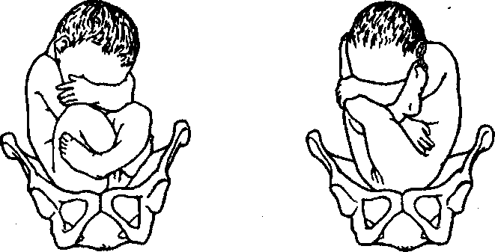
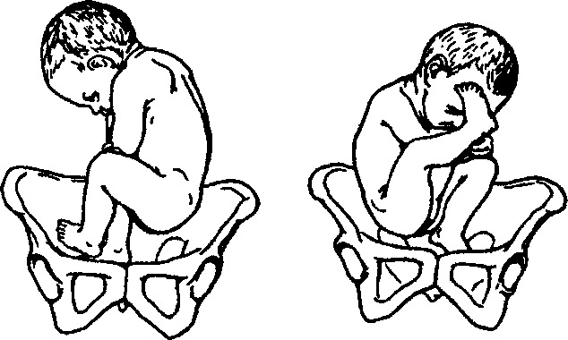
Chapter 11. Pelvic Presentation
Diagnostics
At the stage of anamnesis obtaining one might suspect PP if there are the above-listed etiologic factors in the pregnant woman, and also if the pregnant woman herself indicates that fetal movements are felt mostly in the lower parts of the abdomen, and in the epigastric area a hard part of the fetus is felt (the fetal head).
At external examination: 1) the uterine fundus is high, set against the xiphoid process or deviated from the median line to the side opposite to the fetal position; 2) in the uterine fundus there is palpated a round, evenly smooth, movable balloting part, which goes in to the fetal body through the cervical constriction; 3) above the pelvic inlet there is detected an irregularly-shaped, soft, poorly fixed part, which is not balloting and goes straight in to the body; 4) fetal heartbeats are often auscultated above the navel or at its level, in accordance with its position.
At vaginal examination: 1) the presenting fetal part is irregularly shaped, bigger and softer than the head, is easily pushed off from the pelvic inlet, does not have sutures, fontanels, hair; 2) at pure breech presentation it is possible to palpate the boy's genitals, the fissure between the buttocks, anus, sacral and coccygeal bones, eccentrically located ischial tuberosities, greater trochanter and inguinal curve on the anterior buttock; palpation of the sacral bone helps to specify the position and type; 3) at mixed breech presentation, except for the mentioned above, one can additionally detect two feet with calcaneal tubers, even and short fingers, which gradually enlarge, the big fingers can not be pressed to the sole and drawn aside considerably; 4) at complete footling presentation two feet pass into the shins at right angles; 5) at incomplete footling presentation one foot and buttocks are detected; 6) at knee presentation there are detected round knees with popliteal spaces and movable kneelers. The fetal position may be found by the location of the popliteal space: at the first position the space is turned to the left, at the second — to the right.
At evident labor tumor breech presentation may be taken for face presentation. Thorough examination helps to prevent such a mistake. At breech presentation the examining finger feels the resistance of the anus muscles, whereas at passing into the mouth harder cushions (jaws) are felt. Moreover, the finger removed from the anus is sometimes stained with meconium. The mouth and molar eminences are triangular, whereas the ischial tuberosities and anus are located on one line. The area of genitals and anus are to be palpated very carefully to avoid injuring.
129
PATHOLOGICAL OBSTETRICS
Fig. 62. Fetus in pelvic presentation

The provisional diagnosis of PP is made at the term of pregnancy of 30 weeks, and the concluding diagnosis — at 37-38 weeks (Fig..62).

The obstetric status may be specified by means of ultrasound scanning, which in this case is the most informative method of diagnostics, allowing to detect not only the variety of PP, but also the expected weight and sex of the fetus, head position (the degree of deflexion), placenta localization, amniotic fluid quantity, cord entanglement, the angle between the cervical spine and fetal occipital bone. By the size of this angle there are differentiated 4 variants of head position, which is important for detecting the method of labor management in case of PP: the head is slightly deflexed — "soldier posture" — the 1st degree of deflexion, the angle of 100—110°; the head is moderately deflexed — the 2nd degree of deflexion, the angle of 90—100°; excessive head deflexion — "the fetus is stargazing" — the 3rd degree of deflexion, the angle is less than 90°.
Pregnancy Management
When pregnant women with PP are managed in the conditions of the antenatal clinic one may attempt to correct PP: at the term of 30 weeks with the purpose of self-turning of the fetus onto the head there is recommended the woman's position on the side opposite to the fetal position, knee-elbow position during 15 min 2—3 times a day.
From the 32nd till the 37th week during 7—10 days a complex of correcting exercises by one of the existing techniques (I.F. Dvkan, I.I. Hryshchenko, A.Y. Shuleshova, and others), which causes irritation of mechano- and baroreceptors, increase of the tonus of the uterus and anterior abdominal wall, change of fetal presentation.
The main elements of the I.I. Hryshchenko's and A.Y. Shulesho-va's correcting gymnastics: 1) introductory exercise during 1 min, which unites walking (may be on the spot) with swinging the arms and even breathing; 2) forward and side bending of the pregnant woman's body, consecutive side turns, pulling the hips to the abdo-

Chapter 11. Pelvic Presentation
men at bent knees; 3) the final complex includes the exercises causing contraction of the muscles of the pelvis and pelvic floor.
According to the V.V. Abramchenko's method the pregnant woman is offered twice a day (in the morning and in the evening) on an empty stomach to lie on her back with the pelvic pole elevated due to a lubricating pad up to 30 cm high. The pregnant in the moderate Trandelenburg position, with the hips slightly moved apart, relaxes, breathes evenly during 10—i5 min. She does these exercises during 2—3 weeks.
Performing correcting gymnastics by the Dykan's method the pregnant woman lies down on a hard surface and in turn changes position (on the left and right side — 10 min on each) during 1 h. The exercise is repeated twice a day before meals.
According to different authors, efficiency of the exercises directed at PP correction makes 76.3—94.5 %.
Contraindications to such exercises are: preterm labor threat, placental presentation, low insertion of placenta, anatomically contracted pelvis of the II—III degree.
If fetal self-turning does not take place and therapeutic physical exercises do not help, external abdominal version is performed at full-term pregnancy, but not in the conditions of the antenatal clinic — in the conditions of the hospital of the 3rd level.
At the term of 38 weeks a doctor of the antenatal clinic determines the necessity of hospitalization to the obstetric department of the 3rd level by such indications: compromised obstetric-gynecological history, complicated course of this pregnancy, extragenital pathology; decides the question of possible external abdominal version.
In the conditions of the obstetric department general and obstetric anamnesis is thoroughly examined, the diagnosis is specified (pregnancy term, expected fetal weight, PP variety), internal and external obstetric examination is conducted, ultrasonography; fetal condition is assessed (biophysical fetal profile (BFP), dopplerometry if necessary), readiness of the woman's organism to delivery (the Bishop's score), the question of the possibility of external turning onto the head is decided, the plan of labor management is defined.
If the pregnancy is full-term, in the conditions of the 3rd level hospital there may be performed external fetal turning onto the head, which leads to the increase of physiological deliveries in cephalic presentation.
Indications: incomplete breech presentation at full-term pregnancy and alive fetus.
131
PATHOLOGICAL OBSTETRICS
Conditions: fetal weight < 3,700 g, normal pelvis, empty urinary bladder, possibility to conduct ultrasonography to specify presentation before and after the operation, satisfactory fetal condition (BFP 9—12 points) and the absence of fetal malformations, sufficient mobility of the fetus, normal quantity of amniotic fluid, normal uterine tonus, intact fetal sac, readiness of the surgical ward to render emergency aid in case of complications, the presence of a qualified specialist knowing the procedure of the turning.
Contraindications: complications of pregnancy at the term of making a decision to conduct the turning, compromised obstetric-gynecological history (habitual noncarrying of pregnancy, sterility, perinatal loss), oligo- and hydramnios, anatomically contracted pelvis, scarry changes of the vagina or uterine neck, the 3rd degree of head deflexion according to ultrasonography, placental presentation, severe extragenital pathology, a uterine scar, peritoneal commissures, hydrocephaly, tumor of fetal neck, uterine malformations, tumors of uterus and uterine appendages.
Operation procedure: the woman is in the position on one side with a 30—40° inclination to the side of the fetal back, the fetal buttocks are drawn aside from the pelvic inlet with the doctor's palms introduced between the womb and fetal buttocks, the fetal buttocks are carefully moved to the side of the fetal position, and the head — to the side opposite to the position. The turning is finished by means of displacing the fetal head to the pelvic inlet, and the buttocks — to the uterine fundus.
Possible complications: premature detachment of the normally located placenta, fetal distress, metrorrhexis.
Delivery Course
A high standing of buttocks does not lead to sufficient smoothing of the uterine neck, which is observed when the head is descending into the small pelvis. It is generally known that the amniotic fluid discharges prematurely at PP because of the presence of communicating posterior and anterior waters. This is connected with insufficient grasping of the uneven presenting fetal part with the inferior segment of the uterus. This causes all unfavorable consequences of the so-called "dry labor"; besides, delivery at pelvic presentation is more long-term than at cephalic presentation.
The prophylaxis of delivery complications in this case must begin with the appearance of the first contractions. To prevent early moving of waters the parturient woman is out into bed and recommended
Chapter 11. Pelvic Presentation

to take the position, in which she is least bothered with contractions. It is expedient to put the parturient woman on the side, where the fetal back is. In such position of the parturient woman the uterus under its weight is declined to the side, on which the parturient woman is lying; the pressure of the presenting part on the uterine neck reduces, which leads to birth activity weakening, and this prevents the fetal .sac from early rupture. Besides, such position, reducing the inclination of the parturient woman's pelvis, promotes the synclytic fitting of the presenting part and prevents the umbilical cord from falling out.
Preservation of fetal sac integrity for a longer period of time is necessary for a sufficient opening of the mouth of womb and for the shortening of waterless period duration, not always indifferent for the fetus and parturient woman. In spite of fetal sac integrity, birth activity begins to intensify in the parturient woman. With every next contraction the lower uterine segment, grasping the presenting part more tightly, prevents the umbilical cord from falling out, which is often observed at such delivery.
It is recommended to manage the 2nd stage with a mobilized vein for i.v. introduction of 5 IU of oxytocin in 500.0 of saline (up to 20 drops a min). By indications episiotomy and pudendal anesthesia are carried out. At PP delivery is to be managed by a highly qualified specialist, and at the 2nd stage the anesthesiologist and neonatologist are to be present.
Expulsion stage deserves special attention, since at this aid there may arise such complications as arms throwing, spasm of the internal mouth, rear view formation, fetal hypoxia.
To prevent the mentioned complications delivery at pure breech presentation is managed by Tsov-yanov I. It should be emphasized that manual aid is not an operation, it is doctor's aid at independent birth of the fetus at PP.
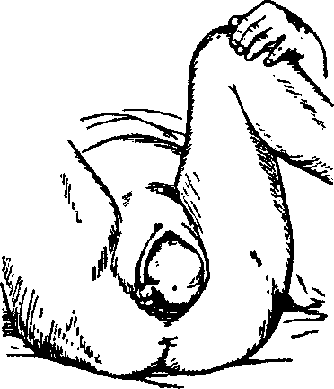
Manual aid by Tsovyanov I is begun at the moment of buttocks disengagement (Fig. 63).
The buttocks, which are being born, are held without any attempts
Fig. 63. Buttocks cutting-in
133

PATHOLOGICAL OBSTETRICS
of fetus extraction (premature pulling leads to the violation of the location of body parts, arms throwing, and head deflexion) (Fig. 64).
The main aim is to preserve the normal location of fetal body parts, not to allow the legs to be born prematurely. At normal body parts location the legs are stretched along the body, the crossed arms are pressed to the thorax, the feet of the stretched legs reach the level
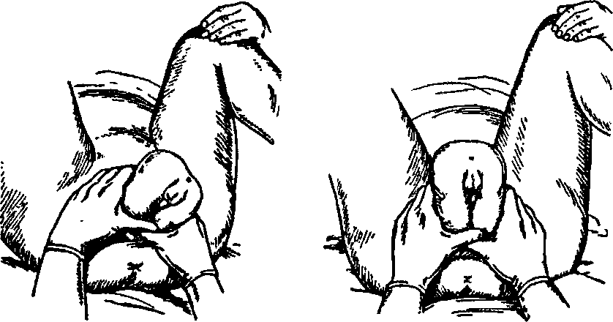
Fig. 64. Location of the obstetrician's Fig. 65. Movement of the obsteri-
hands at buttocks disengagement cian's hands along the fetal body
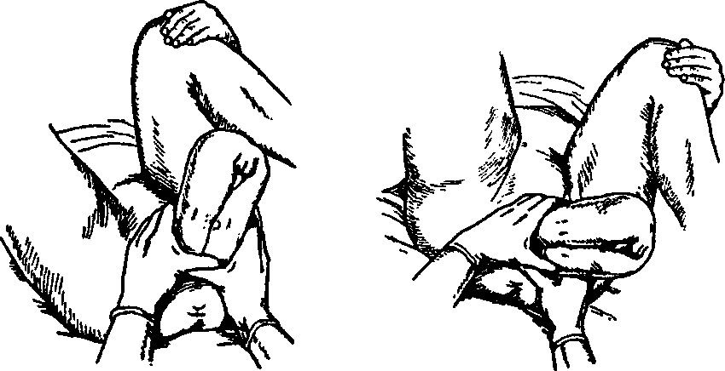
Fig. 66. Further movement of the Fig. 67. Further movement of the obste-
obsterician's hands along the fetal rician's hands along the fetal body after
body internal turning of the fetal shoulders
134
Chapter 11. Pelvic Presentation

Fig. 68. Extraction of the posterior fetal arm by means of elevating the fetus and drawing it aside to the maternal groin opposite to the fetal position
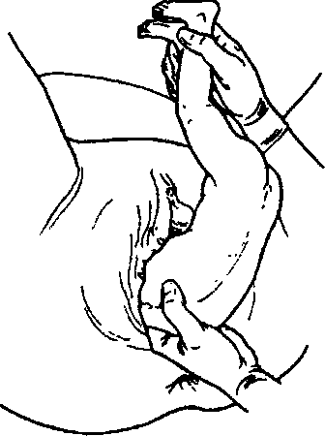
of the face and sustain head flexion (Fig. 65).
Such position of the legs turns the fetal body into a cone, gradually dilating upwards. Therefore the legs are kept pressed to the fetal body with the thumbs. The other four fingers are placed on the fetal sacral bone (Fig. 66).
As the fetus is born, the hands are shifted along the body to the posterior labial commissure of the parturient woman. In the oblique dimension the body is born till the lower angle of the anterior scapula, the shoulder girdle is set in the direct dimension (Fig. 67).
At this moment it is important for the obstetrician to direct the buttocks at himself to ease the independent birth of the anterior shoulder from under the pubic arch. For the posterior shoulder to be born the fetus is lifted upwards again.
To prevent the umbilical cord occlusion with the fetal head after the body is born to the lower angle of the scapulae further delivery of the fetus should not last more than 5—7 min.

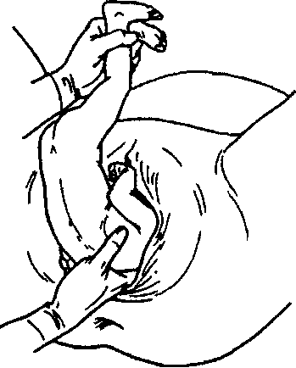
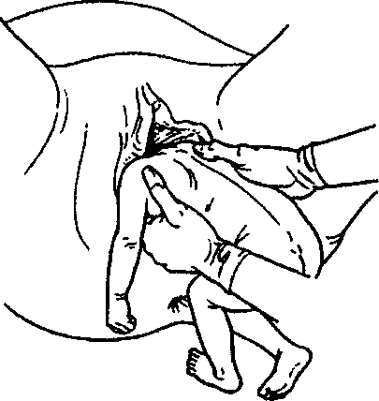

Fig. 69. Turning of the fetal body

Fig. 70. Release of the second arm

135

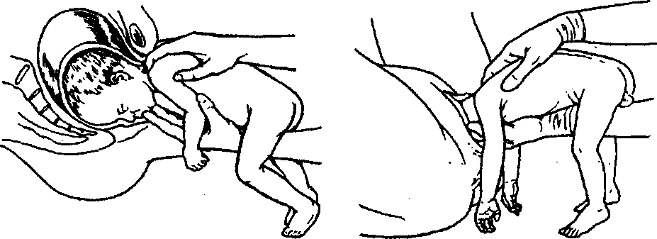
PATHOLOGICAL OBSTETRICS
Fig. 71. Release of the fetal head
At complications, which may arise when the shoulder girdle is born and thereby causing arms throwing, one should proceed to shoulder girdle release by the technique of classical manual aid. One should begin rendering this help already after the fetus is born to the lower angle of the anterior scapula.
The posterior arm is the first to be released (Fig. 68).
With one hand the doctors takes the fetal legs by the shins and directs them forward and to the side opposite to the fetal back. The index and middle fingers are introduced into the vagina along the fetal back (to release the similar fetal hand — the similar obstetrician's hand), and, moving along the fetal back and shoulder, the bend of elbow is reached. Then the arm is descended for it to perform the "washing" movement; the elbow, forearm, and hand appear from the vagina in turn.
The anterior arm is taken out after it was passed into the posterior position also from the side of the hollow of sacrum. For this purpose the fetus is grasped with hands by the pelvis and anterior part of the hips (the fetal abdomen should not be touched — 4 fingers of each hand on the hips, the thumbs — on the fetal buttocks) and turned by 180° (Fig. 69).
The fetal back is under the symphysis; then the other hand is released similarly to the first one (Fig. 70).
Release of the head may be performed in a couple of ways. According to the Mauriceau—Levret's method the fetus is seated in the "riding" position on the obstetrician's hand (Fig. 71), the middle finger of this hand is introduced into the fetal mouth, and head flexion is provided by slight pressure on the lower jaw. The index and middle fingers of the other hand grasp the fetal shoulder girdle in fork-like manner from above (mind the clavicles!). The same hand conducts
136
Chapter 11. Pelvic Presentation

tractions downwards (till there appears the scalp of the head and forms a point of fixation between the suboccipital fossa and pubis), and then to himself and upwards.
There may be used head removal by the Bracht's method — entering the small pelvis in the oblique dimension the fetal head finishes its internal turning, descends onto the pelvic floor and at intensive birth activity is born independently, the obstetrician elevates the fetal body to the parturient woman's pubis.
Some obstetricians use the Veit—Smellie's method. To flex the fetal head by this method the fetus is put astride on the palm and forearm of the obstetrician's lower arm with the fetal arms and legs thrown on both sides. The index and ring fingers of this hand carefully press the upper jaw on lateral surfaces close to the fetal nose, the middle finger is put to the chin and the head is flexed. The external hand is out onto the fetal back, the index and ring fingers are hooklike located on each side of the neck, and the middle finger presses the occiput promoting additional head flexion. After the assistant has increased the flexion, pressing the uterine fundus to the fetal head through the anterior abdominal wall, the obstetrician with the upper hand pulls the fetus down till the suboccipital fossa appears under the symphysis, and then performs tractions horizontally and upwards for the head to be born with the small oblique dimension.
When premature fetuses are born the Myers' method is used — the fetus is placed on the lower hand in the way it is performed at classical manual aid. The obstetrician places the index and middle fingers of the hand on the upper fetal jaw on each side of the nose. The palm of the right obstetrician's hand is at the level of the fetal shoulder girdle, the index and middle fingers are introduced maximally deeply along the spine, which allows reaching the inion in premature fetuses. The joint movement of the obstetrician's fingers during contraction allows performing the necessary degree of fetal head flexion.
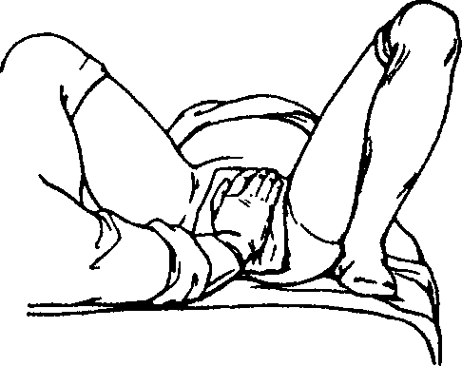
Manual aid at foot presentation (by Tsovya-
Fig. 72. Manual aid at foot presentation by Tsovyanov II
137

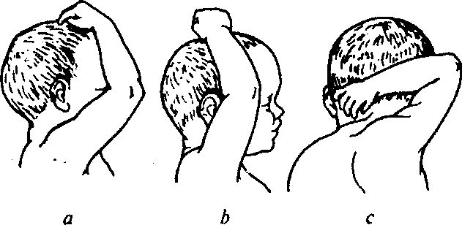
PATHOLOGICAL OBSTETRICS
Fig. 73. Three degrees of the throwing back of the fetal arms:
a — the hand is on the face, in front of the ear; b ~ the hand is on the ear; c — the hand is behind the ear
nov II; Fig. 72) aims at preventing the birth of fetal legs till sufficient cervical dilation and in such a way at promoting the intensification of birth activity. The external genital organs of the parturient woman are covered with a sterile tissue. The fetus is kind of squatting down and appears in complete breech presentation. At sufficient cervical dilation, if the buttocks have already descended onto the pelvic floor, the legs are not kept, the fetus is born independently till the lower angle of the scapulae, further the shoulder girdle and fetal head are released by means of classical manual aid.
The obstetric approach if complications arise in the 2nd period: 1. Throwing back of arms — a complication, at which the arms lose their typical position, move from the thorax up and to the face or occiput (Fig. 73). There are differentiated three degrees of the throwing back of arms: I — the arm is in front of the ear, II — at the level of the ear, III — behind the fetal ear. The most frequent in such cases is severe fetal hypoxia (or even fetal death) because of protracted delivery of the head, since the volume of the head together with the arm increases so much that without rendering immediate help delivery can not end successfully.
The thrown back arms must be released right after the fetus is born to the lower angle of the anterior scapula, because later the head fits tightly into the small pelvis and this anomalous position fixes. The release of the thrown back arms of the 1st and 2nd degree is conducted from the side of the fetal back or thorax. To perform the first method the fetal legs are declined upwards into the-position opposite to the inguinal fold. The four fingers of the internal hand move along the back, shoulder, grasp the arm above the elbow and take it out an-
138
Chapter 11. Pelvic Presentation
teriad, descending from the lateral surface of the head or face on the thorax downwards.
According to the second method the arms are grasped not from the side of the fetal back but from the side of the fetal thorax (only in para II, wit the normal dimensions of the mother's pelvis and small fetal weight). In this case the legs are declined with one hand downwards, and fingers of the other hand are moved to the shoulder, the arms are taken out along the face, chest, and abdomen of the child.
To take out the thrown back arms of the 2nd and 3rd degree the Preobrazhenskiy's method is used. At the 2nd or 3rd degree of the throwing back of arms the lower angles of scapulae rise and sharply diverge to the sides from the backbone. The obstetrician presses the lower angles of the scapulae from the outside inwards, displacing them to the side of the backbone. The muscles attached to the scapulae pull the fetal humerus and elbow downwards to facilitate the subsequent release of the thrown back arm in one of the above-listed ways.
To release the thrown back arm of the 3rd degree the fetus is rotated around its longitudinal axis in the direction of the pathologically located hand as if unwinding a twisted cord. For this purpose the fetus is put onto the forearm, and the palm of the internal hand, as it is done at classical manual aid, pushes the fetus to the side of the small pelvis, and only after this the turning is performed. Here might be a couple of variants:
- if the anterior arm is thrown back, the posterior arm should be released in the usual way. After this (fixing the posterior arm) one should turn the fetal body in such a way that the fetal chest, and not the back, is under the symphysis. After the anterior arm becomes posterior it is released in the usual way;
- if the posterior arm is thrown back, the fetus is rotated around the longitudinal axis in such a way that its back is under the symphysis. After this the anterior arm, which is not thrown back, moves backwards to the side of the perineum and is released in the usual way. Then the second fetal turning is performed for the arm, which is lying freely in front, to turn backwards, where it is released in the usual way.
2. One of severe complications is also the formation of the posterior view at PP, when the back turns backwards, the course of delivery decelerates, coming out of the shoulders and head is complicated. When the head is flexed the area of the bridge of nose rests against the symphysis, and the occiput comes out above the perineum. But more often the head is extended, the chin is held above the symphy-
139
PATHOLOGICAL OBSTETRICS
sis, and the head must be born in the condition of extreme deflexion. Without obstetric help the delivery of the head is delayed and the fetus dies of asphyxia. The head must be released quickly and carefully by means of special maneuvers.
Coming out of the head depends on its condition — if it is flexed or extended. In the first case the inverse Mauriceau's method is used — the obstetrician introduces the first phalanx of the index finger of the upper hand into the fetal mouth and maximally flexes the head till it rests upon the inferior margin of the symphysis with the anterior part of the prefontanel. Simultaneously the other hand is placed in forked manner on the posterior surface of the shoulders and performs tractions upwards till the fetal head is born with the large transversal dimension.
In case of head deflexion and chin holdback above the horizontal pubic ramus it is offered to use the "inverse Prague method" — one hand grasps the fetus by the shoulders from behind, the other — by the legs in the region of ankle joints. First there is performed a downwards traction till there appears the hairy part of the occiput, then — a strong traction downwards and anteriad. The head is born rotating around the symphysis pubis. Performing the maneuver one must exert pressure on the hand above the womb. Episiotomy is obligatory for the prophylaxis of deep perineal ruptures.
- In case of fetal distress at the 3rd stage (the fetal buttocks are on the pelvic floor or are cutting into) delivery is conducted by means of the operation of fetal extraction by the pelvic pole.
- If there appears a spastic contraction of the mouth of womb, it is necessary to introduce i.v. 0.5—1.0 ml of 0.1 % atropine sulfate solution, 2 ml of 2 % of papaverine hydrochloride solution, 2 ml of No-Spa, or stop tractions temporarily. If there is no effect and the uterine neck is thin and smooth, some authors recommend cervicotomy by Dursen on the places corresponding to 2, 6, and 10 hours of the dial plate. If it is possible, the index finger is brought into the child's mouth, the obstetrician significantly flexes the fetal head (corresponding reduction of its dimensions) and shifts the anterior lip of cervix uteri from the occiput upwards under the symphysis pubis of the mother.
Indications to the operation of cesarean section:
- expected fetal weight of 3,700 g and more;
- footling presentation of the fetus;
- fetal head deflexion of the 3rd degree by ultrasonography data;
- fetal neck tumors and hydrocephaly.
140
Chapter 12. Multiple Pregnancy
Because of the high frequency of unfavorable outcomes for the fetus at PP in case of delivery through the natural maternal passages, most obstetricians consider it expedient to expand indications to cesarean section. Thus, if there arise complications of the delivery process at PP, one should more often put a question of operative delivery.
The gestational age of the fetus is important if operative preterm delivery is discussed. At the term of pregnancy of 32—36 weeks (fetal weight 1,500—2,500 g) cesarean section is considered more expedient, since according to literature the number of children, who died after the operation, is 16 times less than at preterm delivery through the natural maternal passages. If the fetal weight is < 1,500 g, the method of delivery does not influence perinatal outcome.
141
MULTIPLE PREGNANCY
Multiple is the pregnancy with two or more fetuses. A woman pregnant with two fetuses is pregnant with twins, with three fetuses — with triplet babies. The children born from multiple pregnancy are called twins.
Multiple pregnancy is observed in 0.7—1.5 % cases, presently there is observed a tendency to its frequency increase because of hy-perstimulation of ovulation in women suffering from infertility at extracorporal fertilization. A couple of follicles (3—4 and more) mature simultaneously, and accordingly, at fertilization of a couple of oocytes multiple pregnancy may arise.
Perinatal mortality at multiple pregnancy is 3—4 times higher than at monocyesis. Perinatal losses directly depend on the body weight of children, making 10 % on average. Perinatal mortality among monozygotic children is by 2.5 % higher than among dizygotic twins, and is especially high in monoamniotic twins.
Etiology and Pathogenesis
Reasons for multiple pregnancy are various and little-studied. A certain role in disposition to multiple pregnancy is played by heredity. Multiple pregnancy is more often observed in the families, where the mother or father or both parents were born as a result of multiple pregnancy. The mother's genotype is more important in this case.
The frequency of multiple pregnancy increases with the woman's age and the quantity of pregnancies.
Follicle-stimulating hormone (FSH), which promotes maturing of a couple of ovocytes, plays a big role in the appearance of multiple pregnancy. This may be determined by heredity and also by medication influence (usage of ovulation stimulators, estrogen-gestagen drug withdrawal, extracorporal fertilization).
Multiple pregnancy may arise: as a result of the fertilization of two or more oocytes, which have matured simultaneously — binovular (dizygotic) twins; also" at the development of two or more embryos from one fertilized oocyte — monovular (monozygotic) twins.
142
Chapter 12. Multiple Pregnancy
Binovular twins may form in case of:
- simultaneous maturing and ovulation of two and more follicles in one ovary;
- maturing and ovulation of two and more follicles in both ovaries;
- fertilization of two and more oocytes, which have matured in one follicle.
Such variants of twins origin are testified to by finding two and more yellow bodies in one or both ovaries at surgical interventions.
There is no definite hypothesis concerning monovular twins formation. Obviously, most often the formation of monovular twins (triplets, etc.) is connected with fertilization of an ovocyte with two and more nuclei. Each nucleus conjugates with the nuclear substance of spermatozoon and an embryo forms. The described oocytes have two and three nuclei. There also exists another mechanism of enzy-gotic twins origin: the only embryo at the stage of breaking divides into two parts; a fetus forms from each part.
During separation before the formation of the internal cell later (at the morula stage) and turning of the external cell layer of the blastocyst into chorion elements, which takes place during the first 72 h after fertilization, two amniotic sacs and chorions form. As a result biamniotic dichorial monozygotic twins form.
If division takes place on the 4th—8th day after fertilization, after the internal cell layer is formed and chorion anlage from the external layer has taken place, but before the laying of amniotic cells, that is before the appearance of the fetal bladder, two embryos form, each in a separate amniotic sac. That is, monochorionic monoamniotic monozygotic twins form.
If by the moment of division the amnion is already laid, which takes place on the 9th—12th day after fertilization, division will lead to the formation of two embryos in one amniotic sac, i.e. monochorionic monoamniotic monozygotic twins.
After the 15th day complete division of embryonic anlages is impossible and adherent twins develop.
In most cases of enzygotic twins formation germinal layers division takes place till the 8th day (monochorionic biamniotic monozygotic twins; Fig. 74).
Dizygotic Twins
Each fertilized ovocyte, which penetrates into the decidual membrane, forms its own amniotic sac and chorion, out of which its own
143
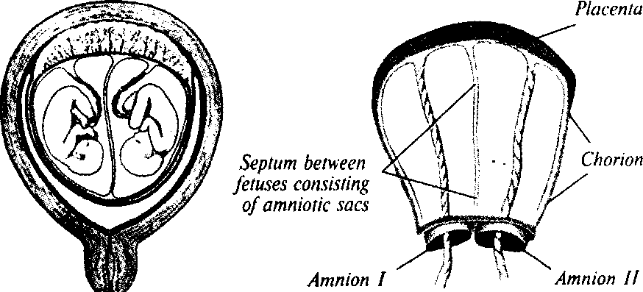
PATHOLOGICAL OBSTETRICS
Fig. 74. Membranes at monochorionic biamniotic twins
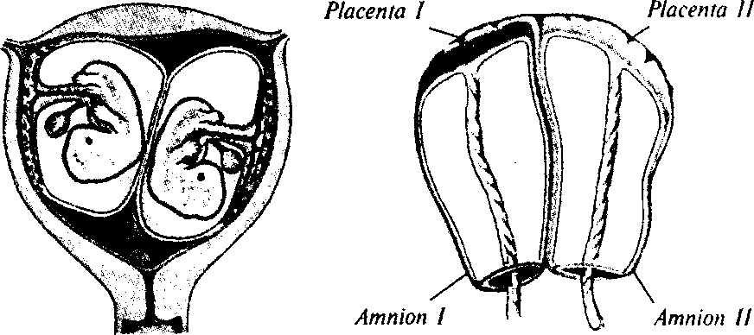
Fig. 75. Membranes at dichorial twins
placenta forms in future. If ovocytes penetrate into the decidual membrane close to each other, the edges of both placentas bear against each other creating an impression of a single formation. In fact each placenta has its own vasculature, each fetal bladder has its own amniotic sac and chorion. The membrane between the two fetal bladders consists of four layers: two amniotic sacs and two chorions, and the decidual membrane is common (dichorial twins; Fig. 75). If fertilized ovocytes penetrate at a great distance, their placentas develop as separate formations and each embryo has its own decidual membrane.
Dizygotic twins make 70 % among all types of twins. Dizygotic twins may be both uni- and heterosexual and be in the same genetic dependence as blood brothers and sisters.
144
Chapter 12. Multiple Pregnancy

The difference in body weight in dizygotic twins is usually insignificant and ranges between 200 and 300 g. In some cases because of different conditions of intrauterine nutrition the difference may be rather considerable — up to 1 kg and even more.
Enzygotic Twins
Enzygotic twins form when at complete division both embryos locate at a distance from one another, each embryo has its own amnion and, thereby, embryos remain separated. These are biamniotic twins. If both amniotic cavities are in one common for the twins chorion, and the membrane between them consists of two layers, such twins are called monochorionic, they share a common placenta. If there forms a common for the two embryos amniotic cavity, monoamniotic twins develop.
Enzygotic twins are always unisexual, have one blood group, identical color of eyes, hair, skin relief of fingertips, form and location of teeth (Fig. 76).
Vascular anastomosis may be often detected in monochorionic placentas — either of an artery with a vein, or an artery with an artery, which conditions the development of the fetofetal transfusion syndrome. Arteriovenous anastomosis is realized through the capillary system of placenta. As a result of such anastomosis blood flows from one fetus to the other. In dichorionic placentas arteriovenous anastomosis is much rarer. The consequences of such anastomosis may be very serious. If blood pressure is symmetrical in the vascular system of placenta, both twins are in identical conditions of nutrition and development. Although, in enzygotic twins this balance may be violated as a result of asymmetric placental circulation, and then one fetus gets more blood (the recipient) than the other (the donor). The latter does not get sufficient nutrition and is in worse conditions for its development; this may be the reason
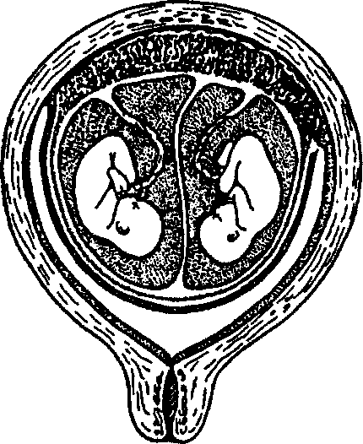
Fig. 76. Enzygotic biamniotic monochorionic twins
145

PATHOLOGICAL OBSTETRICS
for intrauterine fetal development delay. At a sharp violation of balance in the system of placental circulation one of the twins (the donor) gradually peters out, dies and becomes mummified, turning into the so-called papyraceous fetus (fetus papyraceus). Not infrequently the recipient twin develops dropsy and hydramnion conditioned by cardiac insufficiency.
Multiple Pregnancy Diagnostics and Course
The course of multiple pregnancy compared to monocyesis is characterised by a number of unfavorable peculiarities.
Circulating blood volume at multiple pregnancy increases by 50— 60 %, at monocyesis - by 40-50 %.
The most frequent complications of multiple pregnancy course are:
- preterm delivery (25—50 % cases). The average duration of pregnancy with twins makes 37 weeks, with triplets — 35 weeks;
- spontaneous abortion;
- gestoses of pregnancy are observed much more frequently and have a severer course than at monocyesis;
- anemia of pregnancy;
- hydramnios;
- intrauterine fetal development delay.
Before ultrasound study was introduced into the clinical practice the diagnostics of multiple pregnancy was not always easy, not infrequently it was diagnosed at late pregnancy terms and even during delivery. Anamnesis of such pregnant women often showed that they or their husbands are one of twins. An indication to possible multiple pregnancy may be information about the pregnant woman undergoing ovulation stimulation or extracorporal fertilization. In the first trimester of pregnancy one should pay attention to the inadequacy of uterine dimensions with the pregnancy term — the growth of uterus seems to be advancing the pregnancy term.
At late pregnancy term the data of external obstetric examination are of some importance: abdomen circumference, the height of uterine fundus standing appear to be larger than they are supposed to be at this pregnancy term. Sometimes it is possible to palpate many small fetal parts and two and more large balloting parts (heads and pelvic poles). Auscultation finds in different parts of the uterus two foci of distinct heart tones of the fetuses, especially if there is the so-called zone of silence between them (the area where fetal heart tones are not
Chapter _12. Multiple Pregnancy
heard; Fig. 77). Twins are also testified to by different frequency of heart tones.
Biochemical tests have certain significance in multiple pregnancy diagnostics: at this type of pregnancy the level of chorionic gonadotropin and placental lactogen are higher than at monocyesis. The level of a-fetoprotein is also increased.
Ultrasound .study is the most accurate method of multiple pregnancy diagnostics (Fig. 78). Ultrasound diagnostics of multiple pregnancy at early terms is based on the imaging in the uterine cavity of a couple of fetal eggs or embryos and is possible beginning from 5—6 weeks of pregnancy. Except for the early detection of multiple pregnancy, echography in the 2nd, 3rd trimesters allows detecting the character of development, position, presentation of fetuses, localization, structure, quantity of placentas and amniotic cavities, amniotic fluid volume, presence of possible malformations.
Possible variants of position and presentation of twin fetuses (Fig. 79):
1. Both fetuses in longitudinal position:
- both in cranial presentation (Fig. 80);
- both in pelvic presentation;
- one in cranial presentation, the other — in pelvic and vice versa (Fig. 81).
2. Both fetuses in transversal position (Fig. 82).
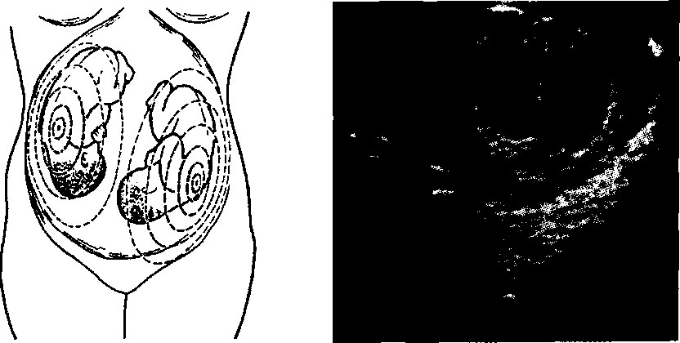
Fig. 77. The scheme of heart- Fig. 78. Ultrasonic image of
beats audibility in twins dizygotic twins at the pregnancy
term of 6 weeks
147
PATHOLOGICAL OBSTETRICS

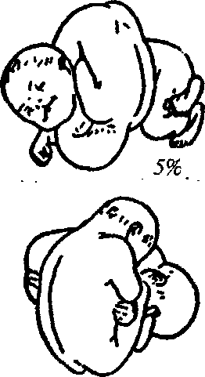
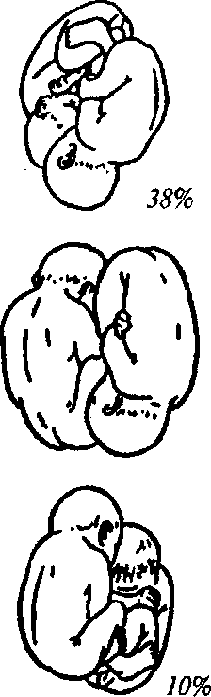
42%

3.7%
0.2%

Fig. 79. Possible types of twin fetuses location, their frequency

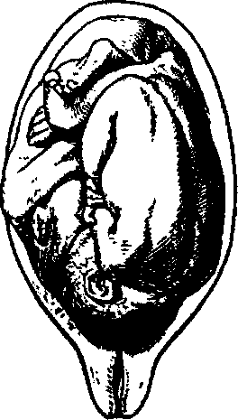
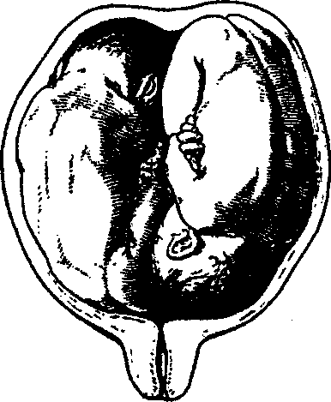

Fig. 80. Both twins in cranial presentation

Fig. 81. One fetus in cranial presentation, the other — in pelvic presentation

148

Chapter 12. Multiple Pregnancy

Fig. 82. Both fetuses in transversal position
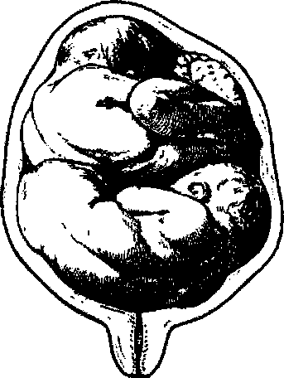
3. One fetus in longitudinal position, the other one — in transversal.
For the prognosis of multiple pregnancy termination of big importance is cardiomonitoring control of fetal condition with application of non-stress test. After 30—32 weeks non-stress test and biophysical profile detection must be conducted daily.
Patients pregnant with twins require special attention throughout pregnancy. Attention should be paid to the function of the cardiovascular system, kidneys, detection of early gestosis symptoms. If there appear symptoms of gestosis or other pregnancy complications, the patient is to be hospitalized to the maternity obstetric service. If the course of pregnancy is uncomplicated, the patient is to be referred to the maternity hospital 2—3 weeks before the delivery, if she is pregnant with triplets — 4 weeks before the delivery. Miscarriage is a serious complication of multiple pregnancy. The very presence of multiple pregnancy is a risk factor for miscarriage appearance and requires treatment-and-prophylactic measures to prevent this pregnancy complication.
Delivery Course and Management
The course of delivery at twins is often accompanied by significant complications:
- untimely discharge of amniotic fluid (premature or early), prolapse of umbilical cord loops and small fetal parts is possible;
- uterine overdistension often causes protracted labor since the period of cervical dilation is longer because of uterine inertia;
- the period of expulsion is also not infrequently protracted. Sometimes the presenting part of another fetus is trying to fit into the pelvis simultaneously, and continuous birth activity is needed for one head to fit in the area of brim;
- belated rupture of membranes, which also leads to delaying of this period of labor;
- untimely discharge of amniotic fluid, labor delaying increase
149

"1
PATHOLOGICAL OBSTETRICS
the risk of postnatal purulo-septic complications in the mother and fetal hypoxia;
- premature abruption of placenta. The reason is quick reduction of uterus volume and intrauterine pressure after the first fetus is born;
- twins collision — a rare but very severe complication of the period of expulsion. Different varieties of fetuses coalescence. Most often one fetal head links to the other fetal head and large parts of both fetuses enter the area of brim simultaneously. This happens in cases when the first twin is born in pelvic presentation and the other one — in cranial (Fig. 83), or the first — in pelvic presentation and the other — in transversal (Fig. 84);
- after the first twin is born the other one can take transversal position even if before the beginning of delivery it was in longitudinal position, which is also a reason for different complications;
- in the puerperal and early puerperal periods hypotonic hemorrhage arises not infrequently because of uterine overdistension;
- subinvolution of uterus is also possible in the puerperal period.
Labor management at multiple pregnancy also has its peculiarities. Multiple pregnancy at pelvic presentation of the first fetus is an indication to cesarean section.
At vertex presentation of the first fetus, intact fetal bladder, regular birth activity and good condition of fetuses labor management is active-expectant with cardiomonitoring control over the fetuses con-

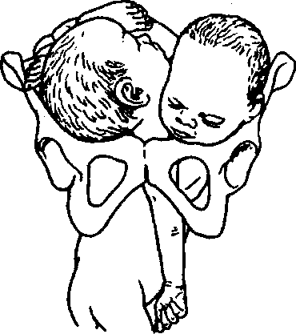
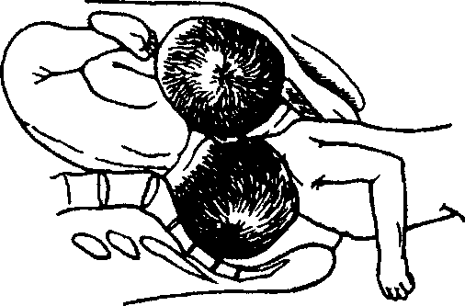

Fig. 83. Twins:

one fetus in footling presentation, the other — in cranial (coalescence of the heads has taken place)
Fig. 84. Twins:
one fetus in footling presentation, the other — in transversal position

150

Chapter 12. Multiple Pregnancy
dition, observation of the character of uterine activity, fitting and descent of the presenting part of the first fetus, condition of the parturient woman. Prophylaxis of uterine inertia and hypotonic hemorrhage is being conducted.
One should provide adequate anesthesia. Lateral position of the parturient woman is optimal for the prevention of aortocaval compression.
Operative delivery is resorted to by indications: cesarean section, vaginal operative delivery (operation of obstetric forceps application, vacuum extraction by the fetal head).
After the first fetus is born, not only the fetal but also the maternal end of the umbilical cord is ligated. If this is not done, and the twins appear to be monoval, the second fetus may quickly die because of hemorrhage through the umbilical cord of the first fetus.
If after the birth of the first fetus the second one is not born during 10—15 min, the fetal bladder is opened, the amniotic fluid is slowly released, and labor is conducted conservatively at longitudinal position. At transversal position of the second fetus, at irregular fitting of the head the parturient woman is anesthetized and combined podalic version of the fetus is performed with its further extraction. If the fetus is large at pelvic or transversal position, cesarean section is carried out. If the second fetus is in the small pelvis cavity and labor is powerless, obstetric operations are also not excluded. In this case obstetric forceps are applied or the fetus is extracted by the pelvic pole.
A question concerning cesarean section may arise at multiple pregnancy and in the process of delivery: uterine inertia, fetal distress, which are not subject to medicamental correction in the absence of possibilities for urgent delivery through the natural maternal passages, prolapse of small fetal parts and umbilical cord loops.
If a woman is pregnant with three and more fetuses, delivery by means of cesarean section is preferred. Cesarean section is also resorted to in case of twins coalescence.
Special attention at multiple pregnancy is to be paid to the third (placental) stage because of a high risk of hemorrhage. One should thoroughly observe the woman's condition and the quantity of blood being lost, prevent hemorrhage, including with uterotonics.
In the puerperal period at multiple pregnancy there most often arises postpartum hemorrhage, subinvolution of uterus, endometritis. Therefore one should conduct timely prophylaxis of these complications, in particular observe contractions of the postpartum uterus, administer uterotonics in case of need.
151
GESTOSES
Gestosis is a syndrome defined as violated adaptation of a woman to pregnancy. Gestosis arises only in connection with pregnancy, is etio-logically linked to fetal egg development, is characterized by various symptoms, complicates the course of pregnancy and usually disappears right after or in some time after the end of pregnancy.
Many theories have been offered to explain gestosis reasons: toxemic, allergic, corticovisceral, endocrine, neurogenic, psychogenic. immune, genetic and others, around 40 theories.
For instance, the genetic theory developed after it was found that in women having a family history of preeclampsia or eclampsia these complications are met 4 times more often. Besides, the genes transferring inclination to preeclampsia (mitochondrial genes) were identified.
The immune theory represents the fetoplacental complex as an allograft and preeclampsia development is a reaction akin to allograft rejection reaction.
Multiple theories of preeclampsia pathogenesis suggest that none of them describes it completely.
The clinical presentation of gestosis is conditioned by activation or dysfunction of endotheliocytes of vessels (first of all of spiral arterioles) and is accompanied by thrombocytes activation. In the plasma there is considerably increased concentration of the markers of the affection of endotheliocytes (endothelin, fibronectin), activation of thrombocytes (thromboxane-prostacyclin, cytoadherence molecules, von Willebrand factor), thrombocytes degranulation products.
An important role in gestoses origin belongs to:
- insufficiency of the uterine spiral arterioles, which causes placental circulation violation;
- vessel endothelium dysfunction connected with autoimmune violations caused by pregnancy.
Risk factors of gestoses onset include:
1. Extragenital pathology:
— arterial hypertension before pregnancy;
Chapter 13. Gestoses
- renal dysfunction;
- metabolic disorder (obesity);
— cardiovascular system diseases (diabetic angiopathy, auto
immune vasculitis);
— sicklemia.
2. Obstetric-gynecologic risk factors:
- conditions accompanied by the formation of the .placenta of big size (multiple pregnancy, diabetes mellitus, gestational edema);
- presence of hypertonic disorders in hereditary anamnesis;
- presence of preeclampsia during previous pregnancy;
- the age of the pregnant (less than 19, more than 30 years);
- isosensitization by Rh-factor and ABO system.
3. Social and living factors:
- bad habits;
- occupational hazards;
- unbalanced diet.
The knowledge of the risk factors of preeclampsia development and their detection allow timely formation of risk groups concerning preeclampsia onset.
13.1. EARLY GESTOSES
There is no single gestoses classification. The MPH of Ukraine and the Association of Obstetricians-Gynecologists of Ukraine recommend the classification of early and late gestoses (Table 6).
In many countries early gestoses are viewed as pregnancy complications or unpleasant symptoms of pregnancy. We consider vomiting and salivation to be early manifestations of organism dysadaptation to pregnancy and therefore view these conditions as gestoses, early by the term of onset.
The diagnostics of the severity of vomiting of pregnant is based on clinical and laboratory data. The latter include: hematocrit, the quantity of protein and its fractions, blood electrolytes, bilirubin, urea, common urine analysis, diuresis.
Moderate and severe vomiting should be treated in the in-patient department.
The main principles of vomiting treatment are:
1. Normalization of the violations of correlation between the excitative and inhibitory processes in the CNS — psychotherapy,
153
PATHOLOGICAL OBSTETRICS
electrical sleep, acupuncture, laser reflexotherapy, sedatives and/or tranquilizers (diazepam, seduxen).
- Antiemetic agents — droperidol, aminazine, etapirazin, cerukal.
- Water-electrolytic balance correction, metabolism correction — Ringer's, Dissol, Trisol solutions, physiologic saline. The solutions of hydroxyethylstarch — refortan, stabisol — are also used.
Unfavorable prognostic symptoms are also icteric discolor of the skin, body temperature more than 38 °C, tachycardia over 120 bpm, albinuria, comatose state, delusion.
Indications to abortion are disease progression against the background of treatment.
Usually early gestoses of pregnant stop during the 13th—14th week of pregnancy.
Table 6 . Early Gestoses Classification

Classification | Definition
1. Vomiting of pregnant (emesis gravidarum): | Vomiting connected to pregnancy
— mild vomiting | — vomiting up to 3—5 times a day on an  empty stomach or after meals  — reduced appetite
— moderate vomiting | — vomiting up to 10 times a day irrespec  tive of food intake  — weight loss, weakness, apathy  — electrolyte imbalance
— severe vomiting (hy-peremesis gravidarum) | — vomiting more than 10 times a day, no  food is hold  — weight loss  — low grade fever  — icteric discolor of the skin and sclerae  — acetonuria with oliguria  — tachycardia, hypotension  — hyperbilirubinemia, hypokalemia, hy-  pernatremia, hypoproteinemia  — hematocrit increase
2. Salivation (ptyalis-mus gravidarum) | — hypersalivation
154
Chapter 13. Gestoses
13.2. LATE GESTOSES
Under the recommendation of the WHO (1989) and on demand of the ICD of the 10th revision (1995), the Association of Obstetricians-Gynecologists of Ukraine recommended and the MPH of Ukraine approved such classification of late gestoses (Tables 7, 8).
Table 7 . Late Gestoses Classification

Classification | Definition
1. Gestational hypertension, or hypertension during pregnancy: | Hypertension which appeared after 20 weeks of pregnancy and is not accompanied by proteinuria up to delivery:
— transient gestational hypertension | — normalization of arterial blood pressure in the woman, who has been having gestational hypertension during 12 weeks after delivery
— chronic gestational hypertension | — hypertension, which appeared after 20 weeks of pregnancy and continues during 12 weeks after delivery
2. Proteinuria during pregnancy | Protein content of 0.3 g/L in an average portion of urine collected twice with an interval of 4 h or more, or protein excretion of 0.3 g a day
3. Edema during pregnancy | Liquid holdup, local or generalized edemata. Diuretic-resistant edemata, pathologic weight gain
Preeclampsia
Hypertension, which appeared after 20 weeks of pregnancy in combination with proteinuria, with/without edemata ("pure" gestosis)
4. Mild preeclampsia | — arterial blood pressure (ABP) systolic and diastolic  140-159 per 90-99 mm Hg  — proteinuria < 0.3 g/day
5. Moderate preeclampsia | — ABP 160-179 per 100-109 mm Hg  — proteinuria 0.3—5.0 g/day  — edemata on the face, hands  — sometimes headache
6. Severe preeclampsia | — ABP > 180 per > 110 mm Hg  — proteinuria > 5.0 g/day  — generalized, considerable edemata  — headache, visual impairment  — hyperreflexia  — pain in the epigastrium and/or right hypochondrium  — oliguria (< 500 ml/day)  — thrombocytopenia
155
PATHOLOGICAL OBSTETRICS
Table 7 continued

Classification | Definition
7. Eclampsia (during pregnancy, in the process of delivery, in the puerperal period, unspecified by the term) | — convulsive attack (one or more) in the pregnant with preeclampsia
Note: The presence of at least one criterion of more severe preeclampsia gives grounds for corresponding diagnosis.
Table 8 . Rare Forms of Gestoses

HELLP-syndrome
H (hemolis) — microangiopathic hemolytic anemia
EL (elevated liver ferments) — the increase of liver enzymes concentration in blood plasma
LP (low-platelet quantity) — the decrease of thrombocytes level

156
Dermatoses, jaundices, acute fatty hepatosis of pregnancy, chorea (tetany). osteomalacia, arthropathy, neuropathy, psychopathy bronchial asthma
This classification does not include the following notions:
- chronic hypertension — hypertension, which is observed before pregnancy, or the one, which appeared (found for the first time) in the period before 20 weeks of pregnancy;
- unspecified hypertension — hypertension found after 20 weeks of pregnancy under the condition of the absence of information about ABT before 20 weeks of pregnancy;
- combined preeclampsia — proteinuria appearance after 20 weeks of pregnancy against the background of chronic hypertension ("combined" gestosis).
Changes in organs characteristic of preeclampsia:
- In the cardiovascular system: generalized vasoconstriction, increase of the peripheric resistance of the vessels, hypovolemia.
- Hematological changes: thrombocytes activation accompanied by consumption coagulopathy, plasma volume decrease, blood viscosity increase.
- In the kidneys: proteinuria, glomerular filtration rate decrease, uric acid excretion decrease.
- In the liver: periportal necroses, subcapsular hematoma.

Chapter 13. Gestoses
- In the CNS: brain edema, intracranial hemorrhage.
- Pathophysiological changes at HELLP-syndrome generally takes place in the liver. Segmented vasoconstriction leads to' hepatic blood flow disturbance and gleason capsule stretch (pains in the upper part of the abdomen). Hepatocelular necrosis conditions transaminases increase.
Thrombocytopenia and hemolysis are caused by endothelium damage in the obstructively altered vessels. If this vicious circle, consisting of endothelium damage and intravascular activation of the coagulation system, is not broken, within a couple of hours there develops thrombohemorragic syndrome (THS) with fatal hemorrhage.
Pregnancy Hypertension Management
Monitoring of the condition of pregnant women with hypertension:
- Examination in the antenatal clinic with taking ABP till 20 weeks of pregnancy twice per three weeks, from "20 to 28 weeks — once a fortnight, after 28 weeks — every week.
- Detecting daily proteinuria on the first visit to the antenatal clinic, from 20 to 28 weeks — once a fortnight, after 28 weeks — weekly.
- Daily domiciliary self-checking of ABP.
- Examination of the oculist on the first visit to the antenatal clinic, at 28 and 36 weeks of pregnancy.
- ECG on the first visit to the antenatal clinic, at 26—30 weeks and after 36 weeks of pregnancy.
- Ultrasonography of the fetus and placenta in the period of 9— 11 weeks, 18—22 weeks, 30—32 weeks.
- Actography (fetal movements test) — daily after 28 weeks of pregnancy.
- Biochemical blood analysis: whole protein, urea, creatinine, glucose, potassium, sodium, fibrinogen, fibrin, fibrinogen B, prothrombin index, bilirubin, coagulogram, hematocrit, hemoglobin.
If necessary, examination may be extended, conducted earlier and in other terms.
Contraindications to carrying of a pregnancy to 12 weeks:
- Severe arterial hypertension (the 3rd degree).
- Severe damages of target organs caused by arterial hypertension:
— of the heart (myocardial infarction, cardiac insufficiency);
157
PATHOLOGICAL OBSTETRICS
- of the brain (stroke, transient ischemic attack, hypertensive encephalopathy);
- of the retina (hemorrhages and exudates, edema of the disk of optic nerve);
- of the kidneys (renal insufficiency);
- of the vessels (dissecting aneurysm of the aorta);
- malignant course of hypertension (diastolic pressure > 130 mm Hg, eye ground changes by the type of neuroretinopathy).
Indications to abortion at late term:
- Malignant course of arterial hypertension.
- Dissecting aneurysm of the aorta.
- Acute disturbance of cerebral or coronary circulation (only after the stabilization of the patient's condition).
4. Early addition of preeclampsia, which resists intensive therapy.
Abortion technique — abdominal cesarean section.
Indications to hospitalization:
- addition of preeclampsia to pregnancy hypertension;
- uncontrollable severe hypertension, hypertensive crisis;
- appearance or progression of changes on the eye grounds;
- stroke;
- coronary pathology;
- cardiac insufficiency;
- renal dysfunction;
- fetal growth inhibition at hypertension during pregnancy;
- appearance of at least one sign of moderate preeclampsia;
- fetal condition violation.
Arterial hypertension treatment. Indications to the administration of constant antihypertensive therapy during pregnancy to the patient with chronic arterial hypertension:
- diastolic pressure >100 mm Hg, the aim is to keep diastolic pressure at the level of 80—90 mm Hg;
- a rise of predominantly systolic arterial pressure to > 150 mm Hg, the aim is to stabilize the level at 120—140 mm Hg (not lower than HOmmHg);
- if the woman had been taking hypertensive preparations before pregnancy, one selects preparations permissible to use during pregnancy (Table 9).
p-adrenoceptor antagonists (pindolol, oxprenolol, atenolol, meto-prolol) do not have teratogenic action, but may cause uterine growth inhibition and giving birth to underweight children. Calcium antagonists, dihydropyridines (nifedipine), especially at simultaneous use
158
Table 9 . Medicaments Used to Treat Arterial Hypertension During Pregnancy

Pharmacologic group,subgroup | Drug | Regimen of use |  | Maximum daily dos
Pharmacologic group,subgroup | Drug | Basal therapy | Quick reduction | Maximum daily dos
Central a-adrenoagonists | Methyldopa | 250-500 mg 3—4 times | — | 4,000
Central a-adrenoagonists | Clonidine | 0.075-0.2 mg 2—4 times | 0.15—0.2 under the tongue or 0.5-1 mlof0.01%i.v. or i.m. | 1.2
P-adrenoceptor antagonists with qualities of thea-blocker | Labetolol | 100-400 mg 2—3 times | 10—20 mg i.v. painfully every 10 min (up to 300 mg) or i.v. drop-by-drop 1—2 mg/min | 2,400
Calcium  antagonists,  dihydropyridines | Nifedipine | 10-20 mg 3—4 times | 5—10 mg under the tongue or i.v. drop-by-drop every 2—3 h | 100
a-adrenoceptor  antagonists,  aj-blockers | Prasosin | 0.5—4 mg 3—4 times |  | 20

PATHOLOGICAL OBSTETRICS
with magnesium sulfate, may lead to uncontrollable hypotension, dangerous inhibition of the neuromuscular function, fetal distress. Myotropic vasodilators (hydralizin) inay cause thrombocytopenia in newborns as they are not effective as a monotherapy. Diuretics are not used during pregnancy, especially the potassium-sparing ones. Furasemide may have embryotoxic action during early pregnancy. Thiazide-type diuretics may only be used in case of cardiac insufficiency or renal pathology in the pregnant woman.
Delivery. If hypertension is controllable and there are no other complications, delivery is conducted through the natural maternal passages.
Cesarean section is carried out routinely at:
- uncontrollable severe hypertension;
- target organs affection;
- severe uterine fetal growth delay.
The third stage of delivery is conducted actively. The usage of er-gometrine and its derivatives in patients with arterial hypertension is contraindicated. In the puerperal period there is provided thorough follow-up of the therapeutist, daily control of ABP, examination of the eye grounds, proteinuria and blood creatinine detection.
Contraindications to lactation include malignant hypertension, severe affections of target organs. Temporary contraindications — uncontrollable hypertension.
Preeclampsia Management
Preeclampsia development prevention:
- Acetylsalicylic acid 60—100 mg/day, beginning from 20 weeks of pregnancy.
- Calcium drugs 2 g/day (in terms of elementary calcium), beginning from 16 weeks of pregnancy.
- Including marine products with a high content of polyunsaturated fatty acids into the food ration.
Preeclampsia Diagnostics
Preeclampsia diagnosis is rightful at the term bigger than 20 weeks of gestation, ABP more than 140/190 mm Hg, or in case of diastolic arterial pressure rise by 15 % from the initial in the 1st trimester of pregnancy with proteinuria present (protein in daily urine more than 0.3 g/L) and generalized edemata (body weight increase by more than 900 g per week or 3 kg per month).
160
Chapter 13. Gestoses
Only the value of diastolic ABP is used as a criterion of hypertension severity in pregnant women, indications to the beginning of antihypertensive treatment and the criterion of its effectiveness.
Additional clinicolaboratory criteria of preeclampsia are found in the Table 10.
Table 10. Additional Preeclampsia Clinicolaboratory Criteria

Signs | Mild preeclampsia | Moderate preeclampsia | Severe preeclampsia
Uric acid, millimole/L | <0.35 | 0.35-0.45 | >0.45
Urea, millimole/L | <4.5 | 4.5-8.0 | >8
Creatinine, micromole/L | <75 | 75-120 | > 120 or oliguria
Thrombocytes • 10⁹/L | > 150 | 80-150 | <80
Screening tests are to be conducted in order to monitor the state of pregnant women from the risk group of preeclampsia development (body weight control, ABP control, thrombocytes quantity investigation, testing urine for protein content, bacterioscopic urine analysis) once in three weeks in the first half of pregnancy, once a fortnight from the 20^{Lh} till the 28th week, and weekly after the 28th week of pregnancy.
When taking ABP one must follow some rules: the patient must be in the state of rest during at least 10 min, the arm freely lies on a hard surface, the cuff is located at the heart level and is wrapped around the shoulder not less than thrice. To detect diastolic pressure the 5th Korotkoff s tone is used, taking the point of the complete disappearance of arterial murmur.
Medical Approach to Preeclampsia
MILD PREECLAMPSIA
Aid provision depends on the condition of the pregnant woman, parameters of ABP and proteinuria. If the pregnant woman's condition corresponds to mild preeclampsia criteria at the term of pregnancy up to 37 weeks, day hospital follow-up is possible. The patient is taught independent monitoring of the main signs of preeclampsia development: taking ABP, controlling liquid and edemata balance, registering fetal movements.
161
PATHOLOGICAL OBSTETRICS
Laboratory investigation is conducted: common urine analysis, daily proteinuria, creatinine and urea of the blood plasma, hemoglobin, hematocrit, thrombocytes quantity, coagulogram, AST and AAT, detecting fetal condition (non-stress test if possible). Medicamental therapy is not administered. Consumption of liquid and dietary salt is not limited.
Indications to hospitalization: appearance of at least one sign ot ■
moderate preeclampsia; fetal condition disorder. j
If the woman's condition is stable within the criteria of mild preeclampsia, pregnancy management is waiting. Delivery is conducted in accordance with obstetric situation.
MODERATE PREECLAMPSIA
Scheduled hospitalization of the pregnant to the in-patient department.
Primary laboratory examination: complete blood count, hematocrit, thrombocytes quantity, coagulogram, AST and AAT, blood group and rhesus-factor (if exact information is not available), common urine analysis, daily proteinuria, creatinine and uric acid of the blood plasma, electrolytes (sodium and potassium), fetal condition assessment.
Preservation regimen: half-bed, limitation of physical and psychic load.
Rational nutrition: food with a high content of proteins, without limiting salt and water consumption, consumption of products not causing thirst.
A complex of vitamins and microelements for pregnant women, iron preparations if necessary. At diastolic ABP > 100—109 mm Hg administration of hypotension drugs (methyldopa — 0.25—0.5 g 3—4 times a day, maximum dose — 3 g a day; if it is necessary, nifedipine is added — 10 mg 2—3 times a day, maximum daily dose — 100 mg).
At pregnancy term till 34 weeks corticosteroids are administered for the prevention of respiratory distress syndrome (RDS) — dexa-methasone by 6 mg in 12 h 4 times during 2 days.
Investigation is conducted with the fixed order of case monitoring of indices:
- ABP control — every 6 h of the first day, further — twice a day;
- fetal heartbeats auscultation every 8 h;
- urine analysis — every day;
- daily proteinuria — every day; ■
162 I
Chapter 13. Gestoses
- hemoglobin, hematocrit, coagulogram, thrombocytes quantity, AST and AAT, creatinine, urea — every three days;
- daily monitoring of fetal condition.
If preeclampsia progresses, preparation to delivery is begun.
Delivery. The method of delivery at any term of gestation is defined by the readiness of the maternal passages and fetal condition. If . preparation of the maternal passages with prostaglandins appears ineffective, cesarean section is carried out. If the uterine neck is mature enough, delivery is stimulated and conducted through the natural maternal passages.
Transition to the management of the pregnant woman by the algorithm of severe preeclampsia is resorted to in cases of increasing of at least one of the following signs:
- diastolic ABP > 110 mm Hg;
- headache;
- visual impairment;

- pain in the epigastric area or the right hypochondrium; - — signs of liver impairment;
- oliguria (< 25 ml/h);
- thrombocytopenia (< 100 • 10⁹/L);
- signs of THS;
- AST and AAT activity increase.
SEVERE PREECLAMPSIA
Hospitalization. The pregnant woman is hospitalized to the department of anesthesiology and intensive therapy of the inpatient department of the 3rd level to assess the degree of pregnancy risk for the mother and fetus and choice of delivery method during 24 h. An individual ward with intensive twenty-four-hour surveillance of medical staff is given.
A peripheral vein is catheterized for long-term fluid maintenance, if CVT is to be controlled — a central vein, to control hourly diuresis — the urinary bladder. By indications — transnasal catheterization of the stomach.
Primary laboratory examination: complete blood count, hematocrit, thrombocytes quantity, coagulogram, AST and AAT, blood group and rhesus-factor (if exact information is not available), common urine analysis, detecting proteinuria, creatinine, urea, whole protein, bilirubin and its fractions, electrolytes.
Thorough case monitoring:
— ABP control — every hour;
163
PATHOLOGICAL OBSTETRICS
- urine analysis — every 4 h;
- hourly diuresis control (urinary bladder catheterization with the Foley catheter);
- hemoglobin, hematocrit, thrombocytes quantity, liver function tests, plasma creatinine — every hour;
- fetal condition monitoring.
Treatment. Preservation regimen (absolute bed rest). At the term of pregnancy till 34 weeks — corticosteroids for the prophylaxis of RDS — dexamethasone, 6 mg in 12 h 4 times during 2 days.
Management policy is active with delivery in the nearest 24 h from the moment of putting diagnosis irrespective of pregnancy term.
ANTIHYPERTENSIVE THERAPY
Arterial hypertension treatment is not pathogenetic, but is necessary for the mother and fetus. ABP decrease aims at preventing hypertensive encephalopathy and cerebral hemorrhages. One should try to bring ABP to the safe level (150/90-160/100 mm Hg, not lower!), which provides preservation of adequate cerebral and placental blood flow. Rapid and sharp decrease of ABP level may cause aggravation of the mother and fetus. Antihypertensive therapy is carried out at diastolic pressure rise > 110 mm Hg. It has been proved that medicamen-tous antihypertensive therapy should not be begun if ABP < 150/100 mm Hg. Constant antihypertensive therapy can reduce the frequency of hypertension progress (severe hypertension development) and increase of the severity of preeclampsia, which has developed, but can not prevent preeclampsia. Constant antihypertensive therapy does not improve consequences of pregnancy for the fetus and even leads to the increased birth rate of low-weight infants and of infants with the weight low for their gestational age. In whole, ABP reduction due to medicamentous therapy may improve consequences of pregnancy for the mother, but not for the fetus. Among antihypertensive drugs during pregnancy there are used: methyldopa 1.0—3.0 g a day (drug of choice), nifedipine 5—10 mg under the tongue, labetalol i.v. 10 mg, adrenoceptor antagonists, clonidine 0.5—1.0 ml of 0.01 % solution i.v. or i.m. or 0.15—0.2 mg under the tongue 4—6 times a day, hydralizine 20 mg (1 ml) i.v. If it is possible to research the type of hemodynamics, antihypertensive therapy is conducted taking it into account. If the type is hyperkinetic, it is expedient to use a combination of labetalol with nifedipine, hypokinetic - clonidine + nifedipine against the background of blood volume renewal, eukinetic - methyldopa + nifedipine.
164
Chapter 13. Gestoses
Diuretics usage should be avoided, especially in cases of preeclampsia (except for pulmonary edema or renal insufficiency). An-giotensin-converting enzyme inhibitors and angiotensin II receptor blockers are categorically contraindicated.
Magnesium sulfate is used as an anticonvulsant with simultaneous antihypertensive action; it is a drug of choice for the prophylaxis and treatment of convulsions, which arise in hospitalized women as a result of insufficient treatment of severe preeclampsia.
It has been absolutely proved that magnesium sulfate prevents the development of eclampsia and is the drug of choice for its treatment. All women with eclampsia must get magnesium sulfate in the course of delivery and during 24 h after delivery. Magnesium therapy is painful introduction of 4 g of dry matter of magnesium sulfate with further continuous i.v. infusion with the speed detected according to the patient's condition. Magnesium therapy is begun from the moment of hospitalization if diastolic ABP > 130 mm Hg. The therapy aims at keeping magnesium ions in the blood of the pregnant woman at the level necessary for convulsions prevention.
Sufficiency of the magnesium sulfate dose is detected by its level in the blood serum during the first 4—6 h. If it is impossible to control the level of serum magnesium, the presence/absence of clinical symptoms of magnesium sulfate toxicity is conducted thoroughly and hourly.
Magnesium intoxication signs are even possible against the background of therapeutic concentrations of magnesium in the blood plasma provided it is combined with other preparations, especially with blockers of calcium channels. When signs of magnesium sulfate toxicity appear, 1 g of calcium gluconate is administered i.v. (10 ml of 10 % solution), which should always be by the patient's bed.
Monitoring of the pregnant woman's condition during antihypertensive and magnesium therapy includes taking ABP every 20 min; heart rate calculation; observation over respiratory rate and character (respiratory rate must be not less than 14 per min); detecting O² saturation (not lower than 95 %); cardiomonitoring control; ECG; knee reflexes check every 2 h; hourly diuresis control (must be not less than 50 ml/h). Besides, one controls symptoms of preeclampsia severity increase: headache, visual impairment (image splitting, "flies flicker" in the eyes), pain in the epigastrium; symptoms of possible pulmonary edema: heaviness in the chest, cough with/without sputum, dyspnea, CVT increase, appearance of crepitation or bubbling rales at lungs auscultation, increase of heart rate and hypoxia signs, consciousness level decrease; fetal condition (hourly heart rate auscultation, fetal monitoring).
165
PATHOLOGICAL OBSTETRICS
Infusion therapy. Strict control of introduced and drunk liquid and diuresis is a condition of adequate infusion therapy. Diuresis must be not less than 50 ml/h. The total volume of introduced liquid must correspond to the daily physiological need of the woman (30—35 ml/kg on average), adding the volume of nonphysiological losses (hemorrhage, etc.). The speed of liquid introduction should not exceed 85 ml/ h or the hourly diuresis + 30 ml/h. the drugs of choice of infusion therapy till the moment of delivery are isotonic saline solutions (Ringer's, NaCl 0.9 %). If blood volume is to be renewed, optimal preparations are 6 % or 10 % hydroxyethylstarch solutions (stabisol, refortan). Hy-droxyethylstarches or dextrans should be introduced together with crystalloids in the ratio 2:1. It is expedient to include fresh frozen donor plasma into the infusion-transfusion program for the liquidation of hypoproteinemia (plasma protein indices < 55 g/L), normalization of the correlation anticoagulants/procoagulants, which is a prophylaxis of hemorrhages during delivery and in the puerperal period.
Hyposmolar solutions — 5 % and 10 % glucose — and their mixtures with electrolytes ("polarizing mixtures") are not used as they often cause hypoglycemia in the fetus, increase lactate accumulation in the brain, thus worsening neurological prognosis in case of eclampsia. Glucose solutions introduction into a patient with severe preeclampsia is resorted to only at absolute indications — hypoglycemia, hypernatremia, and hypertensive dehydration, sometimes — in patients with diabetes mellitus for hypoglycemia prophylaxis.
Delivery. Delivery is conducted taking into account the obstetric-situation. Delivery through the natural maternal passages with adequate anesthesia (epidural anesthesia or nitrous oxide inhalation) is preferred.
If the maternal passages are ready, amniotomy is conducted with further labor induction by oxytocin.
If the uterine neck is not ready and there is no effect from preparation with prostaglandins, or in case of hypertension progressing, convulsive attack threat, or fetal condition aggravation, delivery is conducted by means of cesarean section.
Indications to scheduled cesarean section in case of severe preeclampsia are progressing preeclampsia or fetal condition aggravation in the pregnant woman with immature maternal passages.
If the condition of the pregnant woman or fetus worsens at the second stage of labor, obstetrical forceps are applied or vacuum extraction of the fetus is conducted against the background of adequate anesthesia.
Chapter 13. Gestoses
At the third stage of labor uterotonic therapy is conducted with the purpose of hemorrhage prophylaxis (oxytocin i.v. drop-by-drop).
After delivery preeclampsia treatment is continued depending on the condition of the woman, clinical symptomatology, and laboratory indices. ABP monitoring and antihypertensive therapy are necessary. Doses of antihypertensive drugs are gradually reduced, but not earlier than after 48 h after delivery. Magnesium therapy lasts not less than 24 h after delivery.
PREECLAMPSIA IN THE PUERPERAL PERIOD
Preservation regimen, ABP control, and balanced diet are administered.
Laboratory investigation: complete blood count (hemoglobin, hematocrit, thrombocytes quantity), urine analysis, biochemical blood analysis (AST and AAT, bilirubin, creatinine, urea, whole protein), coagulogram.
Treatment. If hypotension drugs were used before delivery, their introduction is continued after delivery. If the therapy is not effective enough, thiazide diuretics are added. If hypertension appears for the first time after delivery, treatment begins with thiazide diuretics. Magnesium sulfate is administered by indications if there is a risk of eclampsia appearance. Uterus involution is thoroughly controlled. Hemorrhage is prevented by oxytocin introduction.
The parturient woman is discharged from the maternity department after her condition is normalized; the woman is to be followed up by a doctor of the maternity welfare clinic and necessary specialists.
Eclampsia Management
A high risk of eclampsia development is testified to by severe headache, high hypertension (diastolic ABP > 120 mm Hg), nausea, vomiting, visual impairment, pain in the right hypochondrium and/or epigastric area.
The main aims of emergency care:
- convulsions cessation;
- airways patency renewal.
The tasks of intensive therapy after convulsions elimination:
- prevention of recurrent convulsive attacks;
- elimination of hypoxia and acidosis (respiratory and metabolic);
- prevention of aspiration syndrome;
- emergency delivery.
167
PATHOLOGICAL OBSTETRICS
First aid at eclampsia attack development. The treatment in case of convulsions attack is begun on the site. Intensive therapy is resorted to or the pregnant woman is hospitalized to the department of anesthesiology and intensive therapy. The patient is put down onto even surface in the position on the left side, the airways are quickly released by means of opening the mouth and protruding the lower jaw, simultaneously the contents of the mouth cavity are evacuated. If it is possible, if spontaneous breathing is preserved, an artificial airway is introduced and oxygen inhalation is conducted. In case of continuous apnea development immediate forced ventilation with a nasofacial mask with 100 % oxygen supply in the regimen of positive pressure is conducted in the end of expiration. If convulsions repeat or the patient remains in coma, muscle relaxants are introduced and the patient is on artificial pulmonary ventilation (APV) in the regimen of moderate hyperventilation. APV is not the main method of eclampsia treatment; still, hypoxia elimination (the main pathogenetic factor of multiple organ failure development) is the principal condition of taking other measures.
At complete recovery of consciousness, absence of convulsions and convulsive readiness without using antispasmodic preparations, hemodynamics stabilization, hemostasis system condition stability, renewed oxygen capacity of blood (hemoglobin not less than 80 g/L) APV stoppage should be planned, winch must be accompanied by complete cessation of sedative therapy. This condition is to be achieved during the first day.
In case of cerebral hemorrhage and coma of the pregnant woman the question of APV cessation is discussed not earlier than in two days. Intensive therapy is continued in full volume.
Simultaneously with the measures aimed at renewing the adequate gas exchange a peripheral vein is catheterized and antispasmodic drugs introduction is begun (magnesium sulfate — bolus 4 g during 5 min i.v., then supporting therapy 1—2 g/h) with thorough control of ABP and heart rate. The urinary bladder is catheterized. All the manipulations (catheterization of the veins, urinary bladder, obstetric manipulations) are conducted under general anesthesia. After convulsions elimination correction of metabolic disorders, water-electrolytic balance, acid-base balance, and protein metabolism is carried out.
Laboratory analyses: complete blood count (thrombocytes, hematocrit, hemoglobin, coagulation time), whole protein, the level of albumin, glucose, urea, creatinine, transaminases, electrolytes, the level of calcium, magnesium, fibrinogen and products of its degradation, prothrombin and prothrombin time, urine analysis, daily proteinuria.
Chapter 13. Gestoses
The woman, who has had eclampsia, is observed in conditions of the resuscitation and intensive therapy ward or an individual post.
Delivery is conducted urgently. If obstetric situation does not allow immediate delivery through the natural maternal passages (eclamptic attack took place at the second stage of delivery), cesarean section is conducted. Delivery is conducted right after the elimination of convulsions attack against the background of-constant introduction of magnesium sulfate and antihypertensive therapy. If convulsions attack continues, urgent delivery is conducted after the patient is transferred to APV. After operative intervention is over, APV is continued till the stabilization of the patient's condition. After delivery treatment is continued according to the condition of the parturient woman. Magnesium therapy is to last not less than 48 h.
Observation over the woman, who has had preeclampsia/eclampsia after discharge from the maternity department. The woman, who has had moderate or severe preeclampsia/eclampsia, is followed up in the conditions of the maternity welfare clinic with the participation of a therapeutist. The follow-up includes:
- home nursing;
- consultation of specialists (if it is necessary);
- complex examination in 6 weeks after delivery.
The women in need of hypotension drugs treatment are examined every week after discharge from the maternity department with obligatory laboratory control of the level of proteinuria and creatinine concentration in the blood plasma.
If hypertension is kept during 3 weeks after delivery, the woman is hospitalized to the medical hospital. The duration of inpatient follow-up after moderate or severe preeclampsia/eclampsia is 1 year.
The volume and terms of follow-up:
- common urine analysis — in 1, 3, 6, 9, and 12 months after delivery;
- complete blood count — in 1 and 3 months;
- ophthalmoscopy — in 1, 3, and 12 months;
- ECG — in 1 month, then — by therapeutist administration;
- daily ABP control in the course of one year after delivery.
Therefore such parturient women are to observed by a therapeutist and be regularly examined (detecting the content of cholesterol and glucose annually).
Of great importance for the women, who have had eclampsia, and for their husbands is psychiatrist's help, as severe complications of pregnancy often lead to posttraumatic stress disturbance.
169
Chapter 14
PREGNANCY ISOSENSITIZATION
Etiology and Pathogenesis
Isosensitization is one of the clinical forms of pregnancy immuno-pathologies, which arises at incompatibility of the maternal and fetal organisms by various erythrocytic antigens and leads to severe consequences of embryogenesis and postnatal development.
Rh-isoimmunization is humoral immune response to the fetal erythrocytic antigens of Rh-group including Cc, Dd and Ee (Rh-al-leles coded), with the penetration of the formed antibodies through the placenta, which causes extracellular hemolysis (opsonization of fetal erythrocytes with the woman's antibodies and erythrocyte phagocytosis) and anemia and leads to fetal erythroblastosis.
Presently, more than ten isoserologic red blood systems are known. Five basic factors of the rhesus system are known: D, C, c, E, e (Fisher's terminology), which might be marked Rho, Rh', hr', Rh", hr" (Winner's terminology). Rh-positive erythrocytes contain D-fac-tor (Rho-factor), and the so-called Rh-negative erythrocytes do not have it, though they surely have other Rh-system antigens.
Etiology of Rh-sensitization development: artificial abortions; spontaneous abortions; Rh-positive blood transfusion in anamnesis; extrauterine pregnancy; no specific prophylaxis of rhesus incompatibility after the previous pregnancy; rhesus incompatibility at previous pregnancy; erroneous transfusion of Rh-positive blood to a Rh-negative woman; "grandmother theory" (sensitization of a Rh-negative woman at birth conditioned by a contact with Rh-positive erythrocytes of her mother) — up to 20 % of sensitization (reveals itself already at the first pregnancy); usage of one syringe by drug addicts.
At erythrocytic antigens isosensitization hemolytic disease of fetus (HDF; Table 11) or of newborn (HDN) may develop.
Isoimmunization risk is increased by: placenta abruption; operative interventions (manual removal of the afterbirth, cesarean section); viral infections (herpetic, cytomegalovirus); amniocentesis and chorion biopsy; mother's trauma during pregnancy.
170
Chapter 14. Pregnancy Isosensitization
Rh-factor has evident antigenic properties, therefore even one Rh-positive blood transfusion to a Rh-negative woman, but the most frequently — pregnancy and delivery of Rh-positive fetuses lead to isoimmunization. Rh-immunization may arise at operative interventions (manual removal of the afterbirth, cesarean section), after an artificial abortion, spontaneous abortion, extrauterine pregnancy. If fetal erythrocytes having D-antigen, absent in the mother, penetrate into the mother's bloodstream during the first pregnancy, this leads first to the synthesis of Rh-antibodies of M immunoglobulins, which do not penetrate through the placenta, and then to G antibodies, which can penetrate through the placenta. During pregnancy, because of a small amount of fetal erythrocytes and because of active immunosuppressive mechanisms the primary immune response of the mother is reduced, but after childbirth in connection with a big amount of the child's erythrocytes in the mother's bloodstream, which have penetrated during delivery, and because of immunosuppression elimination active synthesis of Rh-antibodies takes place. For this very reason introduction of exogenous Rh-antibodies (anti-D-immu-noglobulin) in the course of 24—72 h after delivery or 24—48 h after abortion (D-antigens appear in the embryo at the beginning of the second month of gestation) is and effective method of reducing both Rh-sensitization and Rh-RDN frequency. In the countries, where such prevention is carried out, Rh-HDN frequency has reduced considerably, for instance, in GB — by 95 %.
Diagnostics in the Course of Pregnancy
ISOSENSITIZATION DETECTION
Anamnesis data. Special attention is paid to obstetric anamnesis, a history of blood transfusions, their complications, information on the character and tolerance of prophylactic immunizations.
First of all, such inspection is conducted on:
- all pregnant women with Rh-negative blood, whose husbands have Rh-positive blood; the pregnant women are inspected for isoan-tibodies presence when they are registered, at 20 weeks, and then every 4 weeks;
- all parturient women, whose children suffer from HDF;
- all women, who have given birth to dead children, children with universal edema, or children hemolytic disease signs.
171
PATHOLOGICAL OBSTETRICS
Table 11. HDF Pathogenesis
Rh (+) fetus
Rh (-) mother
Promoting factors
i
Penetration of fetal erythrocytes into the maternal bloodstream
Synthesis of antibodies to fetal IgM erythrocytes (do not penetrate
through the placenta)
Synthesis of antibodies to fetal IgG erythrocytes (easily penetrate through the placenta, are synthesized in 3 months)
Conjugation with fetal erythrocytes

Erythrocyte destruction
Erythrocyte membrane damage

Unconjugated bilirubin
Erythrocyte capture by the liver, spleen and bone-marrow macrophages

Hyperbilirubinemia
Erythrocyte death

Anemia
EVALUATION OF SPOUSES' BLOOD ANTIGENICITY (RH-FACTOR, BLOOD GROUP)
Detection of Rh-antibody titer (the size of Rh-antibody titer not always reflects the degree of rhesus incompatibility severity). Rh-antibody titer from 1:2 to 1:16 is detected as the one not threatening the development of the edematous form of HD. If the titer is 1:32 and more, the edematous form of HD is more frequent. Rh-antibody titer of 1:63 and more is expedient to be viewed as critical.
Conditions, when antibody titer loses its information value, and control over the dynamics of pregnancy course by the data of amniotic fluid investigation is required:
1) antibody titer is at the critical level and higher when detected for the first time;
172

Chapter 14. Pregnancy Isosensitization
- the titer reaches or exceeds the critical level at any pregnancy term;
- there is detected a considerable increase (for 2 and more dilutions) of the titer between any two consecutive tests, even if the highest index does not reach the critical level;
- any augmentation of antibody titer and ultrasound signs of HDF; --
- stillbirth or birth of children with HD in anamnesis in combination with US signs of HD at this pregnancy.
The Coombs' test: if incomplete (blocking) antibodies are present, on the surface of erythrocytes of the examined patient there is observed the agglutination of erythrocytes at their incubation with antiglobulin serum (indirect Coombs' test) or with dilutions of the patient's serum in reaction with erythrocytes of a donor preliminarily sensitized with salines (direct test).
Rh-factor detection by fetal hemoglobin in the maternal blood flow.
ANTENATAL HDF DIAGNOSTICS
Noninvasive methods:
- antibody-dependent cell-mediated cytotoxicity assay — ADCQ;
- supersonic scanning (allows to diagnose HD signs from 20 weeks of pregnancy; is conducted once a month in the pregnant women of the risk group of HDF development, after 30 weeks — twice a month). Ultrasound investigation is obligatory once a month till 30 weeks, twice a month — after 30 weeks, in case supersonic scanning shows signs of HDF — daily till delivery;
- cardiography (detects signs of chronic intrauterine fetal hypoxia and reduction of compensatory capacity of the fetoplacental complex);
- detection of fetoplacental complex hormones (increase of the level of placental lactogen; estradiol level decrease; a-fetoprotein increase);
- dopplerometric investigation of the uteroplacentofetal blood flow,
- proteinogram of maternal blood (decrease of the level of albumins and y-globulins and increase of the level of [3-globulins in the course of pregnancy).
Invasive methods:
— transabdominal amniocentesis is conducted transabdominal^
in the presence of indications but not earlier than 26 weeks of gesta-
173
PATHOLOGICAL OBSTETRICS
tion. The following parameters are detected: optical bilirubin density (at wave length of 450 nm), whole protein content (HDF — more than 3 g/L), glucose content (HDF — more than 1.5 g/L), creatinine concentration (HDF — less than 150 mmole/L), acid-base balance of the amniotic fluid, estradiol and placental lactogen concentration.
The mechanism of bilirubin concentration increase in the amniotic fluid is conditioned by bilirubin transudation through the Wharton's jelly of the umbilical cord and bilirubin diffusion through the placenta;
— cordocentesis (is conducted from 24 weeks of pregnancy) —
collecting blood from the fetal umbilical cord through the anterior
abdominal wall of the woman (is conducted in specialized medical in
stitutions).
Pregnancy and Labor Management
All pregnant women with Rh-negative blood can be divided into 3 dispensary groups:
- — the group of nonsensitized pregnant women (antibodies are absent);
- — the group of sensitized pregnant women threatened by Rh-in-compatibility (there are antibodies but no HDF signs);
3 — pregnant women with detected Rh-incompatibility (anti
bodies + HDF signs).
General principles of management at the stage of antenatal clinic (Table 12):
- detection of Rh-antibodies titers in the blood (when the woman is registered, at 20 weeks, then once in 4 weeks);
- blood analysis for the presence of group immune antibodies (in pregnant women with the 0 (I) blood group, and the husband with the A (II), B (III), AB (IV) blood group);
- conducting non-specific desensitizing therapy (3 courses of 10 days at the gestation term of 10—12, 22—24, 32—34 weeks in all Rh-negative women, even in the absence of Rh-antibodies in them but in the presence in the anamnesis of spontaneous abortions, stillbirth, delivering children with hemolytic disease in the anamnesis);
- referral of pregnant women to the hospital if antibody titer or HDF signs are detected by means of additional researches;
- conducting prophylaxis of Rh -sensitization in Rh-negative pregnant women in the absence of antibodies at the term of 28—32 weeks by means of introducing human anti-D-immunoglobulin.
Chapter 14. Pregnancy Isosensitization
Non-specific desenstitizing therapy includes:
- reosorbilakt — 200 ml i.v. drop-by-drop No. 3 on alternate days;
- enterosgelum — 1 dose 4 times a day;
- 40 % glucose - 20.0 + 5 % ascorbic acid - 4.0 i.v.;
- 1 % sygethin - 2.0 i.v.;
- cocarboxylase — 100 mg i.v.;
- rutin — 0.02 g 3 times a day;
- teonikol — 0.15 g 3 times a day;
- calcium gluconate — 0.15 g 3 times a day;
- iron preparations (ferrum lek, actiferrin);
- antihistamine preparations are recommended to be taken in the evening (benadryl 0.05, suprastin 0.025).
Management of the 2nd group of pregnant women. This group includes Rh (-) women:
- pregnant women with Rh-antibodies detected;
- pregnant women, whose sensitization factor may be detected by the data of compromised obstetric and posttransfusion history (spontaneous abortions, stillbirth, preterm delivery, hemotransfusions nonregistering Rh-factor, delivering children with HDF), in whome antibodies can not be detected.
Table 12. General Principles of Pregnancy Management at Isosensitization

Rh(-)
w*
Rh affinity of the father
Nn
Rh(+)

Further tests are not needed, the woman is managed as a normal pregnant woman
Screening-test for antibodies presence at 24 and 28 weeks

The test for antibodies presence is negative
The test for antibodies presence is positive

Anti-D-immuno-globulin is introduced at 28 weeks of pregnancy
The test for antibodies
presence is repeated every 2
weeks, and beginning from
the 35th week - once a week
The woman is managed as a patient with isosensitization

Repeated introduction of anti-D-immunoglobulin in the puerperal period
175

PATHOLOGICAL OBSTETRICS
Patients of this group have 5 courses of desensitizing therapy beginning from 12 weeks of pregnancy with an 8-week interval.
Management of the 3rd group of patients is carried out in a specialized obstetric hospital including:
• Non-invasive methods.
Plasmapheresis (PPh) — non-drug method of gravitational blood
surgery. . . ..
Immune correction (influence on the immune system — prophylaxis of viral infection exacerbation):
- donor immunoglobulin — 4.5 ml once a day with a 3-day interval No. 3 i.m.;
- sandoglobulin, polyglobin, normal human immunoglobulin for i.v. introduction in the dose of 150 mg per 1 kg of weight; the treatment is conducted 2—3 times in the course of pregnancy at the term of 13—23 weeks, on average 2 doses of the drug on alternate days i.v. drop-by-drop, 3 infusions per course.
Prophylaxis and treatment of fetoplacental insufficiency (FPI) (under the control of hormones: progesterone, prolactin, HCG, estradiol, estriol):
- actovegin — 5.0 ml i.v. drop-by-drop in 200 ml of sodium chloride physiologic saline No. 10;
- dipiridamol — 4.0 ml i.v. drop-by-drop in 200 ml of sodium chloride physiologic saline No. 10;
- essentiale 5.0 + autoblood 5.0 i.v. 5 times, then 1 capsule 3 times No. 10;
- ATP 1.0 i.m. alternated with cocarboxylase 100 mg i.v. No. 10;
- folic acid 1 tablet 3 times with ferric sulphate 1 tablet 3 times a day;
- vitamin B₁₂100 i.m. and vitamin B₆ 5 % — 1.0 i.m. alternated No. 10.
Rheocorrecting therapy:
— rheosorbilact 200.0 ml i.v. drop-by-drop No. 3 every other week;
— 5 % glucose — 200.0 + curantyl 4.0 i.v. No. 5 every day.
Lymphocytotherapy.
The method of transplanting a husband's skin flap to women with isosensitization. The transplanted flap plays a role of a counter-attracting immune factor and fixes humoral antibodies on its antigens of the same specificity. Presently, in connection with the risk of sensitization increase, absence of the legal basis of the procedure, the risk of complications the method is not recommended to be used giving preference to lymphocytotherapy.
Chapter 14. Pregnancy Isosensitization
• Invasive methods.
Intrauterine substituting blood transfusion (in specialized hospitals). Indications:
- considerable hematocrit decrease (lower than 25 %);
- hemoglobin decrease (less than 80 g/L). Indications to preterm delivery at Rh-incompatibility:

- antibody titer equals or exceeds 1:64 (critical level);
- titer increase at reanalysis by 4 times and more;
- optic bilirubin density 0.35—0.7 and higher; bilirubin concentration in the amniotic fluid 4.7—9.5 mg/L;
- ultrasound signs of HD in the fetus;
- stillbirth and delivering children with HD in the anamnesis.
The optimum delivery method for women with antibodies is delivery at the term of 38 weeks (sensitization presence is rather a contraindication than an indication to cesarean section).
If there are no antibodies and sensitization signs, preterm delivery is not indicated, but delivering an overmature fetus is inadmissible (the optimum delivery term is 39—40 weeks). Vaginal delivery is the most expedient.
1. Delivery by means of cesarean section:
- severe HD at the term of 34—35 weeks, after preliminary prophylaxis of the syndrome of respiratory disorders (SRD) of the fetus (by conventional regimens);
- edematous HD at any term since bearing at full term leads to fetal death;
— conducting a procedure of intrauterine substituting blood
transfusion.
2. Delivery through the natural maternal passages: if the neck
of uterus is mature and it is necessary to conduct preterm delivery,
the optimum method is amniotomy. If the neck of uterus is not ma
ture, it is to be prepared with prostaglandins.
Rh-Sensitization Prophylaxis
Rh-sensitization prophylaxis includes:
- maintenance of the first pregnancy of women with Rh-negative blood and delivery of a healthy child;
- blood transfusion subject to Rh-factor;
- conducting desensitizing therapy during pregnancy;
- carrying out specific Rh-sensitization prophylaxis by means of introducing anti-RhO (O)-immunoglobulin to Rh-negative women
177
PATHOLOGICAL OBSTETRICS
after detecting fetal Rh affinity; anti-RhO (D)-immunoglobulin is introduced once, i.m., in the dose of 300 micrograms in the course of the first 72 h after delivery; the dose of anti-RhO (B)-immunoglobulin is to be increased to 600 micrograms after cesarean section, manual removal of the afterbirth, placental presentation, premature detachment of the normally located placenta;
— to prevent sensitization development immunoglobulin is to be introduced to women with Rh-negative blood after a spontaneous or artificial abortion during 48 h.
Antenatal prophylaxis in pregnant women with Rh-negative blood but without Rh-sensitization (absence of antibodies in the maternal blood flow) is conducted in the critical term of gestation — 28 weeks (many authors also recommend at 34 weeks of gestation).
Human anti-RhO(D)-immunoglobulin is used in Europe.
Postnatal usage — 200—300 micrograms AT in one dose i.m.
Antenatal prophylaxis (from 12 to 28 weeks) — from 120 to 300 micrograms AT in one dose i.m.
Hemolytic Disease of Newborn
Hemolytic disease of newborn (HDN) is a disease conditioned by immunologic havoc because of materno-fetal blood incompatibility by erythrocytic antigens.
HDN classification foresees determination of:
- havoc type (Rh-, ABO-, other systems);
- time of onset (antenatal from; postnatal form);
- clinical form (antenatal (intrauterine fetal death with maceration, edematous (universal hydrops fetalis), anemic, edematous-ane-mic) and postnatal (edematous, icteric, anemic, mixed));
- severity degree at icteric and anemic forms (mild, moderate and severe);
- period of the disease (acute, recovery, residual manifestations);
- complications (bilirubin encephalopathy — nuclear icterus, other neurologic disorders; hemorrhagic syndrome or hydrops fetalis; injuries of the liver (toxic hepatitis, bile clotting syndrome), heart (parenchymatous myocarditis), kidneys, adrenal glands, metabolic disorders — hypoglycemia, hemorrhagic syndrome);
- concomitant diseases and background conditions (prematurity, intrauterine infections, asphyxia).
Chapter 14. Pregnancy Isosensitization
Symptoms allowing to suspect HDN:
- Bilirubin level in the umbilical blood higher than 51.3 micro-mole/L.
- Hemoglobin level after birth lower than 180 g/L and erythrocytes less than 4 • 10¹².
- Hematocrit less than 0.4.
- Enlarged liver, spleen.
- Hourly bilirubin increase more than 6.8 micromole/L in mature children and 5.1 micromole/L in premature children.
Mild HDN is diagnosed at the presence of moderately pronounced clinico-laboratory or only laboratory signs in the child. Hemoglobin level in the umbilical blood during the first hours of life more than 140 g/L, indirect bilirubin (IB) in the umbilical blood less than 60 micromole/L; then — hourly bilirubin increase 3.5—4 micromole/h; hemoglobin more than 180 g/L; bilirubin level by 50 micromole/L and lower than the critical level.
Moderate HDN — hyperbilirubinemia requiring substituting blood transfusion or hemosorption but not accompanied by bilirubin brain intoxication or development of other complications.
Severe HDN is indicated by severe anemia (hemoglobin less than 100 g/L) or icterus (hyperbilirubinemia more than 85 micromole/L) at birth, presence of symptoms of bilirubin injure of brain of any intensity, more than 2 substituting blood transfusions necessary, edematous form of the disease, bilirubin level less than 20 micromole/L than the critical level, hourly bilirubin increase more than 5 micromole/L, the presence of tonoclonic spasms.
Clinical presentation:
- Edematous form — the most severe manifestation of Rh-HDN.
- Icteric HDN ~ the most frequently diagnosed form.
- Bilirubin encephalopathy (BE) is rarely detected clinically during the first 36 h of life, usually the first manifestations are diagnosed on the 3rd-6th day of life.
- Anemic HDN (declares itself at the end of the 1st week — at the beginning of the 2nd week) — the children are pale, flaccid, suck and gain weight badly.
HDN treatment is divided into conservative and surgical.
Presently, the basic method of HDN treatment is substituting blood transfusion (SBT).
Conservative therapy:
— infusion therapy: during the 1st day — 50 ml/kg, further — 20 ml/kg/day. Some authors recommend 60—100 ml/kg for mature
179
PATHOLOGICAL OBSTETRICS
children, 40—60 ml/kg for premature children. The volume of introduced liquid and the volume of feeding are calculated separately till the 4th day. The speed of liquid introduction is 2 drops a min. After each transfusion of 60—80 ml of liquid — diuretics;
— phototherapy.
Indications to phototherapy and SBT depending on the level of total bilirubin in blood serum:
- diuretics (mannitol 0.5—1 g/kg — binds indirect bilirubin, prevents its exit from the bloodstream and encephalopathy development);
- hemolysis reduction (infusion therapy + vitamin E 10 mg/kg/day — OD ml 5 % 3 times a day i.m.);
- bilirubin metabolism acceleration;
- efferent methods (low-volume membranous plasmapheresis);
- bile outflow increase (10 % MgSo₄ solution, allochol);
- metabolic therapy (cocarboxylase 8 mg/kg; inosine 0.3—0.5 ml; pipolphen, lipoic acid 0.3—0.5 ml; lipostabil 0.5 ml/kg);
- cleansing enema.
Surgical therapy. SBT is the most effective during the first 6—9 h. It is indicated in the following cases:
- onset of the first signs of BE irrespective of total bilirubin level of the blood serum;
- inefficient phototherapy if bilirubin level exceeds the values indicated in the figures. A decision to conduct SBT should be preceded by carrying out intensive phototherapy.
The newborn is fed with donor milk since the mother's milk contains Rh-antibodies or hemolysins.
180
Chapter 15
NONCARRYING OF PREGNANCY
15.1. SPONTANEOUS ABORTION
The problem of spontaneous abortion takes one of the leading positions among gynecological pathologies.
In consideration of substantial negative medical, social and demographic consequences of spontaneous abortions and the present demographic crisis in Ukraine the exigency of thorough study of the problem and development of new efficient and safe methods of prophylaxis and treatment of spontaneous abortions is obvious.
Spontaneous abortion is spontaneous miscarriage in early (up to 12 weeks) and late terms (at 13--22 weeks). According to different authors the frequency of spontaneous abortions makes 8—20 % of the general number of pregnancies.
Etiology
Recently many authors pay special attention to the concept of heterogeneous reasons for noncarrying of pregnancy, indicating that noncarrying may be caused by many direct and indirect factors.
Etiological factors include:
- genetic factors and chromosomal anomalies;
- disorders of neuroendocrine regulation in the hypothalamus-hypophysis-ovaries system;
- extragenital diseases of the mother (a cardiovascular pathology, renal disease, diabetes mellitus, abdominal viscera diseases, etc.);
- infectious factors;
- immunological factors;
- malformations and defects of the woman's genitals;
- isthmicocervical insufficiency;
- tumors of the uterus and ovaries;
- genital endometriosis, chronic endometritis, operative interventions on the uterus and appendages;
- therapeutic and spontaneous abortions, preterm delivery in anamnesis;
181
PATHOLOGICAL OBSTETRICS

- peculiarities of the course and pathology of the present pregnancy (severe gestoses, multiple pregnancy, hydramnion, anomalies of placenta attachment and development, premature detachment of the normally located placenta, etc.);
- pathologies of the father's organism;
- unfavorable socio-economic factors (ecological, age of the mother, living conditions, occupational hazards, pernicious habits, stressful situations);
- agnogenic factors.
Clinical Presentation
There are differentiated such stages of spontaneous abortion course:
- threatened abortion (abortus immenens);
- incipient abortion (abortus incipiens);
- progressing abortion (abortus progrediens);
- incomplete abortion (abortus incompletus);
- complete abortion (abortus completus).
Also there is singled out the missed abortion — fetal death with the fetal egg staying in the uterus, sometimes for a long period of time (Fig. 85).
Habitual noncarrying of pregnancy is 2 and more spontaneous abortions in the anamnesis.
Most often pregnant women with threatened abortion note aching pain in the lower parts of the abdomen, loin, periodical uterine contractions. There is no blood-tinged discharge at spontaneous abortion, uterine tone is increased. The uterine neck may be shortened, the external orifice is closed.
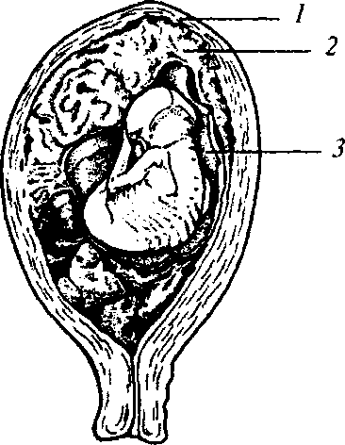
At incipient abortion pain is usually stronger, frequent urination, blood-tinged discharge appears (Fig. 86). Uterine tone increase is observed, further shortening and di-
Fig. 85. Missed abortion:
1 — wall of uterus; 2 — placenta; 3 — amniotic fluid remains
182

Chapter 15. Noncarrying of Pregnancy

Fig. 86. Incipient abortion
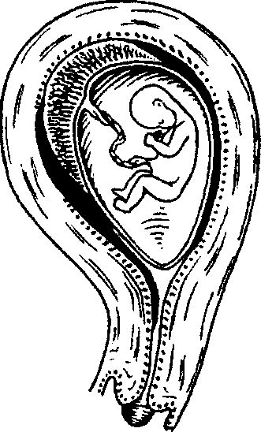
lation of the uterine neck. The fetal egg detaches over a short period of time, therefore uterine dimensions correspond to the term of pregnancy.
Progressing abortion (Fig. 87) is characterised by intense spasmodic pain, significant bleeding, amniotic fluid leakage. The cervical canal of uterus is dilated, the fetal egg is in the cervical canal.
At incomplete abortion a part of the fetal egg comes out and a part remains in the uterine cavity (Fig. 88). Pain in the underbelly is of low intensity, bloody discharge from the cervical canal is of different degree of manifestation. The size of the uterus does not correspond to the term of pregnancy (it is smaller), uterine consistency is not dense. The cervical canal is dilated.
At complete abortion (Fig. 89) the fetal egg is completely released
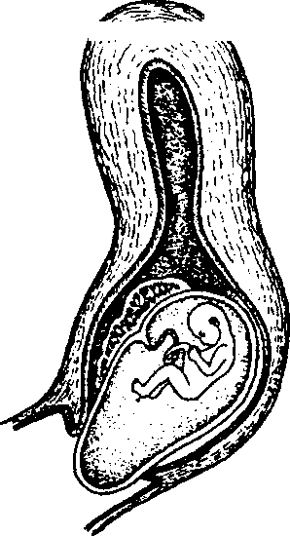
from the uterine cavity, the uterus con
tracts, bleeding stops. The cervical canal
^/•?^~~?^k is closed, sometimes not completely.
Infected abortion due to its protracted course may cause generalized septic diseases up to septic shock. There are differentiated uncomplicated infected, complicated infected and septic abortions.
Diagnostics
During examination of the pregnant woman attention is paid to the presence of pain syndrome, bleeding character, uterine tone (beginning from the 2nd trimester), uterine neck condition, size of the uterus. Besides, one should conduct pelvic ultrasound (if there are indica-Fig. 87. Progressing abortion tions to vaginal sensor application).
183

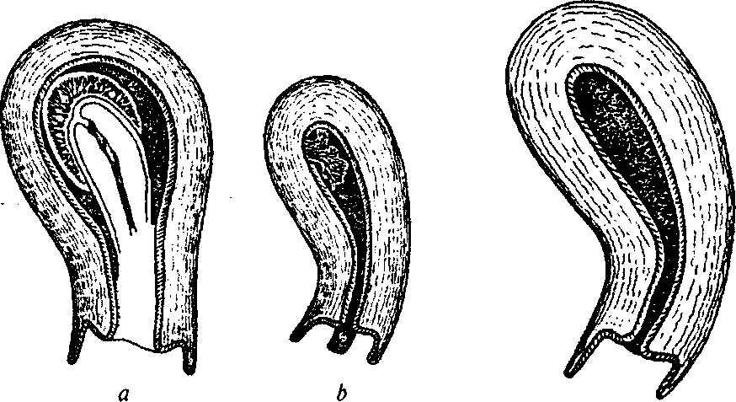
PATHOLOGICAL OBSTETRICS
Fig. 88. Incomplete abortion: Fig. 89. Complete abortion
a — there is afterbirth in the uterus;
b — there isa part of afterbirth in the uterus
Echographic signs of threatened abortion: presence of local myometrium thickening, deformation of fetal egg contours due to uterine hypertension, low location of the fetal egg in the uterine cavity. At incipient abortion ultrasound finds myometrium tone increase, partial detachment of the fetal egg (placenta), further shortening and dilation of the uterine neck. At progressing abortion: the fetal egg is located low, partially in the cervical canal. Ultrasound signs of incomplete abortion are uterine cavity dilation, the fetal egg is not visualized. At complete abortion the uterine cavity is free, slit-like.
For laboratory methods of investigating spontaneous abortions the following factors are important:
- inadequacy of HCG level in blood serum with the regnancy term;
- decrease of progesterone level in blood serum and violation of estrogens and progesterone content ratio;
- increase of the content of free estriol and the change of ct-feto-protein concentration in the blood serum;
- colpocytogram change (estrogenic smear, karyopyknotic index increase to 50 % and more).
In consideration of the heterogeneity of spontaneous abortions reasons endocrine disorders diagnostics is very important. Thus, at hyperandrogenism there is observed the increase of dihydroepiandro-
184
Chapter 15. Noncarrying of Pregnancy
stenedione, Cortisol, testosterone, 17-hydroprogesterone, 17-ketoste-roids, androsterone in blood. If the function of thyroid gland is impaired, the concentration of T₃, T₄, thyrotrophs hormone and thyroid-stimulating antibodies changes.
Among the etiologic factors of spontaneous abortion development infectious diseases take a special place. Therefore it is necessary to examine pregnant woman for TORCH infections, conduct bacterioscopic and bacteriological investigation of discharge.
Treatment
Therapeutic approach at spontaneous abortions: at threatened and incipient abortions there is conducted therapy aimed at maintenance of pregnancy; in other cases — instrument extraction of the fetal egg and its remains.
TREATMENT OF EARLY SPONTANEOUS ABORTION
One should remember that the 1st trimester of pregnancy is the most difficult period, when embryogenesis takes place, the placenta forms and complicated relation of the mother and fetus are established. In this period treatment is to be conducted in such a way that drugs do not have any embryotoxic action. Therefore the therapy of spontaneous abortions at early terms of pregnancy is based on the following measures:
- Hospitalization at threatened abortion symptoms.
- Bed rest.
- Normalization of the neuropsychic condition of the pregnant woman: psychotherapy and sedatives (valerian or motherwort tincture, 10—20 drops 2—3 times a day), persen (1 pill 2—3 times a day), phytosed (1 teaspoon 2—3 times a day).
- Spasmolytic therapy: papaverine, "viburkol" — rectal suppositories (1—2 times a day).
- Vitamin therapy: vitamin E 100—200 mg a day orally in the form of capsules, complex multivitamin preparations (pregnavit, ele-vit, materna, theravit, etc.).
As for hormonal therapy at early terms of pregnancy, a number of researches give controversial data concerning the possibility of unfavorable influence of steroid sex hormones on the fetus.
At the present level of knowledge one should keep to the point that administration of hormonal preparations is substantiated only
185
PATHOLOGICAL OBSTETRICS
at proved hormonal disorders, which are an etiological factor of spontaneous abortion, taking into account the gynecological status and laboratory indices of the level of hormones in blood (progesterone, estradiol, free testosterone, dihydroepiandrosterone, etc.). One should take into account the fact that hormonal disorders may be connected not so much with the level of hormones and their activity, as with changes at the level of receptor apparatus. One "should remember that application of sex steroid hormones is more intensively administered up to 12—24 weeks of pregnancy, because further on the formed placenta takes the hormone producing function upon itself.
Doses of preparations are selected individually using the guidance of clinical and laboratory indices:
- gestagenic preparations: utrogestan (natural micronized progesterone) 100 mg 2—3 times a day vaginally or orally (didrogestero-ne) — 20 mg orally in one stage, and then 10 mg twice a day; 1 % progesterone 1.0 i.m. The preparations are withdrawn gradually, sharp withdrawal may cause abortion;
- an estrogen used is estradiol valerate (1—2 pills a day) — only by strict indications;
- preparations of chorionic gonadotropin (pregnil, prophase);
- at hyperandrogenemia corticosteroids application is indicated: prednisolone — 1.25—5 mg, dexamethasone — 0.125—0.5 mg a day orally.
TREATMENT OF LATE SPONTANEOUS ABORTION
Except for the listed above measures the treatment of late spontaneous abortions includes tocolytic therapy.
Tocolytic therapy (tocolytic agents are preparations inhibiting uterine activity:
- magnesium sulfate (after 12 weeks) i.v. drop-by-drop (20— 30 ml 25 % MgS0₄ with 200 ml of physiologic saline); MgB₆ 2 capsules 3 times a day);
- selective p₂-adrenoceptor agonists (from 14—16 weeks), in particular gynipral in the dose of 10 meg (2 ml) or 25 meg (5 ml) with 200—400 ml of physiologic saline and gynipral pills (one pill every 3 h, and then in 4—6 h).
To eliminate the side action of P₂-adrenoceptor agonists and with the purpose of additional tocolysis Ca canal blockers are administered
186
Chapter 15. Noncarrying of Pregnancy
simultaneously — finoptin, isoptin, lecoptin 2 ml (5 mg) i.v. or 1 pill (40 mg) orally thrice a day.
As a complex therapy of late spontaneous abortion there may be used nonsteroid antiinflammatory agents (indometacin, sulindac, naproxen). Their inclusion into complex therapy is based on modern data concerning their role in the blockade of the production of endogenous prostaglandins, which are known to increase the .contractive activity of myometrium. At the same time, we consider it necessary to emphasize that the proved negative influence on the mother and fetus (may cause preterm closure of the arterial duct — in 62 % cases, endogastric hemorrhages —28 %, necrotizing enterocolitis — 29 %, oligohydramnios — 11 %, etc.) limits their usage with the purpose of treatment and prophylaxis of spontaneous abortions.
TREATMENT OF ISTHMICOCERVICAL INSUFFICIENCY
Isthmicocervical insufficiency is a pathological condition, which arises as a result of inefficiency of the closing function of the uterine neck and is accompanied by painless smoothing and dilation of the uterine neck.
The most frequent reasons for isthmicocervical insufficiency are surgical or other injuries, malformations (organic insufficiency) and endocrine disorders (functional insufficiency) of the uterine neck.
There are used both conservative (hormonal therapy at functional isthmicocervical insufficiency) and surgical treatment means (Fig. 90).
Surgical treatment consists in placing a circular suture on the uterine neck at the level of its internal orifice to narrow the cervical canal (Macdonald's, Shirodkar's, Liubymova's operations). Nonabsorbable suture material is used.
To guarantee successful outcome such conditions are satisfied:
- optimal terms of operation — 12—16 weeks, although it is possible to place a suture at later and earlier terms of pregnancy;
- bacterioscopic and bacteriological investigation of material from the genitourinary tracts of the woman in the period of preparation to the operation;
- tocolytic therapy during operation and in the postoperative period;
- consideration of contraindications to operation:
— concerning the mother — relative: evident uterine hypertension, colpitis; absolute: impossibility of pregnancy carrying because of the mother's state of health, intrauterine infection;
187
PATHOLOGICAL OBSTETRICS

Fig. 90. Placing a circular suture on the region of the internal mouth of uterine neck
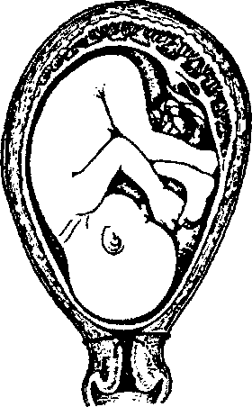
— concerning the fetus — maldevelop-ments.
After the surgery bed rest is indicated during 1—2 days. The suture is'removed at 37—38 weeks, when amniotic fluid discharges or at the beginning of preterm labor.
15.2. INDUCED ABORTION
The problem of birth control, questions of conscious paternity and family planning are topical. According to the WHO, more than 35 million women (about 8 %) terminate pregnancy annually.
Induced abortion causes an irreversible damage to the woman's health, reproductive health of both spouses. Even if there are no appreciable complications right after abortion, it will make itself felt with time and may cause noncarrying of pregnancy (spontaneous abortions and preterm delivery) and other complications of pregnancy and delivery, and also infertility. Thus, the question of the optimal choice of the method of pregnancy termination acquire top priority.
Abortion is any termination of pregnancy during the first 22 weeks. There are differentiated pregnancy termination at early (till 12 weeks) and late terms (from 12 to 22 weeks).
Depending on the methods and reasons for pregnancy termination there are differentiated artificial and spontaneous abortions.
Criminal abortion is conducted out of a medical institution.
Induced abortion is regulated by law in different countries. In some countries induced abortions are forbidden.
Therapeutic (induced) abortion is premeditated termination of pregnancy caused by the influence directly on the fetal egg, uterus, organism of the pregnant woman.
Induced abortion is carried out in the day facility of the antenatal clinic and gynecological departments of medical institutions by an obstetrician-gynecologist of the countries where it is permitted by the law.

Chapter 15. Noncarrying of Pregnancy
Induced termination of pregnancy with the term not exceeding 12 weeks, in the patient older than 14, according to the laws of Ukraine, may be conducted at woman's will. If the patient is younger than 14 or is incapable, abortion may be conducted by an application of legal representatives.
Induced termination of pregnancy at the term of 12—22 weeks is conducted in exceptional cases in the presence of medical indications, indications of non-medical character (the pregnant woman's age less than 15 and more than 45, an invalidity taking place during the pregnancy) by an application of the pregnant woman or her legal representatives (in case of non-age, disability of the person, etc.), on the ground of the conclusion of the Committee detecting indications to induced termination of pregnancy.
Medical indications to the induced termination of pregnancy arise when pregnancy and delivery threaten the health and life of the woman, CNS diseases accompanied by mental insanity, severe diseases of the cardiovascular system, liver, kidneys, malignant formations, open tuberculosis forms, severe forms of toxicosis resisting treatment, intrauterine fetal death, severe forms of hereditary diseases, congenital fetal malformations incompatible with life, etc.
The volume of examination before conducting therapeutic abortion: general examination, examination of the neck of uterus in specula, vaginal examination, bimanual examination, blood grouping, Rh-fac-tor detection, blood analysis for RW, HIV, HBsAg, minute analysis of urogenital discharge, cytological investigation, colposcopy, US, etc. by indications.
It should be noted that acute and chronic inflammatory diseases of female genital tracts, acute infectious diseases (angina, influenza, pneumonia, etc.), the 3rd—4th degree of vagina cleanness are relative indications to induced abortion. In these cases it is expedient to conduct induced abortion after an appropriate course of treatment.
Before conducting the induced termination of pregnancy there is conducted the pre-abortion consultation of the pregnant woman concerning peculiarities of the operation, possible complications, recommendations connected with abortion and postabortal contraception.
After abortion the woman gets information about contraception of unwanted pregnancy.
Methods of induced abortion till 12 weeks of pregnancy:
— the operation of vacuum aspiration — at menstruation delay not more than 20 days;
189
PATHOLOGICAL OBSTETRICS
- the operation of endometrectomy (uterine cavity curettage) — at pregnancy term less than 12 weeks;
- medicamental abortion — less than 49 days from the first day of the last menstruation.
The operation of induced pregnancy termination is conducted with compulsory anesthesia, whose method is selected individually.
It should be noted that after 12 weeks the placenta is formed, dimensions of the uterus and fetus are rather large, which conditions application of other methods of pregnancy termination given below.
Medicamentally induced termination of pregnancy is conducted by the woman's will at the term less than 49 days from the first day of the last menstruation. Medicamental abortion is carried out by an obstetrician-gynecologist in the conditions of the gynecological or day department of an accredited medical institution capable of rendering emergency help.
Contraindications to medicamental abortion: no justifiable information about pregnancy, suspected extrauterine pregnancy, pregnancy term exceeding 49 days from the first day of the last menstruation, an intrauterine device, allergy to preparations used to conduct this method, adrenal insufficiency, long-term glucocorticosteroid therapy. damaged coronary or cerebral vessels, renal insufficiency, liver impairment, porphyria, hemostasis system disturbance, uterine leiomyoma, a uterine scar, breast feeding, the woman's age exceeding 35 years, active tobacco smoking (more than 10 cigarettes a day), sever bronchial asthma, cardiovascular diseases.
Medicamental abortion is carried out by means of using preparations of mifepristone, which has an antiprogesterone action, with mandatory further (in 36—48 h) intake of misoprostol (prostaglandin E). In a couple of hours (as a rule, during 3—6 h) after misoprostol intake blood-tinged discharge begins because of fetal egg expulsion. On the 7th—10th day the patient is to be examined with obligatory ultrasound investigation to confirm the absence of the fetal egg in the uterine cavity. In case of incomplete removal of the fetal egg and continuous bloody discharge diagnostic curettage of the uterine cavity is conducted with further referral of the obtained material for histological inspection.
Induced abortion by the method of vacuum aspiration. Vacuum aspiration is conducted by apparatus and manual (syringe) methods at menstruation delay up to 15—20 days, at the term of pregnancy not exceeding 8 weeks. The method of vacuum aspiration is the safest surgical method of pregnancy termination. It should be added that
Chapter 15. Noncarrying of Pregnancy
the less the pregnancy term, the less dangerous abortion for the woman's health.
Before the operation there is conducted vaginal examination to detect uterine dimensions and position. Then the vagina is opened with specula, processed with alcohol and 5 % iodine alcoholic solution. The anterior lip of uterine ostium is grasped with the bullet forceps and taken out. By means of probing uterine cavity dimensions and cervical canal direction are detected; the cervical canal is later dilated with the Hegar's dilator. At the term of pregnancy less than 5 weeks vacuum extraction may be conducted without cervical canal dilation. At the term of 6—8 weeks anterior dilation of the neck of uterus is conducted with the Hegar's dilator up to No. 8. After canal dilation a tube of vacuum aspirator connected with a vacuum suction device is introduced into the uterine cavity. After this the vacuum suction device is turned on and negative pressure is created in the uterus up to 0.8—1.0 atmospheres.
If manual vacuum extraction is conducted, the necessary negative pressure is created with the help of a plastic aspirator with the volume of 60 ml, which is held in hands (a syringe) and brought into action manually.
The endometrectomy operation is performed in the gynecological department of an accredited medical institution by an obstetrician-gynecologist.
The first stages of the operation till cervical canal dilation are the same as in the vacuum extraction. After cervical canal dilation with the Hegar's dilator up to No. 12 the fetal egg is destroyed and removed from the uterine cavity with a metal curette. If the pregnancy term makes from 9 to 12 weeks except for the curette the abort forceps are also used. The operation is considered completed when all the elements of the fetal egg are removed from the uterine cavity, the uterus has contracted, and there is no hemorrhage.
After conducting the induced termination of pregnancy by a surgical method one must immediately examine the material from the uterine cavity to exclude the possibility of extrauterine pregnancy. In case of need the material is referred for histological investigation.
After induced abortion the woman stays in the in-patient department under the supervision of medical personnel. One should observe the general condition, body temperature, dynamics of uterus contraction and discharge from the genital tracts. US is mandatory. The duration of stay after the operation of induced pregnancy termination is detected by the doctor depending on the patient's condition. Not later than 48 h
191
PATHOLOGICAL OBSTETRICS
after the induced abortion women with Rh-negative blood are introduced 1 dose of anti-Rh immunoglobulin i.m. if there is no immunization. On the 7th—10th day patient's examination and US are carried out.
Induced abortion at the term from 12 to 22 weeks of pregnancy. The late therapeutic abortion is conducted by different methods depending on the pregnancy term, general condition of the woman's health, obstetric anamnesis.
Methods of induced abortion at the term from 12 to 22 weeks:
- induced abortion with application of preparations of mifepristone (orally), misoprostol (orally and intravaginally), prepidil (prostaglandin E) gel (endocervically);
- intraamniotic introduction of dinoprost (prostaglandin F2);
- intracervical introduction of gel with dinoproston (prostaglandin E) with the following induction of uterine contractions by means of i.v. introduction of dinoprost solution;
— intraamniotic introduction of hypertensive NaCl solution.
Sometimes minor cesarean section is resorted to, vaginal cesarean
section at the pregnancy term of 16—20 weeks if by medical indications the pregnancy is to be urgently terminated (severe gestosis, essential hypertension, acute cardiovascular collapse, etc.) at unprepared parturient canal.
After induced abortion endometrectomy is to be conducted.
It is important to know that induced abortion negatively influences the woman's health, which is explained by forced intervention into the hormonal state. Pregnancy termination is an extraordinary stress for the hormonal and nervous systems of the organism. The most frequent abortion complication is acute and chronic inflammatory disease of genitals, which becomes a reason for hormonal dysfunctions, violates the woman's reproductive function (infertility, spontaneous abortions, extrauterine pregnancy). Surgical intervention during abortion may be accompanied by a trauma of the neck of uterus and uterus itself. All this increases the risk of benign and malignant tumors development in future. Thus, after abortion rather frequently there may arise future complications with serious consequences, whose treatment may be long-term and expensive and not always have a positive result.
Women, who have abortion in the anamnesis, at following pregnancy and delivery not infrequently have such complications as placental presentation, pathological attachment and fused placenta, powerless labor, hypotonic bleeding, etc.
192
Chapter 15. Noncarrying of Pregnancy
Every pregnant woman must remember that abortion may deteriorate the psychological climate in the family. Arising malfunctions of the reproductive organs negatively influence sexual relations. Such complications as noncarrying of pregnancy and infertility may cause social tension in the family and divorce.
15.3. PRETERM DELIVERY
Preterm delivery is delivery with spontaneous beginning, progressing birth activity and delivering a fetus weighing 500 g and more at the term of pregnancy from 22 full (the 154th day from the 1st day of the last menstruation) to 37 full weeks.
The problem of preterm delivery is of great medical and social importance. According to the WHO, this pathology makes 5—10 %. Mortality among premature children makes 75 % of all neonatal mortality. Remote effects of premature children are: nervous system pathology (cerebral palsy), neuropsychic development delay, respiratory tract pathology (bronchopulmonary dysplasia), blindness and deafness.
In connection with the peculiarities of obstetric management of delivery and nursing of the children, who were born in different terms of gestation, the following periods should be singled out:
- 22—27 weeks — too early preterm delivery;
- 28—33 weeks — early preterm delivery;
- 34—37 weeks — preterm delivery.
Preterm delivery in the term of 22—27 weeks is most often caused by the infection of the inferior pole of the fetal bladder and its premature rupture, isthmic-cervical insufficiency. The fetal lungs are immature, administration of corticosteroids to the mother does not reduce the frequency and severity of respiratory distress-syndrome of newborns. Perinatal mortality is extremely high. Among all premature newborns in this group (22—27) the following remote effects are the most frequent:
- CNS pathology (for instance, cerebral palsy);
- neuropsychic development delay;
- respiratory tract pathology (bronchopulmonary dysplasia);
- blindness and deafness.
Preterm delivery at the term of gestation of 28—33 weeks is conditioned by various reasons. The fetal lungs are immature, but administration of corticosteroids to the mother leads to the acceleration of their maturing and reliable reduction of respiratory distress-syndrome of newborns.
193
PATHOLOGICAL OBSTETRICS
Effects of preterm delivery at the terms of gestation of 34—37 weeks on the fetus are the most favorable in comparison with previous groups as the fetus already has mature lungs.
At the present stage of obstetric help organization in Ukraine it is optimal to conduct preterm delivery at the term till 34 weeks in medical establishments of the 3rd level of accreditation, which have conditions for intensive therapy and .neonatal resuscitation. It is expedient to secure the rights of the parturient woman to the presence of relatives at delivery.
Risk factors are:
- low socioeconomic standard of living;
- psychoemotional disturbances;
- preterm delivery in anamnesis;
- premature discharge of amniotic fluid;
- asymptomatic bacteriuria;
- chorioamnionitis;
- hemorrhages during pregnancy;
- isthmic-cervical insufficiency;-
- uterus development anomalies;
- mother younger than 18 and older than 35;
- low body weight before pregnancy;
- smoking, drug addiction, stress;
- multifetation;
- congenital defects of fetal development;
- mother's disease;
- injuries during pregnancy;
- reiterated abortions at late terms;
- bacterial vaginitis in women with preterm delivery in anamnesis.
Although the risk factors of preterm labor activity development are well-known, there is no effective strategy of preterm delivery prevention at the moment. Still, it has been proved that detection and treatment of bacterial vaginitis and asymptomatic bacteriuria in women, especially those who have preterm delivery in anamnesis, reduce the risk of delivering fetuses with low body weight and premature discharge of amniotic fluid.
Preterm delivery prediction:
1. The presence of fetal fibronectin (fFN), which structurally differs from the fibronectin of adult tissues, in the secretion of the uterine neck and vagina in the 2nd and 3rd trimesters of pregnancy, allows detecting women with a high risk of preterm delivery.
fFN appearance is connected with the separation of the amniotic
194
Chapter 15. Noncarrying of Pregnancy
and decidual membranes of uterus and discharge of components of territorial matrix into the cervical canal and vagina.
fFN presence in the cervicovaginal discharge at the term till 35 weeks is associated with preterm labor activity and preterm delivery. fFN absence indicates low probability of delivery during the next 4 weeks even at the presence of uterine contractions.
- Measuring the length of the uterine neck during transvaginal ultrasonography (US). The neck length depends on the term of gestation. The average length at the term of 24 weeks makes 34—36 weeks. The probability of preterm delivery increases if the neck length makes less than 25 mm. If the length of the uterine neck is less than (or equal to) 15 mm, the risk of preterm delivery makes 50 %.
- Appearance after 22 weeks of pregnancy of regular cramp-like pains in the abdomen and loin with mucobloody or watery discharge from the vagina (in case of amniotic fluid discharge). The presence of one labor pain in 10 min lasting 15—20 sec leads to the change of form and location of the uterine neck — its progressing contraction and smoothing (the length of the cervical canal less than 1 cm, the neck is dilated by 3—4 cm, the speed of cervical dilatation of 0.8 cm/h). Gradual descending of the fetal head into the pelvis. All this testifies to preterm delivery.
Principles of conducting preterm delivery:
- Evaluating the degree of the risk of the development of maternal and perinatal pathology with the purpose of detecting the level of inpatient care.
- Detecting the plan of conducting delivery and informed agreement of it with the woman.
- Controlling the condition of the mother and fetus, filling in a partogram. After 30 weeks of pregnancy at the presence of necessary equipment and trained medical staff it is recommended to control the condition of the fetus by means of constant fetal monitoring (car-diotocography).
- Using corticosteroids with the purpose of preventing respiratory distress-syndrome till 34 weeks of pregnancy.
- Labor anesthesia by indications.
- Assessment of the condition of the premature newborn and provision of proper nursing: thermal chain maintenance, primary toilet of the newborn, rooming-in from the first hours after birth, wider application of the "kangaroo" method in low-weight children.
- Provision of necessary treatment of the newborn by indications: timely and adequate primary resuscitation in the maternity
195
PATHOLOGICAL OBSTETRICS
ward, quick transportation to the neonatal resuscitation department following the principles of thermal chain, respiratory support and surfactant application, rational antibiotics usage. Peculiarities of preterm delivery management:
1. If it is necessary and if there are no contraindications, the preg
nant woman is transported to the hospital of the 3rd level.
Contraindications to transportation: unstable condition of the pregnant woman, unstable condition of the fetus, the end of the 1st period of pregnancy, absence of an experienced attendant, bad weather conditions or other dangerous factors during transportation.
2. Corticosteroid therapy application allows considerable reduc
tion of respiratory distress-syndrome risk. Betamethasone and dexa-
methasone, penetrating through the placenta, stimulate the enzymes,
which accelerate maturing of the fetal pulmonary tissue. 48 h are
needed to obtain the full-value result. Still, even an unfinished course
of steroid therapy may have an appreciable effect.
Fetal respiratory distress-syndrome prevention is carried out from 24 till 34 weeks of pregnancy:
- under the threat of preterm delivery i.m. introduction o f dexa-methasone — 6 mg every 12 h (24 mg per course) or betamethasone — 12 mg every 24 h (24 mg per course);
- in case of preterm delivery beginning i.m. introduction of dexa-methasone — 6 mg every 6 h (24 mg per course) or betamethasone — 12 mg every 12 h (24 mg per course).
Refresher courses of corticosteroids are not conducted.
Corticosteroids application at the term of 22—28 weeks does not have considerable influence on the frequency of fetal respiratory distress-syndrome but is accompanied by credible reduction of the frequency of severe intraventricular hemorrhages, necrotizing enterocolitis, patent ductus arteriosus, and also improves the results of surfactant therapy and allows reducing the surfactant dose.
Corticosteroids application at the term of 28—34 weeks is accompanied by credible reduction of the level of fetal respiratory distress-syndrome, severe intraventricular hemorrhages, necrotizing enterocolitis, generalized infections during the first 48 h after birth, and also the level of neonatal mortality.
Refresher courses of corticosteroid therapy till 34 weeks of pregnancy are not effective. Thus, they reduce the frequency and severity of fetal respiratory distress-syndrome, but do not reduce perinatal mortality. Moreover, refresher courses of such treatment in the antenatal period may have negative consequences for the fetus, notably
Chapter 15. Noncarrying of Pregnancy
fetal weight loss, psychic development delay, behavioral disorders, sepsis risk increase.
It should be admitted that only betamethasone usage in comparison with dexamethasone is accompanied by credible reduction of perinatal mortality rate.
If emergency delivery is indicated, steroids effect is not expected.
Corticosteroids should not be used at infection presence because of immunosuppression risk. Steroid therapy leads to the increase of the leucocytes and glucose level in blood, therefore it should be applied carefully in patients with diabetes mellitus.
3. Tocolytic therapy is carried out till 34 weeks of pregnancy at cervical dilation less than 3 cm or at treating the threat of preterm delivery with the purpose of conducting corticosteroid therapy and if it is necessary to transfer the pregnant woman to the neonatal centre, no more than 24—48 h (A).
For tocolytic therapy there may be used oxytocin antagonists, p-mimetics, calcium channel-blocking agents, and magnesium sulfate.
Contraindications to tocolysis at preterm delivery:
- any contraindications to pregnancy prolongation;
- gestational hypertension with proteinuria and other medical indications;
- chorioamnionitis;
- a mature fetus;
- fetal death or fetal malformations incompatible with life;
- contraindications to individual tocolytic agents.
Tocolytic preparations usage prolongs pregnancy, but there are no proofs that it leads to reduction of perinatal morbidity and mortality.
Comparative investigations show that oxytocin antagonists — an-thocin, anthozyban — have the same efficiency as p-mimetics. At the usage of oxytocin antagonists side effects are much rarer in the mother.
P-mimetics promote pregnancy prolongation but do not lead to perinatal mortality reduction.
The usage of nifedipine — a calcium channel-blocking agent — for tocolysis is accompanied by credible prolongation of pregnancy, reduction of necrotizing enterocolitis frequency, intraventricular hemorrhages, but any influence on the index of perinatal mortality is absent.
There has not been noticed any efficiency of administering bed rest, sedation and magnesium sulfate for pregnancy prolongation. Tocolysis methods are chosen individually.
At the application of magnesia tocolysis antenatal and children's mortality increases (5 % to 2 %) in comparison with other tocolytics.
197
PATHOLOGICAL OBSTETRICS
4. Intranatal antibacterial therapy is indicated if there are signs
of infection.
At premature discharge of waters and incomplete pregnancy prophylactic administration of antibiotics leads to statistically credible reduction of the frequency of postnatal infections in the mother, neonatal infections, detecting positive hemoculture (A). Macrolides are preferred to broad spectrum antibiotics, since at equal efficiency with semisynthetic penicillins or cephalosporins macrolides cause less complications.
Expectant management (without labor activity induction) at premature discharge of waters may be chosen:
- in pregnant women with a low level of predicted perinatal and obstetric risk (A);
- at satisfactory fetal condition;
- if there are no clinicolaboratory signs of chorioamnionitis (body temperature increase to >38 °C, amniotic fluid smell, fetal heartbeats > > 170 bpm; the presence of two or more symptoms gives grounds for chorioamnionitis diagnosis);
- if there are no complications after discharge of waters (loops of cord prolapse, detachment of placenta, and other indications to urgent delivery).
Monitoring of the mother's and fetus' condition without carrying out internal obstetric examination is conducted under conditions of the obstetric department of the 3rd level of rendering medical aid.
At 35—36 weeks of pregnancy, if there are no signs of infection, antibacterial therapy is begun in 18 h of waterless interval (A). If there is no risk of spontaneous birth activity, internal obstetric examination is conducted in 24 h. If the uterine neck is mature, induction is begun in the morning (after 6 a.m.) with oxytocin or prostaglandins (B); if the neck is immature, preparation to labor is carried out by means of intravaginal introduction of prostaglandin E₂ (A). Cesarean section is conducted by indications (A).
- Labor anesthesia, at informed consent of the pregnant woman, is carried out in the same way as at physiological labor. Narcotic analgesics are not used.
- Management of the expulsive and placental stages of labor is the same as at physiological labor.
Conventional pudendal anesthesia or episioperineotomy are not conducted. The expulsive stage of labor is conducted in the presence of a neonatologist, after birth the newborn is given to the neonatologist.
7. Enema and pubis shave are not administered (as at physiologi
cal labor). In the early puerperal period an ice pack is not applied to
the underbelly.
Chapter 16
PLACENTAL INSUFFICIENCY. FETAL DEVELOPMENT DELAY
16.1. PLACENTAL INSUFFIENCY
Placental insufficiency (PI) is a symptom complex conditioned by violations of transport, trophic, metabolic, and endocrine functions of the placenta due to structural changes in it.
Reasons: gestoses, miscarriage threat, immunoincompatible pregnancy, intrauterine infection, mother's diseases (pyelonephritis, essential hypertension, diabetes mellitus, anemia), etc.
Classification
/. By the term of onset:
- primary — develops in the terms of placenta formation (till the 16th week);
- secondary — usually develops after the processes of placenta formation have finished.
II. By the course: acute and chronic. Acute PI appears at cute violation of decidual perfusion, for instance, at abruption of placenta — sharp violation of blood supply leads to fetal hypoxia or death.
Chronic PI is characterised by gradual worsening of decidual perfusion as a result of the reduction of compensatory-adaptive reactions of the placenta to the action of pathological conditions of the maternal organism, has a long-term course, is accompanied by disorders, chronic oxygen starvation of the fetus.
Chronic PI (depending on the condition of compensatory-adaptive reactions) includes:
1. Relative — compensatory-adaptive reactions are preserved in the placenta:
— compensated (the phase of persistent hyperfunctioning) develops at a threat of miscarriage and not severe forms of gestoses in cases, when these complications are successfully medically corrected;
199
PATHOLOGICAL OBSTETRICS
— subcompensated (the phase of exhaustion of compensatory mechanisms, which have begun) — is more often observed in the women, in whom a complicated course of pregnancy is developing against the background of extragenital pathology.
2. Absolute (decompensated) — the severest form of PI characterised by derangement of compensatory-adaptive reactions and develops against the background of chorion ripening disorders at placenta damages of involutive-dystrophic, circulatory and inflammatory character.
Diagnostics
- Regular clinical observation.
- Dynamic ultrasonography in the 1st, 2nd, and 3rd trimesters.
- Dopplerometry.
- Investigation of the hemostasis system.
- Detecting the content of estradiol, progesterone, chorionic gonadotropin, and a-fetoprotein in the blood serum.
- Investigation of estradiol secretion with urine.
- Detecting the content of oxytocinase, general and placental basic phosphatase in the blood serum.
- Colpocytologic investigation.
Detection of the height of uterine fundus standing (HUFS) is very important in PI diagnostics, the diagnostic value of this method at the term of 32 weeks makes 76 %.
The main method of PI detection is ultrasonographic placento-metry, which enables assessing placenta thickness, area, and structure. Placenta thickness from the 20th till the 36th week of pregnancy approximately equals the term of pregnancy in weeks: at 20 weeks — 20 mm, at 28 weeks — 28 mm, at 36 weeks — 36 mm, after this term the placenta does not thicken further. Placenta thinning (less than 20 mm) or thickening (more than 50 mm) testifies to PI, which appeared as a result of intrauterine infection, immunization, etc.
At placentography there is carried out the assessment of placenta maturity by structure density singling out 4 maturity degrees (0—3). The 1st degree is characteristic of the 28th—32nd week of pregnancy, the 2nd— 32nd— 37th week, the 3rd degree of placenta maturity is characteristic of the term of pregnancy of 38—39 weeks, if it is detected earlier, it testifies to premature placenta aging and fetoplacental insufficiency.
Ultrasonography also detects the biophysical fetal profile on the basis of its functional condition, qualitative and quantitative (in
200
Chapter 16. Placental Insufficiency. Fetal Development Delay
points) assessment of the indices of non-stress test, respiratory movements, motion activity, tone, amniotic fluid volume, placenta maturity degree. Normal indices'of biophysical profile make 9—12 points.
Modern examination methods also include dopplerometric assessment of the blood flow. The essence of Doppler method consists in the fact that depending on the speed of object moving relative to the source of wave radiation the length of the wave of reflected radiation changes. Such devices are used for the qualitative assessment of blood flow in different vessels of the pelvic cavity of the pregnant woman: the uterine artery, carotid artery, umbilical artery, the descending part of the fetal aorta, medial cerebral artery. In case of necessity there are investigated the curves of speed performance of blood flow in the vessel under consideration.
Most often investigation is conducted in the umbilical artery and medial cerebral artery. Blood flow in the umbilical artery is detected by the contractile function of the fetal heart and resistance of the vessels of the fetal part of placenta, whose vascular resistance plays the main role in fetoplacental hemodynamics. The condition of blood flow in this vessel is the most informative index of the vascular resistance of the placental bloodstream.
Diagnostic criteria:
Normal blood flow — a high diastolic component in the dopplero-gram relative to the isoline, the ratio of systole amplitude to diastole is not more than 3.
Pathological blood flow:
- decelerated blood flow — diastolic component reduction, the ratio of systole amplitude to diastole is more than 3;
- terminal blood flow testifies to a strong probability of antenatal fetal death;
- zero blood flow stops in the diastole phase (there is no diastolic component in the dopplerogram);
- negative blood flow acquires reverse direction in the diastole phase.
At PI blood supply to the medial cerebral artery increases. This brain-sparing phenomenon reflects the compensatory centralization of blood supply to the essential fetal organs.
Investigation of the content of placental hormones and fetoplacental complex (estriol, placental lactogen, choriomammotropin, etc.) in biological fluids may diagnose violations of fetal condition at the presence of different pregnancy complications or extragenital pathology. The severity of fetal condition correlates with the amount of secreted hormones.
201
PATHOLOGICAL OBSTETRICS
16.2. FETAL DEVELOPMENT DELAY
Fetal development delay (FDD) or fetal hypotrophy is a pathological condition, at which the newborn's weight or biometric parameters of the fetus are not up to gestational age.
Classification
- Symmetric — the weight and length of the fetus are proportionally reduced, all the organs are evenly reduced in size;
- asymmetric — fetal weight reduction at normal indices of its length, unproportional dimensions of different fetal organs (Table 13).
Table 13. Differential FDD Diagnostics

 | Symmetric | Asymmetric
Beginning | 2nd trimester" | 3rd trimester
Fetometry | Delay of all dimensions increase | Delay of abdomen dimensions increase
Placental blood flow disorders | From the 24th-25th week | After 32 weeks
Amniotic fluid | Oligohydramnios | Norm
Malformations | Frequent | Rare
At symmetric hypotrophy newborns have small body weight at birth, such a child can not be differentiated from a premature newborn. The symmetric form is observed at severe disorders of intrauterine development beginning from the 2nd pregnancy trimester. At asymmetric FDD newborns have a considerable weight deficit at normal body length. This from is characteristic of the fetuses, in which unfavorable development conditions began in the 3rd pregnancy trimester.
There are differentiated 3 degrees of FDD severity:
- the 1st degree — delay by 2 weks;
- the 2nd degree — from 2 to 4 weeks;
- the 3rd degree — more than 4 weeks.
FDD takes place due to the following reasons: chromosome anomalies and hereditary metabolic disorders, congenital defects caused by other factors, prenatal viral infections, action of ionizing radiation and medicinal preparations, placenta pathologies, mother's diseases, intoxication, malnutrition.
202
Chapter 16. Placental Insufficiency. Fetal Development Delay
Diagnostics
If FDD is suspected, complex examination of the pregnant woman is conducted including:
- Detection of the HUFS and abdomen circumference in dynamics (the weight of the woman should be taken into account). HUFS dimensions delay by 2 cm or the absence of any amount of growth during 2—3 weeks at dynamic observation-allows suspecting FDD.
- Sonographic fetal biometry. To asses fetal biometry there are detected the biparietal diameter of the fetal head (BDFH), diameter of the chest and abdomen, length of the fetal hip. Gestational age of the fetus is assessed by the complex of signs. If there is detected inadequacy of one or a couple of basic fetometric indices to pregnancy term, extended fetometry is conducted, correlation of the frontooc-cipital and biparietal dimensions, head and abdomen circumference, biparietal dimension and hip length, hip length and abdomen circumference is calculated.
- Assessment of the biophysical fetal profile.
- Detection of the level of hormones in the maternal organism and amniotic fluid.
- Dopplerometry of the blood flow speed in the umbilical artery.
Treatment
PI therapy should be begun with the treatment of the fundamental illness and prevention of unfavorable factors influence. Medica-mental therapy consists in the administration of drugs, which improve the uteroplacental blood flow (sygethin), microcirculation in the placenta and rheological properties of blood (dipiridamol, actove-gin, essentiale, chophytol), have antioxidant properties (tocopherol). The increase of the uteroplacental blood flow is also promoted by hyperbaric oxygenation.
Delivery
- Delivery through the natural passages is conducted under cardiomonitoring control of the fetal condition at normal or decelerated blood flow in the umbilical arteries, if there is no fetal distress (BFP assessment — 6 points and less).
- Indications to cesarean section:
203
PATHOLOGICAL OBSTETRICS
- critical changes of blood flow in the umbilical arteries (zero and reverse) — urgent preterm delivery is to be conducted irrespective of the pregnancy term;
- acute fetal distress (bradycardia < 100 bpm and pathological heart rate decelerations) irrespective of blood flow type (normal or decelerated) in the umbilical arteries during pregnancy;
■ — pathological BFP (4 points and less) in the absence of biological maturity of the neck of uterus (after 30 weeks of pregnancy).
There is no efficient method of FDD treatment, therefore the key moment in managing such pregnant women is the clear assessment of fetal condition and timely delivery.
Prevention
- Detecting of FDD risk factors and conducting dynamic control over this group of pregnant women.
- The pregnant woman holding to the day regimen and rational nutrition.
- Giving up pernicious habits (tobacco smoking, alcohol consumption, etc.).
204
Chap te r 1 7
UTERINE BIRTH ACTIVITY ANOMALIES
Birth activity anomaly is the state when frequency, duration, rhythm and force of parodynia and labor do not'provide dynamic, within the physiological parameters of time, advancement of the fetus and its expulsion without delivry biomechanism violation.
Disorders of any index of uterine activity are possible — uterine tone, rhythm, frequency and coordination of contractions, intervals between labor pains, delivery duration.
Classification of birth activity anomalies:
I. Pathological preliminary period (false labor).
II. Powerless labor (hypoactivity or inertness of the uterus):
- primary;
- secondary;
- parodynia weakness: a) primary; b) secondary.

- Excessively strong birth activity (uterine hyperactivity).
- Discoordinated birth activity:

- discoordination;
- hypertone of the inferior uterine segment (reverse gradient, inversion);
- uterine tetanus (spasmodic labor pains);
- circular dystocia (contraction ring).
17.1. PATHOLOGICAL PRELIMINARY PERIOD
The preliminary period is observed in 33 % pregnant women at the term of pregnancy of 38—40 weeks. The normal preliminary period is characterised by infrequent, weak spasmodic pain in the underbelly and loin, which appears against the background of normal uterine tone. Its duration may reach 6—8 h. Mature neck of uterus is diagnosed in 87 % women.
The pathological preliminary period is characterised by painful, intermittent by force and sensation dilating pains, which arise against the background of increased uterine tone. The pains are similar to labor pains, but do not lead to structural changes and cervical dilatation. The pains stimulate the pregnant woman, lead to the violation
205
PATHOLOGICAL OBSTETRICS
of the diurnal sleep rhythm and total activity. The duration of pathological preliminary period makes more than 8—12 h.
The pathological preliminary period is observed in women with
functional changes of central nervous system regulation (fear of labor,
neurosis), neurocirculatory dystonia, endocrine system malfunction,
vegetative disorders. The pathological preliminary period may direct
ly turn into uterine inertia. . .. .
Treatment:
- sedatives and debilitants (diazepam, promedol);
- if it is ineffective — single-stage application of tocolytic therapy with (3-adrenoceptor agonists (hexoprenalin 25 mg (5 ml) diluted in 500 ml of sodium chloride isotonic solution and introduced i.v. drop-by-drop slowly 10—15 drops per min);
- preparation to delivery by intravaginal introduction of prostaglandin E2.
Contraindications to ^-adrenoceptor agonists application:
- hypersensitivity;
- premature placenta detachment;
- uterine hemorrhage;
- endometritis;
- extragenital pathology at decompensation stage;
- myocarditis;
- hyperthyroidism;
- glaucoma.
Side effects of $-adrenoceptor agonists:
- headache;
- vertigo;
- tremor;
- tachycardia;
- ventricular extrasystole;
- heart pains, ABP reduction.
If tachycardia arises (>100 bpm), introduction of verapamil and potassium preparations is administered to the parturient woman.
17.2. POWERLESS LABOR
Powerless labor (PL) is a condition with insufficient intensity, duration and frequency of labor pains, therefore smoothing, dilation of the uterine neck and fetus advancement at its correspondence with pelvic dimensions are decelerated.
206
Chapter 17. Uterine Birth Activity Anomalies
There are differentiated primary and secondary types of PL. Primary PL arises at the very beginning of delivery and lasts during the period of dilation. PL arising after a period of long-term regular birth activity and manifesting itself with typical signs indicated above is called secondary.
PL may be diagnosed during 4—6 h of clinical observation and during 2 h if hysterography is possible.
Excessively intensive birth activity develops unexpectedly. Strong labor pains take place in a short interval of time, uterine contractions frequency is more than 5 in 10 min, which promotes quick and sufficient dilation of the uterine orifice.
Parturition is considered rapid if it lasts less than 6 h in pri-mipara women and 4 h in secundipara women, and accelerated — less than 4 and 2 h accordingly. Such types of delivery cause injuries of the uterus and fetus (deep ruptures of the uterus, vagina, perineum, premature detachment of normally located placenta, hypotonic bleeding, cord rupture, cerebral hemorrhage, cephalhematomas).
Treatment:
- Oxytocin (deaminooxytocin or sandost, sandopard 25—50 IU, in the active phase only) or preparation containing oxytocin (pituit-rin, hyphotocin, mammophysin).
- Prostaglandin E2 (dinoproston, prostin E2, prostarmon E, menzaprost-I) 0.5 mg — pills, 5 ml — ampoules (before 4 cm cervical dilation).
- p-adrenoceptor blocking agents (obsidan, propranolol) 5 mg/400 ml of physiological solution.
- Aprophen (1 % — 1 ml) — peripheral and central M- and H-anticholinergic drug — relaxes the neck of uterus, intensifies uterine contractions.
- Ozonized transfusion media.
- Cesarean section if uterine inertia is combined with fetal hypoxia.
17.3. DISCOORDINATED BIRTH ACTIVITY
The frequency of discoordinated birth activity (DBA) makes 1—3%. There are no coordinated contractions in different uterine parts (right and left, superior and inferior parts, violation of coordination
207
PATHOLOGICAL OBSTETRICS
between uterine parts up to fibrillation and tetanus). It usually develops at the 1st stage of delivery till the uterine neck dilates to 5— 6 cm.
The clinical picture is characterised by the hypertone of the inferior segment, irregular, strong, sharply painful parodynia that reminds the picture of threatening hysterorrhexis.
Clinical signs:
- pain;
- violated rhythm of labor pains;
- no dynamics of cervical dilation;
- no head advancement;
- hypertone of the inferior uterine segment (reverse gradient);
- spasmodic parodynia (uterine tetany);
- dystonia of the neck of uterus.
The character of birth activity is detected on the basis of quantitative assessment of the three main processes:
- dynamics of uterine contractions;
- dynamics of cervical dilation;
- dynamics of the advancement of the presenting part of the fetus along the parturient canal.
Assessment methods:
1. Uterine activity (UA) assessment:
- subjective sensation of the parturient woman (inaccurate, different threshold of pain sensitivity);
- palpation;
- external cardiotocography (single-channel and multichannel);
- internal tocography.
2. The neck of uterus:
- vaginal examination;
- cervicodilatometry.
3. Presenting part:
- vaginal examination;
- perineal US.
Treatment. Delivery stimulation therapy with oxytocin, prostaglandins and other uterotonics at DBA is absolutely contraindicated, otherwise uterine tetanus is possible.
The basic components of DBA treatment:
- Anticholinergic drugs.
- Anesthetics (tramal, tramadol, promedol, preparations of morphine type).
208
Chapter 17. Uterine Birth Activity Anomalies
- (3-adrenoceptor agonists (partusisten, intrapartal).
- Psycotherapy, electroanalgesia, seduxen, relanium, narcosis.
- Peridural anesthesia.
- Amniotomy.
- Cesarean section.
Conditions of uterortonics administration:
- absence of fetal bladder;
- correspondence of fetal dimensions to the maternal pelvis. Contraindications:
- clinically and anatomically contracted pelvis;
- operated uterus;
- anomalous positions and presentations of the fetus;
- fetal distress;
- complete placental presentation;

- premature detachment of the normally and low located placenta;
- vaginal stricture;
- renewed perineal rupture of the 3rd degree;
- dystocia, atresia, scar changes of the neck of uterus;

- hypersensitivity. Treatment:
- terbutaline in the dose of 250 meg i.v. slowly during 5 min or
— salbutamol — 10 mg in 1 L of physiologocal liquids for i.v. in
fusions or Ringer's lactate — 10 drops a min.
Criteria of birth activity character assessment: A. Tocographically (Table 14):
Table 14. Tocographic Criteria of Birth Activity Assessment

 | Hypo-dynamics | Norm | Hyperdynamics
Labor pains frequency per 10 min | <2 | 2-5 | >5
Basal tone, mm of mercury | <8 | 8-12 | >12
Labor pains intensity (amplitude), mm Hg | <30 | 30-50 | >50
Labor pains duration, sec | <50 | 60-100 | > 100
Irregular rhythm, min | 3 | 1-2 | <1
Activity, Montevideo units | < 100 | 100-250 | >250
209
PATHOLOGICAL OBSTETRICS
B. By the cervical dynamics (Table 15,16):
Table 15. Birth Activity Assessment by Cervical Dynamics

 | Hypo-dynamics | Norm | Hyperdynamics
Latent phase (duration) | > | 7,5 h (5) | <
(Smoothing of the uterine neck, the rate of dilation up to 3—4 cm) |  | 0.35 cm/h
Active phase (duration) | > | 2-3 h (1-1.5) | <
(The rate of dilation from 4 to 8 cm) |  | 1.5 cm/h
Deceleration phase (duration) | > | 1.5-2 h (1-1.5) | <
(The rate of dilation from 8 to 10 cm) |  | 1.0 cm/h (1.5)
Duration of the 1st stage - | > 18 (14) | 10-12 h (6-7) | <4
Note: Figures for secundipara women are given in brackets.
Table 16. Assessing the Degree of Uterine Neck Maturity according to Bishop

Parameters | Points
Parameters | 0 | 1 | 2
Location of the neck of uterus relative to the axis of pelvis | Dislocated to the sacra | Between the sacra and axis of pelvis | Along the axis of pelvis
Length of the neck of uterus, cm | >2 | 1-2 | 1<
Consistency of the neck of uterus | Dense | Softened | Soft
Dilation of the external orifice, cm | Closed | 1 | 2
Location of the presenting fetal part | Mobile above the area of brim | Pressed to the area of brim | Pressed or fixed in the area of brim
210
Chapter 18
BONY PELVIS ANOMALIES
In an anatomically contracted pelvis all or one of main dimensions is reduced by at least 1.5—2 cm. This is an anatomical notion.
The main index of pelvic contraction is considered to be the dimension of the true conjugate: if it is less than 11 cm, the pelvis is considered contracted.
Reasons for Contracted Pelvis Formation
There are a lot of reasons for contracted pelvis development: insufficient nourishment in childhood, rachitis, infantile cerebral paralysis, poliomyelitis, etc. Pelvic deformities are caused by illnesses or injuries of pelvic bones and joints.
Pelvic anomalies also result from spine deformities, illnesses and deformations of the lower extremities (hip joints pathology, atrophy or absence of a leg, etc.).
In the pubertal period the pelvis is formed under the influence of estrogens and androgens. Estrogens have a stimulating influence on pelvic growth in the transversal direction and its maturing (ossification), and androgens — on the growth of the spine and pelvis lengthwise. Acceleration is one of the factors of transversely contracted pelvis formation since it leads to the elongation of the body in the pubertal period when the increase of transversal dimensions is decelerated.
Considerable psychoemotional loads, stress situations, taking hormonal preparations in order to block menstruation at intensive physical activity in many girls causes "compensatory hyperfunctioning of the organism", which ultimately promotes the formation of transversely contracted pelvis.
In modern conditions the number of women with anatomically contracted pelvis is becoming lower, the pelvis with reduced transversal dimensions is met more often. The spread of the pelvis with reduced dimensions of the broad part of the small pelvic cavity is ranked second. Presently there is noted the increase of the percentage of the so-called worn down forms of contracted pelvis, which are very difficult to diagnose.
211
PATHOLOGICAL OBSTETRICS
Classification
There is no single classification of the forms of anatomically contracted pelvis. Classification is built either on the etiological principle, or on the basis of the evaluation of anatomically contracted pelvis by the form and contraction degree.
Besides, there are differentiated forms of contracted pelvis of rare and frequent occurrence.
Pelvic forms of frequent occurrence:
- Pelvis justo minor.
- Transversely contracted pelvis.
- Flat pelvis:

- simple flat;
- flat rachitic.
4. Generally contracted flat pelvis (Fig. 91).
Pelvic forms of rare frequency:
- Obliquely oval contracted pelvis (Fig. 92).
- Choanoid pelvis.
- Kyphotic pelvis.
- Spondylolisthetic pelvis (Fig. 93).
- Osteomalacic pelvis (Fig. 94).
- Pelvis contracted by tumors and exostoses (Fig. 95).
The Caldwell—Moby's classification (1933) is widely used abroad, it takes into consideration the peculiarities of pelvis structure:
- gynecoid (a feminine type of pelvis);
- android (a male type of pelvis; Fig. 96);

Fig. 91. Small pelvis inlet at various anomalies:
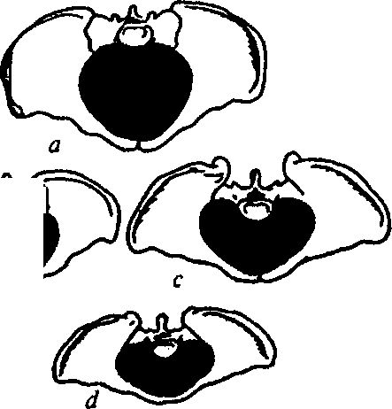
•?y»>W
a — gynecoid pelvis; b — pelvis justo minor; c — simple flat pelvis; d — generally contracted flat rachitic pelvis
212

Chapter 18. Bony Pelvis Anomalies

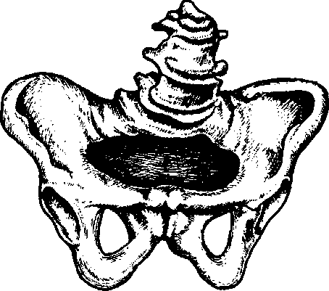
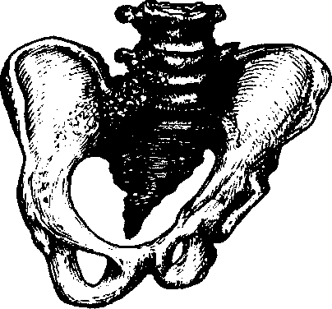

Fig. 92. Obliquely oval contracted pelvis

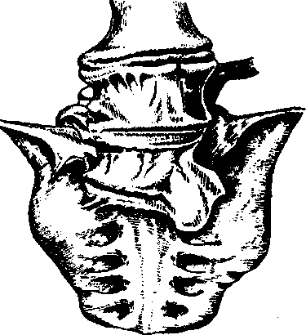
(ankylosis of the left sacroiliac articulation, there is no left wing of sacral bone)
Fig. 93. Spondylolisthetic pelvis

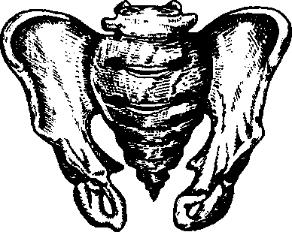
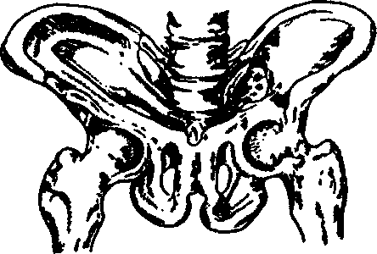
B

Fig. 94. Osteomalacic pelvis
Fig. 95. A — Exostoses on pelvic bones. B — Inverted pelvis

213

PATHOLOGICAL OBSTETRICS

- anthropoid (characteristic of primates);
- platypeloid (flat).
Except for the indicated "pure" pelvic forms, there are differentiated 14 varieties of "mixed" forms. This classification reflects dimensions of the posterior and anterior pelvic segments, which play an important role in delivery mechanism. The plane, which goes through the biggest transversal diameter of pelvic inlet and posterior margin of the ischial spines, divides the pelvis into the posterior and anterior segments. For different pelvic forms dimensions and forms of these segments are different. Thus, at the gynecoid form the posterior segment is larger than the anterior one, its contours are rounded, the form of the pelvic inlet is transverse-oval. If the pelvis is anthropoid, the anterior segment is narrow, long, rounded, and the posterior one is long, but not so narrow, the form of the inlet — longitudinal-oval. At the android form of pelvis the anterior segment is also narrowed, and the posterior one — wide and flat; the form resembles a heart. At the platypeloid form of pelvis both anterior and posterior segments are wide and flat. The form of the inlet is elongated, transverse-oval.
In the classification of anatomically contracted pelvic forms of great importance are not only peculiarities of the structure, but also the degree of pelvic contraction, which is based on the dimensions of the true conjugate.
By contraction degree there are differentiated the following pelvic forms:
I — the true conjugate is smaller than 11, larger than 9 cm.
II — the true conjugate is smaller than 9, larger than 7 cm.
- — the true conjugate is smaller than 7, larger than 5 cm.
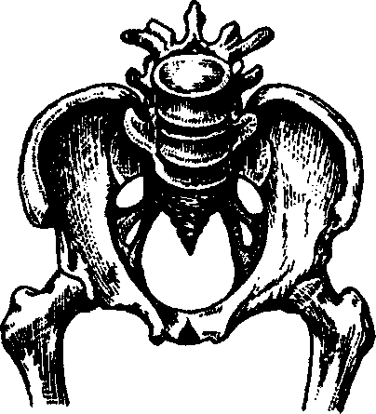
- — the true conjugate makes 5 cm and less (Fig. 97).
Delivery through the maternal passages at the III and IV contraction degrees are impossible.
The modern guide Williams Obstetrics (1997) gives the following classification of contracted pelvises:
Fig. 96. Android pelvis
214

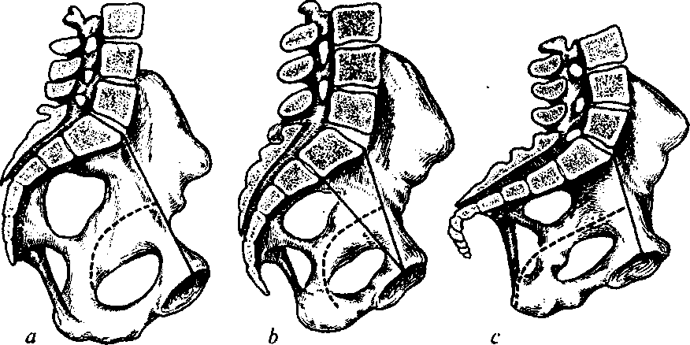
Chapter 18. Bony Pelvis Anomalies
Fig. 97. Detecting the degree of pelvis contraction by the size of the true conjugate:
a — sagittal section of the gynecoid pelvis, the true conjugate is 11 cm; b — sagittal section of the simple flat pelvis with double promontory, both eminences of which are at the same distance from the symphysis — 9 cm; c — sagittal section of the flat rachitic pelvis, the straight sacrum is only with an apex bent forward to a great extent: the broad outlet of small pelvis, the conjugate of small pelvis inlet makes 7.5 cm
- Contracted pelvic inlet.
- Contracted pelvic cavity.
- Contracted pelvic outlet.
- General pelvic contraction (combination of all contractions).
The authors view the pelvic inlet as contracted if the direct dimension is less than 10 cm, transversal — less than 12 cm, and diagonal conjugate is less than 11.5 cm. The condition, at which the pelvic cavity (the narrow part) at interaxial dimension is less than 10 cm is viewed as a suspicion of contracted pelvis, and less than 8 cm — as contracted pelvis. Contraction of the narrow plane may be detected by means of pelvimetry only. Outlet contraction is determined if the dimension between the ischial tuberosities is less than 8 cm. Inlet contraction is rarely met without cavity contraction.
If the external conjugate is 18 cm and less, the pelvis is considered anatomically contracted.
To decide the question about the clinical correspondence of the pelvis to the fetal dimensions and possibility of delivery through the natural maternal passages additional measurements are conducted:
1) abdominal circumference;
215
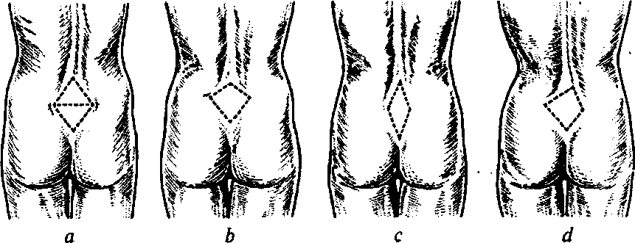
PATHOLOGICAL OBSTETRICS
Fig. 98. Form of the lumbosacral rhomb (diagrammatic representation):
a — at gynecoid pelvis; b — at flat pelvis; c — at generally contracted pelvis; d — at coxalgic pelvis
- pelvic circumference;
- wrist joint circumference (detecting the Solovyov's index);
- form and dimensions of the Michaelis' rhomb (Fig! 98);
- symphysis height;
- two dimensions of the pelvic outlet;
- lateral conjugates;
- diagonal conjugate;
- oblique dimensions of the large pelvis;
- true conjugate;
11) fetal dimensions (height, weight, direct dimension of the
head).
The result of delivery is influenced by the pelvic dimensions, fetal length and weight, character of head fitting, overriding, asynclitism, character of birth activity, time of amniotic fluid discharge.
Women with contracted pelvis are to be hospitalized in two weeks before delivery.
Peculiarities of Delivery Biomechanism at Generally Contracted Pelvis
Pelvis justo minor is a pelvis, all the dimensions of which are reduced by the same quantity of centimeters. For example: normal pelvis — 25-28-31-20, pelvis justo minor (PJM) - 22-25-28-17.
At this type of pelvis the hollow of the sacrum is evident, the pelvic inlet is oval, the promontory is reachable, the pubic arch is reduced.
216
Chapter 18. Bony Pelvis Anomal ies
Such type of pelvis is observed in women of low stature, regular organization of the body.
Diagnostics is based on the data of external pelvimetry and vaginal examination.
Delivery biomechanism is close to the delivery biomechanism at normal pelvic dimensions. Before the beginning of delivery the fetal head is in somewhat flexed condition over the pelvic inlet — with its sagittal suture over the transversal or one of the oblique dimensions. The fixed in the inlet head because of the pressure exerted on it by the uterus begins flexion necessary to get into, and later going through the area of brim. Therefore the delivery biomechanism at pelvis justo minor has the following peculiarities: during the first moment there takes place the maximal head flexion by the pelvic inlet; the occipital fontanel is on the axis of pelvis (Fig. 99).
When the head goes to the third parallel pelvic plane, it is in evidently flexed position; the sagittal suture is in oblique, and sometimes almost direct dimension of the third parallel pelvic plane. Here the fetal head comes across an obstacle of the pelvic part of least dimensions. This obstacle is overcome due to further flexion of the head, which happens at passing from the broad to the narrow part of the pelvis. Flexion becomes maximal. The occipital fontanel takes the central position in the pelvic cavity — is on the axis of pelvis. Due to such flexion the head passes through the narrowest part of pelvis with its least circumference, which goes through the small oblique dimension. The maximal head flexion at passing from the broad to the narrow part of the small pelvis is the second peculiarity of delivery mechanism at pelvis justo minor. Inadequacy between the head and pelvis is compensated by the sharp configuration of the head — it elongates to the side of the occipital fontanel; thus the dolichocephalous form of the head is formed.
The sharp dolichocephalous configuration of the head is the third peculiarity of the delivery mechanism at pelvis justo minor (Fig. 100).
During the third moment after the fixation of the fetal head with the occipital fossa deflexion takes place lower because of the narrowness of the pubic angle; the fourth moment of delivery happens without peculiarities.
Passing of the head at narrow pelvis because of maximal flexion and dolichocephalous configuration requires more time than at normal pelvis. Therefore delivery at pelvis justo minor is prolonged. This explains the formation of a big labor tumor in the area of the occipital fontanel, which elongates the already oblong dolichocephalous fetal head.
217
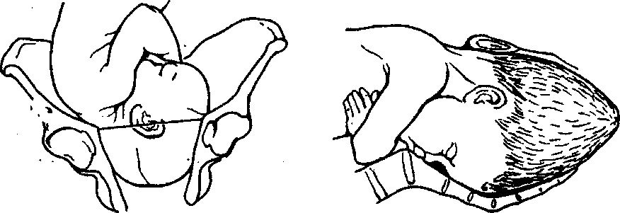
PATHOLOGICAL OBSTETRICS
Fig. 99. Maximal head flexion at Fig. 100. Fetal head configuration
generally contracted pelvis at generally contracted pelvis
(dolichocephalic form)
Peculiarities of Delivery Biomechanism at DoUichopellic Pelvis
DoUichopellic pelvis is characterised by the reduction of transversal pelvic dimensions by 0.5—1 cm and more at increased dimension of the true conjugate and the narrow part of the small pelvic cavity. The pelvic inlet is round or longitudinal-oval. The reduction of the transversal dimension of the Michaelis' rhomb (less than 10.5 cm) is of diagnostic importance. Peculiarities of the doUichopellic pelvis structure include small opening of the wings of ilium and narrow pubic arch. This pelvis reminds the male pelvis and is often observed in women at hyperandrogenism. Vaginal examination shows approach of the iliac spines, a sharp pubic angle.
Proceeding from the transversal diameter of the inlet there are differentiated three degrees of doUichopellic pelvis contraction:
- I-12-11.5cm;
- II-11.4-10.5 cm;
- Ill — less than 10.5 cm.
Accurate diagnostics of this form of pelvis and especially of the degree of its contraction is only possible at the usage of radiopelvime-try, computer diagnostics, magnetic resonance imaging.
DoUichopellic pelvis without any increase of the direct dimension of the inlet is characteristic of asynclitic fitting of the head — it fits in one of the oblique dimensions of the area of brim with the anterior parietal bone, the sagittal suture dislocates backwards.
The flexed head gradually descends into the pelvic cavity and further performs the same movements as at normal delivery mechanism: internal turning, deflexion, external turning.
218
Chapter 18. Bony Pelvis Anomalies
If the reduction of transversal pelvic dimensions is combined with the increase of the true conjugate, there not infrequently arises straight elevation of the head.
If the head is small, the occiput is directed to the symphysis, uterine contractions are active, the head flexes strongly, passes in flexed condition (the sagittal suture is in the direct dimension) through all the pelvic planes and is born as at the anterior type of vertex presentation.
If the occiput is directed backwards, the turning of the flexed head by 180° is possible only in the pelvic cavity (only at a small head and energetic birth activity), and the head comes out in the posterior or anterior type. At straight elevation of the head (especially at the posterior type) there arise complications, which are indications to cesarean section.
Peculiarities of Delivery Biomechanism at Flat Pelvis
Simple flat pelvis is a pelvis, -in which all direct dimensions are reduced. It is formed due to sacral bone displacement to the womb. There are differentiated three varieties of flat pelvis:
- simple flat pelvis;
- flat rachitic pelvis;
- pelvis with reduced direct dimension of the broad part.
For example; normal pelvis — 25—28—31—20, simple flat pelvis — 25-28-31-18, flat rachitic pelvis - 26-26-31-17.
Flat rachitic pelvis is a pelvis deformed because of rickets.
Flat rachitic pelvis is characterized by the following peculiarities:
- the direct dimension of the pelvic inlet is considerably shortened as a result of deep impression of the sacrum into the pelvis — the promontory projects into the pelvic cavity much more than in the normal pelvis;
- sometimes another "false" promontory is observed;
- the sacrum is smoothed and turned back around the axis, which goes in the transversal direction of the lumbosacral plexus;
- the tip of the sacrum comes off the inferior margin of the plexus farther than in the normal pelvis;
- the coccygeal bone is often pulled by the ischiosacral ligaments together with the last sacral vertebra forward (curved forward in the hook-like manner).
The form of the iliac bone: undeveloped, flat wings; unfolded crests because of significant wedging of the sacrum into the pelvis.
219
PATHOLOGICAL OBSTETRICS
The difference between the distantia spinarum and distantia cristarum is either less in comparison with the normal pelvis, or they are equal, or at evident changes of pelvis structure the distance between external spines is bigger than between the crests. The pubic arch is flatter than in the normal pelvis. The axis of pelvis is not a regular arch, as in the normal pelvis, but a broken line. The large and small pelvises are deformed, especially shortened is the direct dimension of the inlet at its normal transversal dimension; due to the promontory, which protrudes considerably into the pelvic cavity, the area of brim has a thread-like form; all the other anteroposterior dimensions of the pelvic cavity are normal or increased; dimensions of the pelvic outlet are larger than usual; in certain cases the direct dimension of the outlet is shortened because of sharp protrusion at a right angle of the coccygeal bone together with the last sacral vertebra.
During the diagnostics of such pelvis one must pay attention to the signs of rachitis the woman had in childhood, reduction of the vertical dimension of the sacral rhomb and the change of its form. At vaginal examination the promontory is reached, the sacral bone is flattened, reclinated, sometimes a "false" promontory is detected, the direct dimension of the outlet is increased.
The first peculiarity of delivery biomechanism is the fitting of the head with the sagittal suture in the transversal dimension of the pelvic inlet and lengthy standing in the place (Fig. 101).
The second peculiarity is insignificant deflexion of the head by the pelvic inlet; the prefontanel is located at the same level with the occipital fontanel or lower. At such deflexion through the least dimension — the true conjugate — the head passes with the small transversal dimension (8.5 cm; Fig. 102). The large transversal dimension (9.5 cm) deviates to the side, where there is more space. The head in such condition adjusts to the pelvic inlet also because the dimension of the somewhat extended head (12 cm) is less than the transversal dimension of the outlet (13—13.5 cm).
The third peculiarity is lateral inclination of the head (asynclitic fitting). There are differentiated anterior (Nehelev's) and posterior (Litsman's; unfavorable) types of asynclitism (Fig. 103).
The anterior asynclitism is formed when the posterior parietal bone is fixed by the protruding promontory, and the anterior parietal bone is gradually descending into the pelvic cavity. The sagittal suture is located closer to the promontory. In such position (the sagittal suture in the transversal dimension of the pelvis — closer to the promontory, the prefontanel is lower than the occipital fontanel) the fe-
220
Chapter 18. Bony Pelvis Anomalies
tal head stands in the pelvic inlet till there takes place its sufficiently strong configuration. After this the posterior parietal bone gets off the promontory, asynclitism disappears, the head flexes. Further on delivery mechanism is the same as at the anterior type of vertex presentation.
The posterior — Litsman's — asynclitism is postparietal fitting of
the head. It is characterized by the deeper fitting of the postparietal
bone. .
Sometimes impression is observed on the newborn's head caused by long-term adjoining to the promontory.
All direct dimensions are contracted in the simple flat pelvis. It is characterised by the deeper impression of the sacrum into the pelvis without any change of the from and curvature of the sacrum; as a result the sacral bone is closer than usually to the anterior pelvic wall and all the direct dimensions of the pelvic inlet, cavity, and oulet are moderately shortened. The curvature of the sacrum is average, the pubic arch is wide, the transversal dimension of the inlet is usually increased. Women with simple flat pelvis have regular organization of the body. External examination shows normal transversal pelvic di-
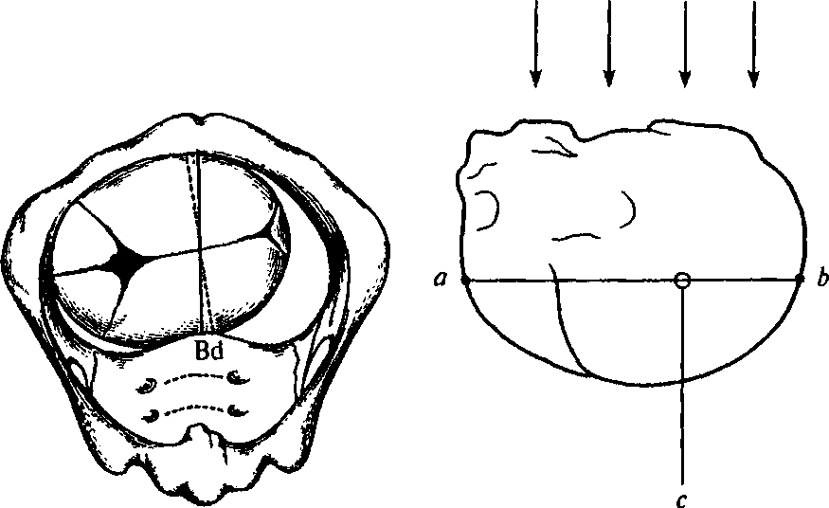
Fig. 101. Beginning of fetal head fitting Fig. 102. Direction of expulsion
at flat pelvis. The head fits with its forces at flat pelvis leads to prefon-
biparietal dimension (Bd) in the tanel descent
transversal dimension of the small pelvis inlet (bottom view)
221
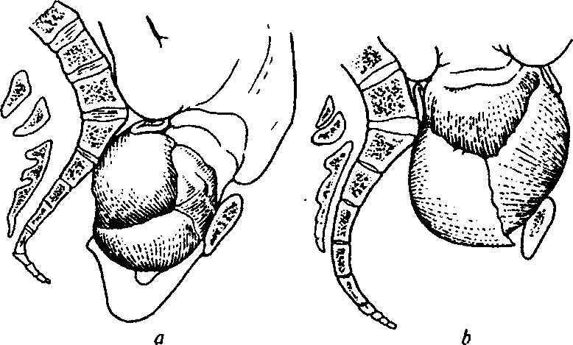
PATHOLOGICAL OBSTETRICS
Fig. 103. Asynclitic fitting of fetal head at flat pelvis:
a — anterior and b — posterior types of asynclitism
mensions and decreased external conjugate. Internal examination shows a decrease of the diagonal conjugate.
Delivery biomechanism at simple flat pelvis is characterized by the absence of internal turning of the fetal head. The fetal head reaches the third parallel pelvic plane, and sometimes the pelvic floor, and the sagittal suture is in the transversal pelvic dimension — there arises low transversal standing of the head (Fig. 104). In some cases the fetal head on the pelvic floor turns with the occiput ahead and is born without assistance. If the turning has not taken place, there appear complications (secondary uterine inertia, fetal asphyxia, etc.), which are indications to operative delivery. Sometimes there arises oblique asynclitic fitting of the head. Delivery at posterior occipital presentation promotes the development of clinical inadequacy of the mother's pelvis and fetal head.
Pelvis with reduced direct dimension of the broad part of the small pelvis is characterised by sacrum flattening, its length increase, reduction of the firect dimension of the broad part of the cavity (less than 12 cm), absence of difference between the direct dimensions of the inlet, broad and narrow parts of the cavity. Other dimensions are usually normal or increased. There are two degrees of contraction: the 1st degree — the direct dimension of the broad part of the pelvic cavity makes 12.4—11.5 cm and the 2nd degree — pelvic dimension is less than 11.5 cm.
222
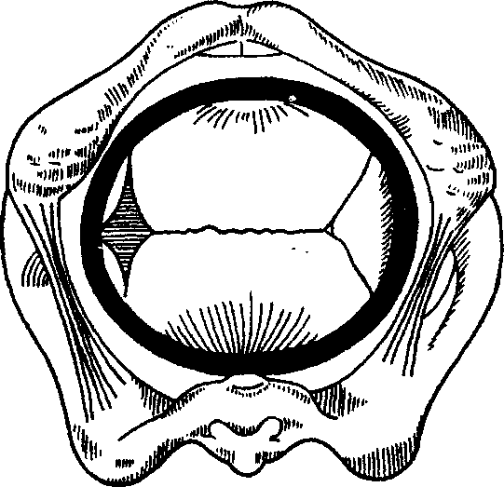
Chapter 18. Bony Pelvis Anomalies
Fig. 104. Low transversal standing of fetal head
(bottom view)
For the diagnostics of this pelvic form the measurement of the pubosacral dimension (the distance between the middle of the symphysis to the place of the 2nd and 3rd sacral vertebrae joint) is informative. For the anatomically normal pelvis the pubosacral dimension makes 21.8 cm. The dimension less than 20.5 cm testifies to contracted pelvis, and less than 19.3 cm allows suspecting evident decrease of the direct diameter of the broad part of the pelvic cavity.
At anatomically contracted pelvis delivery may be:
- normal;
- complicated, but with favorable outcome if correct aid is rendered;
- very difficult, with complications dangerous for the parturient woman and fetus.
At the 1st degree of contraction and average fetal dimensions delivery is managed in expectation, thoroughly observing its dynamics, condition of the parturient woman and fetus. At the 2nd and 3rd degrees of contraction scheduled cesarean section is indicated, and at a dead fetus — an embryotomy. At the 4th degree of pelvic contraction, irrespective of fetal condition, cesarean section is conducted.
Clinically contracted pelvis is all cases of functional inadequacy between the fetal head and mother's pelvis irrespective of their dimensions. This is a clinical notion and is detected in the course of de-
223
PATHOLOGICAL OBSTETRICS
livery at good birth activity. In literature one can meet the terms "pelvic disproportion", "pelvic dystonia", "cephalopelvic disproportion". Risk factors of clinically contracted pelvis appearance:
- anatomically contracted pelvis;
- large fetus;
- deflexion presentation of the fetal head;
- protracted pregnancy;
- fetal hydrocephaly;
- fetal tumors and malformations;
- tumors and malformations of the mother's pelvis;
- tumors of the pelvic organs.
Conditions of diagnosing the clinically contracted pelvis:
- cervical dilation by more than 8 cm;
- fetal sac absence;
- evacuated urinary bladder;
- normal uterine activity.
Diagnostic signs of clinically contracted pelvis:
- no advance of the head at sufficient cervical dilation and normal birth activity;
- level or positive Vasten's symptom (the Tsengeymeyster'^ dimension is bigger than the external conjugate);
- insufficient abutment of the uterine neck to the presenting fetal head;
- high location of the contraction ring;
- symptoms of urinary bladder pressing;
- contractions appearance at high location of the fetal head;
- uterine neck edema with possible spread to the vagina and external genitals.
If there are two or more signs, clinically contracted pelvis is diagnosed.
Obstetric Approach. Diagnosis of clinically contracted pelvis is an indication to immediate delivery by means of cesarean section. If the fetus dies, embryotomy is conducted.
Obstetric forceps and vacuum extraction of the fetus at clinically contracted pelvis are contraindicated.
Delivery Management
At pelvic contraction of the 1st—2nd degree delivery may be: a) normal; b) complicated, but with favorable outcome at adequate help; c) very difficult with complications for the woman and fetus.
224
Chapter 18. Bony Pelvis Anomalies
The course of delivery at contracted pelvis depends on the following factors:
- the degree of pelvic contraction;
- fetal head dimensions;
- the character of presentation and head fitting;
- capability of the head to configuration;
- readiness of the woman's organism to delivery;
- fetal condition.
At favorable combination of indicated conditions delivery is taking its normal course, especially at the 1st degree of pelvic contraction.
In the absence of these conditions cesarean section is more expedient; it is conducted at the end of pregnancy or at the beginning of birth activity. Indications to the section are conditions, at which uterine inertia is possible, or peculiarities of fetal head fitting, which prevent its passing through the pelvic ring: 1) big fetal dimensions; 2) prolonged pregnancy; 3) chronic fetal hypoxia; 4) breech presentation; 5) genitals malformations; 6) a scar on the uterus after cesarean section and other surgeries on the uterus; 7) sterility in anamnesis, etc.
In pregnant women with the 1st—2nd degree of pelvic contraction delivery management is begun through the natural maternal passages with subsequent functional evaluation of the pelvis. It is possible to detect if the anatomically contracted pelvis is narrow or normal functionally only in the course of delivery.
Observation over the urinary bladder condition is very important. Its overfilling and impossibility of independent urinary excretion do not always depend only on the mechanical compression of the urinary canal between the fetal head and symphysis pubis. Quite often this is explained by the violation of urinary bladder innervation, which often accompanies the condition of the lower uterine segment. Combinations of these reasons are possible. The overfilled urinary bladder must be evacuated — this stimulates birth activity, promotes passing of the head through the parturient canal and prevents, to some extent, fistulas formation. Urinary retention may be one of the signs indicating the necessity of conducting cesarean section.
The state of delivery power. During delivery one thoroughly observes the character of birth activity: the strength and frequency of contractions. If there arises powerless labor or discoordinated labor, the question of cesarean section is decided.
Fetal condition and dimensions. External and internal investigations define fetal position, location of the parts of body, dimensions,
225
PATHOLOGICAL OBSTETRICS
head size, density of its bones, the character of the fitting of the presenting part into the pelvis, condition of fetal heartbeats.
The state of the maternal passages. The state of the hard part of the maternal passages is detected by means of external examination, general and additional pelvic measurements, vaginal investigation of the parturient canal walls. The state of the soft maternal passages is of great importance and requires thorough examination in the course of delivery at contracted pelvis.
Beginning of the jamming of the soft tissues of the parturient canal may be indicated by overfilling of the urinary bladder, which arises at long-term standing of the fetal head in one and the same plane; edema of the genitals, the uterus in the first place.
If an edema of the lip of ostium of uterus is detected, it is tucked behind the fetal head.
Considerable edema of the external genitals, bloody discharge from the vagina, urine with blood, thinning and painfullness of the lower segment of uterus, and fetal hypoxia indicate evident jamming of tissues. In such cases urgent delivery is necessary, though it does not always prevent the development of fistulas, fissures, and ruptures of the uterus.
Condition of the uterus requires special attention, especially its lower segment, location of the contraction ring.
Painfullness or significant thinning of the lower segment, high and oblique location of the contraction ring, painfullness and tension of the round ligaments of uterus testify to the superdistension of the lower uterine segment. In such situation birth activity must be stopped, and operative delivery is to be conducted.
Genital tracts infection is a frequent complication of labor at contracted pelvis. Appearance of the first signs of infection requires administration of antibacterial therapy.
Correspondence of the fetal head dimensions to the dimensions of the mother's pelvis — the Tsengeymeystyer's and Vasten's signs allow assessing this correspondence.
Tsengeymeystyer offered to detect the presence and degree of the elevation of the anterior surface of the fetal head over the symphysis by means of measuring and comparing dimensions of the external conjugate and the distance from the supersacral fossa to the anterior surface of the head. The measurement is conducted with a pelvimeter, the pregnant woman in the lateral position. At correspondence of the dimensions of the fetal head and pelvis the external conjugate is by 2—3 cm bigger than the distance from the head to the supersacral fos-
226
Chapter 18. Bony Pelvis Anomalies
sa. If the latter is bigger than the external conjugate, this testifies to head inadequacy to pelvic dimensions. Identical value of both dimensions testifies to the presence of some discordance of the dimensions of the pelvis and fetal head; in this case labor prognosis is doubtful.
The Vasten's sign is detected if there is birth activity, after amniotic fluid discharge and head fixation in the pelvic inlet. The obstetrician places his hand on the surface of the symphysis and slides with it upwards, to the region of the presenting head. If the anterior surface of the head is above the symphysis plane, this testifies to discordance between the pelvis and head (positive Vasten's sign) and delivery can not be completed without assistance.
At insignificant discordance the anterior surface of the head is on the same level with the symphysis (level Vasten's sign). In this case delivery may be completed without assistance at good birth activity and small head dimensions and its configuration, or in operative way — at weak birth activity, big head, anomalies of position and fitting of the fetal head.
At complete correspondence of the head and pelvis the anterior surface of the head is below the symphysis plane (negative Vasten's sign), delivery is usually completed without assistance.
227
Chapter 19 MALPOSITIONS
Malpositions include such positions of the fetus, at which its longitudinal axis does not coincide with the longitudinal axis of the uterus — these are transverse and oblique lies.
Transverse lie is a fetal position, in which the fetal axis forms a right angle with the longitudinal axis of the uterus. In oblique lie the fetal axis and the axis of the uterus cross at an acute angle.
In malposition there are differentiated two positions — the first and the second. There is no presenting part. In the first position the fetal head is turned to the left, in the second — to the right.
Malposition diagnostics is defined by means of the Leopold's maneuvers, internal examination, and ultrasonography.
External examination finds: the form of the uterus is stretched in the transverse or oblique direction, the head and pelvic pole are located in the lateral parts of the uterus, there is no presenting part above the brim.
Fetal heartbeats are auscultated at the level of the navel.
Internal examination may be different depending on gestation sac integrity. If the gestation sac is intact, the whole small pelvis is free, as there is no presenting part above the brim. If waters have discharged, the fetal ribs, clavicles, scapulae, spine or abdomen may be palpated. Sometimes a fetal arm slips to the vagina.
Usually the course of pregnancy at malposition is normal.
In Ukraine there has been worked out the management of preventive conservative correction of malposition with the help of a complex of gymnastic exercises (Shuleshova—Hryshchenko's complex). The exercises are done in the antenatal clinic, under doctor's or experienced obstetrician's supervision. The method is based on the following: fetal mobility increases when the body of the pregnant woman takes different positions, and at a certain stage of exercises the fetus may take the correct position — longitudinal.
Another possibility to correct malposition is preventive external fetal turning. If there are necessary conditions, the turning is per-
Chapter 19. Malpositions
formed after the term of 35—36 weeks of pregnancy if there are no contraindications to this operation. Contraindications to external turning: a scar on the uterus, late gestoses, multifetation, hydramnion, oligohydramnios, placental presentation, diabetes mellitus, essential hypertension, abortion threat, etc.
The operation is performed in the obstetric department by an experienced doctor. There are two variants of external preventive turning: a) at transverse lie — onto the head; b) at oblique lie — onto the part, which is closer to the brim. Complications of the prophylactic turning: premature detachment of placenta, tightening of the umbilical cord, fetal hypoxia, preterm delivery.
At unsuccessful external turning or the presence of contraindications to it the pregnant woman with transverse fetal lie must be under fixed medical supervision until the end of pregnancy.
Hospitalization to the department of pathologies of pregnant women is conducted in the term of 36—37 weeks.
Delivery course at malposition. Malposition makes delivery through the natural passages impossible. In emergency cases a premature dead fetus may be born by the method of self-turning or folding in two.
During delivery at malposition there arises threat not only to the life of the fetus, but also to the life of the mother. If fetal position is not changed, metrorrhexis takes place, which causes death of the fetus and in 60—70 % cases — of the mother. All this forces to treat the choice of delivery method extremely responsibly at malpositions.
Neglected and not neglected transverse lie is an important clinical notion. Transverse lie is not neglected when the fetal sac is intact or when the waters have just discharged and the fetus is movable.
Neglected transverse lie begins developing from the moment of amniotic fluid discharge as the fetal shoulder and adjacent parts of the body are descending into the pelvis. An arm of the fetus may fall out.
It should be emphasized that after amniotic fluid discharge the uterus squeezes the fetus with the walls, and a very complicated obstetric situation arises. In this connection there exist the following variants of delivery.
At the present stage a scheduled cesarean section is recommended at malposition on the 38th—39th week of pregnancy.
In some cases, in the absence of supervision or untimely diagnosis of malposition, the pregnant woman has to give birth in more complicated obstetric situations. If amniotic fluid discharged more than 8—
229
PATHOLOGICAL OBSTETRICS
10 h ago, cesarean section is to be conducted with taking protective measures. If a set of neglected transverse lie symptoms has appeared and the fetus has died, embryotomy is indicated, decapitation in particular. Only in cases when sufficient cervical dilation and amniotic fluid integrity coincide there may performed the operation of classical combined version of the fetus onto the leg. Most often such situation is observed at multifetation for the second fetus.
The operation of classical combined version of the fetus onto the leg is very complicated and therefore, taking into account the tendencies of modern obstetrics, is conducted very rarely.
Conditions for the operation of classical combined version:
- Sufficient cervical dilation.
- Intact fetal sac or amniotic fluid, which has just discharged.
- Normal pelvic dimensions.
- Medium-sized alive fetus.
An absolute contraindication to combined version is fetal immobility (neglected transverse lie).
To conduct the operation one must perfectly know the type and position of the fetus. Both hands of the obstetrician are taking part in the operation.
Combined version technique:
• The first step — obstetrician hand's introduction. A hand (usually right) is introduced into the uterine cavity through the vagina, the fetal sac is burst, the other hand is on the fundus of uterus (Fig. 105).
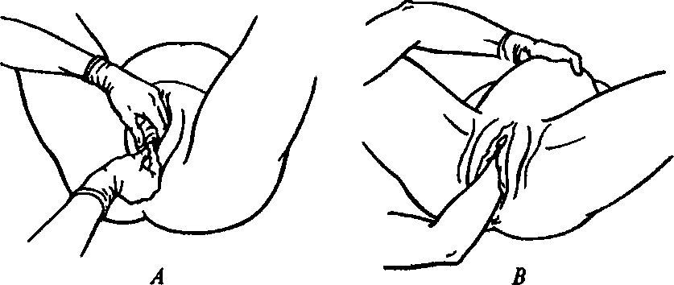
Fig. 105 A — Introduction of a hand into the vagina (the first steps of the version operation). B — Introduction of a hand into the uterus (the second step of the version operation)
230
Chapter 19. Malpositions



Fig. 106. A method of grasping Fig. 107. A method of grasping the fetal

the fetal leg (Fenomenov's) leg with the index and middle fingers
- The second step — looking for the fetal leg. To reach the leg the hand of the internal arm either moves along the fetal body to the place where its leg should be (the short way) or slides along the side of the fetus to the buttocks, from which it is transferred to the hip, and then to the shin (the long way).
- The third step — grasping the fetal leg. The leg may be grasped in two ways. The first: the shin is grasped with the whole hand in such

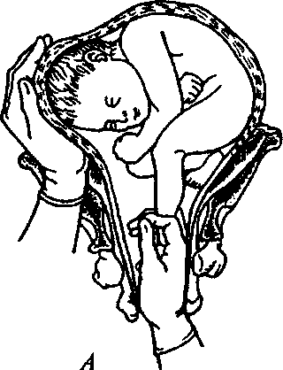
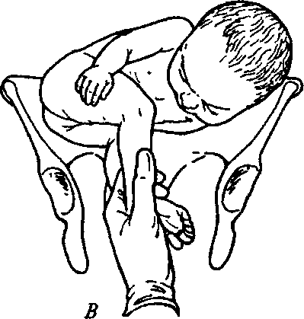
Fig. 108. A — Grasping the superposed leg at the posterior type of transverse lie. B — Grasping both fetal legs at the posterior type of transverse lie

231

PATHOLOGICAL OBSTETRICS
a way that four fingers are placed around the shin, and the thumb — along it reaching the popliteal space (Fig. 106). The second: the index and middle fingers grasp the leg close to the ankle, and the thumb holds the foot (Fig. 107).
• The fourth step — fetal turning proper (Fig. 108). Having grasped the leg, the external hand of the obstetrician is located on the head, the head is carefully moved upwards, to the fundus of uterus. In the meanwhile the leg is moved down with the internal hand and out through the vagina. The operation is over when the leg is out till the popliteal space.
232
Chapter 2 0
OBSTETRIC HEMORRHAGES
20.1. HEMORRHAGES DURING PREGNANCY
Hemorrhage in the second half of pregnancy is most often caused by placental presentation (0.2—0.9 %). Placental presentation is pregnancy complication, at which the placenta is located in the inferior uterine segment below the presenting part, covering the internal ostium of uterus completely or partially.
Reasons: chronic endometritis, degenerative changes after abortions, uterine scars and edemas, late manifestations of the proteolytic properties of trophoblast, influence of chemicals on the endometrium.
Classification:
1. Complete — the placenta covers the internal ostium comp
letely.
2. Incomplete — the placenta covers the internal ostium partially:
- lateral placental presentation — the internal ostium is covered by 2/3 of its area;
- marginal presentation — the placenta margin reaches the internal ostium.
3. Low insertion of placenta — the placenta is located in the infe
rior uterine segment by 7 cm below the internal ostium not covering
it (Fig. 109).
The degree of presentation is clarified at cervical dilation by 5— 6 cm.
Clinical picture: the main symptom is uterine bleeding not accompanied by pain against the background of normal uterine tone, is of undulating character, may repeat periodically, arises spontaneously or after physical load.
External examination shows: high location of the presenting fetal part, often pelvic presentation or fetal malposition, "blowing" murmur of the placenta over the womb is auscultated.
Most frequently hemorrhages at placental presentation appear after 28—29 weeks of pregnancy because of inferior uterine segment formation in this period or because of birth activity beginning, when connection between the contracting inferior segment and uncontract-ible placenta is violated.
233
PATHOLOGICAL OBSTETRICS
Internal obstetric examination (conducted only in the operating theater!) detects the pasty state of the vagina fornix tissues, spongi-ness, vessels pulsation.
Diagnostics: anamnesis, clinical implications — repeating hemor
rhage onset, which is not accompanied by pain and uterine superten-
sion, external and internal obstetric examination, auxiliary methods
of investigation (US). -•
Pregnancy and delivery management. Immediate hospitaliza-
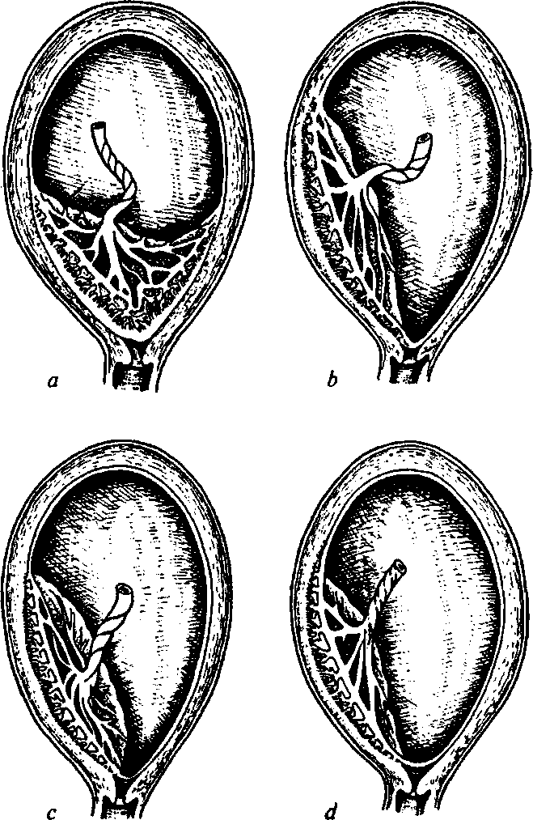
Fig. 109. Placental presentation:
a — central; b — lateral; c — marginal; d — low
234
Chapter 20. Obstetric Hemorrhages

tion, in the presence of intensive progressing bleeding (more than 250 ml) accompanied by hemorrhagic shock signs and fetal distress irrespective of pregnancy term or fetal condition (alive, distress, dead) — immediate delivery by means of cesarean section.
In case of small blood loss (less than 250 ml), no symptoms of hemorrhagic shock, fetal distress,.absence of birth activity, immaturity of the fetal lungs at pregnancy term less than 37 weeks — expectant management: tocolytic therapy by indications, acceleration of fetal lungs ripening (at the term less than 34 weeks) — dexamethasone 6 mg in 12 h, 2 days, monitoring the condition of the pregnant woman and fetus.
If blood loss is less than 250 ml and pregnancy is full-term, in the conditions of the operating theatre the degree of presentation is clarified:
— in case of partial placental presentation, possibility to reach
the amniotic sac and cephalic presentation of the fetus, active uterine
contractions, amniotomy is performed. When the hemorrhage is
stopped, the delivery is conducted through the natural maternal pas
sages. After the fetus is born — i.m. introduction of 10 IU oxytocin,
close observation of uterine contractions and the character of vaginal
discharge. The third period of delivery is conducted actively, with an
operation of manual detachment of placenta, because in most cases
presenting placenta is characterised by partial intimate attachment or
even adherence of placenta. If
hemorrhage resumes, cesarean section is carried out;
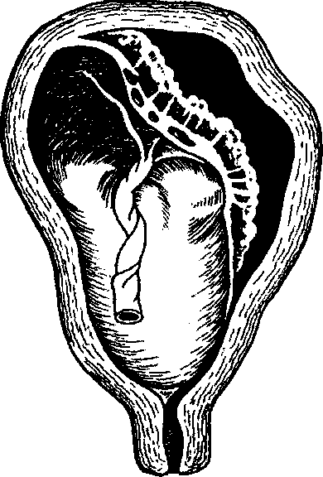
- at complete or incomplete placental presentation, fetal malposition (fetal, oblique, transverse lie) cesarean section is carried out;
- at incomplete presentation, dead fetus amniotomy is possible, at bleeding arrest — delivery through the natural maternal passages.
Fig. 110. Bulging out of the uterine wall in the place of hematoma at placenta detachment
235

PATHOLOGICAL OBSTETRICS
At complete placental presentation without bleeding — routine cesarean section at the term of 37—38 weeks.
Premature detachment of normally located placenta (Fig. 110) takes place during pregnancy or in the 1st—2nd period of pregnancy. The frequency makes 0.02—0.07 %.
Reasons: gestoses, chronic diseases causing sclerotic changes of tissues and vessels — essential hypertension, nephritis, diabetes mel-litus, prolonged pregnancy, multiple pregnancy, dropsy of amnion, etc.
Causes: short umbilical cord, injury, rapid contraction of the overstretched uterus.
Classification:
- Complete detachment (detachment of the whole placenta).
- Partial detachment: marginal or central. Clinical course variants:

- Minor detachment is not diagnosed clinically till the moment of placenta birth.
- Local detachment with the size beginning from 1/4 of the placenta usually has an acute beginning, local pains, uterine hypertension, fetal hypoxia signs (or intrauterine fetal death), signs of internal (sometimes external) hemorrhage.
- Large-scale (or complete) placenta detachment has a presentation of pain and hemorrhagic shock: pressure drop, rapid pulse, cold sweat, uterine hypertension, impossibility to detect fetal parts, intrauterine fetal death.
Uteroplacental apoplexy (Couvelaire uterus) arises at impregnation of the uterine wall with blood from a retroplacental hematoma, the myometrium loses the ability to contract, a large quantity of tromboplastic substances get into the bloodstream — there develops a massive hemorrhage due to hypotension and coagulopathy.
Treatment. In case of premature placenta detachment during pregnancy or in the 1st period of labor, onset of symptoms of hemorrhagic shock, THS, fetal distress signs irrespective of the pregnancy term — urgent delivery by means of cesarean section.
If symptoms of Couvelaire uterus are present — extirpation of the uterus without the appendages.
Restoration of the volume of blood loss, hemorrhagic shock and THS treatment.
In case of non-progressing placenta detachment at incomplete pregnancy (less than 32 weeks) dynamic observation is possible (conducting therapy for fetal lungs ripening) in institutions with round-
23«
Chapter 20. Obstetric Hemorrhages
the-clock duty of qualified doctors, obstetricians-gynecologists, anesthesiologists, neonatologists. There is carried out monitoring of the condition of the mother and fetus, cardiotocography, ultrasonography in dynamics.
20.2. HEMORRHAGES IN THE COURSE OF DELIVERY AND IN THE PUERPERAL PERIOD
The reasons for hemorrhages at the 3rd stage and in the puerperal period may be various. The main of them: impaired motor function of the uterus, violation of placenta detachment and removal, impaired blood clotting, injuries of the maternal passages.
Placenta Attachment Anomalies
Reasons for fused placenta: inflammatory processes in the anamnesis, postoperative scars on the uterus, abortions, metrofibroma, uterus malformations, increased proteolytic activity of the chorion.
Degrees of fused placenta:
- placenta aclhaerens — the chorion villi penetrate into the basal layer of the decidual membrane (Fig. Ill);
- placenta accreta — the chorion villi penetrate through the whole basal layer of the decidual membrane to the muscular layer of the uterus (Fig. 112);
- placenta insreta — the chorion villi penetrate into the depth of the uterine muscular layer;
- placenta percreta — the villi penetrate the muscular and serous uterine layers.
Normally the myometrium contracts in the puerperal period and the placenta begins detaching from the placental bed, which leads to the violation of intervillous lacuna integrity. Bleeding may be moderate, or acquires profuse character from the very beginning. The degree of bleeding depends on the area of the placental bed, with which the placenta loses connection, contractility of the myometrium and coagulation value of blood. The placenta detaches gradually, but if it is attached intimately or is fused, these processes are violated, which is accompanied by bleeding and the absence of signs or incomplete placenta detachment.
If the placenta is fused, there is no bleeding and placenta detachment signs along it.
237
1
PATHOLOGICAL OBSTETRICS

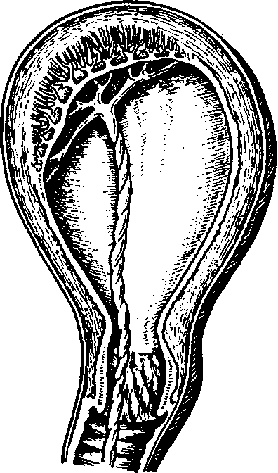
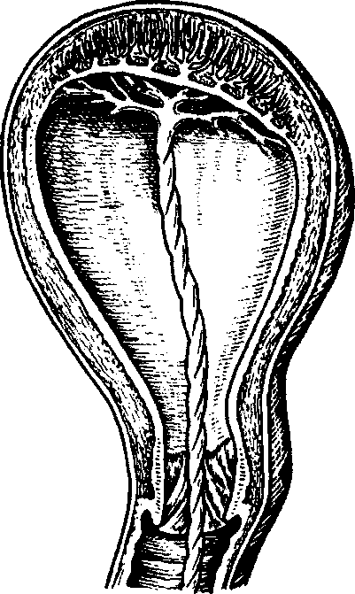

Fig. 111. False fused placenta

Fig. 112. True fused placenta

Fig. 113. Manual detachment of placenta
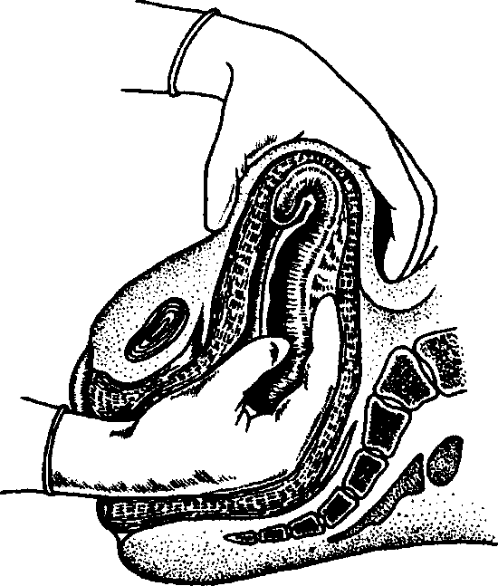
238

Chapter 20. Obstetric Hemorrhages
At placenta percreta (placenta invasion of all uterus layers) the main symptom is internal bleeding.
Obstetric management. The duration of the 3rd stage of labor makes 10 to 30 min. 2—3 signs are enough to establish the fact of placenta detachment, and if it is not born, one should apply external maneuvers of placenta removal.
If the volume of blood loss is up to 0.5 % of body weight and if bleeding continues, worsening of the general condition of the parturient woman in the absence of external bleeding — urgent manual detachment and removal of placenta under i.v. anesthesia (Fig. 113).
If during 30—40 min there are no signs of placenta detachment and external or internal bleeding, true fused placenta is diagnosed and placenta detachment is attempted only in the operating theatre.
At true fused placenta or placenta invasion — laparotomy, extirpation of the uterus without the appendages.
An established defect of the placenta is an indication to manual revision of the uterine walls under i.v. anesthesia irrespective of bleeding presence.
Hemorrhages in the Early and Late Puerperal Period
Hypotonic hemorrhages. Uterine hemorrhages during the first hours of the puerperal period are most often connected with the impaired contractile function of the uterus (hypo- and atonic conditions). Atony is such a state of the uterus, at which the myometrium completely loses the ability to contract, but usually reacts with contraction to mechanical, physical, and pharmacological irritators.
Reasons for hypotonic hemorrhages:
- General reasons: late gestosis, endocrinopathies, acute and chronic infections, etc.
- Local reasons: a large fetus, hydramnion, uterine maldevelop-ment, chorionamnionitis.
- Complicated delivery course.
- Operative delivery.
- Impaired functions of the neuromuscular apparatus of the uterus due to hemostasis defects associated with complications of pregnancy and delivery or hereditary/congenital diseases.
- Iatrogenic reasons.
Clinical presentation. Bleeding may be of two types: 1) right after the placenta is born the uterus loses the ability to contract, it is atonic, does not react to mechanical, temperature and me-
239
PATHOLOGICAL OBSTETRICS

Fig. 114. Bimanual compression of the uterus
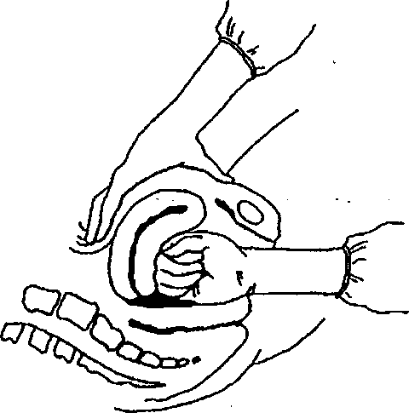
dicamentous irritators, it is massive, in a couple of minutes > 1,000 ml, quickly leads to the shock state;
2) bleeding begins after uterus contraction, the uterus relaxes periodically, tones up under the action of contracting drugs, then becomes flaccid again. Blood is discharged in small portions — undulatingly: periods of bleeding increase are changed by almost complete arrest, blood loss increases gradually. This bleeding is hypotonic.
Obstetric management:
- urinary bladder emptying;
- external massage of the uterus (20—30 sec in 1 min);
c) oxytocin introduction.
The initial dose:
— 10 IU i.m. or i.v. or i.v. infusion of 20 IU in 1,000 ml of physio
logic saline, 60 drops a min.
The second dose:
— 10 IU i.m. or i.v. in 20 min if profuse bleeding continues or i.v.
infusion of 10 IU in 1,000 ml of physiologic saline with the speed of
30-40 drops a min.
The maximum dose:
— i.v. not more than 3 L of liquid containing oxytocin;
d) ergometrine - the first order preparation for the treatment of
hypotension of the uterus, which does not react to oxytocin. The initial
dose makes 0.2 mg i.m. or i.v. slowly, the second dose - 0.2 mg i.m. in
15 min if bleeding does not stop, but not more than 5 doses (1.0 mg).
Carboprost (15-metil PGF2a) - the preparation for the treatment of atony of the uterus, which cannot be treated with oxytocin/er-gometrine. For most women one dose is enough, the efficiency makes 86-96 %. The initial dose of 0.25 mg, deep i.m. injection into the myometrium; the second dose of 0.25 mg every 15 min, if bleeding does not stop, but not more than 8 doses (2.0 mg);
240

Chapter 20. Obstetric Hemorrhages
e) if the parturient women does not react to the measures being
conducted, one should arrest bleeding temporarily by means of: 1) bi
manual compression of the uterus (Fig. 114): the doctor puts on steri
le gloves and introduces one hand into the vagina, makes a fist. The
fist is to be located in the anterior fornix and to press on the anterior
uterine wall. The other hand presses the posterior uterine wall
through the anterior abdominal wall in the direction of the hand in
troduced into the vagina. The doctor continues pressing until bleed
ing stops and the uterus begins contracting, or 2) internal massage of
the uterus and then 3) abdominal aorta pressing;
f) if bleeding is not arrested conservatively, one should proceed to
surgical hemostasis: compression sutures on the uterus (e.g. Lynch's
suture); bilateral ligation of the uterine arteries; bilateral ligation of
the internal iliac arteries; hysterectomy.
If bleeding resumes and blood loss volume makes 1.5 % and more of the body weight, surgical treatment is indicated — extirpation of the uterus without appendages; if bleeding continues — ligature of the femoral arteries.
Coagulopathic hemorrhages — hemorrhages caused by violations of the blood clotting system.
Reasons: dead fetus, premature detachment of the normally located placenta, amniotic fluid embolism, after massive blood loss, at septic conditions, hereditary violations of the blood clotting system, etc.
THS arises, which is characterised by:
- bleeding, which can not be explained by any other reason: for instance, continuous bleeding at well-contracted uterus and no injuries of the parturient canal;
- the blood, which is running out of the uterus or w⁷ound, does not clot or clots poorly;
- bleeding sickness is present;
- fibrinogen content and thrombocyte number decrease below the critical level (accordingly less than 1.5 g/L and 50 • 10⁹/L).
Diagnostics: clinical presentation, monitoring of laboratory indices: prothrombin index, thrombocyte number, fibrinogen quantity in blood, the time of blood clotting is detected (if the system of blood clotting is violated, it exceeds 7—8 min, the clot is fragile, comes apart easily) and a test of blood clot dissolution is carried out: 2 ml of blood from the patient's vein is poured into a tube with a blood clot of a healthy woman of 2 ml volume, and if the clot dissolves in 2—3 min, blood clotting in the patient is reduced.
241
PATHOLOGICAL OBSTETRICS
Traumatic injuries of the maternal passages:
- injury of the vulva, vagina, clitoris — suturing, and in case of necessity compressing bandage of tampon type. At a clitoris injury — placing U-sutures. If a hematoma of the vagina forms, it is opened and the bleeding vessel is sutured;
- cervical rupture — suturing. At a cervical rupture of the 3rd degree — manual revision of the uterine cavity walls to exclude hystero-rrhexis;
- hysterorrhexis — at complete and incomplete hysterorrhexis irrespective of blood loss volume it is necessary to urgently conduct operative intervention in the volume of hysterectomy.
Intensive Therapy of Massive Obstetric Hemorrhages
Physiological blood loss during delivery makes 0.5 % of body weight. At a blood loss exceeding the physiological (>0.8—1.2 % of body weight) microcirculation crisis arises — hemorrhagic shock (HS; Table 17).
HS is an acute cardiovascular collapse conditioned by inadequacy of the circulating blood volume with the bloodstream capacity, which is caused by blood loss and is characterised by the imbalance between tissue need in oxygen and the speed of its real supply. This is the severest complication at pathological bleeding.
Table 17. HS Classification by the Clinical Course and Severity Degree
(L.P. Chepkyi with co-authors, 2003)

Severity degree | Shock stage | Blood loss volume
Severity degree | Shock stage | % blood volume | % body weight
1 | Compensated | 15-20 | 0.8-1.2
2 | Subcompensated | 21-30 | 1.3-1.8
3 | Decompensated | 31-40 | 1.9-2.4
4 | Irreversible | >40 | >2.4
The 1st degree of HS (moderate — blood loss makes 0.8—1.2 % of body weight) — moderate hypovolemia. General condition is moderately severe. Consciousness is not lost, weakness, palpitation. Cutaneous coverings are pale. Pulse — 90—100 bpm, ABP > 100 mm Hg, CVT - 80-100 mm of water.
Chapter 20. Obstetric Hemorrhages
The balance between blood volume and bloodstream capacity is maintained at the expense of a spasm of mostly venous vessels of the parenchymal organs, as a result of emission of catecholamines, aldosterone, ACTH, antidiuretic hormone, glucocorticoids, rennin-angio-tensin, which sustains central hemodynamics for some time and provides normal functioning of vitally important organs (the brain, heart, kidneys).
The 2nd degree of HS (evident — blood loss of 1.3—1.8 % of body weight) — evident hypovolemia. Pulse up to 120 bpm, ABP < 100 mm Hg, CVT — less than 60 mm of water. General condition is grave. Weakness, vertigo, blackout, thirst, hyperhidrosis, dyspnea, muffled heart sounds, lethargy. Evident paleness of cutaneous coverings, acrocyanosis, extremity coldness. There develops severe tissue hypoxia, decompensated acidosis, activated emission of biologically active substances (serotonin, kinin, prostaglandins, histamine, etc.), vessel dilation. Disproportion between blood volume and bloodstream capacity increases.
The 3rd degree of HS (severe — blood loss of 1.9—2.4 % of body weight) — severe hypovolemia. Hemodynamics is considerably violated, the patient's condition is grave and is assessed as critical, psychataxia, stupor, anxiety, body temperature reduction, sharp paleness of cutaneous coverings, peripheral cyanosis. Pulse up to 140 bpm, ABP < 70 mm Hg, CVT — very low (40—0 mm of water).
The 4th degree of HS — extreme — blood loss more than 2.5—3 % of body weight. The woman's condition is critical, consciousness is lost. General paleness, mottled extremities. Pulse is weak, sometimes can not be detected, only heart rate can be calculated, breathing is shallow, tachypnea, pathological motile excitation, hyporeflexia, anuria, low body temperature. Decompensated metabolic acidosis. Depending on the individual peculiarities of the organism, on the degree of anatomical and functional adequacy of vitally important organs, on the critical reserves of organs, dysfunction of an organ declares itself: shock kidney, shock lungs, shock liver.
Basic principles of treating obstetric hemorrhages and HS:
- arrest of bleeding;
- detecting the stage of compensated blood loss;
- blood volume adjustment;
- normalization of blood stream tone;
- correction of hemorheology, blood structural, biochemical, and electrolytic composition, colloid-osmotic properties;
- desintoxication;
- desensitization;
243
PATHOLOGICAL OBSTETRICS
- correction of the clotting, anticoagulative, fibrinolytic and protease systems;
- regulation of the activity of vitally important organs;
10) prophylaxis of infectious complications.
Blood volume adjustment is the basis of infusion program at acute blood loss. Organism can survive having lost 2/3 of corpuscular volume, but will not sustain a loss of 1/3 plasma, besides, hypoxia at massive blood loss is a result of circulatory, and not hematic insufficiency.
At the 1st degree of HS there are used blood substitutes with Theological action (rheopolyglucin with albumin, lactosol in different combinations), hydroxyethylized starch (6 % solution of refortan and stabisol) in combination with crystalloids (Ringer's solution, lactasol, quartasol) in the ratio 1:2. It is not expedient to use glucose solutions to adjust blood volume at HS, since glucose quickly moves to the intracellular centre not increasing blood volume considerably but only causing cellular hyperhydration.
At accompanying THS and also with the-purpose to prevent it one is recommended to use fresh frozen plasma (up to 600—800 ml/day), cryoprecipitate.
At blood loss exceeding 1.0 % of body weight, to restore system hemodynamics and increase blood oxygenation (at hemoglobin content less than 80 % and hematocrit less than 25 %), after introducing blood substitutes one should start blood preparations transfusion. At blood loss of 2—2.5 % of body weight it is possible to connect artificial oxygen carrier — perftoran in the dose of 1.5—5 ml/kg. Transfusion of untested donor blood (so-called 'direct') according to the Law of Ukraine On the Prevention of Developing Acquired Immunodeficiency Syndrome (AIDS) and Social Security of Population, Chapter II, Article 10, is carried out in exceptional cases, "when the patient's life is really threatened and the only way to save the patient is urgent blood transfusion, and there is no examined blood in reserve, 'direct' transfusion of blood not tested for HIV-infection is allowed under the agreement of the patient or her legal representative. At that, the patient or her legal representative must be warned about the possible contagion risk. If the patient is unconscious, the decision about transfusing blood not tested for HIV-infection is made by a council of physicians, which must be testified in writing in the medical history" (the Order No. 5.09.05/671 of the Ministry of Public Health of Ukraine of 11.26.98). A specimen of transfused untested blood must be immediately sent for appropriate laboratory investigation.
At HS of the 2nd degree active therapy is necessary and the most
Chapter 20. Obstetric Hemorrhages
important is transfusion of fresh donor blood and administration of colloidal and crystalloid solutions in the ratio 1:1.
ITT should be begun with blood substitutes on the basis starch (refortan, stabisol) and gelatin (gelofuzin).
If i.v. introduction of 800—1000 ml of any blood substitute with the speed of 50—100 ml/min does not lead to a change (increase) of ABP, there is evident pathological depositing and further increase of the volume velocity of infusion is inexpedient. In this case, not stopping the infusion of blood substitutes, vasopressors are used (remes-typ — from 0.2 to 1.0 mg; dopamine to 5 mcg/kg/min or glucocorticoids — hydrocortisone up to 1.5—2.0 g/day and other). Repeated infusion of FFP is pathogenetically justified as well as at previous stages (up to 400—600 ml 2—4 times a day).
At the 3rd stage of HS all the measures mentioned above last. Transfusion of concentrated red cells is expedient only after stabilization of hemodynamics and peripheral circulation. With antifibrinolytic purpose there are introduced inhibitors of proteases and tranexame acid — 500—700 mg on physiologic saline (Table 18).
After the surgery is over (hysterectomy) and till microcirculation crisis is eliminated, adequate functions of the respiratory, cardiovascular and excretory systems are recovered, prolonged ALV is conducted. Prevention and treatment of respiratory distress are also necessary.
At all stages of HS for simultaneous multicomponent therapy one should use 2—4 veins at one stage (one or two of them — central).
Infusion-transfusion therapy should be carried out taking control of pulse, ABP, CVT, hourly diuresis, hemoglobin, hematocrit.
Untimely or inadequate HS treatment causes a prolonged period of microcirculatory bloodstream dilatation, which is accompanied by transition of the intravascular fluid and fine-dispersed protein (albumin) into the interstitial stream. The blood serum clots, its rheology is violated, erythrocytes, thrombocytes and cells of vascular endothelium disintegrate and aggregate, thromboplastin accumulates, sedimentation processes activate, prothrombin changes to thrombin, fibrinogen — to fibrin. THS of blood develops.
THS is a complex pathological syndrome based on the activation of vascular-thrombocyte or coagulation hemostasis (external or internal), as a result of which at first blood clots in the blood stream, blocks it with fibrin and cellular aggregates, and if the potential of the coagulation and anticoagulation systems is exhausted, loses the abili-
245
Table 18. Infusion-Transfusion Therapy of Obstetric Blood Loss (O.M. Klytunenko, 2002)

Blood loss volume |  |  | Total transfusion  volume  (in % to CBV  deficit) | Infusion-transfusion media
CBV  deficit,  % | %of  body  weight | Blood  volume,  ml | Total transfusion  volume  (in % to CBV  deficit) | Crystalloids  (0.9%,NaCl  solution,  Ringer's  solution, etc.),  ml/kg | Colloids |  |  | b
 |  |  |  |  | Synthetic | Natural |  | b
 |  |  |  |  | Refortan, gelofusin, etc., ml/kg | FFP,  ml/kg | Albumin (10-20 %),ml | b
10-20 | 1-1.5 | 500.0-1000.0 | 200-300 (up to 2.5 L) | 10-15 | 10 | — | —
20-30 | 1.5-2.0 | 1000.0-1500.0 | 200 (up to 3 L) | 10 | 10 | 5-10 | —
30-40 | 2.0-2.5 | 1500.0-2000.0 | 180 (up to 4 L) | 7 | 7 | 10-15 | 200
40-70 | 2.5-3.6 | 2500.0-3000.0 | 170 (up to 5 L) | 7 | 10-15 | 15-20 | 200
>70 | >3.6 | > 3000.0 | 150(>6L) | Up to 10 | Up to 20 | >20 | >200

Chapter 20. Obstetric Hemorrhages
ty to coagulate, which declares itself as profuse bleeding and development of the symptom of multiple organ failure. Classification:
- By the clinical course: acute, subacute, chronic, recurrent.
- By the clinical stages of the course (Table 19, 20):

- the 1st — hypercoagulation;
- the 2nd — hypocoagulation without generalized activation of fibrinolysis;
- the 3rd — hypocoagulation with generalized activation of fibrinolysis;
- the 4th — complete incoagulability of blood.
THS develops against the background of HS and is characterised by pathological changes in the systems of coagulation and anticoagulation, vascular-thrombocyte hemostasis, in the fibrinolytic and protease blood systems.
Clinical presentation: clinical manifestations of acute THS are connected with ischemic and hemorrhagic lesions of organs and tissues, which have a branched network and declare themselves with:
- hemorrhages of skin, mucous tunics;
- hemorrhages from injection sites, incisional wounds, uterus, etc.;
- necroses of some areas of skin and mucous tunics;
- CNS manifestations — euphoria, disorientation, clouded state;
- acute renal, hepatic, pulmonary, adrenal insufficiency.
Table 19. THS Diagnostics

THS  stages | Clinical manifestations | The character of coagulation properties of blood
I | Hyperemia of the cutaneous coverings with cyanosis, cutis marmorata, rigor, restlessness | Activization of the kalikrein ki-nin system, intravascular blood cell aggregation
II | Increase of hemorrhage from the genital tracts, injured surfaces, petechial skin rash, nose bleeding. The blood, which is running out, contains loose clots, which are lysed quickly | Exhaustion of the hemostatic potential, consumption of the VIII, V, XIII factors, fibrinogen, thrombocytes, activation of local fibrinolysis
247
PATHOLOGICAL OBSTETRICS
Table 19 continued

THS  stages | Clinical manifestations | The character of coagulation properties of blood
III | Discharge of liquid blood, which does not coagulate. General bleeding sickness of injection sites, operative field, hematuria, hemorrhagic exudates in the serous sac | Sharp exhaustion of coagulation factors as a result of the formation ofa large quantity of thrombin. Inflow of plasminogen activators into the bloodstream
IV | Discharge of liquid blood, which does not coagulate. General bleeding sickness of injection sites, operative field, hematuria, hemorrhagic exudates in the serous sac | Extreme hypocoagulation. High fibrinolytic and anticoagulation activity
Table 20. Laboratory Criteria of THS Stages

THS  stages | Basic laboratory indices
THS  stages | Time of blood clotting by Lee-White, min | Spontaneous clot lysis | ACTC,  sec | Thrombocyte number,  • 10⁹/L | Prothrombin time, sec | Thrombin  time,  sec | Fibrinogen, g/L
I | <5 | No | <30 | 175-425 | < 10 | <24 | >5
II | 5-12 | No | <30 | 100-150 | 12-15 | >60 | 1.5-3.0
III | > 12 | Quick | 60-80 | 50-100 | 15-18 | > 100 | 0.5-1.5
IV | >60 | Clots  do not  form | >80 | <50 | >18 | > 180 | Not detected or traces
Norm | 6-9 | No | 30-40 | 150-300 | 11-12 | 16-20 | 2.0-4.5
Treatment:
1. The treatment of the fundamental illness, which has caused THS development (surgical intervention, medicamental and infusion therapy).
248
Chapter 20. Obstetric Hemorrhages
- Intravenous stream introduction of 700—1,000 ml of warmed to 37° C fresh frozen plasma (FFP) containing antithrombin III. If bleeding does not stop, additional introduction of 1000 ml of FFP is necessary. On the following 2nd—3rd day FFP is used in the dose of 400—600 ml/day. If it is possible, antithrombin III is introduced every 3 h.
- Given the speed of the hypercoagulation stage changing into the hypocoagulation stage, no possibility of clear laboratory diagnostics of THS stage one should refuse from the routine use of the heparin.
- Beginning from the 2nd stage protease inhibitors introduction is indicated depending on the stage (Table 21).
Table 21. Recommended Doses of Proteolysis Inhibitors Depending on the THS Stage

Drug, IU | THS stage
Drug, IU | I | II | III | IV
Trasilol | — | 50,000-10,000 | 100,000-300,000 | 300,000-500,000
Contrical | — | 20,000-60,000 | 60,000-100,000 | 100,000-300,000
Gordox | — | 200,000-600,000 | 600,000-100,0000 | 1,000,000-4,000,000
- Restoration of blood clotting factors by means of introducing plasma cryoprecipitate (200 IU - the 2nd stage, 400 IU - the 3rd stage, 600 IU — the 4th stage). If it is possible, male recombinant Vila factor (novoseven) is introduced, 60—90 mcg/kg (1—2 doses).
- Thromboconcentrate — in case of thrombocyte number reduction to less than 50 • 10⁹/L. Thromboconcentrate dose is chosen depending on the clinical situation.
- Local bleeding arrest from the wound surface in all cases by means of coagulation, vessels ligation, wound tamponade, application of local hemostatics.
HS treatment, especially with THS development, should be conducted by the obstetrician-gynecologist only together with the anesthesiologist and hematologist.
Autohemotransfusion (AHT) is applied in the group of women of high risk of uterine hemorrhages development.
249
PARTURIENT MATERNAL TRAUMATISM
Parturient traumatism of the mother is the injury of the soft tissues of the parturient canal, neck and body of uterus, which took place during the pathological course of delivery, untimely and unqualified obstetric help.
Cervical ruptures are observed in 6—15 % deliveries according to different authors. Hysterorrhexis makes 0.1—0.05 % of all deliveries.
The reasons for the injury of the soft tissues of the parturient canal is the most often unskilled perineum protection, delivery of a fetus with big weight, of an overmature fetus, or accelerated labor and also its prolonged character; incorrect fitting of the fetal head, narrow-pelvis, breech presentation, rigidity, inflammatory changes of the perineum tissues, surgical delivery.
There are differentiated ruptures of the vulva, vagina, perineum, neck and body of uterus, inversion of uterus, postpartum fistulas, separation of symphysis and symphysiolysis.
Ruptures of the vulva, vagina, and perineum are the most frequent.
21.1. VULVA, VAGINA, PERINEUM RUPTURES
Vulva ruptures usually take place in the region of the small lips of pudendum, clitoris and are a surface injury.
Clinical presentation and diagnostics. Injury is accompanied by external hemorrhage, sometimes rather intensive.
Treatment. Ruptures in the region of the small lips of pudendum are sutured with catling not touching the underlying tissues to prevent hemorrhage from the cavernous bodies.
A catheter is introduced into the urethra before suturing ruptures in the region of the clitoris.
Uninterrupted or single sutures are inserted under local or intravenous anesthesia.
Traumatic injuries of the vagina (Fig. 115). If perineum rupture is localized in its lower third, it is often combined with vulva rupture.
250
Chapter 21. Parturient Maternal Traumatism

Fig. 115. Ruptures of the external genitals and vagina:
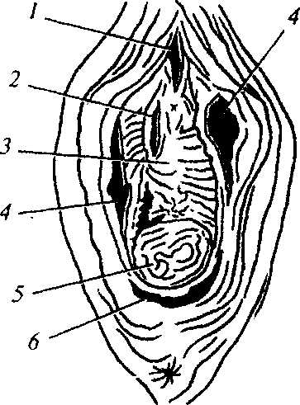
1 — of clitoris; 2,3 — anterior wall of vagina; 4 — mucosa of small pudendal lips; 5 — posterior wall of vagina; 6 — posterior commissure
Vagina rupture in the upper third sometimes proceeds to the fronix of vagina and is then combined with the rupture of the neck of uterus. The middle part of the vagina is rarely injuried due to its elasticity and ability to stretch. Sometime tissue ruptures takes place only in the deep submucosal layers and the mucous layer remains intact.
Vagina ruptures are most often longitudinal, less frequently — transversal, sometimes they penetrate deep into the paravaginal fat.
The code number ICD-10 0-71.4 indicates obstetric rupture of the upper part of the vagina only.
Clinical presentation and diagnostics. Clinically vaginal laceration declares itself either with hemorrhage or — at submucosal rupture, when a venous or arterial vessel is damaged, — hematoma formation. The code number ICD-10 0-71.7 indicates obstetric pelvic hematoma; 0-71.8 — other adjusted obstetric injuries.
Diagnostic criteria:
- at examination — a tumor-like mass of blue-and-violet color;
- at vulva hematoma — the small and large lips are edematous, tense, of crimson coloring;
- vagina hematomas more often form in the posterior regions;
- the most frequently is a symptom of a hysterorrhexis not diagnosed during delivery;
- no subjective sensations at small hematomas;
- at quick increase of the hemorrhage in size there appears sensation of pressure, spreading, burning pain, laboratory investigation detects anemia signs;
- if hematoma is infected, pain increases, has a throbbing character, body temperature rises, hectic character of the temperature profile, leucocytosis in blood, ESR acceleration.
Treatment. Vaginal lacerations are sutured with single or uninterrupted sutures by the rules of the surgical treatment of wounds. If
251

PATHOLOGICAL OBSTETRICS

Fig. 116. Closure of a rupture in the region of clitoris
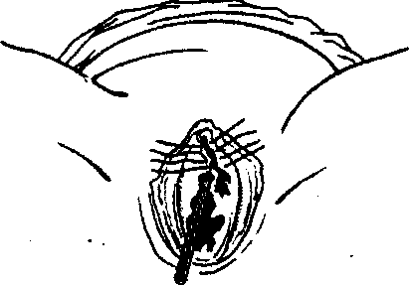
(a catheter is introduced into the urethra)
hematomas are small and do not progress in size, if there are no sings of infection, bed rest, cold, hemostatics, Z-sutures or uninterrupted sutures and antibacterial therapy are indicated (Fig. 116).
If hematomas are large (Fig. 117):
- the doctor is to follow the superior hematoma level through the abdominal wall by the method of deep palpation (if hematomas enlarge quickly);
- if hematomas enlarge, anemization increases, hemorrhagic shock signs appear, laparotomy is carried out with the purpose of internal ileal artery ligation. In 5—6 days the hematoma is dissected and drained for infection prevention. It is not expedient to dissect and empty a light hematoma (thrombus abruption at thrombosed vessels resumes hemorrhage).
If hematoma is infected — dissecting, draining, antibiotics administration.
Perineal ruptures. There are differentiated spontaneous and forced perineal ruptures. The latter appear at technical errors of conducting vaginal embryotomies or incorrect rendering of manual aid.
Perineal rupture degrees:
- the 1st degree — rupture of the posterior perineal commissure, a small part of perineal skin (up to 2 cm), perineal muscles remain intact;

- the 2nd degree — damaged perineal skin, vaginal walls and perineal muscles. The sphincter and rectum remain intact;
Fig. 117. Vulva hematoma
252

Chapter 21. Parturient Maternal Traumatism

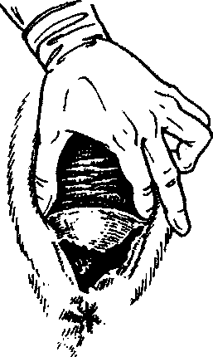
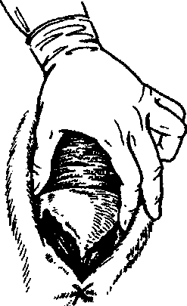
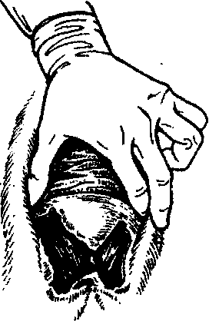
a

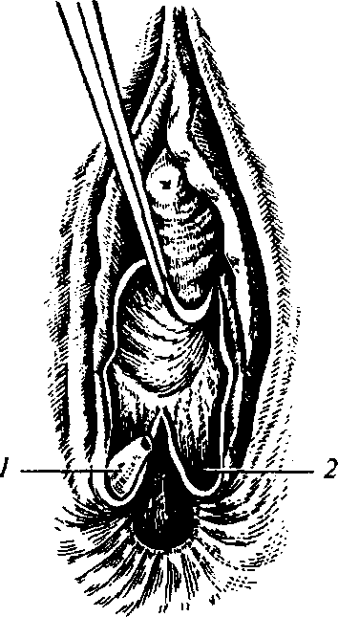
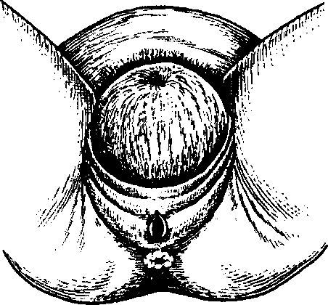

Fig. 118. Perineal rupture:

a - of the 1st degree; b - 2nd degree; c — 3rd degree; d — 3rd degree complete (1 — a sphincter flap; 2 — the place of sphincter abruption)
Fig. 119. The moment of central perineal rupture occurrence

253

PATHOLOGICAL OBSTETRICS

— the 3rd degree — except for the rupture of the perineal skin and
muscles there ruptures the external sphincter of the rectum (incom
plete rupture of the 3rd degree); if the mucous tunic of the rectum
ruptures, the 3rd degree rupture is complete.
A rare type of the injure is the central perineal rupture (Fig. 118): rupture of the posterior vaginal wall, pelvic floor muscles and perineal skin; the posterior commissure and sphincter of the rectum remain intact. Delivery takes place through this formed aperture.
Sometimes the perineal muscles are deeply injured (Fig. 119) without any violation of skin integrity.
Clinical presentation and diagnostics. There are differentiated 3 main signs of perineal rupture threat: 1) superdistension of the perineum with the fetal head violating venous blood drainage, which is accompanied by tissue cyanosis; 2) perineum edema, testified to by tissue luster; 3) paleness of the perineal skin, which is a manifestation of arterial vessels squeezing, exsanguination of tissues, which can not resist further squeezing, which results in perineal rupture.
Diagnostic criteria of perineal rupture: tissue defect, wound sur-. face, hemorrhage from the maternal passages.
The treatment is conducted in accordance with the general wound treatment principles:
- every uninfected wound must be sutured during the first hour after delivery;
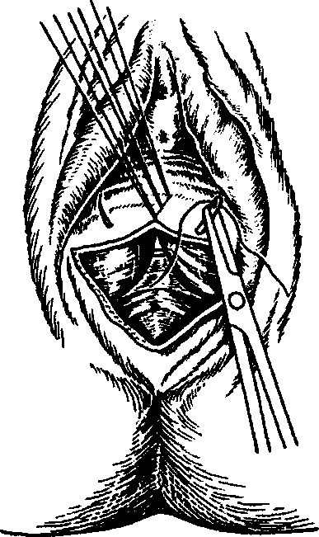
- perineal ruptures of the 1st—2nd degrees are sutured under local anesthesia (novocaine, lido-caine);
- the vaginal muscles, fat and mucous tunic, and perineal skin are sutured with polyglycogen filament;
- before suturing the damaged tissue is removed in the region of the wound lips with sharp scissors;
- sutures are inserted to renew anatomic correlations. The
Fig. 120. Suturing a 2nd degree perineal rupture
254

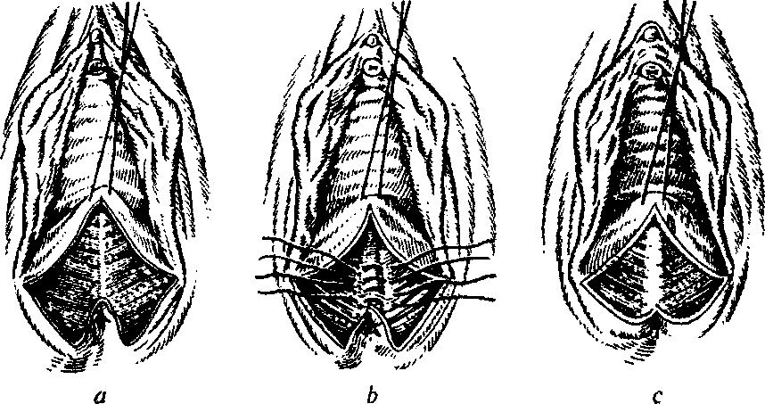
Chapter 2 1. Parturient Maternal Traumatism
Fig. 121. Suturing a 3rd degree perineal rupture:
a — placing the first knot on the apex of the vaginal wall rupture; b — placing submerged knots on the rectum sphincter; c — the view after rectum sphincter reintegration (the 3rd degree rupture has turned into the 2nd degree rupture)
operation of suturing perineal ruptures of the 1st—2nd degree begins with inserting a suture into the anterior corner of the wound; then 3—4 buried sutures on the perineal muscles (vicryl, chromic catgut); restoration of the perineal skin with the help of 3—4 silk ligatures or a subcuticular cosmetic suture;
— 3rd degree sutures are inserted under anesthetic (Fig. 120). Suturing consists of the following moments:
- Restoration of the rectum and sphincter. At first, silk sutures are placed on the mucous tunic of the rectum with immersing knots into the lumen of the rectum. The muscular layer is sutured with chromic catgut, the knots are tied into the wound lumen.
- Restoration of the rectum sphincter. The contracted part of the muscle is to be found. Then its integrity is restored with some vicryl sutures. The tools are interchanged, the surgeon's hands are scrubbed. Further layerwise suturing is conducted as at the 1st—2nd degree rupture.
Aftercare: perineal sutures are processed 3 times a day and after every urination and defecation.
After processing the sutures are dried with a sterile gauze tampon and dubbed with potassium permanganate solution or 1 % brilliant green solution. Quicker wound healing is promoted by ultraviolet ir-
255
PATHOLOGICAL OBSTETRICS
radiation. The parturient woman is not recommended to sit during 2—3 weeks after delivery.
At the 1st—2nd degree perineal rupture fluid diet is administered during 4—5 days.
At the 3rd degree perineal rupture the patient is to have no excrements during 5 days after surgery (Fig. 121).
21.2. CERVICAL RUPTURE
Cervical ruptures most often happen in the bottom-up direction, i.e. from the external mouth to the internal one.
3 degrees of cervical rupture are differentiated by depth:
- the 1st degree — cervical rupture from one or both sides not more than 2 cm long;
- the 2nd degree — a rupture longer than 2 cm, which does not reach the fornix of vagina (Fig. 122);
- the 3rd degree —-a rupture of the uterine neck to the fornix of vagina or reaching the upper part of vagina.
The 3rd degree rupture is a severe type of obstetric traumatism, at which it is impossible to exclude the transition of the rupture to the region of the inferior uterine segment.
Fig. 122.2nd degree cervical rupture
256
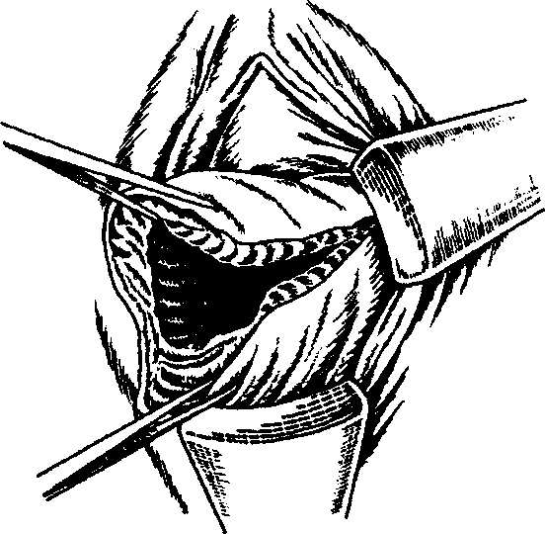
Chapter 21. Parturient Maternal Traumatism

Fig. 123. Placing sutures in case of 2 degree cervical rupture
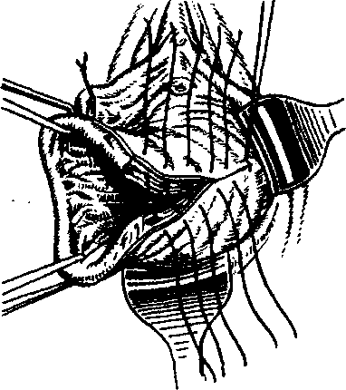
Clinical picture and diagnostics. Shallow ruptures 0.5—1 cm long are usually asymptomatic. Deeper ruptures are accompanied by hemorrhage. If the descending cervical part of the uterine artery is injured, the hemorrhage is rather voluminous and begins right after the fetus is born. Blood exudes in the form of a vermeil trickle if the placenta is detached and the uterus is well-contracted.
If the tissues are damaged because of being pressed to the pelvic bones with the fetal head, no hemorrhage may be observed though the tissues of the neck of uterus have been considerably injured.
If there is no bleeding, cervical ruptures may be identified only during vagina examination with the help of specula and smooth forceps.
Treatment. Cervical ruptures are sutured with single or uninterrupted sutures by the rules of surgical wound repair.
The 3rd degree cervical rupture is an indication to manual examination of the uterine cavity to exclude its lower segment rupture.
Cervical ruptures may be sutured with single- or multiple-layer sutures (Fig. 123).
There is a technique of later cervical ruptures suturing — after delivery, on the 3rd—5th day. In this case the muscular ring of the circular layer is formed, even small ruptures are visible, but this technique requires removal of the damaged rupture margins.
21.3. HYSTERORRHEXIS
Hysterorrhexis is the violation of uterus integrity in any part during preganancy or delivery.
According to different authors, hysterorrhexis frequency makes 0.03—0.005 % of the general quantity of deliveries. Maternal and perinatal mortality at this complication makes about 3—4 % and 40 % accordingly.
257

PATI10LOGICAL OBSTETRICS
Hysterorrhexis classification: I. By pathogenesis:
1. Spontaneous hysterorrhexis:
- at morphological myometrium changes;
- at a mechanical obstacle to fetal birth;
- at morphological myometrium changes and a mechanical obstacle to fetal birth combined.
2. Forced hysterorrhexis:
— pure (at delivery vaginal surgeries, at an external injury);
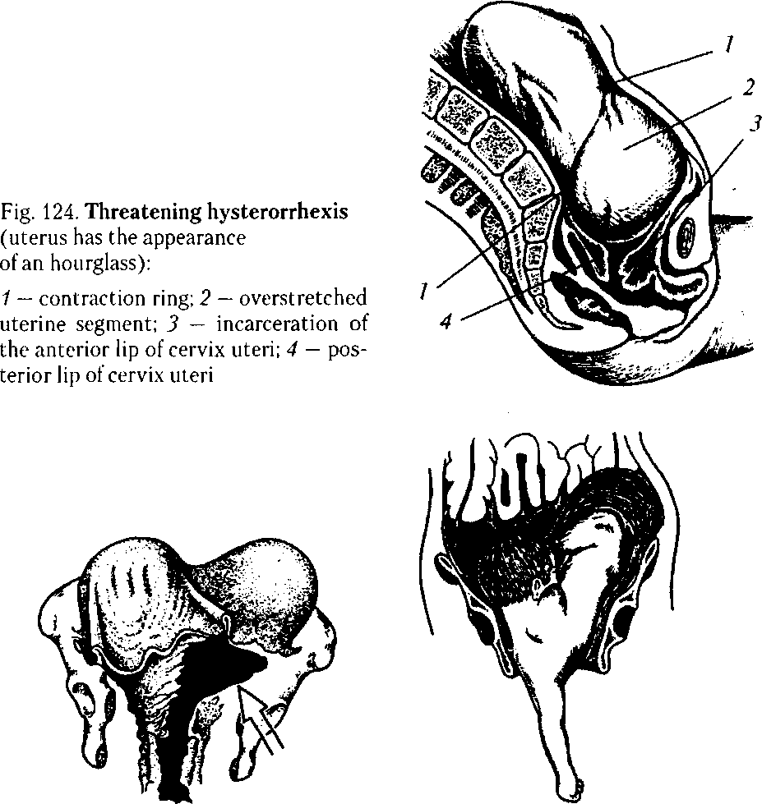
Fig. 125. Incomplete hysterorrhexis Fig. 126. Complete hysterorrhexis
at transverse lie
258
Chapter 2 1. Parturient Maternal Traumatism

Fig. 127. Complete hysterorrhexis in the inferior segment
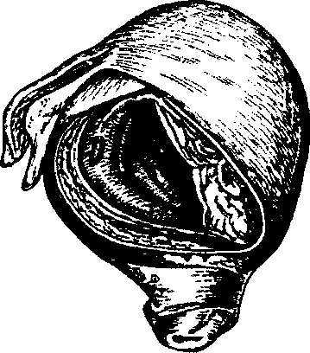
— mixed (at different combina
tions of gross interference, morpho
logical myometrium changes, a me
chanical obstacle to fetal birth).
II. By the clinical course:
1. Threatening hysterorrhexis
(Fig. 124).
2. Hysterorrhexis, which has al
ready taken place.
III. By the injury character:
- Incomplete hysterorrhexis (not penetrating into the abdominal cavity; Fig. 125).
- Complete hysterorrhexis (penetrating into the abdominal cavity; Fig. 126).
IV. By the localization:
1. Rupture in the lower uterine segment (Fig. 127):
- anterior wall rupture;
- lateral rupture;
- abruption of the uterus from the vaginal vaults.
2. Rupture in the body of uterus:
- anterior wall rupture;
- posterior wall rupture.
3. Rupture in the fundus of uterus.
Etiology and pathogenesis. Mechanical obstacles to fetal birth and pathological processes of the muscular layer of uterus, which arise before or during pregnancy and delivery, are considered the main reasons for hysterorrhexis. The mechanical theory of hysterorrhexis emergence belongs to Bandl (1875). He explained hysterorrhexis during pregnancy by inconsistency of the presenting fetal part dimensions with the dimensions of the mother's pelvis. If there is an obstacle to fetus expulsion, rapid birth activity develops, the superior uterine segment contracts more and more, the fetus gradually moves into the thin-walled stretched inferior segment. Its superdistension and rupture happen especially easily if the uterine neck has not moved behind the fetal head and is jammed between it and a pelvic wall. At that, the contraction ring reaches the level of the navel; the uterus acquires the form of an hourglass. If birth activity is pro-
259

PATHOLOGICAL OBSTETRICS
longed, superdistension and thinning of the inferior segment reaches the highest level, its rupture takes place. At complete hysterorrhexis and great vessels damage hemorrhage into the abdominal cavity begins. If the uterus is ruptured in the anterior part of the inferior segment, or if it is torn from the vaginal vaults, the urinary bladder is sometimes drawn into the rupture. At incomplete hysterorrhexis there forms a hematoma depending on injure localization: between the leaves of broad ligament, under the uterine serosa, in the prevesical fat.
The theory of histopathic hysterorrhexis belongs to N.Z. Ivanov (1901) and Y.F. Verbov (1911). According to it, hysterorrhexis happens because of degenerative-inflammatory myometrium processes, its scar changes after surgical interventions on the uterus. Presently, it has been detected that at prolonged labor the metabolism is imba-lanced, which is accompanied by accumulation of toxic compounds damaging the tissues — "biochemical uterine injure". Hysterorrhexis takes place against the background of weak and discoordinated contractions of the uterus.
Today, because of the expansion of indications to abdominal delivery, frequent reconstructive surgeries on the uterus, hysterorrhexis along the scar is observed more often.
According to the American Association of Gynecology and Obstetrics, when women with a scar on the uterus are delivering a child, hysterorrhexis is observed in 0.2—1.5 % at transversal dissection of the inferior segment, in 1—7 % cases at longitudinal dissection, and in 4— 9 % — at corporal or T-incision of the uterus. I.F. Zhordaniya and L.S. Persianinov pay attention to mechanical and histopathic factors at hysterorrhexis. At that, histopathic myometrium changes are the background, against which the smallest errors in labor management may lead to hysterorrhexis. This rupture type differs from the one described by Bandl by the fact that pathological changes do not rupture, but kind of tear apart in the place of the deepest focal changes, therefore foreign authors use the terms "dehiscence, separation scar" and not "hysterorrhexis". When the scar tears apart, the extraembryonic membranes are intact, the fetus does not move into the abdominal cavity.
There are differentiated force factors leading to hysterorrhexis. They include: the Kristeller's maneuver, embryotomies, application of obstetric forceps, vacuum extraction in the absence of conditions and violations of surgery technique. Hysterorrhexis may take place at an attempt to turn the fetus at neglected transverse lie, at fetal extraction by the pelvic pole under the condition of incomplete opening
Chapter 21. Parturient Maternal Traumatism
of the uterine mouth, at releasing the thrown back fetal arms and extracting the following extended fetal head.
Hysterorrhexis is promoted by long-term birth activity stimulation with oxytocin (10 IU), especially in women older than 30, multipara, at multiple pregnancy, a large fetus, narrow pelvis.
Clinical presentation and diagnostics. Hysterorrhexis clinical presentation is versatile. There are differentiated a threatening rupture, a rupture, which has already begun, and a rupture, which has taken place.
1. A "typical" hysterorrhexis takes place at inconsistent dimensions of the fetus and the mother's pelvis. A threatening rupture is conditioned by superdistension of the inferior segment. It is characterised by painful parodynia, the woman's wish to bear down at the high standing of the presenting part. The parturient woman screams, holds her hands on the stomach, asks for help, does not know what to do with herself. The face is frightened, the pupils are dilated, the pulse is accelerated, the lips and tongue are dry, body temperature rises, urination is complicated.
Examination and objective inspection show sharp painfulness at palpation of the inferior uterine segment, its tension, positive overriding symptom. Lower, at the level of the navel, the contraction ring is detected, the uterus acquires the form of an hourglass, the round ligaments are located asymmetrically, sometimes there is observed an edema of the external genitals and vagina.
Fetal heartbeat is difficult to auscultate because of abdomen tension and frequent labor pains; there develops acute fetal hypoxia, the fetus may die. A cardiotocogram records decelerations of different degree of intensity.
Vaginal examination not infrequently shows sufficient cervical dilatation, the uterine neck sags into the vagina since the presenting part is located high. A labor tumor is detected on the fetal head, head configuration is not infrequent. During parodynia at clinical inadequacy the head does not perform progressive motions, the neck does not pull on the head, its edema takes place.
At a rupture, which has begun, the clinical presentation is conditioned by uterine wall integrity violation, blood vessel rupture, hematoma appearance in the myometrium. The parturient woman is excited, screams, has a strong feeling of fear, the pupils are dilated. The symptoms of the erectile stage of shock are observed.
Parodynia is painful, of convulsive character. There appears an irresistible wish to bear down at the high standing of the presenting
261
PATHOLOGICAL OBSTETRICS
part and sufficient cervical dilation. Blood-tinged discharge appear from the genital tracts, blood traces are found in the urine. Fetal car.-diac function is violated, active fetal movements appear, sudden death may take place.
Vaginal examination usually shows sufficient cervical dilation, the head stands high, a labor tumor is found, there are no progressive motions of the fetus at sufficient cervical dilation, positive overriding symptom.
The clinical picture of the rupture, which has taken place, is characterized by the following signs: sharp pain in the abdomen at the height of one of labor pains, birth activity arrest, symptoms of the torpid stage of shock and intra-abdominal hemorrhage. The skin and mucous tunics become pale, the pupils dilate, the eyes are "sunken", the pulse is accelerated and weak, breathing is shallow, there appear nausea, vomiting, vertigo, loss of consciousness, arterial pressure decreases. After hysterorrhexis there quickly appears and increases meteorism as a result of bowels atony, hemorrhage from the vagina is observed, which increases at pushing the presenting fetal part. The fetus dies. When the fetus moves into the abdominal cavity, the abdomen of the parturient woman acquires irregular shape, small fetal parts are easily palpated through the abdominal wall. The well-contracted uterus is detected by the fetus. Symptoms of peritoneum irritation appear in connection with blood getting into the abdominal cavity.
2. The course of hysterorrhexis at histopathic myometrium changes has no evident clinical presentation.
During pregnancy histopathic hysterorrhexis happens at the presence of a scar on the uterus, its inability to stretch at fetal weight increase. The symptoms of rupture threat are conditioned by overdistension of the scar tissue and peritoneum covering it. At that, vomiting, nausea, pain in the epigastric region appear due to reflexes; then they localize in the inferior parts of the abdomen, more on the right side. At uterus palpation attention is attracted by painful palpation of the uterus along the scar, sometimes the painfullness is local; indirect signs of its inability: recesses, roughness.
The clinical presentation of the rupture, which began during pregnancy, is detected by the presence of hematoma in the region of the scar. Nausea, vomiting, vertigo, pain along the scar, uterine hypertension, the signs of acute fetal hypoxia are characteristic. There may appear bloody discharge from the genital tracts.
Chapter 21. Parturient Maternal Traumatism
During delivery at threatening histopathic hysterorrhexis the symptoms enumerated above are accompanied by the violation of the uterine birth activity: dystocia, weakness, restlessness of the parturient woman, painful, unproductive parodynia.
At a rupture, which has begun, during the first stage of delivery, in connection with hematoma presence in the uterine wall, the uterus remain tense between labor pains, becomes painful at palpation. Fetal hypoxia develops because of hypertension. There may appear bloody discharge from the genital tracts, especially against the background of parodynia weakening or arrest.
At the second stage of labor hysterorrhexis is characterised by parturient woman restlessness, pain in the underbelly, sacrum, weak and painful parodynia, which has a tendency to arrest, bloody discharge from the vagina, acute fetal hypoxia.
Symptoms of the histopathic hysterorrhexis, which has taken place, resemble the symptoms observed at a mechanical rupture, only that at the morphologically changed uterus they are not clearly marked and appear gradually. Hemorrhagic shock symptoms prevail. At histopathic hysterorrhexis due to gradual increase of tissue defect the fetus may be born alive through the natural maternal passages.
Hysterorrhexis may be suspected in the puerperal period on the basis of hemorrhagic shock symptoms.
In the course of any labor stage incomplete hysterorrhexis may take place. More often it is located in the lower uterine segment, between the leaves of the broad uterine ligament, or under its serosa. Pains in the underbelly are characteristic, with irradiation onto the sacral part and into the leg. External hemorrhage may be absent. Internal hemorrhage symptoms appear in case of profuse bleeding. The woman's condition deteriorates, paleness of cutaneous coverings appears, the pulse is accelerated, ABP reduces. If the fetus was born without assistance at incomplete hysterorrhexis, a defect of the uterine wall may be detected at manual examination of the uterine cavity. Ultrasonography is used to clarify the diagnosis.
If a hematoma forms in the parametrium, during abdominal-vaginal inspection the uterus moves to the side opposite to the rupture, a mass without clear contours is palpated on its side, sometimes reaching the pelvic walls.
In some cases incomplete hysterorrhexis declares itself in a couple of days after delivery with the following symptoms: skin and mucous
263
PATHOLOGICAL OBSTETRICS
tunics pallor, pulse acceleration, ABT decrease, pains in the underbelly, meteorism, body temperature rise.
Abruption of the uterus from the vaults is a rather rare complication observed during delivery. The reason for this pathology is most often inadequacy between the presenting part and pelvic dimensions. The clinical picture of this complication is characterised by rapid birth activity or, vice versa, prolonged labor. The parturient woman feels severe tensive pains in the underbelly in the sacrum region. The presenting part does not perform progressive motions, it is tightly fixed in the pelvic inlet. The lower uterine segment is painful at palpation. Fetal condition worsens. Urination delay is marked, presence of blood in the urine. Moderate or profuse bloody discharge from the genital tracts is observed. Vaginal examination shows the edematous uterine neck, insufficient dilation. A defect of the vaginal fornix is found, which reaches the parametrium.
Hysterorrhexis is diagnosed on the basis of the clinical signs enumerated above. Differential diagnostics of threatening hysterorrhexis, hysterorrhexis, which has begun, and hysterorrhexis, which has taken place, is conducted with clinically contracted pelvis, acute appendicitis, detachment of normally located placenta, amniotic fluid embolism. Symptoms of the threat of uterus rupture along the scar during pregnancy (usually in the 3rd period) not infrequently resemble the clinical presentation of appendicitis (nausea, vomiting, stomachache). At appendicitis the tongue is furred with farina, leucocytosis is detected, symptoms of peritoneum irritation are observed in the lower parts of abdomen on the right. To diagnose the disease one should find in the anamnesis the possibility of scar changes of the uterine muscle, perform ultrasonography with uterine walls investigation, measure the thickness and assess the structure of the region of possible scar presence.
Differential diagnostics of the threat and the rupture, which has begun, and clinically contracted pelvis is complicated. Clinically contracted pelvis is characterised by: 1) appearance of painful parodynia at the high standing of the presenting fetal part; 2) head fitting characteristic of the from of pelvic contraction; 3) evident head configuration or the absence of configuration at overmature pregnancy, evident labor tumor; 4) the absence of progressing motions of the head or buttocks at sufficient cervical dilation and energetic birth activity; 5) fetal hypoxia signs onset; 6) positive overriding symptom; 7) evident symptom of urinary bladder compression.
264
Chapter 2 1. Parturient Maternal Traumatism
Histopathic hysterorrhexis, which has begun, during pregnancy and delivery should be differentiated from premature detachment of the normally located placenta. The diagnosis may be clarified with the help of ultrasonography. If it is impossible to differentiate hysterorrhexis, which has begun, from premature detachment of the normally located placenta, one should remember that both complications are indications to surgical treatment.
Hysterorrhexis, which has begun, should be differentiated from amniotic fluid embolism, which is most often observed at the end of the 1st and 2nd delivery stages. At embolism there quickly develops shock with symptoms of acute cardiovascular collapse, with a sharp pressure drop, onset of cyanosis, tachypnoe, dyspnea.
Treatment. If a pregnant woman belongs to the risk group of hysterorrhexis threat, a plan of delivery is worked out during pregnancy observation and by the 38th—39th week of pregnancy a decision is taken concerning the method of delivery (abdominal or through the natural maternal passages). Symptoms of anatomico-functional inferiority of the scar are:
- painful sensation in the region of the lower segment;
- pain at palpation of the lower segment through the anterior vaginal fornix, its heterogeneity, recess;
- at ultrasonography: lower segment thickness less than 4.0 mm, different sound conduction and thickness, balloon-like form.
Cesarean section in women with a threat of hysterorrhexis is performed:
- at a combination of contracted pelvis of the 1st—2nd degree and large fetal weight (388 g and more);
- at frontal fitting, at the high straight standing of the sagittal suture;
- at contracted pelvis of the 3rd—4th degree;
- at the maternal passages blacked with tumors;
- at cicatrical changes of the uterine neck, vagina.
During pregnancy at a threat of hysterorrhexis emergency cesarean section is carried out. During delivery at a threat of hysterorrhexis it is necessary to stop birth activity urgently and narcotize. If the fetus is alive, cesarean section is carried out. After abdominal wall section there may be observed serous exudate, urinary bladder edema, hemorrhages on the uterine serosa. The lower segment is usually thinned. The uterus is dissected in the lower segment very carefully not to damage vessels in the region of uterine sidewalls. After extraction of the fetus and placenta the uterus is to be thoroughly examined.
265
PATHOLOGICAL OBSTETRICS
If the fetus is dead and there are necessary conditions, an embryotomy is carried out. If the doctor does not know the technique of the surgery, cesarean section is preferable. At transverse lie of the fetus cesarean section is also expedient. Such surgeries as fetal turning with its consequent extraction, application of obstetric forceps and vacuum extractor are absolutely contraindicated because of hysterorrhexis threat. Corporeal cesarean section is performed because of lowerseg-ment overdistension; if there is a scar in the lower uterine segment, its wall is dissected along the scar; before suturing the wound on the uterus the scar tissue is to be removed. Cesarean section peculiarities: the uterus is obligatorily withdrawn from the pelvic cavity for thorough revision of its walls integrity.
An urgent surgery is indicated if hysterorrhexis has been detected. The parturient woman is transported to the operating theater immediately; if the woman's condition is grave, surgery is conducted in the labor ward. Urgent antishock therapy is conducted with central veins mobilization. Transfusion of blood components and substitutes is begun before the operation, continued during the operation and in the postoperative period till hemodynamics indices are stabilized.
The question of surgery extent is decided individually depending on the dimensions and localization of the rupture, the time, which has passed after the rupture, blood loss degree, infection, the woman's condition.
Indications to an organ-sparing surgery:
- incomplete hysterorrhexis;
- a linear rupture with even edges;
- the absence of infection signs;
- a small anhydrous space;
- preserved uterine activity. Indications to supravaginal amputation:
— fresh ruptures of the uterine body with uneven crushed edges,
preserved vascular bundle, moderate blood loss with any signs of THS
and infection.
At terminal state of the patient surgical treatment is conducted in two—three stages with a surgical pause after arrest of bleeding, during which shock is fought.
Indications to hysterectomy:
- rupture of the body or lower segment of the womb, which has passed to the neck with crushed edges;
- impossibility to detect the inferior angle of the wound;
Chapter 2 1. Parturient Maternal Traumatism
— rupture of the uterine neck passing to the body.
Indications to extirpation of the uterus with uterine tubes:
- preliminary indications at long-term anhydrous space (more than 10-12 h);
- manifestations of chorioamnionitis, endometritis;
- presence of a chronic infection.
In all cases of surgical treatment concerning hysterorrhexis or at cesarean section concerning threatening hysterorrhexis abdominal cavity draining is conducted.
At the end of the operation the urinary bladder, bowels, and ureters are examined.
At abruption of the uterus from the vaults hysterectomy is indicated. If hysterorrhexis is accompanied by bladder perforation, the bladder is sutured from the side of the abdominal cavity. If a ureter injure is suspected, methylene blue is introduced i.v. and its arrival to the abdominal cavity or into the urinary bladder at cystoscopy is traced.
At profuse hemorrhage the internal femoral arteries are ligated. At a big injure and considerable hemorrhage the internal femoral arteries are ligated before the beginning of the main extent of operation.
If there is no qualified specialist, who may ligate the internal femoral arteries, the operation is begun with clamping the main vessels along the uterine sidewall.
The abdominal cavity is drained through an opening in the posterior fornix after extirpation and through counteropenings at the level of the femoral bones:
- at extraperitoneal hematomas formation the peritoneum is not sutured above them, drainage is conducted;
- in the postoperative period antishock, infusion-transfusion, and abacterial therapy is carried out together with thromboembolic complications prevention.
Even given the present state of medical aid at delivery, if complete hysterorrhexis takes place, prognosis for the fetus remains unfavorable because of placenta abruption. Prognosis for the mother depends on the volume of blood loss, severity of general condition, urgency of the rendered qualified aid.
Perinatal mortality at hysterorrhexis makes about 46 % (R.D. Eden et al, 1986) to 70 % (S.P. Rachagan et al, 1991).
Maternal and perinatal mortality at hysterorrhexis during pregnancy and delivery makes 3—4 % and 40 % accordingly.
267
PATHOLOGICAL OBSTETRICS
21.4. INVERSION OF UTERUS
Inversion of uterus is a severe pathology, at which the fundus of uterus falls out with its internal surface. If uterus inversion takes place at the placental stage, the placenta, which has not detached, falls out together with the uterus.
Etiology and pathogenesis. Uterus inversion usually takes place at uterine hypotonia. Spontaneous uterus inversion is infrequent. Usually uterus inversion is promoted by a combination of the relaxed uterus and big pressure on it from above when conducting the Crede—Lazarevich's maneuver without preliminary massage of the uterus, and also sharp pulling by the umbilical cord at the placenta, which has not detached.
Clinical presentation. In the placental or early puerperal periods severe sharp pains in the abdomen and shock signs appear (rapid pulse, skin pallor, ABP decrease).
The pain is caused by peritoneum irritation, tension and draw of the ligaments due to the change of organ topography. Inversion may be partial if only the body of uterus is everted, and complete, if the w^{r}hole uterus.is ectropic. If the uterus is not replaced, its necrosis takes place.
Treatment. Uterine inversion requires urgent antishock measures and uterus replacement under deep anesthesia. After replacement the
Fig. 128. A — A roentgenogram of symphysis pubis separation. B — Symphysiolysis roentgenogram
268
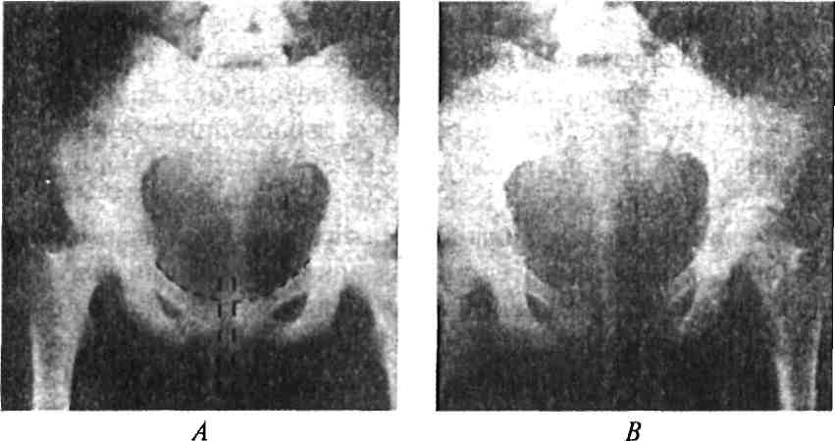
Chapter 21. Parturient Maternal Traumatism
uterus is plugged with a sterile bandage, drugs contracting the uterus are introduced i.v.
If an attempt to replace the uterus was not successful, the uterus is to be extracted, prefarebly through the vagina.
21.5. SEPARATION OF SYMPHYSIS PUBIS AND SYMPHYSIOLYSIS (Fig. 128)
During pregnancy moderate softening of the pelvic junctions takes place due to increased blood supply and serous impregnation of the cartilages and junctions. Sometimes there is observed excessive softening of the pelvis, especially of the symphysis pubis. At such a state pressure of the fetal head on the pelvic bones may cause separation of the pubic bones (by more than 0.5 cm). Such pathology is most often observed in women with contracted pelvis or a large fetus. At pathologic labor and operative interventions considerable separation of symphysis pubis and symphysiolysis may take place. Sometimes symphysiolysis is accompanied by urinary bladder and urethra damage.
Clinical presentation. The parturient woman complains of pain in the region of the symphysis pubis which increases at leg movements, especially at moving apart the legs bent in the knee and hip joints.

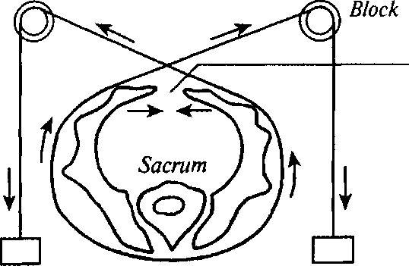
Symphysis
Block
pubis separation
Weighting Weighting
Fig. 129. The scheme of a "hammock" for injured symphysis reposition

269

PATHOLOGICAL OBSTETRICS
Palpation of the symphysis pubis shows edema, painfulness and recess in the region of bone ring separation.
Radiological exploration of the pelvic bones is conducted to clarify the diagnosis; echography may be used for this purpose.
Treatment. Bed rest during 3—5 weeks in the supine position, crossed bandaging in the region of pelvis, administration of calcium preparations, vitamins, "hammock" application (Fig. 129). If there are infection signs, antibiotics are prescribed. After treatment the parturient woman requires rehabilitation treatment.
At pelvic junctions separation or rupture after treatment in women there may be observed gait disorder and painful sensations in the region of the symphysis pubis.
If there is separation or rupture of symphysis pubis in the anamnesis, it is a direct indication to operative delivery at the next labor.
Chapter 22
FETAL DISTRESS. POSTNATAL ASPHYXIA
22.1. FETAL DISTRESS
Presently all the violations of fetal functional condition are denoted by the term "fetal distress". It should be noted that with the help of modern noninvasive methods of investigation it is impossible to find the true reasons for fetal cardiac dysfunction. Therefore in clinical practice one should use the term "fetal distress" instead of "chronic fetal hypoxia" and "acute fetal hypoxia", which are not clinical.
In its turn the term "fetal hypoxia" means the state conditioned by the reasons, which lead to acute or recurrent restriction of "access of oxygen to the fetus or to the violation of fetal ability to use oxygen in cellular metabolism. The notions of "fetal hypoxia" and "postnatal asphyxia" must be clearly defined. It should be noted that the term "hypoxia" is to be used in relation to the intrauterine fetus, because, in spite of significant biochemical changes shown by blood analysis, hypocapnia and not hypercapnia declares itself. Concerning newborns it is more correct to use the term "asphyxia", which means the violation of gas metabolism with the development of hypoxia, hypercapnia, and acidosis.
Etiological factors of fetal hypoxia are divided into preplacental, placental and postplacental.
Preplacental:
1. A group of pathological conditions leading to the violation of
oxygen transport to the uterus and placenta:
- violation of maternal blood oxygenation (cardiovascular and pulmonary pathology of the mother);
- hemic hypoxia of the mother — anemia of pregnancy at Hb < 100 g/L;
- generalized circulatory injury (hypotension of pregnancy, essential hypertension, preeclampsia with predominant hypertensive syndrome).
2. Circulatory injury in the uterine vessels:
— pathological changes of the spiral arterioles in the area of the
271
PATHOLOGICAL OBSTETRICS
placental bed as a consequence of inflammatory diseases of the endometrium and abortions in the history;
— occlusive vascular violations of the spiral arterioles in the area
of the placental bed, peripheral vasoconstriction (preeclampsia, over
mature pregnancy, diabetic retinal angiopathy).
Placental proper.
- primary placental insufficiency caused by a disturbance of the development and maturation of the placenta (small placenta, placenta bipartite, angioma, etc.);
- infectious-toxic injuries to the placenta in the late terms of pregnancy;
— detachment of placenta.
Postplacentah
- flexure of the umbilical cord (prolapse, compression, winding, knot);
- fetal malformations and pathologies.
By the rate of development there is differentiated acute and chronic hypoxia. The reasons for acute hypoxia: placenta detachment, umbilical factors, inadequacy of the perfusion of the intervillous lacuna of the maternal part of the placenta at acute maternal hypotension (anaphylactic shock, metrorrhexis).
All the other listed above factors lead to chronic fetal hypoxia.
The main clinical manifestations of fetal hypoxia are:
- the change of heartbeats character (heart rate, the change of heart sounds, arrhythmia);
- the change of fetal movements intensity;
- the appearance of meconium in the amniotic fluid (except for the cases of pelvic presentation).
However, the diagnosis of fetal hypoxia only on the basis of these data not infrequently has erroneous results. In this connection to confirm fetal hypoxia there are detected the indices of the acid-base balance in the blood taken from the skin of the fetal head. A characteristic sign of hypoxia is evident reduction of BE, pH of blood lower than 7.20.
Fetal Distress in the Course of Pregnancy
For the diagnostics of fetal distress in the course of pregnancy the following methods are used:
1. Auscultation of heart function (beginning from the 20th week of pregnancy) — heart rate bigger than 170 bpm and less than 110 bpm testifies to fetal distress.
Chapter 22. Fetal Distress. Postnatal Asphyxia
Auscultation of fetal heart function is carried out at each visit of an obstetrician-gynecologist or a midwife.
2. BFP (from the 30th week of pregnancy) — the total of the
points for biophysical parameters is evaluated:
- 7—10 points — satisfactory fetal condition;
- 5—6 points — doubtful test (to be repeated in 2—3 days);
- 4 points and less — pathological evaluation of the BFP (the question of urgent delivery is to be decided).
3. Dopplerometry of blood velocity in the umbilical artery (reflects
the state of microcirculation in the fetal part of the placenta, whose vas
cular resistance plays the basic role in fetoplacental hemodynamics).
Diagnostic criteria are:
1. Pathological blood flow:
- decelerated blood flow — reduced diastolic component; the ratio of systole to diastole makes more than 3;
- terminal blood flow (testifies to a strong possibility of antenatal fetal death).

- Zero — the blood flow in the diastole phase stops (no diastolic component in the dopplerogram).
- Negative (reverse) — the blood flow in the diastole phase acquires reverse direction (the diastolic component below the isoline in the dopplerogram).
Management of pregnancy with fetal distress:
- Treatment of concomitant diseases of the pregnant woman, which lead to fetal distress.
- Staged case monitoring of the fetal condition.
- Outpatient observation and prolongation of pregnancy is possible at normal indices of the biophysical methods of fetal condition diagnostics.
- At decelerated diastolic blood flow in the umbilical arteries BFP investigation should be conducted:

- if there are no pathological BFP indices, repeated dopplerometry is to be conducted with an interval of 5—7 days;
- if there are pathological BFP indices, dopplerometry is to be conducted at least once in two days, the BFP — daily.
5. Detection of the deterioration of blood flow indices (onset of
constant zero or negative blood flow in the umbilical arteries) is an
indication to urgent delivery by means of cesarean section.
Treatment:
— Till 30 weeks of pregnancy the treatment of concomitant dis
eases of the pregnant woman, which lead to fetal distress.
273
PATHOLOGICAL OBSTETRICS
— After 30 weeks of pregnancy the most effective and justified
method of fetal distress treatment is timely operative delivery.
Delivery:
1. Is possible through the natural maternal passages (at cardio-
monitor control over fetal condition) at:
— normal or decelerated blood flow in the umbilical arteries, if
there is no fetal distress (6 BFP points and less). - •
2. Indications to urgent delivery by means of cesarean section af
ter 30 weeks of pregnancy are:
- critical changes of blood flow in the umbilical arteries (zero and reverse);
- acute fetal distress (pathological bradycardia and heart rate deceleration) independent of the blood flow type (normal or decelerated) in the umbilical arteries during pregnancy;
- pathological BFP (4 points and less) at the absence of biological maturity of the uterine neck.
Prevention'.
- Detection of the risk factors of arrested fetal development and conduction of case monitoring of the patients of this group.
- Adhering to the day regimen, rational nutrition.
- Quitting bad habits (smoking, alcohol consumption, etc).
Fetal Distress in the Course of Delivery
To diagnose fetal distress in the course of delivery the following methods are used:
1. Auscultation of fetal heartbeats.
The technique of auscultation during delivery:
- calculation of cardiac beats is conducted for a full minute — every 15 min during the active phase and every 5 min during the second stage of delivery;
- obligatory auscultation before and after a contraction or a labor pain;
- if there are any auscultative violations of fetal heartbeats a cardiography investigation is carried out.
2. Cardiotocography (CTG):
— at fetal distress in the course of delivery CTG usually shows
one or a couple of pathologic signs: tachycardia or bradycardia, per
sistent rhythm monotony (recording width of 5 bpm and less), early,
variable, and especially late decelerations with the amplitude bigger
than 30 bpm.
274
Chapter 22. Fetal Distress. Postnatal Asphyxia
Unfavorable prognosis is also testified to by:
- deceleration of fetal heart rate at the height of deceleration lower than 70 bpm irrespective of the type and amplitude of deceleration relative to heart rate;
- transition of late or variable decelerations to persistent bradycardia.
3. Detection of meconium in the amniotic fluid at fetal sac rupture:'
— the presence of meconium in the amniotic fluid in combination
with pathological changes of fetal cardiac rate is an indication to ur
gent delivery at cranial presentation.
Delivery management
- Avoid the dorsal position of the parturient woman.
- Stop oxytocin introduction if it was administered earlier.
- If the reason for pathological fetal cardiac rate is the mother's condition, appropriate treatment is to be conducted.
- If the mother's condition is not the reason for pathological fetal cardiac rate, and fetal heart rate remains pathological during the last three contractions, one should carry out internal obstetric examination to determine the obstetric situation and find out possible reasons for fetal distress.
- Fetal distress detection requires urgent delivery:

- at the first stage of delivery — cesarean section;
- at the second stage:

- at cranial presentation — vacuum extraction or obstetric forceps;
- at breech presentation — fetal extraction by the pelvic pole.
22.2. POSTNATAL ASPHYXIA
Postnatal asphyxia is a syndrome accompanied by gas metabolism derangement with hypoxia, hypercapnia, and acidosis.
The reasons for asphyxia may be classified in such a way: I. Central reasons, which are accompanied by the primary inhibition of the respiratory centers as a result of:
- fetal hypoxia;
- immaturity of the fetal nervous system;
- an injury of the fetal nervous system;
- pharmacological depressions.
275
PATHOLOGICAL OBSTETRICS
II. Peripheral reasons conditioned by the violation of oxygen supply to the fetal brain right after birth:
- airways obstruction resulting from the aspiration of the amniotic fluid, meconium, blood, fetal coat fragments;
- anatomical or functional immaturity of fetal lungs;
- dysfunction of the fetal cardiovascular system (congenital heart disease, hypovolemia, shock, delay of rearrangement of the fetal type of circulation into extrauterine);
- severe fetal anemia;
- congenital anomalies (choanal atresia, diaphragmatic hernia, etc.).
Irrespective of the reasons for fetal hypoxia, they result in the decrease of oxygen level in the fetal blood, development of respiratory and metabolic acidosis, which increases the inhibition of respiratory centres, is accompanied by further derangement of pulmonary ventilation, augmenting of hemodynamic and metabolic disorders.
Postnatal asphyxia most often results from fetal hypoxia. Therefore till the moment of birth there already exists overstrain or derangement of the adaptation mechanisms of the fetal organism in response to intrauterine hypoxia.
The degree of asphyxia is evaluated by the Apgar score on the 1st and 5th min after birth. However, if on the 5th min of life the assessment does not exceed 7 points, additional evaluations are to be conducted every 5 min up to the 20^{Ul} min of life (the final decision about the inefficiency of resuscitation measures), or to double assessment of 8 and more points.
At the present stage the Apgar score is considered insufficiently informative in the prognosis of asphyxia development. More exact information is given by finding the so-called multiple organ insufficiency (MOI) caused by severe asphyxia at birth.
The main MOI criteria are: violations of the indices of the cardiovascular, respiratory, nervous, homeostasis, urinary, and digestive systems, metabolic disorders (pH_{a} 7.1 and less; BE_{a} 15 micromole/L and less; the level of natrium in blood plasma < 130 micromole/L or > 150 micromole/L; the level of potassium in blood plasma < 3 micromole/L or >7 micromole/L; the level of glucose in blood, under the condition of complete parenteral nutrition, < 3.5 micromole/L or > 12 micromole/L.
The newborns born in asphyxia are treated in three stages:
- the 1st — resuscitation;
- the 2nd — intensive syndrome therapy;
- the 3rd — rehabilitation.
276
Chapter 2 2. Fetal Distress. Postnatal Asphyxia
Preparation to neonatal resuscitation at a high degree of perinatal risk, and also at complicated delivery before the child's birth: one is to prepare the place and means for resuscitation, check the availability and perfect readiness of equipment and instruments, a set of medicaments, beforehand turn on the heating system of the resuscitation table and conditioning of the breathing gas. After evaluating the fetal condition the neonatal resuscitation department should be signalled about the "necessity of turning on the couveuse.-
The problem of temperature rate requires special attention. The newborn supercools easily in the process of resuscitation. This is promoted by the fact that the newborn is not even wiped because of haste, and when the amniotic fluid evaporates, heat loss increases (about 540 calories are needed for the evaporation of 1 ml of water).
I.v. introduction of solutions, whose temperature is not controlled, also promotes the supercooling of the newborn. During artificial pulmonary ventilation (APV) there increases the organism's loss of not only water, but also heat. Resuscitation and intensive therapy without any special measures concerning the optimization of temperature rates is accompanied by the increase of peripheric vessels spasm, which increases the acidosis degree.
At the present stage neonatal resuscitation is conducted by the neonatologist-resuscitator.
The basic components of the resuscitation help to the newborn are known as the "ABC-steps" of resuscitation.
A. Airways patency recovery (A — airways).
B. Breathing stimulation or recovery (B — breathing).
C. Circulation support (C — circulation).
Resuscitation stages:
1. Provision of airways patency:
- to evacuate the content of the oral cavity and pharynx from the moment the fetal head is born, not waiting for the shoulders birth;
- to continue the suction in the "draining" position after the fetus is born;
- at massive aspiration the toilet is to be conducted using the guidance of a laryngoscope;
- the toilet is to be finished with the suction of stomach content to prevent recurrent aspiration after regurgitation or vomiting.
2. APV is conducted after the airways toilet if there is no indepen
dent breathing during 40—60 sec after birth. Respiratory systems of
different types are used for this. One is recommended to stick to the
following rules when conducting APV:
277
PATHOLOGICAL OBSTETRICS
- the newborn's head is given the position of flexion, for this it is the best to put the newborn on a special table with a movable head support, or to put a roll of diapers under the head;
- after APV beginning one is to conduct lungs auscultation and make sure of the full value of the toilet and efficiency of ventilation, which allows timely change of the APV regimen in case of need. In the newborns with pulmonary vessels hypoperfusion the APV in the regimen "active inspiration — active respiration" (with negative pressure on expiration), at excessive blood filling of the lungs and at continual atelectases the application of the APV with increased resistance on expiration of 5—6 mm Hg is administered;
- if masked APV is ineffective during 2—3 min, trachea intubation is performed under the guidance of a laryngoscope (at a severe stage of asphyxia, massive aspiration, and even at the presence of green amniotic fluid — right after birth), the correct position of the intratracheal tube is controlled auscultatively;
- in case of need one carries out a repeated toilet of the airways and sanation of the tracheobronchial tree through the intratracheal tube (the catheter diameter must make 2/3 of the tube's diameter). If the aspirate is dense, isotonic natrium solution is previously introduced with a sterile syringe into the intratracheal tube and then evacuated;
- if APV through the intratracheal tube is ineffective, in immature newborns it is indicated to use the helium-oxygen mixture containing 30 % oxygen, during 10—15 inspirations;
- if the APV apparatus is absent or out of order, one must conduct mouth-to-mouth ventilation, being especially careful when exhaling air into the intratracheal tube.
3. Cardiac resuscitation. In case of apparent death, single heartbeats
or even at heart rate < 60 bpm one must conduct closed-chest cardiac
massage simultaneously with APV. The chest is pressed to the spine
2—3 times with the tips of two fingers in such a way that the recess
makes 1 cm. If cardiac function is not renewed, 0.2 ml of 0.1 % adren
aline hydrochloride solution is stream introduced into the umbilical
vein, 3—5 mg of 10 % glucose solution per kg of body weight, 1—2 ml
of 10 % calcium gluconate solution, glucocorticoids (10 mg/kg of
body weight or hydrocortisone 4 mg/kg — prednisolone).
If there is no effect, 0.2 ml of 0.1 % adrenaline solution and 1 — 2 ml of 4 % sodium bicarbonate solution are introduced into the cardial cavity, cardiac massage is continued. It is expedient to conduct APV with cardiac massage during 10 min.
4. Correction of volemic and metabolic disorders.
Chapter 23 OBSTETRIC OPERATIONS
23.1. OBSTETRIC FORCEPS
Vagina] operative deliveries remain an integral part of modern obstetrics. A variety of such surgeries is the application of obstetric forceps, which aims to extract the fetus by the head with the help of obstetric forceps if it is necessary to finish the 2nd stage of delivery quickly.
Obstetric forceps were invented at the beginning of the 17th century by Chamberlain, but the honor of inventing the forceps belongs to Palfin, who was the first to make his invention public.
Obstetric forceps structure. There are hundreds" of forceps models falling into four categories by their type:
- French forceps (Levret's), constructed according to French obstetricians' demands, who viewed forceps as an instrument not only extracting, but also compressing and reducing the fetal head dimensions. The French forceps are big, rough, their lock is immovable and is fixed with a screw.
- English forceps (Simpson's) in contrast to the French ones are light and have an absolutely free lock.
- German forceps (Naegele's) are a transitory form between the French and English forceps. Their lock is half movable, the forceps are of medium size, rougher than the English, but lighter than the French.
- Russian forceps (Lazarevich's) do not have a pelvic curvature, they are straight and have a movable lock (Fig. 130).
It should be noted that the main model of forceps used in Ukraine is the Simpson's forceps in Fenomenov's modification.
The Simpson—Fenomenov's forceps consist of two branches, left and right. Every branch has three parts: a spoon, a lock, and a handle.
The spoons of forceps have two curvatures: the head spoon — when it is applied to the fetal head, it repeats the curvature of its form and corresponds to its size, and the pelvic spoon — it corresponds to the axis of pelvis. The forceps branches meet in the lock (there is a groove on the left branch, into which the right branch is inserted).
279
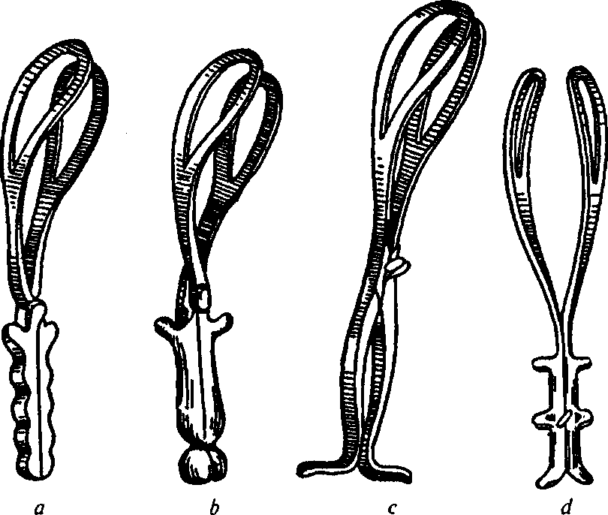
PATHOLOGICAL OBSTETRICS
Fig. 130. Obstetric forceps:
a — Simpson's forceps; /; — Negele's forceps; c — Levre's forceps; d — Lazare-vich's forceps
The forceps handles are rectilinear, their internal surface is straight, the external — ribbed, which prevents sliding of the obstetrician's hands. On the external surface of the handles close to the lock there are the so-called Bush's hooks. The forceps branches are differentiated by the following signs: 1) on the left branch the lock and lock plate are on the surface, on the right — underneath; 2) if the forceps are put on the table, the Bush's hook and ribbed surface of the handle on the left branch are turned to the left, on the right — to the right.
The operation of obstetric forceps application is carried out if there are necessary conditions in case of complications, which require urgent termination of delivery.
Indications from the mother's side:
- severe forms of late gestoses (preeclampsia and eclampsia in the course of delivery);
- an extragenital pathology, which requires exclusion (shortening) of the 2nd period;
280
Chapter 23. Obstetric Operations
- delivery endometritis;
- primary or secondary uterine inertia;
- acute infectious diseases of the mother (pneumonia, hepatitis, viral infections of the upper air passages);
- premature detachment of the normally located placenta if there are conditions to finish delivery through the natural maternal passages.
Indication from, the fetus' side:
— fetal distress.
Conditions for forceps application:
- thorough evaluation of the general condition of the parturient woman, fetus and delivery course;
- full cervical dilatation;
- absence of the fetal bladder;
- correspondence between the dimensions of the mother's pelvis and fetal head;
- alive mature fetus;
— ■ the fetal head is in the cavity of the small pelvis for the cavity
forceps and in the area of pelvic outlet — for the output obstetric for
ceps.
Contraindications to forceps application:
- a dead fetus;
- hydrocephaly;
- deflexion fitting (brow and face);
- incomplete cervical dilatation;
- an intact fetal bladder;
- indefinite location of the presenting part and its high standing;
7) inadequacy of the fetal head and the mother's pelvis.
Preparation to the operation includes:
- catheterization of the urinary bladder;
- disinfection of the external genitals;
- narcosis;
- detailed obstetric investigation with the detection of the foreseeable fetal weight, location, position, presentation and degree of fetal head fitting into the small pelvis;
- location of the folded forceps.
Operation technique: forceps application consists of four steps: 1) introduction of the spoons of forceps; 2) locking of the forceps and trial traction; 3) tractions; 4) removal of the forceps.
The first step. The obstetrician introduces four fingers of the right
281
PATHOLOGICAL OBSTETRICS
hand into the vagina along its left wall. Then, with three fingers of the left hand takes (as a pencil) by the handle the left branch of the forceps and lifts the handle to the front and to the right inguinal fold of the parturient woman in such a way that the tip of the forceps spoon enters the pudendal fissure according to its longitudinal diameter. The spoon is introduced into the pudendal fissure, pushing its lower rib with the 1st finger of the right hand and using guidance of the fingers introduced into the vagina. The spoon must slide between the 2nd and 3rd fingers. When the left spoon is properly placed on the fetal head, the handle is given to the assistant, who holds it from under the right leg of the parturient woman. After this the obstetrician introduces the right branch of the forceps. When the spoon is moved along the parturient canal, it captures the convexity with its head curvature (and not only with the tip), and the forceps handle carefully moves to the midline of the body and retrad. The best variant is to capture the head from the occiput to the chin according to the oblique dimension of the head. The forceps must be placed in the biparietal way (Fig. 131,132).
The second step. In order to lock the forceps the forceps handles are taken with both hands, the thumbs are placed on the Bush's hooks and the handles are connected. After this the trial traction is carried out, which is aimed at testing the correct application of the forceps and the absence of the threat of their slipping-off. For this purpose the forceps handles are captured with the right hand from above, controlling with the 2nd finger of the left hand if the forceps slip off (Fig. 133).
The third step. During tractions the forceps are usually captured in the following manner: the lock is captured with the right hand from above, the 3rd finger is put in the gap between the spoons over the lock, and the 2nd and 4th fingers — on the Bush's hooks. The left hand covers the forceps from below. Direction and character of tractions are differentiated. Directions of tractions correspond to the labor bio-mechanism and movement of the head along the pelvic axis. By their character tractions are divided into pendulous, circular, and static. Only static tractions should be conducted.
Duration of a single traction corresponds to parodynia duration. After 4—5 tractions the forceps are disconnected and a 1—2 min pause is made (Fig. 134).
The fourth step — the forceps are disconnected and removed at head disengagement (this is unsafe) or after its birth. Preliminary epi-siotomy or perineotomy is necessary. The birth of the fetal shoulders and body usually does not cause difficulties.
282
Chapter 23. Obstetric Operations
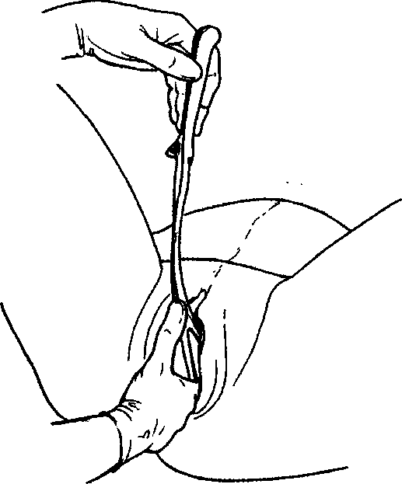
Fig. 131. Introduction of the left spoon of forceps
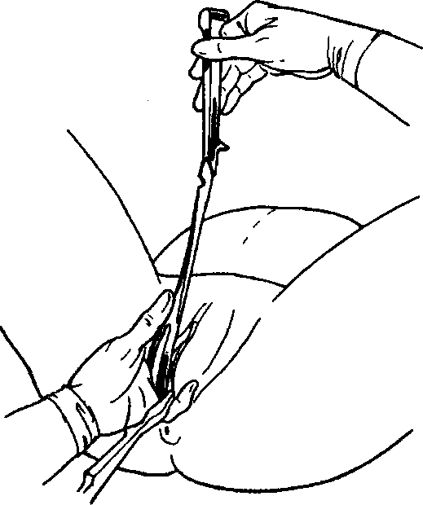
Fig. 132. Introduction of the right spoon of forceps
283
PATHOLOGICAL OBSTETRICS
When obstetric forceps are applied, the triple M.S. Malynovskyi's rule is resorted to.
The first triple rule — "three to the left — three to the right". The left spoon is the first to introduce, with the left hand into the left part of the pelvis. The right hand is the second to introduce, with the right hand into the right art of the pelvis.
The second triple rule — "three axes": when the forceps are applied, three axes must coincide — the longitudinal axis of the pelvis, head, forceps. For this purpose forceps introduction must be directed with tips up, the spoons must be placed in the biparietal way, the guiding point must be in one plain with the locking part of the forceps.
The third triple rule — "three positions — three tractions".
The 1st position — the fetal head is in the area of brim with its small or large segment. Tractions are directed at the toes of the sitting obstetrician. The forceps, applied at such position of the fetal head, are called high and are not used nowadays.
The 2nd position — the head in the cavity of the small pelvis. Tractions are directed at the knees of the sitting obstetrician. The forceps, applied at such position of the fetal head, are called cavitary.
The 3rd position — the head in the area of pelvic outlet. Tractions are directed at themselves, and after a point of fixation is formed — upwards. The forceps, applied at such position of the fetal head, are called exit.

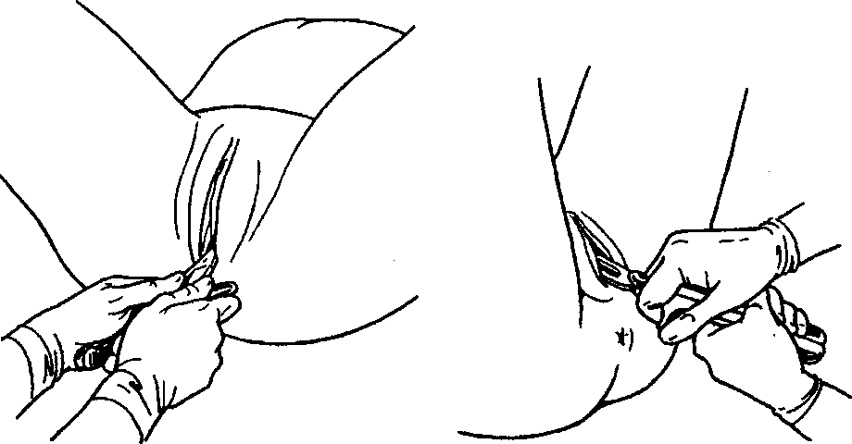

Fig. 133. Forceps locking

Fig. 134. Traction by the fetal head

Chapter 23. Obstetric Operations
Complications:
- Sliding-off of the forceps (horizontal and vertical).
- Injury of the soft tissues of the parturient canal of the woman.
- Birth traumas of the fetus (injury of the fetal scalp, nerves, bones, cephalohematomas, intracranial hemorrhages).
23.2. VACUUM FETUS EXTRACTION
Modern methods of operative vaginal delivery include vacuum extraction of the fetus.
Vacuum extraction was offered in 1954 by Malstrom as an alternative to obstetric forceps to reduce the quantity of complications of operative delivery.
Vacuum extractor consists of the vacuum apparatus (in which negative pressure is created) and a cup of different dimensions, which are applied on the fetal head.
' In order to reduce complications not only the technique of the operation, but also models of vacuum extractors are improved. There are fungiform metal cups, soft belled and tubular silicone and plastic cups. A disadvantage of metal cups is that they are cumbersome to assemble and insulting to the fetal scalp. A disadvantage of light cups is the strong probability of their detachment.
Indications to vacuum assisted delivery:
- uterine inertia at the 2nd stage of delivery — prolonged 2nd stage;
- delivery chorioamnionitis;
- fetal distress at the 2nd stage of delivery (if there are no conditions for cesarean section);
- pathological conditions of the mother, at which shortening of the 2nd stage of labor is recommended for maternal benefit.
To prevent complications vacuum extraction is conducted only in appropriate conditions; the rules given below are to be followed. Conditions for the operation:
- thorough evaluation of the general condition of the parturient woman, fetus and delivery course;
- full cervical dilatation;
- absence of the fetal bladder;
- correspondence between the dimensions of the mother's pelvis and fetal head;
- alive mature fetus;
285
PATHOLOGICAL OBSTETRICS
— the fetal head is in the area of pelvic outlet and in the pelvic
plane of least dimensions.
Vacuum extraction is conducted at intensive uterine activity provided the parturient woman agrees to it and takes active part under constant cardiomonitor control of the fetal condition.
Contraindications to vacuum extraction:
- deflexion fitting of the fetal head;
- pregnancy term less than 36 weeks;
- fetal head not engaged in the maternal pelvis;
- incomplete cervical dilatation;
- cephalopelvic disproportion;
- unknown position of the fetal head;
- an extragenital pathology and pregnancy complications requiring shortening of the 2nd labor stage.
Obstetric forceps application after vacuum extraction of the fetus is not an absolute contraindication, but this technique is undesirable because of a high risk of complications.
Operation technique. Preparation to the operation is the same as at other vaginal surgical interventions.
Before vacuum extraction of the fetus one should conduct thorough obstetric examination of the patient. In particular, one should detect the foreseeable fetal weight, location, position, presentation and presentation type, the degree of fetal head fitting into the small pelvis, etc.
The doctor pulls the lips of pudendum apart with one hand and carefully introduces the cup of the vacuum extractor into the vagina with the other. The cup is placed on the fetal occiput (the centre point of the vacuum cup is located 3 cm anterior to the posterior fontanels along the sagittal suture of the fetal head. One should make sure that there are no soft tissues of the parturient canal between the cup and the fetal head.
The traction direction at vacuum extraction does not differ from the traction direction at obstetric forceps application. Tractions are began synchronously with expulsive pains along the pelvic axis according to labor biomechanism, their duration coincides with expulsive pains duration. The doctor performs tractions with one hand and presses the cup base with the other. The hand, which is on the cup base, controls movement of the fetal head at each traction and timely detects the sliding-off of the cup. After disengagement of the parietal tuber the cup is removed (Fig. 135).
286
Chapter 23. Obstetric Operations

The main rules of the operation:
- vacuum extraction must be completed during 15 min after the beginning of the operation;
- repeated application of the cup after its sliding-off may be performed only twice;
- correct choice of the cup model and correct direction of tractions (according to the labor biomechanism) are important;
- each tractions should be accompanied by fetal head movement along the parturient canal of the mother.
Complications. Vacuum extraction performed by an experienced obstetrician-gynecologist under conditions of following the rules given above is rarely complicated.
It has been detected that vacuum extraction is less traumatic for the parturient woman than obstetric forceps. Discussions concerning the comparison of the frequency of neonatal complications at obstetric forceps application and vacuum extraction are still going on.
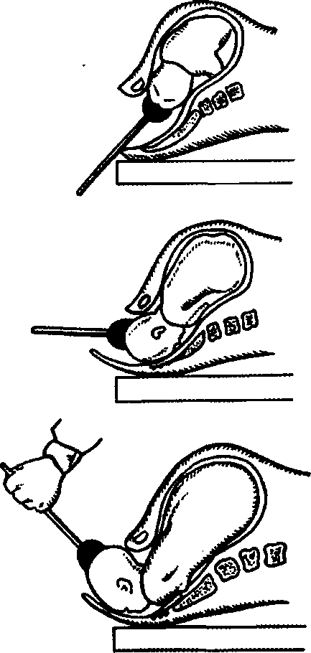
Maternal complications include damage of the pelvic floor and rectum, fecal and urinary incontinence.
Neonatal complications include scalp injuries, cephalo-hematoma, retinal hemorrhage, neonatal jaundice.
Severe complications like intracranial hemorrhage more often develop at multiple unsuccessful attempts of vacuum extraction, especially if they are followed by forceps application. One of the factors lead-
Fig. 135. Stages of vacuum-assisted extraction of the fetal head
(a scheme)
287

PATHOLOGICAL OBSTETRICS
ing to such complications is sharp pressure reduction during detachment of the cup from the fetal head.
According to the world practice, regardless of the improving technique of the operation and vacuum extractor models, the general quantity of operative vaginal deliveries has a tendency to reduction, and the number of cesarean sections — to increase.
23.3. FETUS EXTRACTION BY THE PELVIC POLE
Fetus extraction by the pelvic pole (FEPP) consists in operations, due to which the fetus, who is in one of three variants of pelvic presentations, is extracted from the maternal passages.
There are three types of FEPP operations: extracting the fetus by one leg, by two legs, by the inguinal fold.
Indications:
- Severe diseases of the parturient woman requiring urgent termination of delivery (cardiac infarction, cerebral hemorrhage, retinal detachment, acute heart failure, vasogenic shock, crush kidney, acute hepatic failure, pneumonia, pulmonary edema, hypertensic crisis, etc.).
- Severe pregnancy pathology (preeclampsia, eclampsia, amniotic fluid embolism, premature placenta detachment).
- Intrauterine fetal hypoxia (prolapse of cord loops, knotting, abruption of umbilical cord, etc.).
- Deterioration of the mother's condition after the operation of classical externo-internal pedalic version.
Conditions:
- sufficient cervical dilation;
- fetal bladder rupture;
- dimensions of the fetal head correspond to the pelvic dimensions;
- alive fetus;
- at pure pelvic presentation the inguinal fold must be in the area of pelvic outlet.
Fetal extraction at pelvic presentations consists of 4 stages: 1 — extraction of the fetus to the navel, 2 — extraction of the fetal trunk to the inferior angle of the anterior spatula, 3 — release of the fetal shoulders and arms, 4 — release of the head.
Chapter 23. Obstetric Operations
Operation of Fetus Extraction by One Leg

The surgery is conducted at foot presentations. Operation technique consists of three stages.
The first stage — extraction of the fetus till the inferior angle of scapulas. Its execution consists of three consecutive steps:
- the anterior leg is grasped with the hand, the thumb is located parallel to the shin length (according to Fenomenov) and does not become interwoven with it at an angle. The other fingers grasp the shin from the front (Fig. 136);
- the posterior limb is reached by downward tractions. The leg is grasped as close as possible to the pudendal fissure as it is pulled out (it may be pulled with both hands). An area of the anterior inguinal fold and a wing of the femoral bone are born from under the symphysis (Fig. 137). This area is fixed under the symphysis for the posterior buttock to disengage above the perineum. Then the anterior hip is elevated with both hands, the posterior buttock is born above the perineum, and the posterior leg falls out without assistance or is extracted;
- after the buttocks are born the surgeon's hands are moved onto the fetus in such a way that the thumbs are located on the sacra and the rest are covering the hips (Fig. 138). Tractions are performed downwards and in the direction of the surgeon. The body is born in the oblique dimension, with the back forward to the symphysis.
The obstetrician's hands can not be placed on the fetal abdomen, since it threatens with a damage of the abdominal viscera. The body is extracted till the inferior angle of scapulas with tractions in the direction of the doctor — this is the end of the first stage.
The second stage — releasing the shoulder girdle. It consists of two steps:
1) releasing the posterior shoulder and arm. For this, the fetus is grasped with a hand by both shins, and the body is elevated upwards and to the side, parallel to the inguinal fold, opposite to the


Fig. 136. Grasping the fetal leg:
a — correct traction by the leg; b —incorrect traction by the leg
a
289

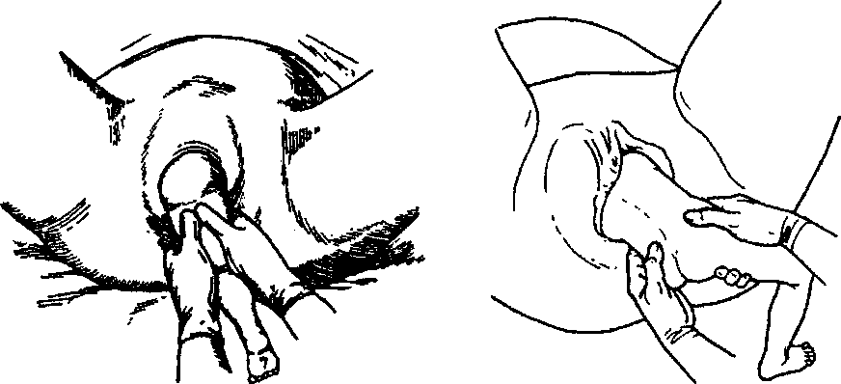
PATHOLOGICAL OBSTETRICS
Fig. 137. Grasping the fetal leg with both Fig. 138. Grasping the extracted
hands at fetus extraction by the leg fetal buttocks with both hands
side of the released arm. After this two obstetrician's fingers (the 2^{tul} and 3rd) are introduced into the genital tracts from the side of the hollow of the sacrum, in whose direction the fetal shoulder is turned and where the shoulder is located. Then two fingers are brought to the bend of elbow and the arm is taken out to the face with a "washing movement". Before this the fetus is brought into the median position. Not infrequently the anterior shoulder and arm are born after this. If this does not take place, the second step has begun;
2) releasing the anterior shoulder and arm. For this the anterior arm is brought backwards. With this purpose the doctor grasps the body and the arm, which has been born, with both hands in the form of a "boat", and turns through the oblique dimension opposite to the one, in which it was. The back and occiput must be turned into the straight dimension. Now the shoulder and arm are turned backwards, they are extracted with the same maneuvers as the previous arm.
The third stage — releasing the head. The head is taken out by means of the Mauriceau—Levret's maneuver. The arm, which was releasing the second fetal arm, is introduced into the vagina. The fetus is kind of "riding" the forearm of this arm. Then the end of the index finger of the internal hand is introduced into the fetal mouth promoting head flexion and its internal version. The index and long fingers of the external hand are bent and located on the sides of the neck as a fork in such a way that the fingertips do not press the clavicles and supraclavicular fossae. Then downward tractions of the fetus are per-
Chapter 23. Obstetric Operations
formed with the external arm. When a part of the suboccipital fossa is under the symphysis pubis, the fetus is slowly pulled upwards, after what first the mouth appears above the perineum, then — the face, and only after this — the scalp.
During the operation of fetus extraction the assistant carefully
presses the uterine fundus to preserve regular location of the fetal
parts of body. '
Operation of Fetus Extraction by Both Legs (Fig. 139)
This operation is resorted to at full foot presentation. It begins when the obstetrician pulls out both legs or they are born from the pudendal fissure without assistance. Each leg is grasped with a hand in such a way that the thumbs lie along the gastrocnemius muscle, and other fingers grasp the shins. As the fetus is extracted, both obstetrician's hands slide along the legs upwards in such a way that they are also close to the vulva. First, tractions are performed downwards and in the obstetrician's direction, and after the buttocks are born the obstetrician places the arms in such a way that the thumbs are on the femoral bone of the fetus and the other fingers grasp the hips from the front. Fingers are not allowed to rise above this level not to harm the fetal viscera.
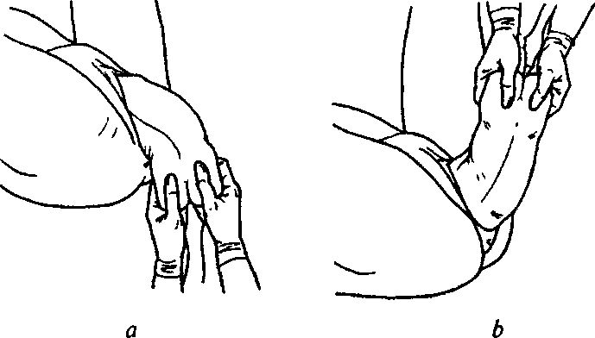
Fig. 139. Fetus extraction by both legs:
a — grasping both fetal legs with hands, relocation of the obstetrician's hands on the fetal buttocks and downward traction of the fetal body; b — drawing the fetal body aside to the maternal inguinal region, opposite to the fetal position, shoulder girdle release
291
PATHOLOGICAL OBSTETRICS
Then tractions are performed downwards and in the obstetrician's direction till the body is born first to the navel, and then — to the inferior angle of the anterior scapula.
Further fetal extraction is carried out in the same way as at the previous operation.
Operation of Fetus Extraction by the Inguinal Fold (Fig. 140)
The index finger of an obstetrician's hand is introduced into the similar inguinal fold. The thumb is placed on the sacra along their full length. At the operation of extraction by the buttocks the obstetrician should help himself with the other hand, grasping the wrist joint of the first hand with it. Having grasped the fetal pelvic pole in such a way tractions are performed downwards till the anterior buttock and femoral bone come under the symphysis pubis.
After the anterior buttock is born and the femoral bone comes under the symphysis pubis tractions are directed upwards. Lateral bending ob the body takes place, the posterior buttock disengages. Then, the hook-like flexed index finger of the other hand is introduced into the posterior inguinal fold and the fetus is extracted till the inferior angle of the scapulae. The legs usually fall out without assistance.
The arms and head are released in the same way as at pelvic fetal presentations.

Fig. 140. A — Operation of fetus extraction by the inguinal fold. B — Operation of dead fetus extraction by the inguinal fold with the help of a hook

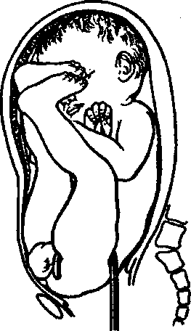
B

292

Chapter 23. Obstetric Operations
23.4. CESAREAN SECTION
Cesarean section (CS) is a delivery operation, during which the fetus is extracted through the section of the anterior abdominal wall and uterus close to the natural maternal passages if delivery through the latter is impossible or dangerous.
The risk for the life and health of the woman at cesarean section is 12 times higher than at delivery through the natural maternal passages, therefore the surgery is carried out by strict indications only.
Indications to CS are divided into 2 groups: maternal and fetal.
Maternal indications:
- Anatomical (the 3rd and 4th degrees) contraction of pelvis and rarely observed forms of contracted pelvis.
- Clinically contracted pelvis.
- Central placental presentation.
- Partial placental presentation with hemorrhage and absence of conditions for urgent natural delivery.
- Preterm detachment of normally located placenta with the absence of conditions for urgent natural delivery.
- Threatening or progressing hysterorrhexis.
- Two or more uterine scars.
- Inconsistent uterine scar.
- A uterine scar after corporal CS.
- Scar changes of the neck of uterus and vagina.
- Birth activity anomalies resisting medicamental correction.
- Significant varix dilatation of the uterine neck, vagina, and perineum.
- Malformations of the uterus and vagina, which prevent child delivery.
- Condition after perineum rupture of the 3rd degree and plastic operations on the perineum.
- Condition after surgical treatment of urogenital and entero-genital fistulas.
- Tumorous formations of pelvic organs, which prevent fetus birth.
- Cervical carcinoma.
- Inefficient treatment of severe gestosis and impossibility of urgent natural delivery.
- Traumatic injuries of the pelvis and spine.
- An extragenital pathology, which requires exclusion of the 2nd
293
PATHOLOGICAL OBSTETRICS
stage of delivery (if there is a conclusion of an appropriate specialist in accordance with the guidelines). Fetal indications:
- Fetal hypoxia confirmed by objective investigation methods in the absence of conditions for urgent natural delivery.
- Chronic hypoxia and fetal development delay syndrome resisting medicamental-therapy.
- Pelvic presentation of a fetus weighing more than 3,700 g.
- Prolapse of pulsing cord loops.
- Fetal malposition after amniotic fluid discharge.
- High straight standing of the sagittal suture.
- Flexion fitting of the fetal head.
- Pregnancy as a result of application of lacertus reproductive technologies or after long-term infertility treatment.
- Verified genital herpes.
- Agony or apparent death of the pregnant woman, the fetus being alive.
- Multiple pregnancy at pelvic presentation of the 1st fetus.
- Multiple pregnancy at transversal position of one fetus when birth activity begins.
Conditions necessary to conduct the operation:
- alive fetus, except for the cases of massive bleed ing at complete placental presentation, premature placenta detachment, pelvic contraction of the 4th degree;
- intact fetal bladder or waterless interval up to 24 h;
- no signs of infection in the pregnant woman;
- the woman agrees to the operation (if there are no life-saving indications);
Contraindications:
- dead fetus;
- fetal malformations incompatible with life or deep prematurity;
- acute infectious disease of the woman;
- prolonged labor (more than 24 h). Methods of conducting CS operation:
1) intraperitoneal:
- corporal (classical) CS;
- in the inferior uterine segment by transversal section;

- CS in the inferior uterine segment with temporary isolation of the abdominal cavity;
- extraperitoneal CS;
- Stark's technique.
294
Chapter 23. Obstetric Operations
Anesthesia. There may be used inhalational (general) or regional (spinal or epidural) anesthesia. Epidural anesthesia often leads to considerable deterioration of the newborn's condition, therefore when it is applied, the interval of time from the beginning of anesthesia till the moment of fetal extraction should not exceed 10 min.
Organization of CS operation: according to different clinics, about 40 % are scheduled." An operation is'scheduled if its necessity is confirmed by a council of physicians; in this case the time of the operation does not matter. It is expedient to conduct the operation when birth activity begins, since it promotes maturation of the fetal surfactant system.
Intraperitoneal CS technique. Transversal suprapubic or inferior median laparotomy. Section of the peritoneum of recess between the urinary bladder and uterus by 1.5 cm above the urinary bladder fundus. Section of the muscle of the anterior uterine wall within the largest circumference of the presenting part with a scalpel (up to 1.5—2 cm) with the following dilation.of the wound by the method of Gusa-kov or Dorfler. Extraction of the fetus. Before the signs of placenta detachment appear — local hemostasis and restoration of muscle integrity in the section angles. Placenta removal by tractions by the umbilical cord. The uterine walls are to be wiped with a gauze swab or scraped with an obstetrical curette. The wound on the uterus is sutured with a single-layer uninterrupted suture. Lately preference is given to synthetic materials, which may be hydrolyzed. Peritonization. Hemostasis control. Examination of adjacent organs. Restoration of the anterior abdominal wall (Fig. 141, 142).
Extraperitoneal CS (without peritoneum section) is performed in the case of long-term anhydrous period, body temperature rise to more than 37.5 °C, presence of endometritis, amnionitis, chorioamnionitis during delivery. This method was practically refused after the introduction of effective antibiotics and in connection with frequent cases of urinary bladder and ureters injure caused by this intervention.
General blood loss during CS operation makes 600—800 ml.
Methods of considerable blood loss prevention: improvement of operation technique, autohemotransfusion application, preoperational artificial hemodilution, optimization of anesthesia methods, particularly refusal from halogenoform inhalation anesthetics, which significantly relax the uterus.
In case of hypotonic bleeding and blood loss exceeding 1,000 ml operation volume expands to hysterectomy. Limitation to supravaginal amputation in such cases is erroneous.
295
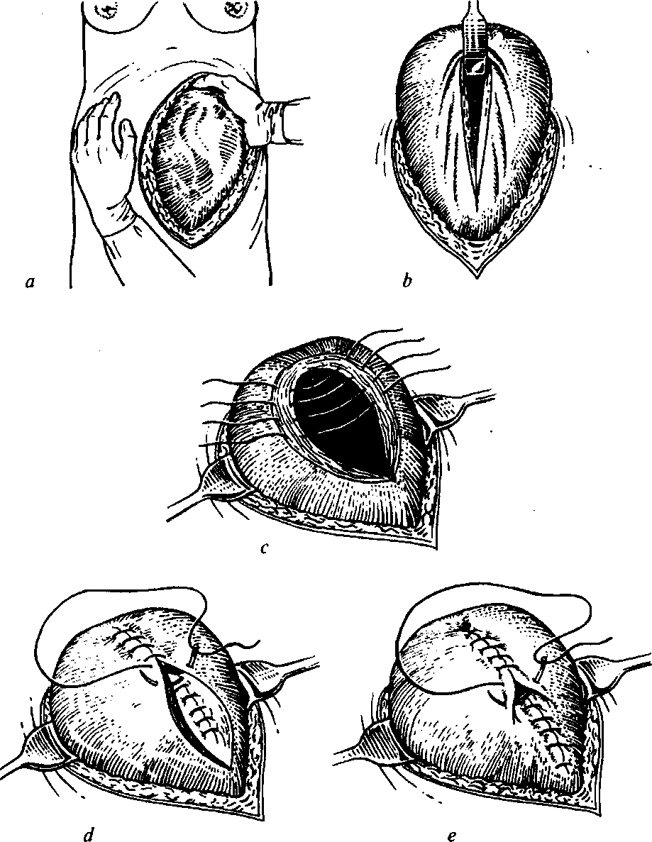
PATHOLOGICAL OBSTETRICS
Fig. 141. Classical CS
(operation stages):
a — the uterus is delivered to the incisional wound; b — the narrow elevator is introduced into the superior angle of uterine wall incision, which reduces hemorrhage; c — placing the first layer of sutures on the uterine incision after fetus extraction; d — continuous gut suture on the uterine wall (the second layer); e — continuous gut suture on the serous tunic of uterus (the third layer)
296
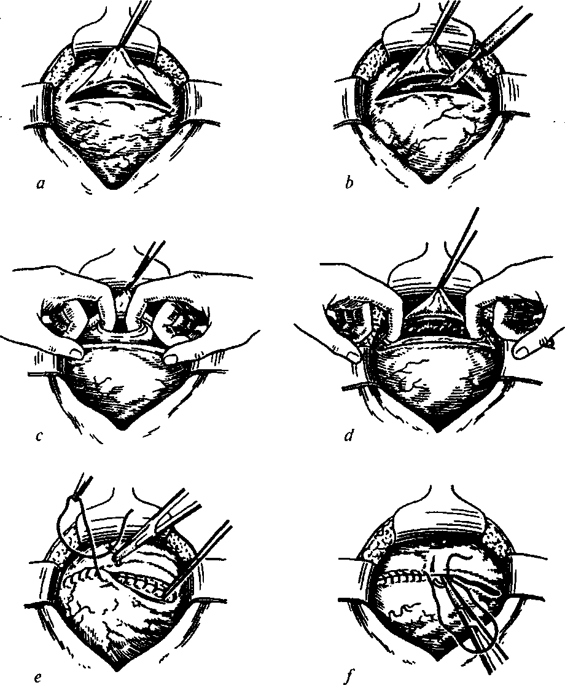
Chapter 23. Obstetric Operations
Fig. 142. CS in the inferior uterine segment.
a — transverse incision of the peritoneum of vesicouterine fold; b — small transverse incision of the inferior uterine segment; c — moving the lips of the wound apart with two fingers introduced into the incision; d — wound dilation to the dimensions necessary for unhindered fetus extraction; e — suturing the uterine wall incison;/— peritonization of the uterine incision
297
PATHOLOGICAL OBSTETRICS
CS complications: endometritis, salpingitis, wound infection, hemorrhage, pulmonary collapse, deep venous thrombosis, pulmonary artery embolism, anesthesia complications (for instance, stomach content aspiration).
23.5. EMBRYOTOMIES
Embryotomies are divided into three groups:
- operations reducing the volume of the fetus: craniotomy, exenteration; y&'
- operations of fetus partition and extraction part by part: decapitation, spondylotomy, disarticulation;
- operations reducing body volume at the expense of maximal increase of mobility between separate parts of the fetal body: cleidotomy, cephalocentesis at hydrocephaly, fractures of extremities bones.
Craniotomy, decapitation, and cleidotomy belong to typical embryotomies; spondylotomy and evisceration or exenteration — to atypical embryotomies.
After each embryotomy one should thoroughly check the integrity of the maternal passages, perform manual examination of the uterine walls, and check the urinary bladder by means of catheterization.
Craniotomy — fetal head perforation.
The notion of craniotomy includes such consecutive interventions:
- head perforation;
- head excerebration — brain destruction and matter extraction;
- cranioclasia — pressing of the perforated head with the following extraction through the maternal passages.
Indications: all cases of death of the fetus with the expected weight of more than 2,500 g with the purpose to avoid parturient canal traumas.
Conditions for craniotomy:
- absence of absolutely narrow pelvis (c. vera > 6 cm);
- cervical dilatation at head perforation and excerebration must be > 6 cm, at cranioclasia — complete;
- the fetal head must be fixed by an assistant during all three moments of the operation;
- craniotomy is conducted under narcosis, this provides anesthetic effect, protects the psyche of the parturient woman, facilitates the fixation of the fetal head by the assistant through abdominal coverings;
298
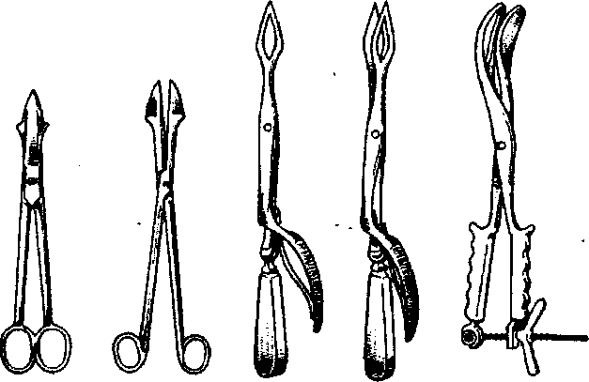
Chapter 23. Obstetric Operations
Fig. 143. Instruments for craniotomy and cranioclasia
— the operation must be conducted under direct vision, even in
cases when the fetal head tightly adjoins in the pelvic cavity at com
plete cervical dilation.
To conduct the operation of craniotomy one needs such special instruments'.
- perforator/Blot's lanceolated perforator/Fenomenov's perfo-rator/Smellie's scissor perforator (Fig. 143);
- scoop catheter/Agafonov's excerebrator/big blunt scoop/ blunt curet;
- Brown's cranioclast;
- vaginal specula and elevator;
- fork or bullet forceps;
- scalpel;
- Fenomenov's or Siebold's scissors.
Head perforation technique (Fig. 144). With the help of the wide flat specula the access to the uterine neck and the lower pole of the fetal head is opened. At unstable position of the fetal head special attention should be paid to the full-value fixation of the head by the assistant. To guarantee better fixation on the cutaneous covering of the head (preferably in the centre) there are applied two pairs of powerful fork forceps (these might be bullet forceps), after what the skin is dissected to the bone with a scalpel or scissors for 2x3 cm, preferably parallel to the sagittal suture. Then, with a finger the coverings are detached from the bone. The perforator is placed perpendicularly (vertically) relative to the bare bone, but not obliquely, as otherwise sliding and maternal passages injure might happen. The Blot's perfo-
299
PATHOLOGICAL OBSTETRICS
rator easily perforates the sutures and fontanel, cranial bones perforation is complicated. The bones are drilled slowly, until the wide part of the back catches up with the perforation. After this the perforator handles are brought together, in this case the plates of the spear-shaped end are broadened and additional incisions are made in the edges of the opening. Only after this the spear-shaped end of the perforator with separated plates is introduced into the perforating opening and energetically turned to and fro (approximately by 90°), trying to obtain the expansion of the perforating opening in the skull to 3—4 cm in diameter.
The Fenomenov's perforator reminds a gimlet. On one end of the instrument the handle has a crossbeam, on the other — a gimlet-like cone-shaped tip. The Fenomenov's perforator has a protector in the form of a cartridge, which is put on the perforator.
The margins of the perforating opening obtained at perforation with the Blot's perforator may be sharp and injure the maternal passages. The margins of the free opening obtained at perforation with the Fenomenov's perforator have even surface and are safe.

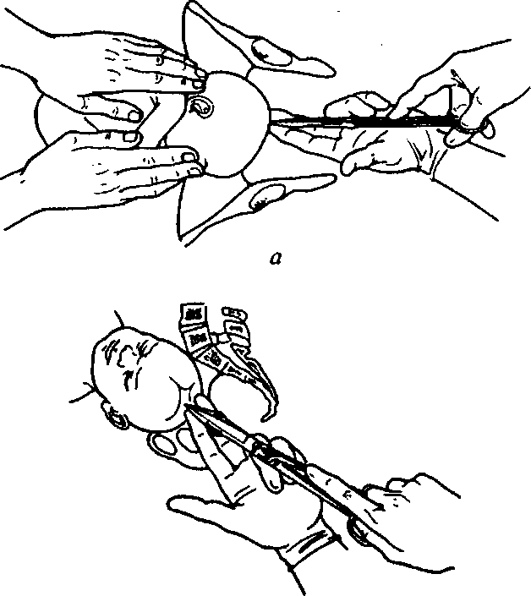

Fig. 144. Craniotomy

b

Chapter 23. Obstetric Operations
The points of the fetal head subject to perforation depend on the conditions and character of the presenting part (the part of the head located on the axis of pelvis). At synclitic fitting of the head, at vertex presentation the sagittal suture and the small fontanel are accessible to perforation. At asynclitic fitting an opening is formed through the bone. At sincipital presentation the place of perforation is the large fontanel. At brow presentation — the frontal bone or frontal suture. At face presentation — the eyesocket or hard palate. At the presentation of other parts — the suboccipital fossa or maxillary area.
Excerebration. A large blunt scoop/Fenomenov's scoop/big cu-ret, which is used to destroy the brain, is brought into the piercing opening. The offered washing out of brain from the skull with the help of the fountain syringe is excessive.
Cranioclasia (Fig. 145). After craniotomy and excerebration expulsion of fetus is possible by natural flow, especially if perforation and excerebration were conducted without sufficient cervical dilatation. If there are indications to immediate termination of delivery, cranioclasia is performed simultaneously with narcotizing. The Brown's cranioclast is used for this purpose.
The cranioclast is constructed upon the model of forceps and consists of two crossed branches: an external one and an internal one. Similarly to the obstetrical forceps the cranioclast consists of branches, a lock, and a handle with an integrated screw-nut device. The scoops of the cranioclast have pelvic curvature. The internal scoop is massive, solid, there are transverse furrows on the inside. The external scoop is fenestrated, wider than the internal one.
The internal (solid) scoop is always brought first into the perforating opening using guidance of the left hand fingers. If the vagina was opened in the zone of the fontanel, the scoop is introduced under direct vision as deep as possible, to the skull base. After this the handle of the introduced scoop is given to the assistant. The external scoop is also introduced using guidance of the left hand (not to injure
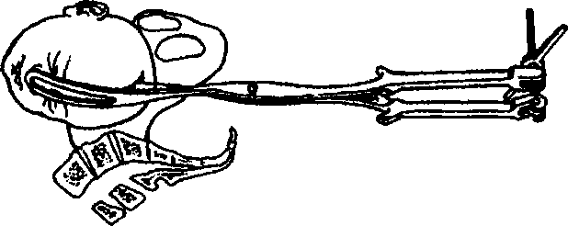
Fig. 145. Cranioclasia
301
PATHOLOGICAL OBSTETRICS

the vagina walls) and applied onto the external surface of the skull for it to correspond to the position of the internal branch. The external branch is applied very carefully, its direction is watched not to make a mistake and not to cover the uterine orifice. Having made sure that the cranioclast branches are applied correctly, the screw-nut device is applied and linked by screwing. Circumstances force the cranioclast to be applied onto the most accessible part of skull, but if there are options, the places of cranioclast application are the facial and occipital parts of the skull. Before beginning tractions the obstetrician checks the correctness of cranioclast branches application once more. The first, trial traction usually already shows if the cranioclast has been applied correctly, if the head is nonrigid. Direction and character of tractions must corresponds to those used when the obstetrical forceps are applied: at high elevation of the head — downwards, at the head located on the pelvic floor — horizontally, at appearance of the suboccipital fossa — upwards. The cranioclast scoops are removed as soon as the head is brought out of the pudendal fissure.
Decapitation — beheading of fetus.
Indications: neglected transverse lie of fetus.
Conditions:
- sufficient dilation of the uterine orifice;
- accessibility of the fetal neck for examination and manipulation;
— sufficient pelvic dimensions (c. vera > 6 cm).
Instruments: the Brown's hook and Siebold's scissors (Fig. 146).
Operation technique (Fig. 147). A loop is put on the slipped out
arm of the fetus and given to the assistant, who pulls it down and to the side of the pelvic pole. Then a hand is brought into the vagina and further into the uterus, and also, when the arm has not slipped out, the fetal neck is found and seized by putting the first finger in front and other four — on the back of the neck. Sliding on the arm with the button down the decapitation hook is brought into the uterus and put on the fetal neck.
(i

Fig. 146. A — Brown's decapitation hook. B — Siebold's scissors
B

302

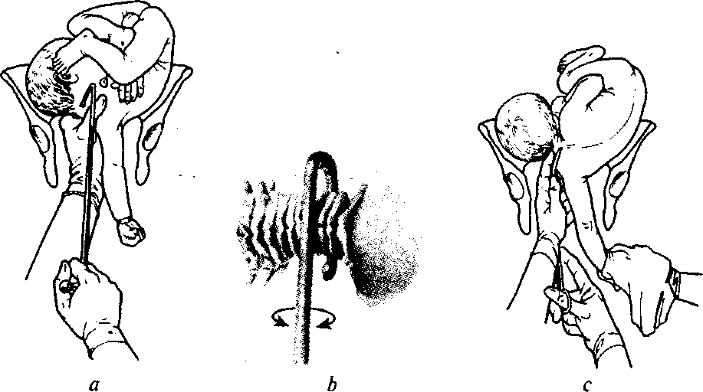
Chapter 23. Obstetric Operations
Fig. 147. Decapitation operation.
a — decapitation hook introduction; b — rotatory movements with the decapitation hook; c — dissection of the soft tissues of fetal neck with the scissors
After this the handle of the Brown's hook is powerfully pulled down and rotated. When the spine is broken, characteristic crunch can be heard. The hook is removed and using guidance of the internal hand the soft tissues of the fetal neck are cut with the scissors.
The body of the decapitated fetus is taken out by pulling the arm. Still, sometimes it is difficult to take out the shoulders. In such cases the clavicle is dissected (cleidotomy is conducted). The head is taken out from the uterine cavity with a hand. For convenience and reliability a finger of the internal hand is put into the fetal mouth. If attempts to take the head out fail, the doctor conducts craniotomy, then excerebration, and the head is taken out with an instrument (the two-pronged forceps are the best; Fig. 148).
After the operation is over, the placenta is removed and then manual revision of the uterine walls is conducted to make sure the walls are uninjured.
Cleidotomy — clavicle dissection (Fig. 149).
Indications: difficulties of taking out the fetal shoulders.
Shoulder girdle circumference at unilateral cleidotomy reduces by 2.5—3 cm, at bilateral — 5—6 cm.
The assistant pulls the born fetal head downwards. The operating doctor introduces four fingers of the left hand into the vagina and
303
PATHOLOGICAL OBSTETRICS

Fig. 148. A - Ex
traction of the fe
tal body after de
capitation. B —
Grasping and
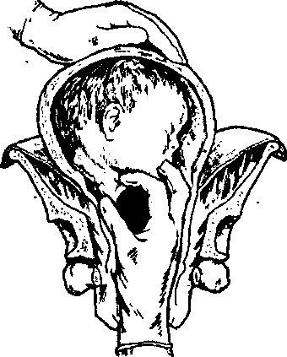
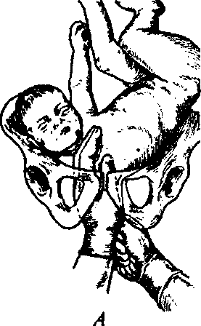
extracting the fetal head after decapitation
B

feels about for the anterior clavicle, with the right hand taking hard blunt scissors (Fenomenov's or Siebold's scissors), reaching the clavicle with them and dissecting the clavicle with one or two strokes. To dissect the other clavicle the doctor reaches the posterior clavicle with fingers of the left hand and dissects it in the same way. The operation is more often conducted after craniotomy.
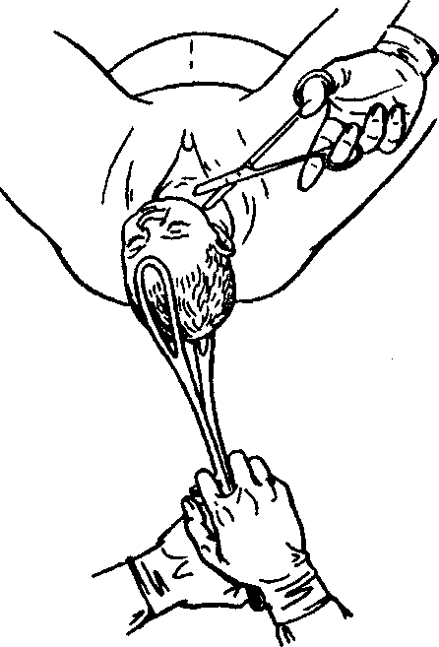
Exenteration and spondylotomy: spondylotomy — spine dissection (Fig. 150); exenteration — internals extraction from the abdominal or thoracic cavity (Fig. 151).
Not always the fetal neck
is reached at neglected trans
verse lie of fetus: it may be
located so high that decapi
tation is impossible. In such
cases the volume of fetal
body is to be reduced by or
gans extraction from the ab
dominal or thoracic cavity,
after what the folded fetus is
Fig. 149. Cleidotomy taken out.
304

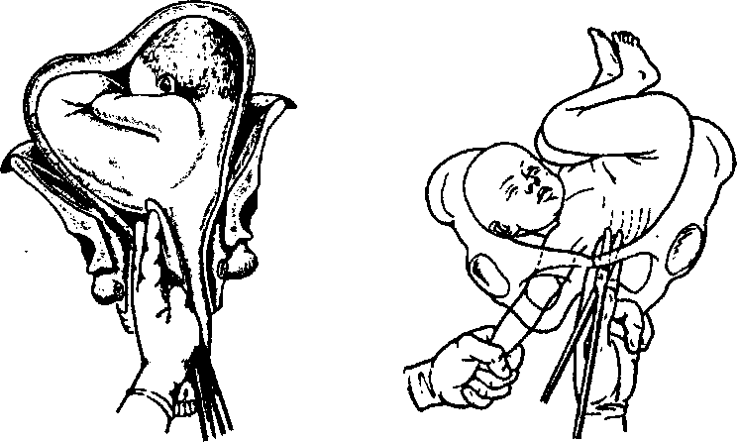
Chapter 23. Obstetric Operations
Fig. 150. Spondylotomy Fig. 151. Exenteration:
opening of the fetal chest
In exceptional cases after exenteration it is necessary to "dissect the spine at any level — to conduct spondylotomy. The spondylotomy procedure:
- the left hand is introduced into the vagina and the place for body wall (of the abdominal or thoracic cavity) perforation is looked for;
- the perforator is introduced using guidance of the internal hand;
- perforation of the body in the intercostal space and gradual dilation of the perforating opening. If it is necessary, one or two ribs are dissected;
- the destroyed organs are gradually removed from the abdominal or thoracic cavity with an abortzang or forceps through the obtained opening. The spine is dissected with the Fenomenov's or Siebold's scissors.
Exenteration is also indicated at double fetuses, which have grown together with deformities. Independent of the case, the additional head is decapitated and excerebrated or the additional abdominal or thoracic cavity is eviscerated, etc.
305
Chapter 24
POSTNATAL INFECTIOUS COMPLICATIONS
Postnatal infections remain one of the basic reasons for maternal mortality. Postnatal infections most often take place at body temperature rise to more than 38° C and uterus painfullness even in 48—72 h after delivery. During the first 24 h after delivery normally body temperature rise is not infrequent. About 80 % women with body temperature rise during the first 24 h after delivery through the natural maternal passages do not have signs of an infectious process.
In the International Classification of Diseases of the 10th review (ICD-10,1995) the following postnatal diseases are singled out:
085 Postnatal sepsis.
Postnatal:
- endometritis;
- fever;
- peritonitis;
- septicemia.
086.0 Surgical obstetric wound infection.
Infected (after delivery):
- wound of cesarean section;
- perineal suture.
086.1 Other infections of the maternal passages after delivery:
- cervicitis;
- vaginitis.

- Superficial thrombophlebitis in the puerperal period.
- Deep phlebothrombosis in the puerperal period. Deep vein thrombosis in the puerperal period. Pelvithrombophlebitis in the puerperal period.
Etiopathogenetic factors of infection development:
- Presence of an infectious agent and its characteristics (the type of the microorganism, its virulence, toxigenicity, invasiveness, and dose).
- The state of the portal of infection entry (localization, the degree of tissues damage).
306
Chapter 24. Postnatal Infectious Complications
- The state of nonspecific protection factors (organism resistance) and specific mechanisms (immunity).
- Physiological resistance of the microorganism:

- biological barriers (the skin, mucous tunics);
- reticuloendothelial system organs (the liver, spleen, lymph nodes);
— .bactericidal component of biological fluids (lysozyme, comple
ment, properdin);
— inflammation reaction and phagocytosis mechanism.
Despite the great variety of agents in the majority of cases at post
natal infection the following are singled out:
- gram-positive microorganisms (25%): Staphylococcus aureus — 35 %, Enterococcus spp. — 20 %, Coagulase-negative staphylococcus — 15 %, Streptococcus pneumoniae — 10 %, other — 20 % ;
- gram-negative microorganisms (25 %): Escherichia coli — 25 %, Klebsiella/Citrobacter — 20 %, Pseudomonas aeruginosa — 15 %, En-terobacterspp. — 10 %, Proteus spp. — 5 %, other — 25 %;
- mixed infection of gram-positive and gram-negative microorganisms — 20 % ;
- fungi of the Candida genus — 3 %;
- anaerobic flora — 2 %;
- unestablished flora — 25 % cases.
Microorganism virulence is, in laboratory environment, a minimal dose of microbal bodies capable of causing an infectious process or lethal outcome in experimental animals; in clinical conditions it is detected by the degree of severity and consequences of the pathological process.
Microorganism toxigenicity is the ability to produce toxic substances in the form of ferments and toxins, which influence the metabolic processes of the organism.
Ferments produced by pathogenic microorganisms are divided into two groups by the character of influence on the microorganism:
- Ferments splitting high-molecular compounds of the microorganism and promoting the appearance of aggressive qualities of the agent (hyaluronidase, deoxyribonuclease, fibrinolysin, collagenase, proteinase).
- Ferments indirectly promoting the pathogenetic action of bacteria (urease, decarboxylase, lipolytic and acid-restorative).
Toxins are divided into two groups:
— exotoxins — high-toxic, have pronounced antigenic and aller
genic properties. Outside a cell exotoxin is thermolabile and high-
sensitive to acids and disinfectants. The place of their action is the
307
PATHOLOGICAL OBSTETRICS
vessel endothelium, leucocytes, lymphoid tissue, and vegetative nervous system;
— endotoxins are released when a bacterial cell dies; they are less
toxic and more thermoresistant.
Invasiveness is the ability of bacteria to overcome protective barriers of the microorganism and spread in tissues by forming ferments (hyaluronidase, phospholipase, elastase, eollagenase).
The portal of infection entry is the area of tissue or organ through which pathogenic microflora gets into the patient's organism. There may be a couple oiways of getting into the organism:
- endogenous way (autoinfection) due to microflora in the patient's organism, in case of reduction of the natural organism resistance. It may be: a) opportunistic flora, which vegetates on the skin and mucous tunic of the organism; b) "dormant" infection, which is in chronic infection foci — tonsillitis, caries, osteomyelitis. The patient's organism becomes tolerant to its own microflora — this is a characteristic feature of autoinfection;
- exogenous — infection gets into the patient's organism from the environment through the damaged skin, mucous tunics, wounds;
- iatrogenic is a purulo-infectious process conditioned by the actions of medical workers.
Infection spread in the organism may be: blood, lymphatic, intercellular, intracanalicular (through the vagina, neck, uterine cavity, and uterine fallopian tubes), by combined ways.
The mechanism of wound infection development:
- Penetration of the agent into tissues or organs.
- Microorganisms reproduction, toxins and ferments release.
- Development of the local and general reaction of microorganism response.
Postnatal infection may be caused by:
- wound infection: infected episiotomy, laparotomy wound, wound of the perineum, vagina, uterine neck;
- endometritis, parametritis;
- mastitis;
- infection of the upper respiratory tract, especially at general anesthesia application;
- epidural tunics infection;
- thrombophlebitis: the lower extremities, pelvis, vein catheterization sites;
- urinary infection (asymptomatic bacteriuria, cystitis, pyelonephritis);
308
Chapter 24. Postnatal Infectious Complications
- septic endocarditis;
- appendicitis.
Predisposing factors of postnatal complications development include:
- Cesarean section. The presence of suture material and ischemic necrosis of infected tissues alongside with an incision on the uterus create ideal conditions for septic complications..
- Protracted labor and preterm rupture of membranes leading to chorioamnionitis.
- Tissue trauma at vaginal delivery:

- forceps application;
- episiotomy;
- manual placenta removal;
- repeated vaginal examinations during delivery;
- intrauterine manipulations (internal version);
- internal monitoring of the fetal condition and uterine contractions;
- reproductive tract infections.
4. Low social level combined with bad nutrition and unsatisfac
tory hygiene.
24.1. WOUND INFECTION
Wound infection appears as a result of the infection of scratches, fissures, ruptures of the neck, mucous tunic of the vagina and vulva, wounds after excision of the perineum, anterior abdominal wall after cesarean section.
Inflammatory reaction is characterized by such general clinical manifestations:
- local inflammatory reaction: pain, hyperemia, edema, local temperature rise, malfunction of the injured wound;
- generalized reaction of the organism: hyperthermia, intoxication signs (general weakness, tachycardia, ABP decrease, tachypnoe).
Diagnostics takes into account the following data:
- clinical: examination of the injured surface, assessment of the clinical presentation, complaints, anamnesis;
- laboratory: common blood analysis (leucogram), common urine analysis, bacteriological investigation of the exudate, immuno-gram;
- instrumental: US.
309
PATHOLOGICAL OBSTETRICS
Clinical signs of wound infection development in the wounds healing by primary intention:
a) complaints:
- of intensive, often throbbing pain in the region of the wound;
- of body temperature rise — subfebrile or to 38—39 °C;
b) local changes:
- hyperemia around the wound without positive dynamics;
- appearance of tissue edema, which gradually increases;
- palpation detects tissue infiltration, which often increases; appearance of deep infiltrates is possible (necrotizing fasciitis, which may spread to the buttocks, anterior abdominal wall — often a fatal complication);
- serous exudate often changes to pus.
Clinical signs of wound infection development in the wounds healing by secondary intention:
- progressing edema and infiltration of the tissue around the wound;
- appearance of dense painful infiltrates without clear contours;
- signs of lymphangitis and lymphadenitis;
- wound surface is covered with continuous fibrinopurulent incrustation;
- deceleration or cessation of epithelization;
- granulations become pail or cyanotic, their hemorrhagic diathesis sharply decreases;
- exudate quantity increases, its character depends on the agent:

- staphylococcus conditions the appearance of thick yellowish pus, and some strains cause the development of local putrid infection with the formation of the foci of tissue necrosis and grayish pus with sharp smell;
- streptococcus is characterized by the appearance of liquid pus of yellow-green color, ichor;
- colibacillary and enterococcal infections condition the appearance of brown pus with characteristic smell;
- blue pus bacillus, Pseudomonas aeruginosa, leads to the appearance of green pus with specific smell.
The type of the agent also defines the clinical course of wound infection:
• staphylococcosis is characterized by the fulminant deve
lopment of the local process with evident manifestations of
purulo-resorptive fever;
310
Chapter 24. Postnatal Infectious Complications
- streptococcosis has a tendency to diffuse spread in the form of phlegmon, with low-grade local symptoms;
- blue pus bacillus is characterized by the flaccid, protracted course of the local process after acute onset with evident manifestations of general intoxication.
Bacteriological investigation of exudate is conducted with the . purpose of detecting the agent and its sensitivity to antibiotics. Material sampling is to be performed before the beginning of antibiotic therapy. Material for the investigation may be the exudate, pieces of tissue, lavage from the wound. Material is taken with sterile instruments and placed in sterile tubes or vials with standard medium. Material is to be inoculated in the course of 2 h after sampling. Simultaneously with material sampling for bacteriological investigation one should perform not less than two Gram-stained smears for express-diagnostics.
There may be used accelerated methods of identifying the wound infection agent with the help of multimicrotest systems, lasting 4— 6h. •
In the absence of microbal growth in the clinical material one should exclude such reasons:
— presence of high concentrations of local or systemic antibacte
rial preparations in the material;
- violation of the regimen of specimen storage and transportation;
- procedural mistakes in the bacteriological laboratory;
- effective control over the infectious wound process with antibacterial preparations.
You will find the US technique in the chapter Fetal Condition Imaging and Assessment except for fact that the sensor is placed on the lesion area in order to image the infiltration process.
Treatment: in most cases local treatment is sufficient. The treatment includes surgical, pharmacological, and physiotherapeutic methods.
Surgical wound treatment. The initial handling of the wound is performed by primary indications. Repeated initial handling is performed if the first surgical intervention was not radical for some reason and repeated intervention was necessary before the development of infectious complications in the wound.
Surgical treatment of wound consists in:
- removal of dead tissue — primary necrosis substrate — from the wound;
- removal of hematomas (especially deep ones), foreign bodies;
311
PATHOLOGICAL OBSTETRICS
- final arrest of bleeding;
- restoration of damaged tissues.
Secondary treatment of the wound is carried out by secondary indications, as a rule, in connection with pyoinflammatory complications of the wound. Repeated secondary treatment of the wound at severe forms of wound infection may be conducted iteratively. In most cases secondary, surgical treatment of wound includes:
- removal of the focus of infectious-inflammatory alteration;
- wide opening of recesses, leakages;
- full-blown drainage providing exudate outflow.
The pharmacological method is antibiotic prophylaxis and antibiotic therapy.
Antibiotic prophylaxis is systemic administration of an antimicrobial preparation till the moment of microbial contamination of the wound or development of postoperative wound infection, and also if there are signs of contamination, on the condition that primary treatment is surgical.
Antibacterial prophylaxis principles:
- predominately a single dose of an antimicrobial preparation, in case of long-term anhydrous period and other risk factors of infectious complications development one should resort to full-blown prophylactic doses;
- at noncomplicated cesarean section the first dose of antibiotic is introduced after clipping the umbilical cord and then twice more with an interval of 6 h;
- the same preparation may be used for antibiotic therapy in case of complications arising during surgery or infectious process signs detected;
- prolongation of antibiotic introduction after 24 h from the moment of surgery termination does not lead to any increase of the efficiency of wound infection prophylaxis;
- preterm prophylactic administration of antibiotics before surgical intervention is not expedient.
Antibiotic therapy is the usage of antibiotics for long-term treatment in case of infectious process onset. Antibiotic therapy may be:
- empirical — based on the usage of broad spectrum preparations, active relative to potential agents;
- object-orientated — preparations are used according to the results of microbiological diagnostics.
Local application of antiseptics is very important. For wound cleansing one can use 10 % solution of sodium chloride, 3 % hydrogen
312
Chapter 24. Postnatal Infectious Complications
peroxide, 1:5,000 furacilinum solution, 0.02 % chlorhexidine solution, etc. For quicker healing one may use liners with levomecol, levo-sin, synthomycin or solcoseryl ointment, etc.
Physiotherapeutic procedures in the period of reconvalescence include UHF-inductotherapy, ultraviolet irradiation, electrophoresis with medicamental preparations.
Prophylaxis of wound infection consists in rational management of labor and puerperal period, observance of aseptics and antiseptics.
24.2. POSTNATAL ENDOMETRITIS
Postnatal endometritis is inflammation of the superficial layer of endometrium. Endomyometritis (metroendometritis) is the spread of inflammation from the basal layer of endometrium to myometrium. Perimetritis is the spread of inflammation from the endometrium and myometrium to the serous uterine layer.
The initial stage of postnatal infectious process may have different intensity and polymorphous presentation. One should differentiate classical, obliterated and abortive forms of endomyometritis, endomyometritis after cesarean section. The classical form usually develops on the 3rd—5th day after delivery. This form is characterized by fever, intoxication, psyche alteration, evident leucocytosis with leuco-gram shift to the left, pathological discharge from the uterus. At the obliterated form of endomyometritis disease usually develops on the 8th—9th day after delivery, temperature is subfebrile, local manifestations are low-grade. The abortive form has a course similar to the classical form, but is quickly arrested at a high level of immunological protection. Endomyometritis after cesarean section is often complicated with pelviperitonitis, peritonitis, which may develop during the 1st—2nd day after the surgery.
Diagnostics is based on:
- clinical data: complaints, anamnesis, clinical examination. Vaginal examination shows the moderately sensitive uterus, subinvolution of the uterus, purulent discharge;
- laboratory data: common blood count (leucogram), common urine analysis, bacteriological and bacterioscopic investigation of the cervical and uterine discharge (urine and blood if it is necessary), im-munogram, blood biochemistry;
- instrument data: US.
313
PATHOLOGICAL OBSTETRICS
Treatment: in most cases the treatment is pharmacological, but surgical is also possible.
Complex treatment of postnatal endomyometritis includes not only systemic antibacterial, infusion, detosication therapy, but also local treatment. Antibiotic therapy may be empirical and object-orientated (see above). Preference is given to object-orientated antibiotic therapy, which is possible by using accelerated methods of agent identification (using multimicrotest system). If fever lasts during 48—72 h after treatment beginning, one should suspect resistance of the agent to the applied antibiotics. Treatment with intravenous antibiotics is to last for 48 h after disappearance of hyperthermia and other symptoms. Tableted antibiotics are to be administered for 5 more days. Antibiotics get into the maternal milk in small doses. In most cases it does not lead to clinically significant consequences. Nevertheless, the immature ferment system of the newborn may not manage the complete excretion of antibiotics, which may cause a cumulative effect.
Local endomyometritis therapy consists in aspiration-washing drainage of the uterine cavity with the application of a dual-lumen catheter, through which the uterine walls are irrigated with solutions of antiseptics, antibiotics. There are used cooled to +4° C solutions of 0.02 % furacilinum, 0.02 % chlorhexine, 0.9 % isotonic solution with the speed of 10 ml/min. Contraindications to aspiration-washing drainage of the uterine cavity are: inconsistency of sutures on the uterus after cesarean section, infection spread beyond the uterus, up to 3—4 days of puerperal period. If it is not possible to wash the pathological inclusions in the uterine cavity by means of drainage, they are to be removed by vacuum aspiration or careful curettage against the background of the conducted antibacterial therapy and normal temperature if it is possible. Correct treatment of postnatal endomyometritis makes the basis of the prevention of widespread forms of infectious diseases in parturient women and their localization at the first stage.
Surgical treatment consists in laparotomy and extirpation of the uterus without the appendages or extirpation of the uterus with the uterine tubes, or with the appendages, depending on the spread of the inflammatory process. Surgical treatment is resorted to in case of conservative treatment inefficiency and presence of negative dynamics during the first 24—48 h of treatment, development of systemic inflammatory response symptom (SIRS).
314
Chapter 24. Postnatal Infectious Complications
24.3. THROMBOTIC COMPLICATIONS IN THE PUERPERAL PERIOD
Superficial thrombophlebitis. Acute thrombophlebitis declares itself with pain along the damaged vein. Complaints of the local sensation of fever, reddening and painfulness along the saphenous vein. The vein is palpated as a dense painful cord, hyperemia may spread beyond the borders of vein induration, adjacent tissues infiltration and lymphadenitis may arise. General condition of the parturient woman is slightly affected with subfebrile temperature, rapid pulse.
Thrombophlebitis of deep veins. Complaints of pain in the muscles, more frequently gastrocnemius, which increases at palpation and movement, sensation of spreading, extremity edema, sometimes cyanosis, fever. The evidence of manifestations depends on the site of thrombosis of deep veins. Thrombus localization is detected with the help of Doppler ultrasonic investigation. At iliac-femoral thrombosis clinical presentation declares itself during a couple of hours, impetuously and brightly. There arises sharp pain in the leg, fever, edema of the extremity and external genitals, cyanosis or paleness of cutaneous coverings.
Septic thrombophlebitis of pelvic veins. At endometritis, myometritis the infectious agent gets into the venous blood flow, damages the vessel endothelium and promotes thrombus formation, anaerobic infection prevails. The veins of the ovary are involved in the process, and thrombi may get into the inferior vena cava, renal vein. Complaints of pains in the underbelly with irradiation into the back, groin, abdominal distension, fever. During vaginal examination there is palpated a thickening in the form of a cord in the region of uterine angles. At septic thrombophlebitis migration of small thrombi into the pulmonary circulation may take place.
Diagnostics is based on:
- clinical findings: complaints, anamnesis, clinical examination (see in the text);
- laboratory data: coagulogram, common blood analysis (leuco-gram), common urine analysis, bacteriological and bacterioscopic investigation of the cervical and uterine discharge (urine and blood if it is necessary), immunogram, blood biochemistry;
- instrument data: US.
The treatment of thrombotic complications in the puerperal period along with antibiotics and disintoxication should include low-molecular anticoagulants, preparations improving the rheological pro-
315
PATHOLOGICAL OBSTETRICS
perties of blood (acetylsalicylic acid, pentoxyphillin), elastic compression. In acute period bed rest is obligatory as well as elevated position of the affected limb, anesthesia. Prophylactic measures of thromboembolisms are actions directed at the limitation of stasis in the saphenous veins; active behaviour of the parturient woman after delivery and usage of elastic compression stockings are important.
24.4. LACTATIONAL MASTITIS
Lactational mastitis is inflammation of the mammary gland (mostly unilateral) during lactation in the puerperal period. It develops more frequently in 2—3 weeks after delivery.
Most frequently the portal entry of infection is nipple cracks, in-tracanalicular penetration of the infectious agent through the mammary ducts at breast feeding or expression of breast milk; the spread of the agent from endogenous foci is very rare.
Risk factors:
- nipple cracks;
- lactostasis.
Nipple cracks may take place at nipple malformations, late beginning of breast feeding, irregular feeding technique, feeding lasting longer than 20 min, rough expression of milk, individual lability of the epithelial nipple cover, violation of the sanitary-hygienic standards of the puerperal period.
At lactostasis body temperature rise may last up to 24 h, if longer than 24 h — this condition is to be considered mastitis.
By the character of the inflammatory process course mastitis can be:
- serous;
- infiltrative;
- suppurative;
- infiltrative-suppurative, diffuse, nodular;
- suppurative (intramammary): areola furunculosis, areola abscess, abscess in the gland thickness, abscess behind the gland;
- phlegmonous, purulo-necrotic;
- gangrenous.
By focus localization mastitis can be: subcutaneous, subareolar, intramammary, retromammary and total.
The clinical presentation of mastitis is characterized by acute onset, evident intoxication (general weakness, headache), body temperature rise to 38—39° C, chill, pain in the region of the mammary gland
316
Chapter 24. Postnatal Infectious Complications
increasing at feeding or expression. The mammary gland expands, hyperemia and tissue infiltration without clear margins are marked. This picture is characteristic of serous mastitis. If treatment is ineffective, serous mastitis develops into infiltrative during 1—3 days. Palpation detects dense, sharply painful infiltrate, lymphadenitis. This stage lasts 5—8 days. If the infiltrate does not resolve against the background of the treatment being conducted, its suppuration takes place — suppurative mastitis (intramammary). Intensification of local inflammation symptoms is observed, considerable increase and deformation of the mammary gland; if the infiltrate is located not at a great depth, suppuration is accompanied by fluctuation. Infiltrate suppuration takes place during 48—72 h. If a couple of infiltrates have suppurated in the mammary gland, mastitis is called phlegmonous. Body temperature is 39—40 °C, chills, evident weakness, intoxication. The mammary gland is sharply enlarged, painful, pastose, well-marked surface venous network, the infiltrate occupies almost the whole gland, the skin above the damaged area is edematous, lustrous, red with a bluish tint, often with lymphangitis. At phlegmonous mastitis infection generalization with transition into sepsis is possible. Diagnostics is based on:
- clinical data: examination of the mammary gland (see in the text), assessment of clinical presentation, complaints and anamnesis;
- laboratory: common blood analysis (leucogram), common urine analysis, bacteriological and bacterioscopic investigation of the exudate, immunogram, coagulogram and blood biochemistry;
- instrument findings: US is the main method of mastitis diagnostics.
Treatment may be conservative and surgical.
Antibiotic therapy should be started from the first signs of the disease, which promotes the prevention of suppurative inflammation development. At serous mastitis the question of breast feeding is decided individually. One should take into account: opinion of the parturient woman, anamnesis (for instance, suppurative mastitis in the anamnesis, multiple scars on the mammary gland, mammary gland prosthetics), antibiotic therapy, which is being conducted, the data of bacteriological and bacterioscopic investigations, nipple crack presence and evidence. Beginning from infiltrative mastitis breast feeding is contraindicated because of a real threat of child's infection and cumulative accumulation of antibiotics in the child's organism, but lactation may be preserved by means of breast milk expression. If conservative mastitis therapy is ineffective, surgical treatment is adminis-
317
PATHOLOGICAL OBSTETRICS
tered during 2—3 days. Surgical treatment consists in radical section, removal of the necrotized tissues and adequate drainage. At the same time antibiotic, disintoxication, and desensitizing therapy is being conducted. Timely surgical treatment allows preventing the development of the process and SIRS.
Postnatal mastitis prophylaxis consists in teaching women the rules of breast feeding and personal hygiene. Nipple crack and lactostasis are to be timely detected and treated.
24.5. SYSTEMIC INFLAMMATORY RESPONSE SYNDROME
Inflammation is a normal response of the organism to infection and may be defined as local protective response to tissue damage, the main task of which is to destroy the microbe-agent and damaged tissues. Still, in some cases the organism responses to infection with an excessively massive inflammatory reaction.
Systemic inflammatory reaction is a systemic activation of inflammatory response, secondary relative to functional inconsistency of mechanisms of restriction of microorganisms spread, their waste products from the local lesion zone.
Infection generalization may be caused by:
- irregular surgical approach and inadequate volume of surgical intervention;
- irregular choice of the volume and components of antibacterial, disintoxication, and symptomatic therapy;
- reduced or changed immunoreactivity of the microorganism;
- a severe concomitant pathology;
- a wide spread of antibiotic-resistant microorganism strains;
- a change of the etiological structure of the agent of suppurative infection;
- no treatment conducted.
The mechanism of sepsis development consists in homeostasis violation, as an uncontrollable cascade of changes in the system of inflammation, coagulation and fibrinolysis, which take place simultaneously with consequent lesion of vascular endothelium, microvascular dysfunction, ischemia and development of multiple organ failure with possible lethal outcome.
Coagulation is a process associated with inflammation: multiple antiinflammatory cytokines induce production of tissue factor from the endothelial cells and monocytes initiating coagulation:
Chapter 24. Postnatal Infectious Complications
- normally procoagulation cascade is always balanced with the mechanism of anticoagulation;
- at sepsis anticoagulation systems quickly peter, their activity reduces as sepsis progresses;
- most natural anticoagulation mechanisms and systems are depressed or damaged.
Fibrinolysis:
- fibrinolysis is a normal response of the organism to the elimination of excessive thrombus formation while coagulation is being activated;
- fibrinolysis suppression in combination with coagulation activation is dynamic basis of sepsis coagulopathy.
Coagulopathy — in most sepsis cases disbalance between the processes of inflammation, coagulation, and fibrinolysis is reflected in the spread of coagulation and microvascular thrombosis, which is called the syndrome of disseminated intravascular clotting (DIC syndrome). Sepsis patients may have two types of the syndrome:
- diffuse bleeding — fibrinolysis-dominant DIC syndrome;
- diffuse hypercoagulopathy — coagulation-dominant DIC syndrome.
Coagulopathy at sepsis leads to the development of multiple organ failure.
In 1992 the American Society of Anesthesiologists offered the following classification of septic conditions.
Systemic inflammatory response syndrome (SIRS), is manifested with two or more signs:
- body temperature higher than 38 X or lower than 36 °C;
- HR more than 90 bpm;
- respiratory rate more than 20 per minute or PaC0₂ lower than 32 mm Hg;
- leucocyte number more than 12-10⁹/L or less than 4-10⁹/L, more than 10 % of immature forms.
Sepsis is a systemic response to reliably detected infection in the absence of other possible reasons for the changes characteristic of SIRS. Sepsis is manifested with the same signs as SIRS.
Sepsis can not be considered a result of the direct influence of a microorganism on a macroorganism, it should be considered a consequence of significant violations in the immune system, which develop from the condition of excessive activation, "hyperinflammation phase", to the condition of immunodeficiency, "immune paralysis
319
PATHOLOGICAL OBSTETRICS
phase". The immune system of the organism is an active participant of self-destructive process.
Severe sepsis is characterized by the violation of organs funktion-ing, tissue hyperfusion, and arterial hypotension. Acidosis, oliguria, impairment of consciousness are possible. When severe sepsis develops, the following signs join:
- thrombocytopenia less.than 100,000/L, which can not be explained by other reasons;
- C-reactive protein level increase;
- positive blood inoculation for the detection of circulating microorganisms;
- positive endotoxin test (LPS test).
Septic shock (SIRS shock) is defined as severe sepsis with arterial hypotension, which develops irrespective of adequate infusion therapy. The disease is diagnosed if the listed above clinicolaboratory signs are accompanied by:
— arterial hypotension (systolic pressure less than 90 mm Hg or
reduction by more than 40 mm Hg from the baseline);
— impairment of consciousness (less than 13 points by the
Glasgow scale);
— oliguria (diuresis less than 30 ml/h);
— hypoxemia (Pa0₂ less than 75 mm Hg at breathing the
atmospheric air);
- Sp0₂ less than 90 %;
- lactate level increase — more than 1.6 mmole/L;
- petechial skin rash, necrosis of a part of skin;
Multiple organ failure syndrome is acute violation of the organs and systems.
Predisposing factors of sepsis development include:
- presence of an infection focus;
- reduction of general organism resistance;
- possible penetration of the agent or its toxins into the bloodstream.
To diagnose sepsis and its consequences one should conduct such measures:
- monitoring of arterial pressure, HR, central venous pressure (CVP);
- calculation of respiratory rate, blood gases, Sp0₂;
- hourly diuresis control;
- taking the rectal body temperature at least 4 times a day to compare with the body temperature in the axillary parts;
320
Chapter 24. Postnatal Infectious Complications
- inoculation of the urine, blood, obtained from the cervical canal and lesion focus, if possible;
- detection of the acid-base balance of blood and oxygen saturation of tissues;
- calculation of thrombocyte number and detection of the content of fibrinogen and fibrin monomers;
- ECG, US of the abdominal viscera and X-ray thoracic examination.
This will enable to detect the possible source of infection in the puerperal period.
The underlying principles of remedial measures:
- Hospitalization into the intensive care department;
- Correction of hemodynamic violations by means of conducting inotropic therapy and adequate infusion therapy.
The volume of infusion therapy is detected during the assessment of arterial pressure, pulse arterial pressure, CVP, HR, diuresis. CVP enables controlled infusion of blood preparations, colloid and crystalloid solutions (a test with volume loads).
To conduct infusion one uses derivatives of hydroxyethylstarch (refortan, venofundin) and crystalloids (0.9 % solution of sodium chloride, Ringer's solution) in the 1:2 ratio. 20—25 % albumin solution is administered for hypoproteinemia correction. The usage of 5 % albumin at critical states promotes the increase of patients lethality.
Infusion should include 600—1000 ml of fresh frozen plasma since it contains antithrombin.
Using glucose is not expedient because its administration to patients in critical states increases lactate and C0₂ production, ischemic lesion of the brain and other tissues. Glucose infusion is used only in cases of hypoglycemia and hypernatremia.
Inotropic support is used if CVP remains low. Dopamine is introduced in the dose of 5—10 mcg/kg/min (maximum to 20 mcg/kg/min) or dobutamine — 5—20 mcg/kg/min. If there is no stable ABP increase, 0.1—0.5 mg/kg/min noradrenalini hydrotartras is introduced, dopamine dose is reduced to 2—4 mcg/kg/min at the same time. Simultaneous administration of naloxone up to 2.0 mg is justified — it promotes ABP increase.
If complex hemodynamic therapy is ineffective, it is possible to use glucocorticoids, hydrocortisone — 2,000 mg/day together with H₂-blockers (ranitidine, famotidine).
3. Support of adequate ventilation and gas exchange. Indications to ALV are: Pa0₂ less than 60 mm Hg, PaC0₂ more than 50 mm Hg
321
PATHOLOGICAL OBSTETRICS
or less than 25 mm Hg, Sp0₂ less than 85 %, respiratory rate more than 40 per min.
4. Surgical treatment (see above).
Indications to laparotomy and extirpation of the uterus and uterine tubes are:
— no effect from the conducted intensive therapy (24 h);
— endomyometritis, which can not be treated conservatively
(24-48 h);
- uterine hemorrhage;
- suppurative formations in the region of the uterine appendages. Indications to surgical sanation of the focus are:
- presence of nondrainable suppurative cavities at wound infection;
- presence of necrotizing tissue at wound infection.

- Normalization of the intestine function and early enteral digestion.
- Timely correction of metabolism under constant laboratory control.
- Antibacterial therapy. Taking into account that microbiological express-diagnostics is impossible at this stage, one should use broad spectrum antibiotics with low bactericidal effect for antibacterial therapy. Endotoxin formation, induced by antibiotics, increases in the following order: carbapenems (tienam) — to the least extent; aminoglycosides, fluoroquinolones, cephalosporins — to the biggest extent. Monoantibiotic therapy is more expedient for successful treatment of severe forms of purulo-septic diseases. This method is to be preferred to the usage of antibiotic combinations as it is less toxic. In monotherapy carbapenems and cephalosporins of the 3rd generation are used. One should remember that carbapenems do not induce endotoxin shock as opposed to cephalosporins.
After microorganism identification and detection of its sensitivity to antibiotics one proceeds to antibiotic therapy by the data of antibi-oticogram.
If during 48—72 h after treatment beginning there is no positive dynamics, one should suspect agent resistance against the used antibiotic, it should be changed according to the results of bacteriological investigation.
8. Antimediator therapy is based on the usage of multiclonal im
munoglobulins in combination with pentoxyphillin. Since in Ukraine
there are no multiclonal immunoglobulins, one should use pentoxy
phillin and dipiridamol in the complex sepsis therapy.
322
EXTRAUTERINE PREGNANCY
Pregnancy is extrauterine if the fertilized oocyte is implanted outside the uterine cavity.
Recently the frequency of extrauterine pregnancy has increased. This can be explained by the increase of the spread of inflammatory processes of female genitals, increase of the quantity of abortions and their complications, violations of hormonal correlations in the woman's organism, including those connected with the use of hormonal drugs, increase of the age of women planning pregnancy, improved extrauterine pregnancy diagnostics. Presently, 1.4 % of all pregnancies are extrauterine.
The Main Etiological Factors and Pathogenetic Mechanisms of Extrauterine Pregnancy Development
Reasons, which may lead to the development of extrauterine pregnancy, are various. The main of them are:
- inflammatory processes of the female genitals, including those caused by sexually transmitted infections (especially Chlamidia, urea-plasmic, and gonorrheal infections). Chronic salpingitis is found in almost half of the women with extrauterine pregnancy. In this case extrauterine pregnancy is caused by the emergence of peri- and intra-tubal adhesions, uterine tubes peristalsis damage;
- adhesion process of the pelvic organs as a result of acute appendicitis, inflammatory complications after abortions or deliveries, operative interventions;
- surgical interventions on the uterine tubes — ligation, organ-sparing operations for extrauterine pregnancy;
- adenomyosis;
- malformations of the internal genital organs: genital infantilism, diverticula of the uterine tube. At genital infantilism the uterine tubes are long, twisted, their peristalsis is deficient;
323
PATHOLOGICAL OBSTETRICS
- long-term use of intrauterine contraceptives. The use of pro-gestin-only pills, injections of medroxyprogesterone increase the risk of extrauterine pregnancy, which is connected with the decrease of uterine tubes motility in the first place;
- lacertus reproductive technologies;
- infertility. The risk of extrauterine pregnancy is increased at infertility irrespective of its cause;
- the woman's age older than 35.
There are a couple of possible mechanisms of extrauterine pregnancy development:
- Acceleration of fertilized oocyte development as a result of hormonal disorders and inflammatory processes of the pelvic organs, which leads to preterm implantation of the fertilized oocyte into the wall of the uterine tube.
- Violation of fertilized oocyte transportation as a result of inflammatory processes, operative interventions on the pelvic organs, hormonal disorders. This leads to the formation of peri- and intratu-bal adhesions, damage of the pili and villi of the ciliated epithelium, fusions in the orifice of the uterine tube, disorders of the peristalsis of the uterine tubes. In some cases the uterine tube is incapable of grasping the oocyte, it gets into the extrauterine space, where fertilization takes place. In this case there may take place the development of ovarian or abdominal pregnancy, or implantation in the ampullar part of the uterine tube as a result of impossibility of heavy oocyte penetration into the isthmic part. In other cases, as a result of the deceleration of uterine tube peristalsis, antipcristalsis and adhesions formation there takes place the implantation of a fertilized oocyte in any part of the uterine tube.
Extrauterine Pregnancy Classification
Depending on the implantation of the fertilized oocyte there are differentiated such types of extrauterine pregnancy:
- Tubal.
- Ovarian.
- Abdomainl.
- Rare forms:

- combined (uterine-tubal, tubal-ovarian, tubal-abdominal);
- intraligamentous;
- corneal;
324
Chapter 25. Extrauterine Pregnancy
— cervical.
By its course extrauterine pregnancy may be:
- progressing;
- violated (tubal abortion, uterine tube rupture);
- still pregnancy.
TUBAL PREGNANCY ' '
About 90 % of all extrauterine pregnancies are tubal. Tubal pregnancies are subdivided into:
- interstitial (about 8 % of tubal pregnancy cases), when pregnancy develops in the interstitial part of the uterine tube;
- isthmic (about 28 % cases of tubal pregnancy) — pregnancy develops in the isthmus of uterine tube;
- ampullar (about 64 % cases of tubal pregnancy) — pregnancy develops in the ampullar part. Sometimes the fetal egg localizes in the fimbrial part of the uterine tube.
Being implanted in any part of the uterine tube, the fertilized tube due to the fluxing action of its trophoblast begins to sink into the mucous tunic, then it penetrates deeper, into the muscular layer. Since there are no favorable conditions for fetal egg development in the uterine tube, pregnancy is aborted. This most often
/ 2 3
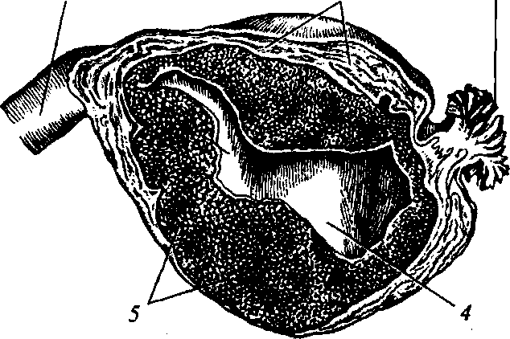
Fig. 152. Still tubal pregnancy:
1 — unaltered stretch of tube; 2 — tube wall; 3 — ampulla of uterine tube; 4 — amniotic cavity; 5 — blood clots
325
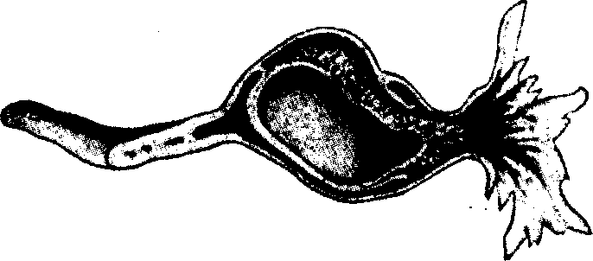
PATHOLOGICAL OBSTETRICS
Fig. 153. Violated extrauterine pregnancy of the tubal abortion type
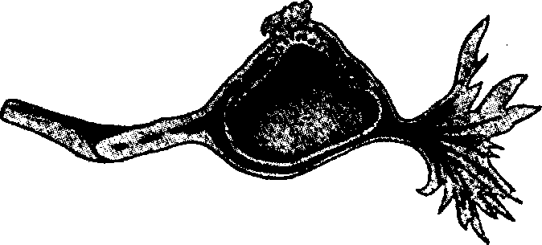
Fig. 154. Violated extrauterine pregnancy of the tube rupture type
takes place on the 4th—6th week (it rarely develops more than 8 weeks).
Thus, by its course tubal pregnancy may be violated and progressing.
There are differentiated two main types of tubal pregnancy abortion:
- By the type of tubal miscarriage — internal rupture of the fetal reservoir to the side of the uterine tube lumen. The fetal egg detaches from the tube walls, dies and under the influence of peristalsis is gradually pushed into the abdominal cavity through the ampullar end, which is accompanied by hemorrhage of different intensity and formation of a peritubal hematoma (Fig. 152). Blood gets into the abdominal cavity through the uterine tube, and through the uterus — outside in the form of bloody discharge. Tubal abortion is more characteristic of pregnancy developing in the ampullar part of the tube (Fig. 153).
- By the type of uterine tube rupture — rupture of the fetal reservoir to the side of the uterine tube wall, by which not only the cap-
326
Chapter 25. Extrauterine Pregnancy
sulc, but also the tube wall itself form. If the fetal egg is implanted in the isthmic or interstitial part, tube rupture is accompanied by considerable hemorrhage (Fig. 154).
In rare cases the fetal egg, which has got into the abdominal cavity from the uterine tube and preserved vital capacity, is implanted in the abdominal cavity. Secondary abdominal pregnancy develops, which in exceptional cases is preserved till late terms.
Tubal pregnancy diagnostics is rather complex. This is connected with the variety of clinical manifestations — from minor pain in the underbelly with smearing blood-tinged discharge from the genital tracts to hemorrhagic shock. The clinical picture depends on the character of its course (Table 22).
Progressing tubal pregnancy is difficult to be diagnosed at early terms as it is accompanied by changes in the organism characteristic of the uterine pregnancy course: delay of menstruation, nausea, mammary glands swelling, change of gustatory, olfactory and other sensation characteristic of pregnancy, cyanosis of vagina, uterine neck. The general condition of the patient is satisfactory. In 90 % women with this pathology unilateral pain of minor intensity is observed in the underbelly. The uterus enlarges and softens due to decidual changes and hypertrophy of the muscular layer. Still, as a rule, uterine dimensions are less than the foreseen pregnancy term. Vaginal examination shows unilateral enlargement and painfulness of the uterine appendages, an ovary enlarged at the expense of the yellow^{r} body of pregnancy may be palpated. Sometimes there is no menstruation delay. In some cases menstruation begins in time or somewhat early, but its course its unusual (discharge is insignificant and of brown color).
Violated tubal pregnancy by the type of uterine tube rupture is usually easy to diagnose with subitaneous severe bleeding. Acute symptoms of the disease often appear unexpectedly without any preliminary complaints of the patient, sometimes against the background of preliminary pain in the underbelly. In some cases it is possible to detect the connection of the disease with physical load. There is menstruation delay in the anamnesis, although in 25—30 % cases this symptom is absent.
In the complex of symptoms of uterine tube rupture during tubal pregnancy abortion the most important are the signs of internal hemorrhage with hemorrhagic shock development and peritoneum irritation signs. Suddenly there arises pain in the underbelly with irradia-
327
Table 22. Diagnostic Signs of Different Forms of Tubal Pregnancy

Clinical signs | Progressing extrauterine pregnancy | Tubal miscarriage
Pregnancy signs | Positive | Positive | Positiv
General condition of the patient | Satisfactory | Deteriorates periodically, short-term losses of consciousness, long-term periods of satisfactory condition | Collap of mass progre genera
Pain | Absent | Has a character of attacks, which repeat periodically | Appear attack
Discharge | Absent or insignificant blood-tinged | Blood-tinged discharge of dark color, appears after a pain attack | Absent tinged
Vaginal examination | The uterus does not correspond to the term of menstruation delay, a retor-shaped painless formation is detected close to the uterus, the fornices are free | Similar, painfulness at uterus displacement, formation without clear contours, the posterior fornix is smoothed | Simila uterus and ap affecte posteri
Additional methods of examination | US, p-HCG, laparoscopy | Culdocentesis, laparoscopy | Are

Chapter 25. Extrauterine Pregnancy
tion into the loin and rectum. At massive bleeding hemorrhagic shock symptoms arise — general weakness, impairment or loss of consciousness, cold sweat, paleness of the cutaneous coverings and mucous tunics, arterial pressure reduction, weak, rapid pulse. Positive phrenicus symptom is detected in the horizontal position of the patient, conditioned by phrenic nerve irritation. The abdomen is moderately swollen, more painful on the side, where the uterine tube rupture appeared, tense. In case of considerable hemoperitoneum the symptom of Shchetkin—Blumberg is positive. Percussion detects dullness of percussion sound in the abdomen flanks. Examination of the uterine neck with specula shows cyanosis of the neck of uterus, minor bloody discharge from the genital tracts (there may be no discharge). Bimanual investigation shows that the uterine dimensions are less than the foreseen pregnancy term. A tumor-like formation of soft consistency is detected in the region of the appendages, it is painful at palpation. There is noted the overhang of the vagina fornices, sharp painfulness of the posterior vagina fornix ("Douglas' cry"), painfulness at uterine neck displacement.
Violated tubal pregnancy by the type of tubal abortion. It is much more complicated to diagnose the disease when pregnancy is aborted by the type of tubal abortion. Tubal abortion develops gradually and is characterised by slow augmenting of symptoms. Periodical deteriorations of the general condition of the patient are typical. Short-term loss of consciousness, unilateral spasmodic pain in the abdomen, blood-tinged brown discharge from the genital tracts. Bimanual investigation palpates somewhat enlarged uterus (the uterine dimensions are less than the foreseen pregnancy term) and a tumor-like, boundedly motile formation in the region of the appendages. In some cases there is detected the overhang and smoothing of the vaginal fornices. At uterine neck displacement and palpation of the posterior vaginal fornix painfulness is much less evident than at tubal rupture.
Laboratory Investigation Methods
1. Analysis of the HCG level in blood serum and urine. One should remember that HCG increase in the blood serum and urine testifies to the presence of pregnancy, but does not detect its localization. Extrauterine pregnancy is characterized by the level of p-subunit of HCG being less than the expected pregnancy term. Investigation shows that the level of p-HCG in dynamics increases slower than at progressing uterine pregnancy.
329
PATHOLOGICAL OBSTETRICS
- Leucocyte count increases in the blood serum (up to 10— 15 • 10⁹/L).
- Progressing reduction of hemoglobin, erythrocytes, and hematocrit indices according to the blood analysis results.
Instrument Investigation Methods
1. US. Since uterine pregnancy is rarely combined with extraute
rine, detection of the fetal egg in the uterus excludes extrauterine
pregnancy. In 10 % cases of extrauterine pregnancy erroneous results
are connected with the fact that accumulated liquid or blood clots
may be mistaken for a fetal egg. The most characteristic US signs of
extrauterine pregnancy are:
- absence of a fetal egg in the uterine cavity;
- a fetal egg imaged out of the uterine cavity;
- detected formation of heterogeneous structure in the region of uterine tubes projection;
- considerable quantity of free fluid in the Douglas cul-de-sac at violated extrauterine pregnancy.

- Diagnostic laparoscopy allows reliable diagnosis of extrauterine pregnancy and its localization.
- Diagnostic scraping of the uterine cavity walls. Extrauterine pregnancy is characterised by the absence in the scraping of fetal egg elements and the presence of decidual tissue.
- Puncture of the abdominal cavity through the posterior vaginal fornix is conducted for the diagnostics of violated tubal pregnancy in the absence of ultrasonography. One of the signs of tubal pregnancy is the presence of liquid blood, which does not coagulate, in the punctuate (Fig. 155).
Other Forms of Extrauterine Pregnancy
Ovarian pregnancy is usually terminated early. The clinical presentation depends on bleeding intensity. If it is insignificant, a hematoma may form. The clinical presentation at long-term bleeding into the abdominal cavity does not differ from the one taking place during acute termination of tubal pregnancy.
Cervical pregnancy develops at the implantation of a fertilized oocyte in the region of the isthmus and neck of uterus (Fig. 156). Chorionic villi deeply penetrate the muscles of the uterine neck, and sometimes — the parametrium. Cervical pregnancy spread makes about 0.1 %,
330
Chapter 25. Extrauterine Pregnancy

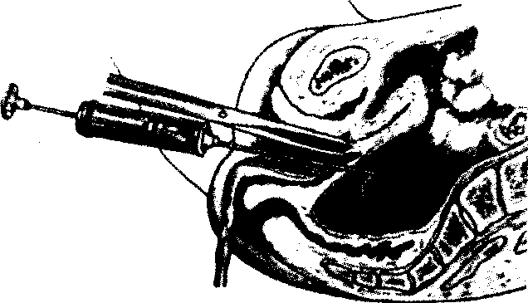
Fig. 155. Puncture through the posterior fornix of vagina

but it is extremely dangerous because of fatal hemorrhage possibility. The first manifestation of cervical pregnancy is not infrequently bleeding in the first or second half of pregnancy (up to 20 weeks) as a result of placenta detachment or violated integrity of the uterine neck vessels. Gynecological examination in the region of the uterine neck shows a ball-shaped tumor, the external orifice of the uterine neck is located eccentrically, the uterine neck exceeds the uterine body by its size. Taking into account the strong probability of profuse bleeding development, extirpation of the uterus used to be the only method of treatment. Endometrectomy attempts may lead to fatal hemorrhage, bleeding arrest measures (uterus tamponade, parametrium clamping, deep suturing of the uterine neck, angiographic embolization of the arterial uterine vessels) may fail to stop such hemorrhage, even urgent extirpation does not always save. Lately there have appeared isolated facts testifying to positive results of the conservative treatment of cervical pregnancy with the help of methotrexate.
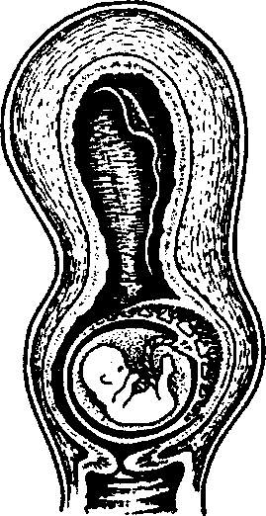
Abdominal pregnancy. A peculiarity of this extrauterine pregnancy form is the fact that the peritoneum in the place of fetal
Fig. 156. Cervical pregnancy
331

PATHOLOGICAL OBSTETRICS
egg attachment cannot form a continuous capsular membrane, as a result of which the fetal reservoir remains "open" at first. Later on, the peritoneum of the abdominal viscera, omentum, intestine loops serve as a capsule for the "open" part of the fetal egg.
Termination of abdominal pregnancy usually takes place in late terms and is always accompanied by the clinical picture of shock, acute abdomen, increasing anemia. Sometimes infection may join, and then the clinical presentation reminds an inflammatory process, which acquires acute or protracted character. In some cases the pregnancy may be born at full term.
Intraligamentous pregnancy. Being implanted on the mesenteric part of the uterine tube, the fetal egg melts the tube wall with the villi of its trophoblast and goes deep between the leaves of the broad ligament of uterus. Intraligamentous pregnancy is usually terminated early.
Corneal pregnancy. Termination of this type of pregnancy most often takes place during the 5th—6th month. The pregnancy may be born to the full term. The clinical presentation of pregnancy termination differs from the termination of tubal and other forms of extrauterine pregnancy by profuse bleeding.
Extrauterine Pregnancy Treatment
Principles of managing patients with ectopic fetation:
- Suspected extrauterine pregnancy is an indication to urgent hospitalization.
- Early diagnostics allows reducing complications quantity.
- If extrauterine pregnancy is diagnosed, urgent operative intervention is to be carried out. Operative intervention may be conducted both by means of laparotomic and laparoscopic approach. The approach of surgical treatment depends on the clinical situation. At tubal pregnancy it is possible to remove the fetal egg with following tuboplasty. Such operations should be conducted to preserve the uterine tube in parous, nonparous, and infertile women. In such cases the doctor should consider the general condition of the patient, the woman's age, the condition of the uterine tube wall, concomitant gynecological and extragenital diseases.
- Presently, the optimal method of extrauterine pregnancy treatment is laparoscopic organ-sparing operations.
Laparoscopic technique advantages include: — endoscopic microsurgical instruments allow conducting organ-sparing plastic operations;
Chapter 25. Extrauterine Pregnancy
- minimum tissue injure;
- shortened duration of operative intervention;
- quick restoration of the physiological functions of the organism in the postoperative period;
- shortened stay in the in-patient department;
- shortened rehabilitation period;
- reduced quantity of scar changes of the anterior abdominal wall;
- cosmetic approach.
5. In case of evident clinical presentation of violated ectopic feta
tion, hemodynamic disorders, hypovolemia, the patient is urgently
hospitalized for medical intervention in the shortest term by laparo-
tomic approach. At the present time laparotomy is performed at se
vere patient's condition and impossibility to conduct a laparoscopic
operation because of adhesions process.
Thus, grave patient's condition, massive blood loss, evident hemodynamic disorders, (hypotension, hypovolemia, hematocrit less than 30 %) are absolute indications to operative intervention by laparo-tomic approach with removing the pregnant uterine tube and conducting anti-shock therapy.
6. Surgical treatment of extrauterine pregnancy is optimal. Pres
ently it is possible to apply conservative methods of extrauterine
pregnancy treatment.
The appearance of preparations inhibiting trophoblast growth attracted gynecologists' interest to their application in the conservative treatment of extrauterine pregnancy. One of the preparations is methotrexate — folic acid antagonist, which is introduced at extrauterine pregnancy to destroy trophoblast tissues. Methotrexate may be introduced i.m. (systemic medicamental therapy) or inside the fetal egg of the extrauterine pregnancy using the guidance of a transvaginal ultrasonic sensor (local methotrexate introduction). Local methotrexate introduction has an advantage over systemic treatment: preparation toxicity decreases due to its dose reduction.
Analysis of the data of controlled randomized studies allowed most of the authors to arrive at a conclusion that medicamental treatment of extrauterine pregnancy requires further research with the purpose of developing an optimal method of introduction (systemic, local, or combined), determination of the therapeutic dose and therapy duration. Therefore this method is not recommended for wide use. It may be administered only for the prophylaxis of trophoblast
333
PATHOLOGICAL OBSTETRICS
growth, when the surgeon is not certain if the fetal egg has been completely removed.
- At pre-hospital stage in case of violated extrauterine pregnancy the volume of acute care is detected by the general condition of the patient and blood loss volume. Infusion therapy (volume, the speed of preparations introduction) depends on the stage of hemorrhagic shock. - -
- A complex approach is resorted to for the treatment of women with extrauterine pregnancy. The approach includes:

- operative intervention;
- fight against bleeding, hemorrhagic shock, blood loss;
- postoperative period management;
- reproductive function rehabilitation. Surgeries conducted at tubal pregnancy:

- salpingotomy. Longitudinal salpingotomy (uterine tube dissection) is performed with further fetal egg removal. After the fetal egg is removed, the section is usually not sutured. After longitudinal salpingotomy uterine pregnancy happens more often than after uterine tube resection;
- uterine tube resection. A segment of the uterine tube with the fetal egg is removed. After this it is possible to form an anastomosis between the remaining parts of the uterine tube. Another advantage of this operation is complete removal of the trophoblast;
- fetal egg expulsion (artificial tubal abortion). Such operation is possible at progressing tubal pregnancy, when the fetal egg is localized close to the distal orifice of the ampule. The risk of extrauterine pregnancy recurrence is twice as high as after other operations. Uterine pregnancy frequency is said to reach 92 % after artificial tubal abortion;
- salpingectomy is performed in case of violated extrauterine pregnancy accompanied by massive bleeding; uterine tube rupture in the isthmic part. Indications to uterine tube removal also include expansion rupture of the tube, concomitant pyoinflammatory and oncological diseases.
HABHAJlbHE BH£AHHfl
BenukiBCbKa IpHHa EopnciBHa
Top,neeBa rajuraa ^MHTpiBHa
Bypna Onhva AHaTOJiii'BHa
Ta m.
AKYinEPCTBO
ni^py^HMK (Ahza. Moeow)
nianHcaHo no npyxy 10.11.08.
<I>opMaT 60x90 1/16. nanip o4>ceT.
TapH. Petersburg. /JpyK 0(J)ceT.
Ym. npyK. apK. 27,3.
3a\i. No 8-888.
BM^aBHMUTBO "MeiUlUMHa"
01034, m. Km'ib, Byji. CrpuieubKa, 28.
Cbuioutbo npo BHeceHHH no /],ep:>KaBHoro peecrpy BH/jaBuiB,
BHroTiBHMKiB i po3noBCK)Zi>KyBaHiB KHJDKKOBo'i npoayKuii.
RKNq 1585 Bin 01.12.2003
Teji.: (044) 581-15-67, 234-58-11, 537-63-66
E-mail: med@society.kiev.ua

